**D2.1. Scenarios and use case**

**> Technical requirements:**

**WP2.3 Requirements and business analysis (draft version 1.2):**

- need for semantic interoperability among platforms (requirements 180 and 249).

- requirements 248 and 251 emphasize the need for interoperability among IoT platforms and emergency systems within the INTER-LogP use case. Two challenges in this context are:

* C1: How to process sensor data using ontologies and standards such as SAREF, W3C SSN, OASIS EDXL-DE (distribution) and EDXL-RM (sensor allocation)?
* C2: How to integrate sensor data with domain-specific ontologies and standards? In the emergency domain, relevant ontologies and standards include OASIS EDXL for alerting (CAP), situation reporting (SitRep), tracking victims (TEP) and hospital availability (HAVE); and can include e-Health, logistics and environmental.

**D2.3 Requirements and business analysis (1.3, September 2016)**

**-** [**IoT Requirements and business Annex v1.2 – draft**](http://www.inter-iot-project.eu/wp-content/uploads/2016/02/D2.3_INTER-IoT_Requirements-and-business_v1.2.pdf)**:**

**3.1 INTER-LAYER requirements**

**3.1.1 Non-functional requirements**

|  |
| --- |
| **Semantic and syntactic interoperability [180]** |
| The mixing and mashing of data gathered by many IoT applications adds values to the collected data as a whole and to facilitate such data exchanges, the IoT applications require common data formats and application programming interfaces (APIs) so data can be accessed and combined as needed. For achieving semantic interoperability, syntactic interoperability must be enabled. It can be achieved through simple translation. IoT Platform Semantic Mediator can receive requests in selected data formats and semantics and translate them to the data formats and semantics of target IoT platform. IoT Platform Semantic Mediator provides interfaces for data interchange formats at least such as OWL, RDF, XML, and JSON. |
| **Acceptance criteria:**  There will be mechanisms to translate data format and semantics of exchanged message to achieve communication with common understanding on both sides. Syntactic interoperability among different protocols, W3C SSN, ETSI SAREF and One M2M as a minimum. FI-WARE and OGC SensorThing as a may. |

**3.4 INTER-LogP requirements**

**3.4.1 Non-functional requirements**

|  |
| --- |
| **Create new services to access different platforms [248]** |
| Access to resources and services of a virtual entity from another IoT platform or application when certain rules are met. |
| **Acceptance criteria:**  The port IoT platform, the terminal IoT platform and the haulier IoT platform need to exchange data about the trucks and containers entering in the port area. This data could improve the port management by offering faster and predictable services (e.g. the Estimated Time of Arrival).  IoT platform has to coordinate with emergency systems. |

|  |
| --- |
| **Semantic interoperability among platforms [249]** |
| The data provided by an IoT platform to another IoT platform must be understandable for the receiver platform. |
| **Acceptance criteria:**  The data provided by a road haulier IoT platform about a truck to the port IoT platform must be understandable for the port IoT platform, to be able to be used. |

**3.4.2 Functional requirements**

|  |
| --- |
| **Ability of IoT platforms to coordinate with emergency systems [251]** |
| In environments where there may be some risks for people, IoT platforms must be able to contact and coordinate automatically with emergency services when an accident occurs. |
| **Acceptance criteria:**  The port IoT platform will be able to coordinate with emergency systems located in the vicinity of the port. |

Access to <http://jira.inter-iot.eu/secure/Dashboard.jspa>

**> Scenarios and use cases:**

We propose to address one or more cross-domain scenarios (INTER-LogP and INTER-Health), according to INTER-IoT deliverable D2.4 (use cases and scenario definition), through the IoT EWS.

**D2.4. Use cases manual (December 2016)**

**3.3 INTER-Health/LogP scenarios**

**3.3.1 Business scenarios description**

|  |
| --- |
| **Accident at the port area [9]** |
| The objective is to interoperate the wearable medical devices with IoT platforms such as the road haulier company and the port emergency control centre are able to react quickly, thus reducing time responses during accidents and health prevention. |
| **Interoperability requirements:**  Data & Semantics: There should be primitives for data interpretation in the different platforms (e.g. medical data).  Application Services: There should be primitives between the haulier IoT platform and the port IoT platform for sharing information about the driver. The haulier company monitors the health of their drivers at any times. The haulier IoT cloud platform and the port emergency control system share security and safety information.  Middleware: The personal health device alerts the haulier IoT platform.  Networking: There should be primitives to connect the truck to the port platform.  Device: - |

**3.3.2 Analysis**

“how e-Health and e-Care could use IoT platforms dedicated to transport to prevent the occurrence of accidents and to support evacuation or attention in case of **emergency situations**.”

Accident at the port area – readiness: high – reasons: The testing of this scenario could be part of emergency simulation exercises that are executed periodically at the port area.

**Kind of user:** The users are Haulier companies, drivers, train companies, port authorities and cruise companies ([10] ferry case).

**Scenarios by Interacting systems:**

[9] Accident at the port area

Devices: Medical device, Truck

Equipment: Pacemaker, Tachograph, GPS, Personal Computer

Connectivity: BT / BTLE, 2G-3G-4G, WiFi/ADSL, Internet https

Platforms: Fleet Management system, Valenciaport PCS, Truck’s owner IoT Platform, Port Control System,

Emergency Control Centre IoT platform

**Scenarios by Users Interaction:**

The interaction parameter describes how the users of the scenarios interact with the system. In the INTER-Health/LogP scenarios the main interactions are with:

* DEVICES (smartphones, DGPS for activity monitoring and localization, medical wearable devices, alcohol sensors). All the scenarios use one or more kinds of devices. The different devices are used mainly by final users: drivers and passengers.
* WEB INTERFACE (personal computer on application): it is used in most scenarios,
* APP on platform to collect measures and calculate variables such as Alcohol on blood.

**Scenarios by data:**

[9] Produced: driver medical data, truck position. Consumed: safety event. [17]

**Scenarios Motivations:**

The Inter-Health/LogP are motivated by decreasing fatal accidents at the port and improving safety related to Health conditions accidents. This would be improved by the real time reaction. As well, introducing Health IoT systems in the public transport sector enables emergency medical personnel early access to data available for treatment and improving triage in case of emergencies.

[9] The scenario is focused on improving safety within the port. It wants to react in real time when an accident happens.

**Scenarios users’ goals**:

The users’ goals in the heath/logistic services are

* From the point of view of the drivers to improve citizen protection from drivers under the influence of alcohol or drugs.
* From the point of view of Port Authority to detect accidents and react in real time
* From the point of view of haulier companies to improve the safety of their drivers and reduce accidents
* From the point of view of train and cruise companies to have a greater customer satisfaction by improving their assistance of medical staff triage.

**Scenarios by Interoperability layers:**

For all the scenarios described the interoperability requirements and the layers involved are outlined:

Data & Semantics:

* There should be primitives for data interpretation in the different platforms (e.g. medical data).
* There should be primitives for data interpretation in the different platforms (e.g. mapping objects among platforms; correlation between the same kinds of measures; etc.).

Middleware:

* The personal health device alerts the haulier IoT platform.
* A health IoT system will allow the addition of new medical sensors.

Application Services:

* There should be primitives between the haulier IoT platform and the port IoT platform for sharing information about the driver. The haulier company monitors the health of their drivers at any times. The haulier IoT cloud platform and the port emergency control system share security and safety information.
* It will also make healthcare borderless and facilitate collaborative care.

Networking: There should be primitives to connect the truck container to the port platform.

Device: Integrate a device to measure the level of alcohol and drugs with the truck system.

**4.1.5 SCADA port sensor system integration with IoT platforms [7]**

The scenario is focused on opening access to relevant data that is managed by the SCADA system of the port, i.e. enabling new business models and applications therefore providing more added value to the port.

**4.1.12 IoT access control, traffic and operational assistance [30]**

The scenario is focused on providing new mechanisms for access controls and trucks monitoring in restricted areas through interoperability of IoT platforms and devices.

**4.3.1 Accident at the port area [9]**

The scenario is focused on improving safety within the port. The target is to support a faster reaction when an accident happens to a driver of a truck who wears several health sensors.

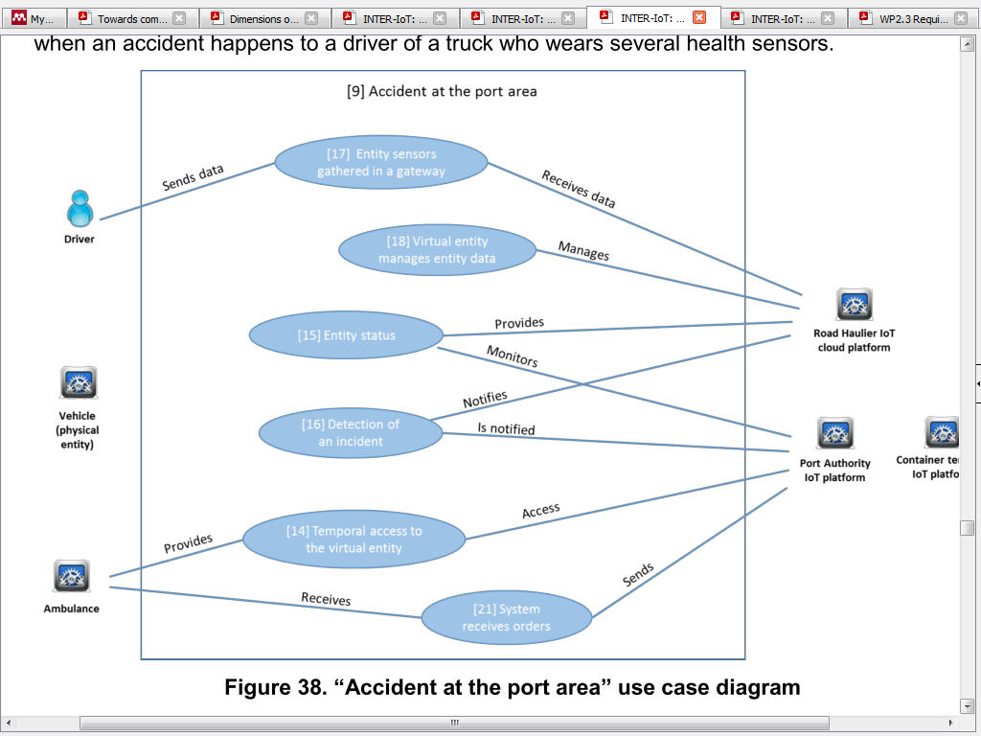

The main actors involved in the scenario are:

* Vehicle: It is the physical entity of the scenario. It access to the port facilities.
* Driver: He is the user who is driving the vehicle and he has health sensors. He has a health issue or an accident inside the port.
* Ambulance: It is an external which that is guided by the emergency control centre of the port authority when it is inside the port facilities.
* Road haulier IoT cloud platform: It’s the platform of the owner of the vehicle and it is used to manage all the vehicles and drivers of the company. It monitors the health sensors of the driver.
* Port authority IoT platform: It’s the platform that manages all the systems of the port.
* Container terminal IoT platform: It’s the platform that manages all the systems of the container terminal.

**INTER-LAYER Use Cases:**

* 24 Request query to AS2AS: Requirements: [236], [239], [240], [241]
* 28 AS2AS service cataloguing: Requirements: [180], [236], [238]
* 29 AS2AS service discovery: Requirements: [180], [236], [238]
* 30 AS2AS service composition: Requirements: [236], [239], [240], [241]
* 38 IPSM translation: Requirements: [179], [180], [183], [220
* 66 IPSM alignment configuration: Requirements: [178], [179], [183], [184]
* 67 IPSM channel configuration: Requirements: [178], [179], [183], [184]

The use case scenarios will be detailed and discussed along with INTER-IoT team within WP1 (D1.1), considering an adequate scope for the budget and deadline constraints.

As start point, we will address the scenarios of **accidents at the port area**, i.e. emergency scenarios within requirement 248, where a service makes available data of incidents in the port PCS (Port Community System), integrating with data from the terminal and hauler IoT platforms, including location of trucks and containers with GPS tracking devices, the container terminal management system and health sensors attached to the drivers. Health sensors can include the approach of BodyCloud from INTER-IoT partner, if body sensor networks are made available. One scenario within this use case is to detect the risk of an accident while the driver is driving, checking his/her vital signals’ changes in a way that is considered dangerous to drive. The specific rules and thresholds will be detailed with INTER-Health specialists. Another scenario is to detect accidents with containers in the port area, integrating data from the terminal and port platforms. It can include alerting ambulances when victims are reported, with similar scenario of HL7 – EDXL-TEP transformations, e.g. incoming victims from the port to ambulance (docs.oasis-open.org/emergency/TEP-HL7v2-transforms/v1.0/TEP-HL7v2-transforms-v1.0.html). Within this use case a scenario can include attaching mobile Personal Emergency Response System (mPERS) to port employees, detecting the risk of emergencies based on SOS emergency and fall detection capabilities. Another scenario that can be exploited within this use case is to detect air quality variations in the port to detect risk of accidents with the port employees. This scenario can include an outdoor air quality monitoring sensor supporting the detection of dangerous gases for humans and variations of CO2. Accidents in the port area can also be avoided by detecting the risks of floods in the routes, which can be enabled by smart buoys near the port shore, integrated with meteorological sensors and/or forecasting websites, and the incidents system from the port. If the transportation company provides service to transport sensitive medicine (e.g. Botox for TMJ), a new use case can be added: **accidents with people taking sensitive transported medicines**. In a smart home scenario, a person who needs special medication orders a temperature-sensitive medicine. The emergency service detects that the person felt at home (with mPERS) and sends an alert to the doctor and the nearest hospital with information about the medicine, i.e. temperature measurements during transportation, along with patient data (e-health sensors). In any case, we recommend to involve the port of Valencia emergency command control and to analyze the trends report of IoT solutions from DHL, emergency response procedures of Hedland port (e.g. for marine incidents with dangerous goods) and MEMS provided by STMicroelectronics. The IoT EWS will only be able to address the scenarios if INTER-IoT provides the necessary access to the data and to the involved stakeholders, considering their privacy issues.

**Scenarios:**

**IoT devices supporting:**

- 2 Arduino Raspberry PI Zero:

<http://www.theverge.com/circuitbreaker/2017/2/28/14762228/raspberry-pi-zero-w-wireless-adds-wifi-and-bluetooth>

- 1 GPS tracking device (e.g. TK-103):

<https://www.amazon.com/Thinpax-GPRS-Tracker-TK103-Vehicle/dp/B004X46UJE>

Obs: GPS compliant to open source GPS tracking system as <http://opengts.sourceforge.net/>

- 1 MySignals complete e-Health toolkit:

<http://www.my-signals.com/#what-is-mysignals>

<https://www.cooking-hacks.com/mysignals-sw-ehealth-medical-biometric-complete-kit-ble>

- 1 MPERS (medical alert system):

<https://www.veesag.com/product/mpersens-2/>

<http://www.toptenreviews.com/health/senior-care/best-medical-alert-systems/>

- 1 Waspmote gases sensor board pro:

<http://www.libelium.com/calibrated-air-quality-gas-dust-particle-matter-pm10-smart-cities/>

<https://www.cooking-hacks.com/waspmote-gases-sensor-board-pro>

xx

Deliverables:

<http://www.inter-iot-project.eu/deliverables>

<https://files.inter-iot.eu/proposer/>

xx