**Molecular Graphics using PyMOL – Tutorial Quiz**

WSBS PyMOL Tutorial Jonathan Ipsaro October 24, 2018

­­­­­­­

1. Duplicate the following image of PDB entry 3U4X

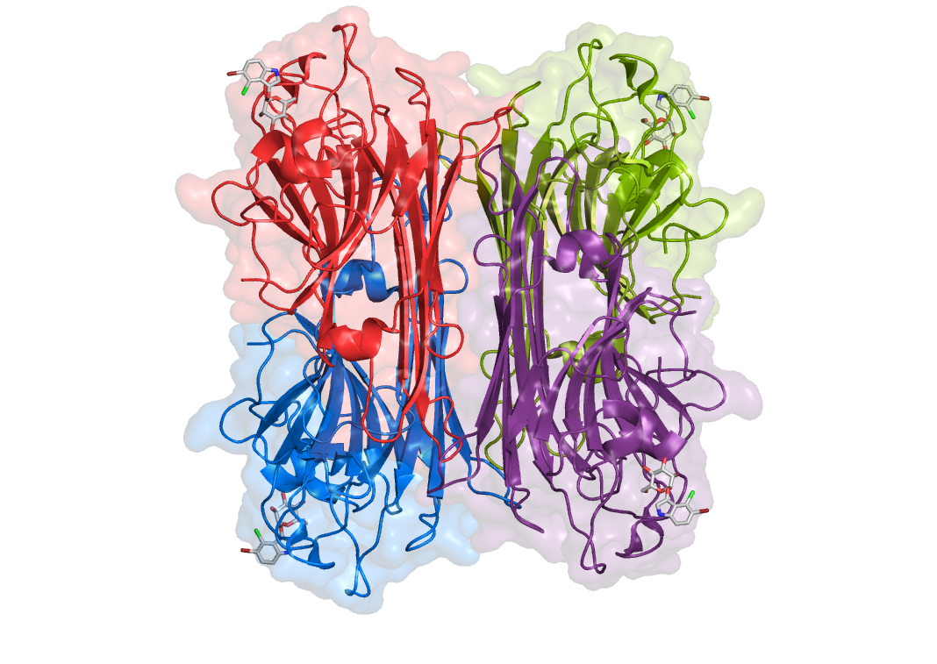

Please note:

There are no shadows

The surface transparency is at 80%

Specific coloring of the bound ligands

The view is orthoscopic (not perspective)

2. Calcium binds to this molecule. What are the amino acids involved?

3. Manganese binds to this molecule. What are the amino acids involved?

**Answers:**

2. Calcium binds to this molecule. What are the amino acids involved?

Tyr12, Asn14, Asp19

3. Manganese binds to this molecule. What are the amino acids involved?

Asp10, Asp19, His24