**Molecular Graphics using PyMOL – Tutorial Quiz**

WSBS PyMOL Tutorial Jonathan Ipsaro October 24, 2018

­­­­­­­

1. Duplicate the following image of PDB entry 6D41.

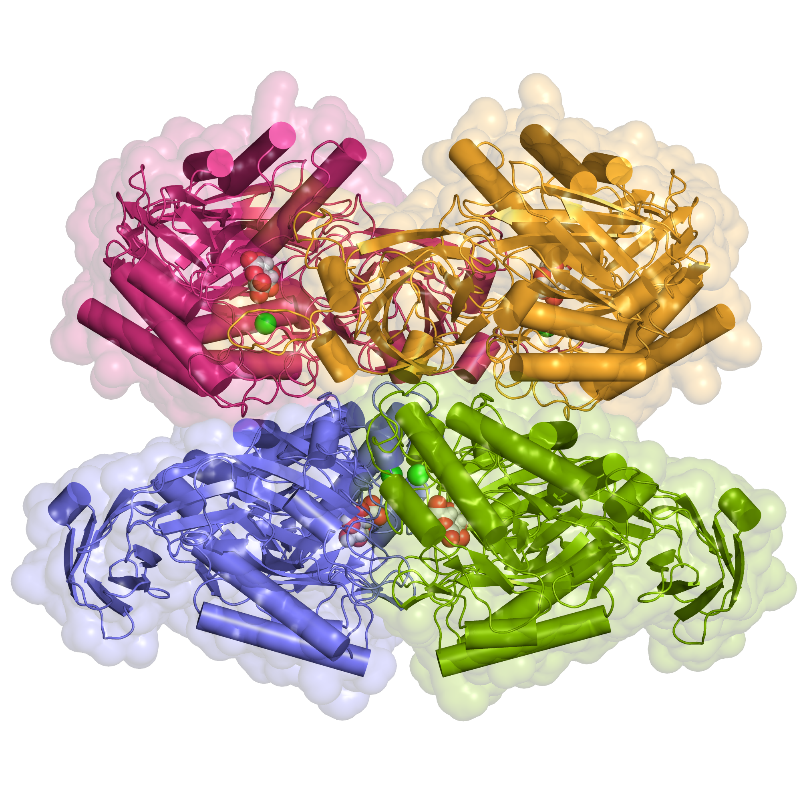

1. What is the resolution of this structure?
2. What are the unit cell dimensions?
3. What was the crystallization condition?
4. Where were the diffraction data collected?