Imagine a banking application.

A bank has many systems:
- Login Server → Handles customer login
- Payment Server → Handles money transfers
- Database Server → Stores customer information
Every second, these servers generate logs.
Our project will act as a central monitoring system that collects and processes these logs.
Real-Time Example: Bank Log Monitoring System
Step 1: Multiple Servers Generate Logs
Situation:
A customer opens the banking app and transfers ₹500.
Many things happen internally.

Login Server creates a log:
Meaning:
A customer successfully logged into the banking application.
Payment Server creates a log:
Meaning:
The money transfer process started.
Database Server creates a log:
Meaning:
The database had a problem while processing the transaction.
At this point:

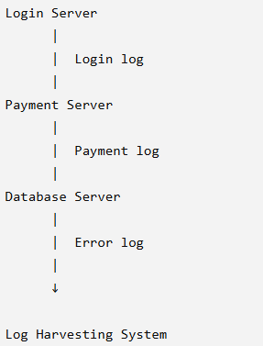

The problem:
There are many servers producing thousands of logs.
Someone needs to collect all of them.

Step 2: TCP Socket Communication
What happens?
The servers need a way to send logs to our monitoring system.
A TCP socket acts like a communication channel.
Think of it like a phone call.
Bank server:
"I have a new log message."
Socket:
"I will deliver it to the monitoring system."
Flow:
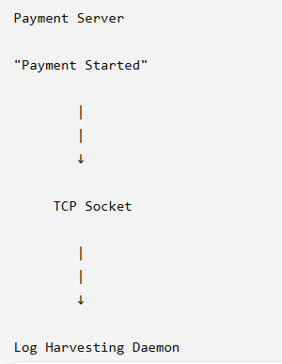

The socket ensures:
- Data reaches correctly
- Data arrives in order
- No messages are lost

Step 3: Multiple Simulated Servers
In a real bank:
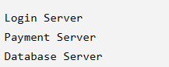
In our project, we don't have real servers.
So we create Python programs that behave like them.
Example:
Client 1 (Login Server)
Sends:

Client 2 (Payment Server)
Sends:

Client 3 (Database Server)
Sends:

These are called simulated server instances.

Step 4: Multi-Threaded Log Harvesting Daemon
Now the central monitoring system receives logs.
Imagine:
At the same time:
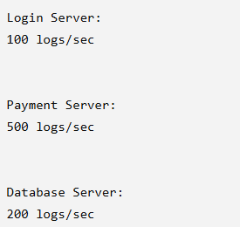
A single worker cannot handle everything efficiently.
Without Threads
One employee:

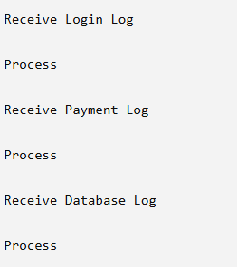
With Threads
Three workers:
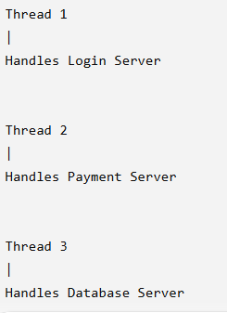
All work simultaneously.
This is called multi-threading.
Step 5: Real-Time Stream Buffer Handling
Now a technical problem occurs.
The Payment Server sends:

But the network may break the message.
The receiver may get:
First:

Second:
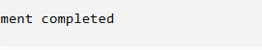
The system cannot process incomplete information

Solution: Buffer
The system temporarily stores incoming data.
Example:
First received:

Stored in buffer:


Second received:
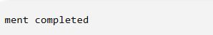

Buffer becomes:

Now it is a complete log.
The system processes it.
Step 6: Regex Validation
Now we check:
"Is this a proper log?"
Expected format:

Example:
Correct:

Checking:
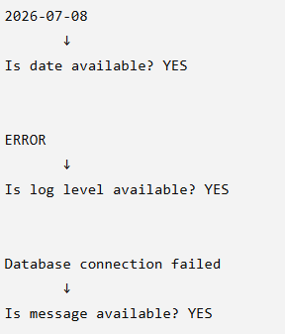
Accepted.

Wrong log:

Checking:

Rejected.
Regex acts like a security guard checking whether logs follow the correct format.
Step 7: Structured Payload Creation
Currently:
Raw log:
This is just text.
We convert it into organized data:
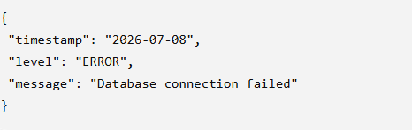
Now the computer understands each part separately.
Why?
Tomorrow the bank manager asks:
"Show me all ERROR logs."
The system can easily search:
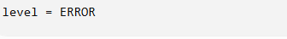
Step 8: Partitioned Binary Storage
Now we save the processed logs.
Instead of storing everything together:

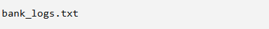
we separate:
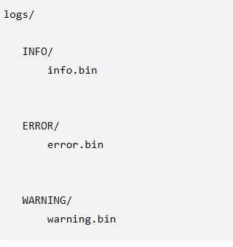

Example:
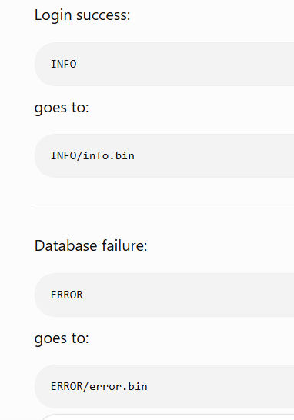
Why?
Suppose the bank wants only failed transactions.
Instead of searching millions of logs:
