GetComment.py Documentation
v 1.0

Table of Contents
About this document 3
1 Revision history 4
2 General info about Gathering Comments application 5
2.1 2.1 It has following components (methods): 5
2.2 Preconditions to run the application: 5
3 General info about Gathering Comments application 5
3.1 Getting directories that have KPI reports. getFiles() 5
3.2 Iterator for files runFiles() 6
3.3 Iterator by each file sheets searchInBook() 6
3.4 Cell parser parseData() 6
3.5 SQLite connector getCur() 6
3.6 writeToDb() 7
3.7 Writer into files writeToFile() 7
4 Tutorial on how to use getComments.py 7

About this document
This document is organized as follows:

- Revises history of changes.
- Introduction to GetComments application and preconditions.
- Describe components of application in detail.
- Provide short tutorial how to use it.

Revision history
Version | Date | Author | Comment
1.0 | 2015-03-01 | Jakhongir Ashrapov | Final version 1.0

General info about Gathering Comments application
Comment gatherer application (hereby “getComment.py”) is an application that gathers comments from country KPI reports and inserts it into SQLite3 database.
Goal:
Writing getComments.py is driven by 1st line Support and Managers for automation of gathering and analyzing the 1st line support comments from KPI reports in order to keep track of incidents/issues and overall to decrease noticing period.

2.1 It has following components (methods):
- Getting directories that have KPI reports. getFiles()
- Iterator for files runFiles()
- Iterator by each file sheets searchInBook()
- Iterator by each cells getColComment()
- Cell parser parseData()
- SQLite connector getCur()
- DB writer writeToDb()
- Writer into files writeToFile()

Preconditions to run the application:
- Installed Python 2.x or higher.
- Installed XLRD 0.9.2 API or higher.
- Installed ODBC driver for SQLite3 for importing data from SQLite into Excel

General info about Gathering Comments application

Getting directories that have KPI reports. getFiles()
This method reads dir.txt located in the same folder as script and return list(massive) of files that should be scanned. Folders in files should have following format

dir.txt
monitoring\Sweden

In this case application will get all KPI reports having RA_??_*[0-9].xls* format.

Iterator for files runFiles()
This method will get the list of files and iterate over files, opens file and calls searchInBook() method.

Iterator by each file sheets searchInBook()
This method will iterate by each first row of each workbook and calls getColComment() if it finds “desc=someComment” from the first row in sheet.

Cell parser parseData()
This method will find matches in each cell and writes them into variables and sends back to seachInBook() method.

SQLite connector getCur()
This method tries to load SQLite3, open comments.db file, if it doesn’t exists it creates it with comment table that have following columns:
insert_date
filename
customer_type
happened
noticed
author
description
sheet_name
row_num
path
original_text
difference
monthly_flag
new_flag
real_flag
dublicates_flag

In the end it returns connection.

writeToDb()
This method will get the cursor from connection object created by 3.5 method and inserts values into comment table

Writer into files writeToFile()
This method which is not called in 1.0 version will write given parameters into .csv file.

Tutorial on how to use getComments.py
4.1 In order to run the script preconditions should be met.(see 2.2)
4.2 In order to run the script one should copy it and run ensuring that dirs.txt exists and has values.
4.3 Create ODBS DSN as follows:

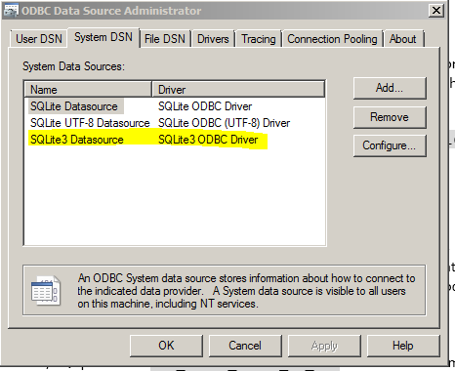

  - Create new data connection in Excel:
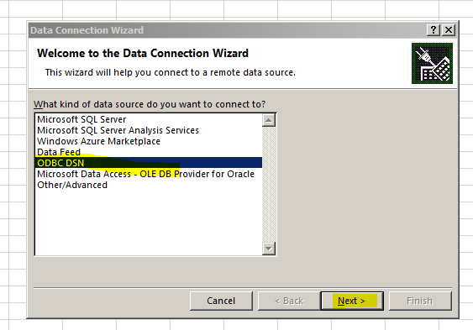

  - If needed change “select * from comment” into needed SQL script.

