AutoRefresh
Documentation
v 1.0

Contents
About this document 3
1 Revision history 4
2 General info about AutoRefresh application 5
2.1 An application consists of two parts: 5
2.2 Preconditions to run the application: 5
3 Description of parts of AutoRefresh application 6
3.1 Updater_master.py components 6
3.2 slave_deamon.py components 6
4 Tutorial on how to use Auto Refresh 7

About this document
This document is organized as follows:

- Revises history of changes.
- Introduction to an application and preconditions.
- Describe components of application in detail.
- Provide short tutorial how to use it.

Revision history
Version | Date | Author | Comment
1.0 | 2015-03-01 | Jakhongir Ashrapov | Final version 1.0

General info about AutoRefresh application
AutoRefresh application is an application that updates Excel table external connections to refresh the data on tables.
Goal:
The purpose of this application is to update tables used for graphs without human interaction.

An application consists of two parts:
- Scheduler (hereby “updater_master.py”)
- Excel updater (hereby “slave_deamon.py”)

Overall schema how it works is following:
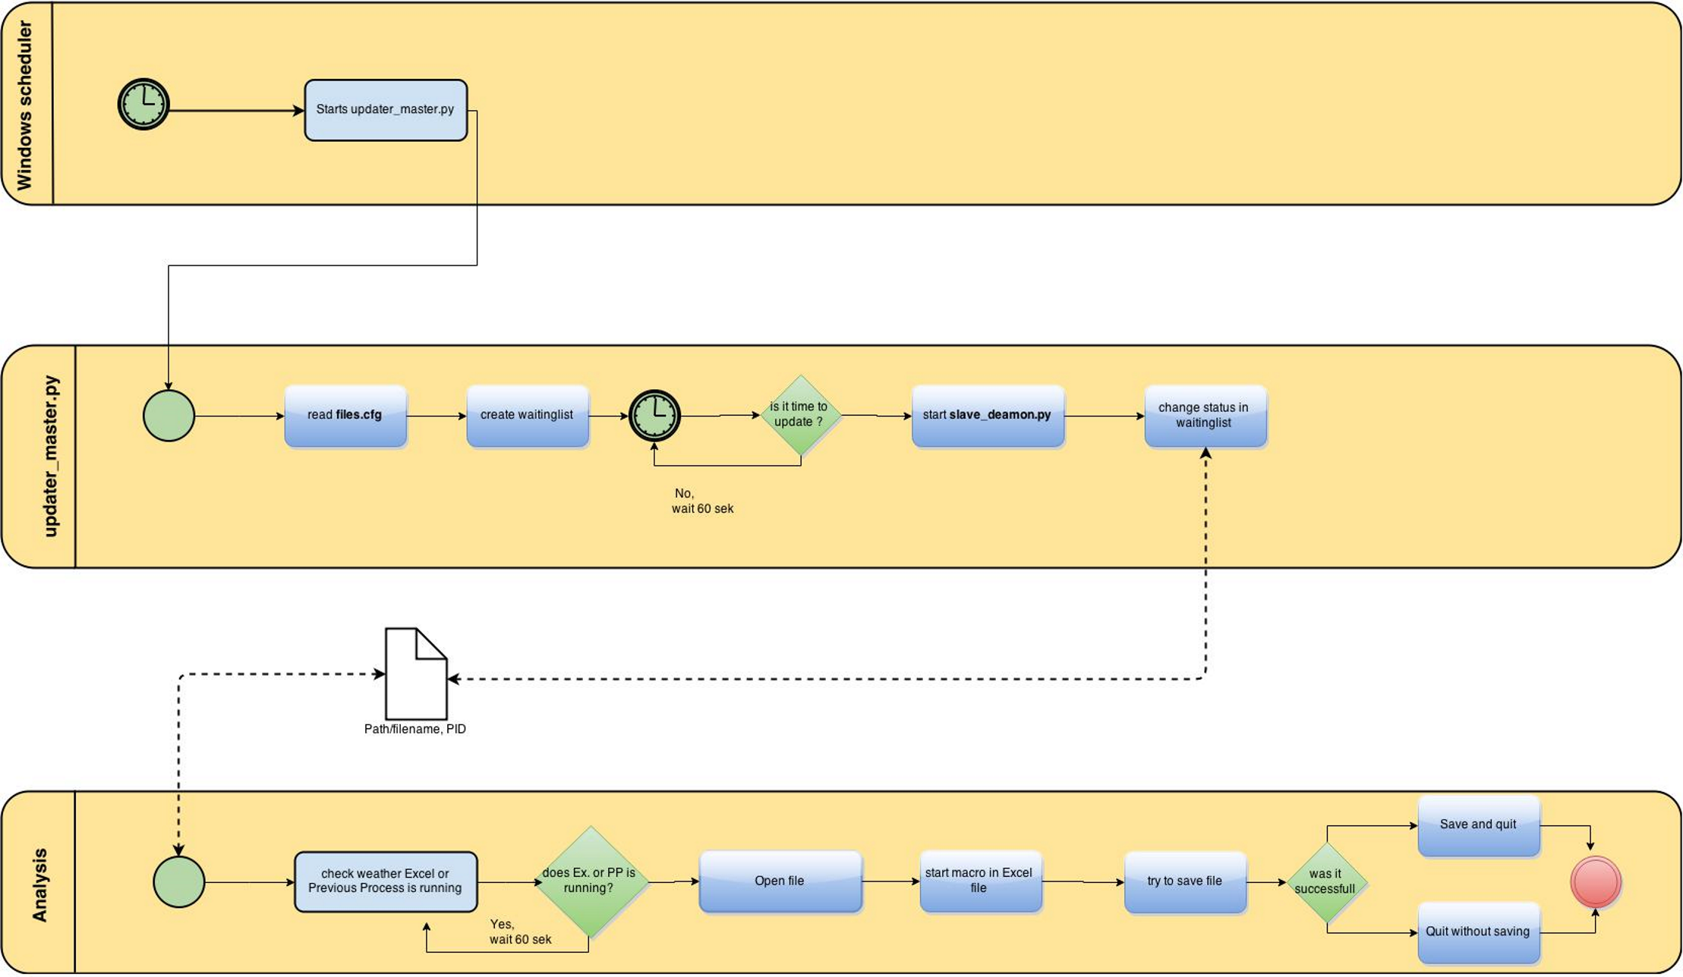

Preconditions to run the application:
- Installed Python 2.x or higher.
- Installed Win32COM API.
- Installed ODBC driver suitable for importing data from DB into Excel

Description of parts of AutoRefresh application
An application has two runnable files:
- updater_master.py - for scheduling files
- slave_deamon.py – for executing and updating one file

Updater_master.py components
- getFiles() – getting file names from files.cfg file
- createDeamons() – executing another runnable file
- localDeamon() – checking scheduled files
- Class OneTask - keeping meta data

slave_deamon.py components
- isExcelRunning() – check wheather Excell is running
- check_pid() – check weather previous executed deamon is running by Process ID
- changeFiles() – create old_upd folder and copy current file to temp folder, and rename file to updating_x
- changeBack() – after updating is finished, change updating_ to mmdd_hhmi_
- callMacro() – for executing Excel, calling macro and then saving it

Tutorial on how to use Auto Refresh
4.1 In order to run the script preconditions should be met.(see 2.2)
4.2 Create DSN with the same names as in Excel connections:
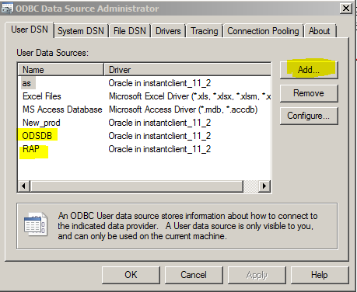

  - Check Excel file for any faults as links to non-existing files, security checks.
  - Create “PT” sheet in Excel file for tracking scripts runtime
  - Insert given macro into Excel files and save as Macro Compatible format (*.xslm)
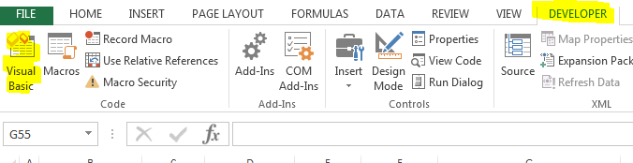

In Developer View:

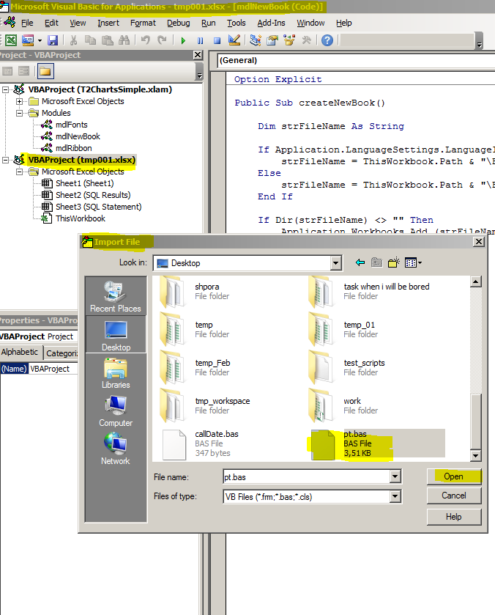

The file pt.bas goes with this application, the purpose of it creating the list of connections and update sequentially.

