DEPARTMENT OF TECHNICAL EDUCATION
Bengaluru - 560001
The Oxford Polytechnic
RECOGNIZED BY THE GOVT. OF KARNATAKA
APPROVED BY AICTE, NEW DEHIL
1ST PHASE, JP NAGAR, BENGALURU, KARNATAKA 560078

PROJECT ON CYBER SECURITY
An Advanced Approach for Detecting Behavior-Based Intranet Attacks by Machine Learning.
Submitted of the Project to certification of the Polytechnic
CYBER SECURITY
IN
Diploma in Computer science and Engineering
Submitted by
MOHAMMAD UMAR KHAN
400CS22032
Under the Guidance of
RANJITHA T N
HOD MALATHI
Associate professor,
Department of Computer science and Engineering
THE OXFORD POLYTECHNIC

YEAR OF SUBITTION 2024-2025

1. Problem Statement
Intranet attacks represent a growing threat to internal organizational security. These attacks exploit trusted network connections and often bypass conventional defenses, making them difficult to detect. Traditional security systems fail to identify these sophisticated attacks, necessitating an advanced solution.
2. Impact of the Project
Technical Perspective
- Enhanced Security: Improves detection of sophisticated intranet attacks by analyzing network traffic and user behavior.
- Real-Time Monitoring: Provides continuous surveillance of network activities, enabling timely responses to threats.
- Advanced Detection: Utilizes machine learning algorithms to identify both known and unknown attack vectors, reducing false positives.
Social Perspective
- Trust and Safety: Enhances the security of internal networks, thereby protecting sensitive information and maintaining user trust.
- Privacy Compliance: Ensures compliance with data privacy regulations, safeguarding personal and organizational data.
Business Perspective
- Cost Efficiency: Reduces potential financial losses from data breaches and cyber-attacks.
- Reputation Management: Strengthens the organization’s reputation by demonstrating a commitment to advanced cybersecurity measures.
- Operational Continuity: Minimizes disruptions caused by security incidents, ensuring smooth business operations.
3. Solution to the Problem
Block Diagram
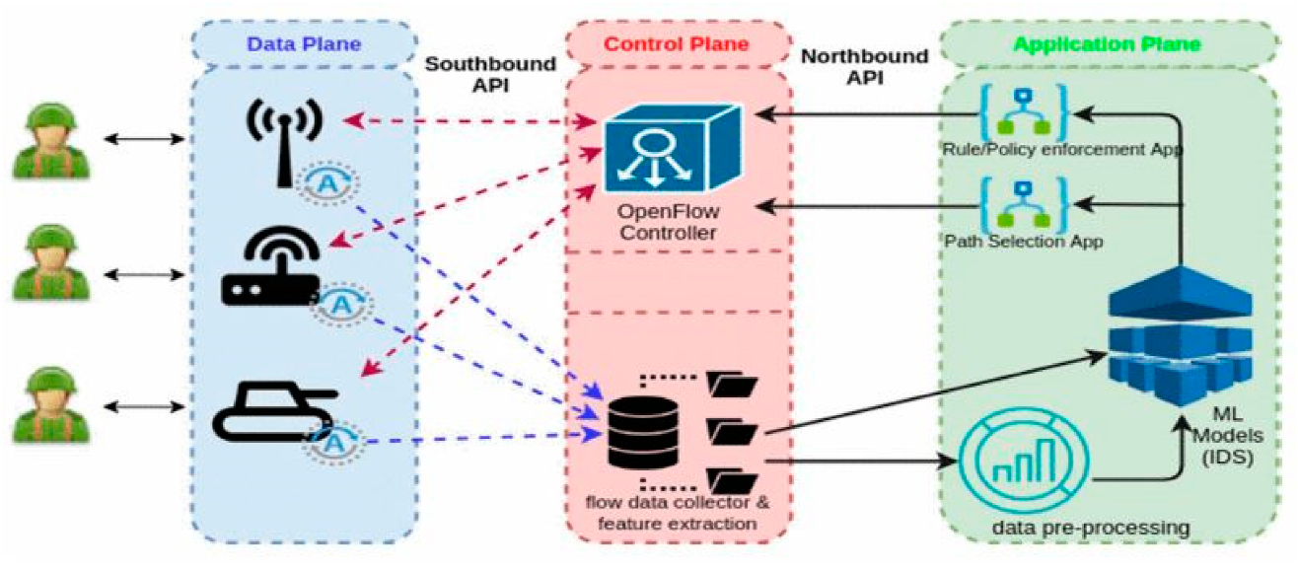
The proposed system consists of the following components:
- Data Collection Module: Gathers network traffic data from multiple intranet points.
- Feature Extraction Module: Extracts relevant features such as login frequency, data packet size, and communication patterns.
- ML Model Training Module: Uses supervised learning for labeled data and unsupervised learning for unknown attacks.
- Real-Time Monitoring Module: Continuously monitors network traffic and user behavior.
- Anomaly Detection Module: Classifies detected anomalies as potential intrusions or false alarms.
- Alert and Response Module: Generates alerts and initiates predefined responses for identified attacks.
Use Cases
- Normal Network Activity: The system monitors and records regular network behavior.
- Suspicious Activity Detection: Identifies deviations from normal behavior and flags them for further analysis.
- Alert Generation: Sends real-time alerts to security personnel for immediate action.
- Response Initiation: Triggers predefined responses such as network isolation or user session termination.
Software Requirements
- Frontend: Built with React for user interface.
- Backend: Developed using Express and MongoDB for data storage and management.
- Machine Learning Tools: Implemented using Python, Spyder, and various ML libraries (e.g., scikit-learn, TensorFlow).
Budget
- Computational Resources: 1000 INR
- Software and Tools: 1500 INR
- Guidance Cost: 5000 INR
- Total Estimated Cost: 30000 INR
4. Advantages
- Effective against Insider Threats: Detects malicious activities from within the organization.
- Identifies Unknown Threats: Uses unsupervised learning to detect new and evolving attack patterns.
- Reduces False Positives: Enhances detection accuracy by combining multiple ML algorithms.
- Scalable: Can be deployed across large networks efficiently.
- Continuous Improvement: Learns from new data and adapts to emerging threats.
5. Disadvantages
- Initial Setup Complexity: Requires significant effort to set up and configure the system.
- Resource Intensive: Needs substantial computational resources for real-time monitoring and analysis.
- Data Privacy Concerns: Must ensure compliance with data privacy regulations during data collection and analysis.
- False Negatives: There is still a possibility of some sophisticated attacks evading detection.
6. Application
Intranet Attack Challenges in Modern Organizations
Organizations rely on internal networks for critical communications and data exchanges, making intranet-based cyber attacks a significant threat. These attacks exploit trusted environments, often remaining undetected by traditional signature-based or rule-based systems.
The Role of Machine Learning in Cybersecurity
Machine learning offers a dynamic and adaptive solution for detecting cyber threats by learning from network data patterns and identifying anomalies. This project leverages ML to detect behavior-based intranet attacks, enhancing security through real-time monitoring and adaptive learning.
7. Conclusions
Intranet attacks pose a significant threat to organizational security due to their ability to exploit trusted network connections and evade traditional security measures. These sophisticated attacks require advanced detection mechanisms that can adapt to dynamic network environments and evolving threat landscapes. This project proposes an advanced machine learning-based framework for detecting behavior-based intranet attacks, leveraging both supervised and unsupervised learning techniques to identify known and unknown threats with high accuracy. By implementing this system, organizations can enhance their security posture, protect sensitive information, and ensure operational continuity.

