Amzflashdealsmi System

Software Requirements Document

(Draft 1 – August, 2000)
Roberta Crumrine

Introduction

http://amzflashdealsmi.com/vip/control/login.php

user name:calgaryasm@gmail.com
password: 0hnUsQUvv5

1.1 Purpose
This document details the functionality required for the Amzflashdealsmi System (CIS).

1.2 Document Conventions
Although this document is intended as a set of Requirements, draft of system design, some technical information has been included with the requirements description.

1.3 Reference

2.Overall Description

2.1 Product Perspective

The Amzflashdealsmi System(AFS) provides: complete solution for post a campaign.
A campaign is a web pages which has is own url. Each campaign has different offers, Most of offer has 4 pages,Landing,Buy Now,Expired,Expired with Upcoming Offer.We can call it template. Each offers gives coupons.

2.2 Product Functions
- Multi-account control, different user can has their own campaign
- Manipulate Campaign, View, Create,Edit, delete a campaign.
- Manipulate Offers. Each Campaign has one or more offers. Add offers based on campaign. Edit offers, duplicate offers,remove offers.
- Coupon, Coupon is based on offers. Each offers has some coupons. User can add,remove coupon, view coupon status.
- Plugins. AFS provides a lot plugin options which control the show time of pages.

2.3 Design and Implementation Constraints

2.3.1 Structure
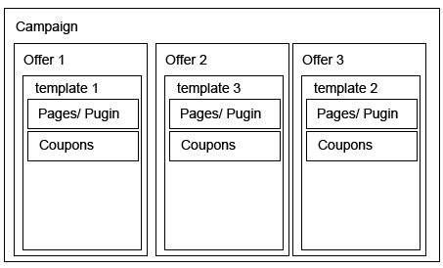

As discussed before. AFS start campaign. Each campaign has multiple offers. Each offers can select templates, then it will has different page setting. Each pages has some plugin options, such as sign up or ever green. User can able or enable it. Coupon setting is in the offer as well.

2.3. Premiere System design
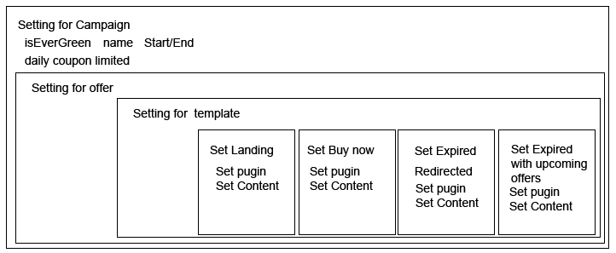

Main system will separate into 4 stages.
- Campaign Setting.
- Offer Setting.
- Select Template
- Based on Template,User can set each page.
4.1 It should be easy to add templates or modify templates.
4.2 Plugin, should be easy to add or modify a plugin as well.

3. System functionality

3.1 Page flows
For user :
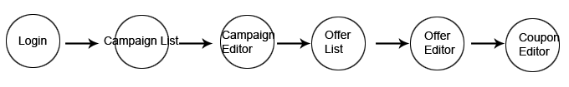

For Admin: Admin can manage users.

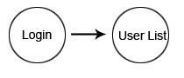

4. System Features

4.1 Login in
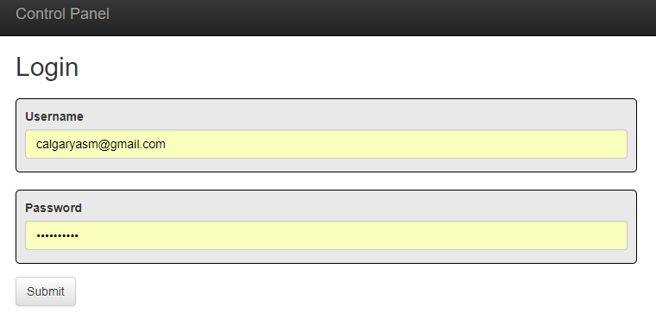
Description
Type user name and password to login the system

4.2 Campaigns list
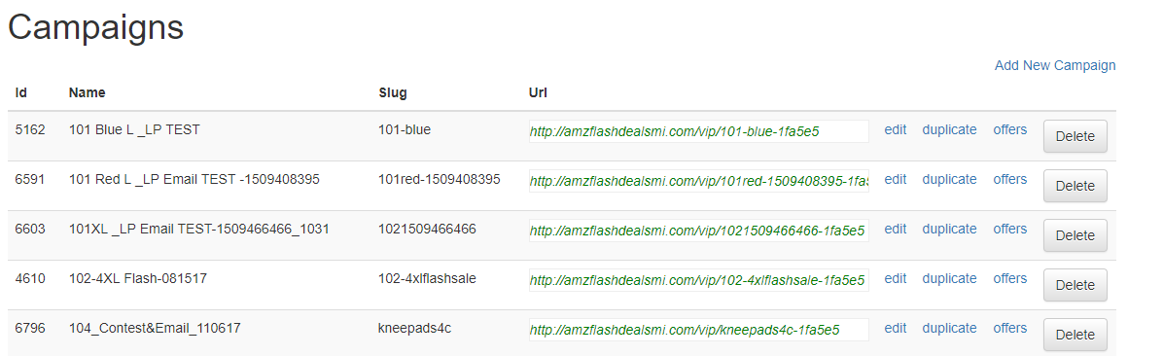

Description
In this page, user can add, edit, duplicate ,delete or direct edit offer.
Duplicate means, same offer with different campaign name.

4.3 Campaigns Setting
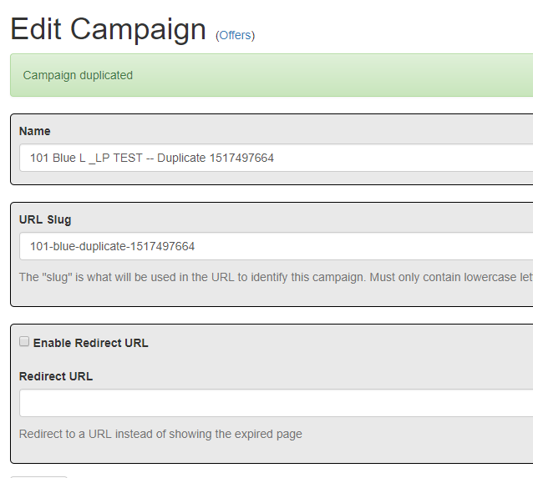

Description
Enter Name, User Slug<ID>,
Enable Redirect URL/Redirect to a URL instead of showing the expired page[This is a plugin]

4.4 Offer list
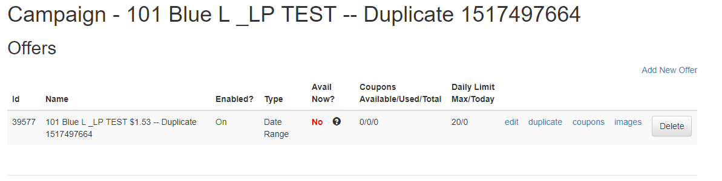
In this page, user can add, edit, duplicate ,delete or direct edit coupons.
Duplicate means, same coupons with different offer name.

4.5 Offer Setting page
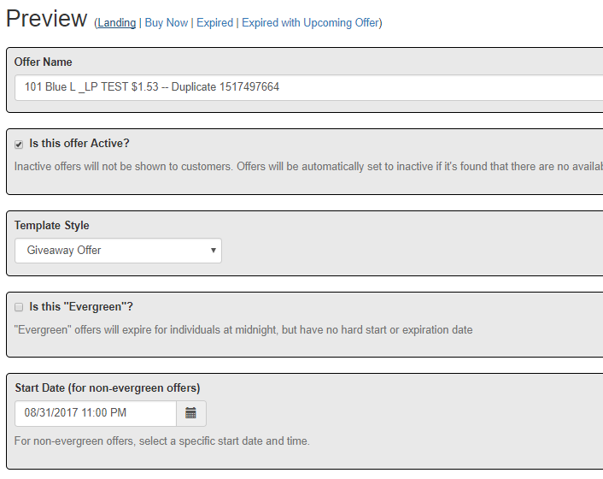

Type or select:
Offer Name
Is this offer Active?
Template Style: Different template style will gives different webpage style.
Is this "Evergreen"? "Evergreen" offers will expire for individuals at midnight, but have no hard start or expiration date
Start Date
Expiration
Daily Coupon Distribution Limit

4.6 landing page Setting
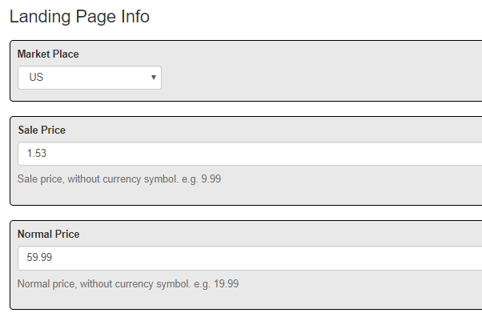

Market Place, US or UK
Sale Price
Normal Price
Product Name
Brand
Company Email Address
Signup: Aweber Custom List [this is a plugin]
Landing Page Tracking/Analytics Code[this is a plugin]
Benefit 1
Benefit 2
Search Keywords
Add to wishlist? If checked, the Buy Now page will instruct them to add the product to the wishlist before they purchase it.
Product Type
Lead Sentence
Product Description
Deal Description
Free Product Name
Free Product Value
Custom Buy URL：A custom Buy URL that adds both products to the Amazon cart
Deal Description
Discounted Product Name
Discounted Product Value
Discounted Product Percentage Off
Custom Buy URL：A custom Buy URL that adds both products to the Amazon cart

4.7 Thank You Page Info
Thank You Page Tracking/Analytics Code
Is UpViral Active?If checked, the Buy Now page will show the UpViral form using the embed code below.
UpViral Embed Code

4.8Product URLs
Seller ID (optional)
Product ASIN
Canonical URL (optional)
Keywords (optional)
URL Rotation (optional) replace the rule
SUPER NOVA URL
There are 5 options for your Product URL
- Product ASIN - You are required to place your ASIN above. If you do not select any options below, then all buyers will be sent to the raw Amazon link in this format:http://www.amazon.com/dp/xxxxxxx
- Canonical URL - If you input your Amazon canonical URL, this will override the basic ASIN url.
- Super URL (Keywords) - If you place keywords (one per line) below, the SUPER URL links will be used.
- URL Rotation - if you place URLs (one per line), the URL rotation will be used.
- SUPER NOVA URL - Choose this option to use the new SUPER NOVA URL. Seller ID required above. Keywords are optional below.

SUPER NOVA URl ：https://www.amazon.com/s?marketplaceID=ATVPDKIKX0DER&me=A1A4U1WT1WWZ8Z&merchant=A1A4U1WT1WWZ8Z&keywords=patella+support+xl

http://www.amazon.com/dp/xxxxxxx

Keywords (optional)
https://www.amazon.com/patella brace men/dp/B00YJUDZYA/ref=sr_1_1?ie=UTF8&qid=1517500632&m=A1A4U1WT1WWZ8Z&sr=8-1&keywords=patella brace men

4.9 Deal Club
Deal Club Name (optional)
Deal Club URL (optional)

4.10 Coupon Setting
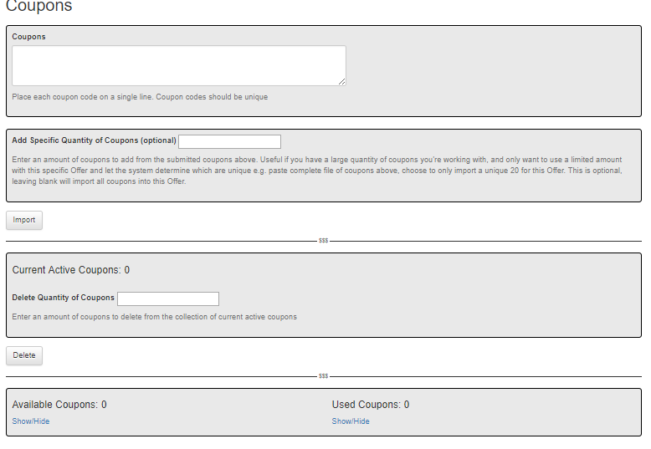
Coupons ：Place each coupon code on a single line. Coupon codes should be unique
Add Specific Quantity of Coupons (optional)
Show active coupon

Basic & Advance Design
Basic design will fellow amzflashdealsmi.com
http://amzflashdealsmi.com/vip/control/login.php
Most used information need to type in first before see the change.
We just need to implement the template and plugins.

Advance Design
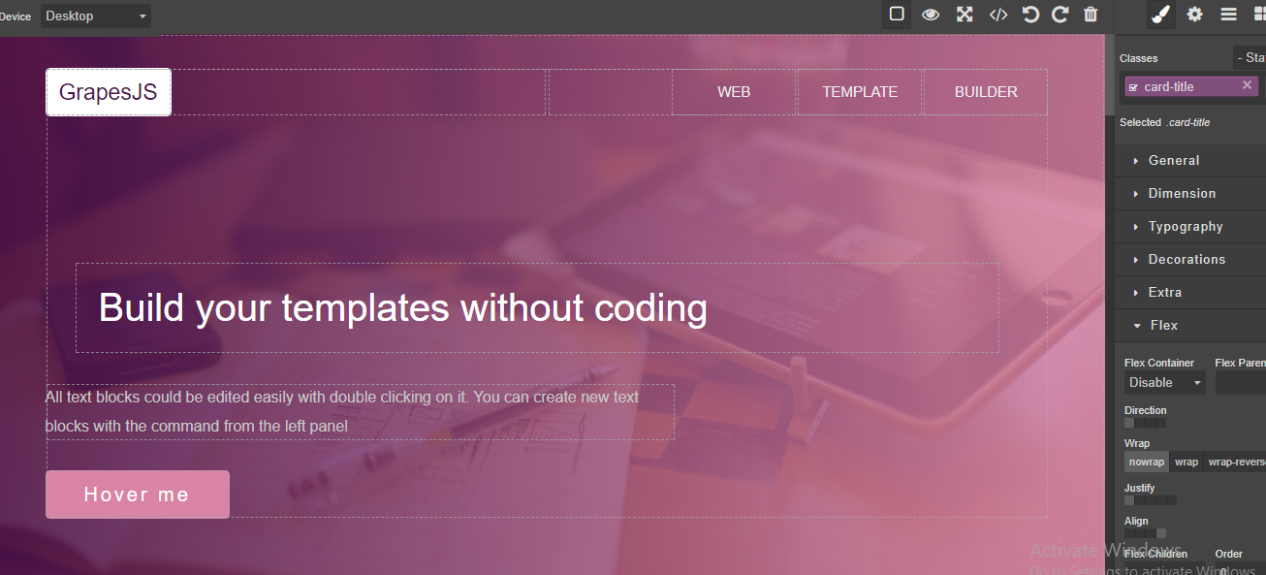

It is webpage editor. When we create a template, we can open the template then wording into the page directly, then publish as a webpage.

Appendix : Template overview
Giveaways：
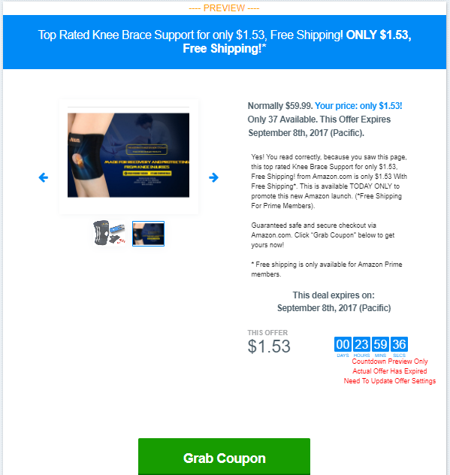

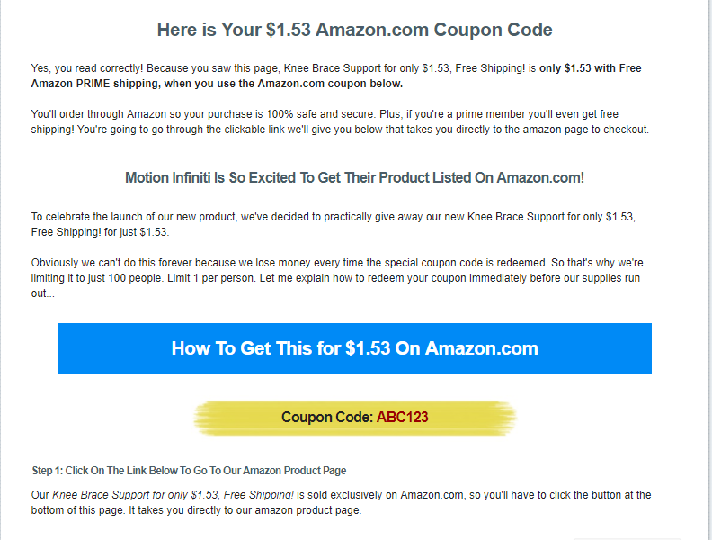

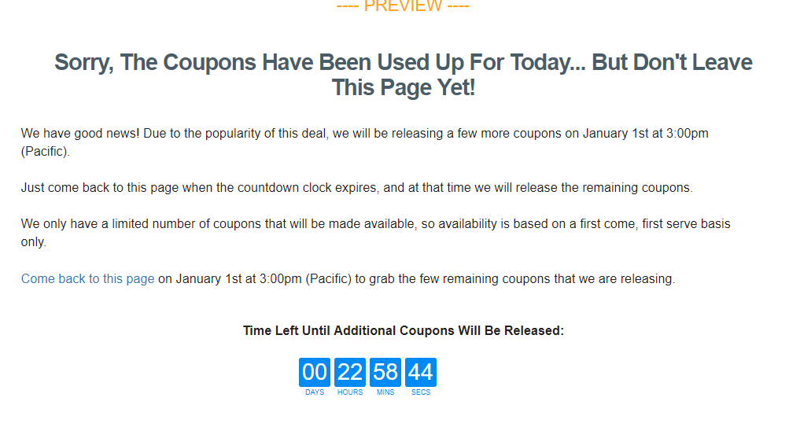

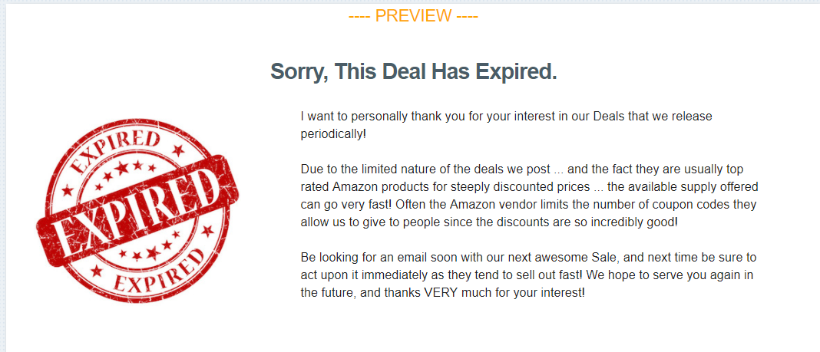

Flash Sale
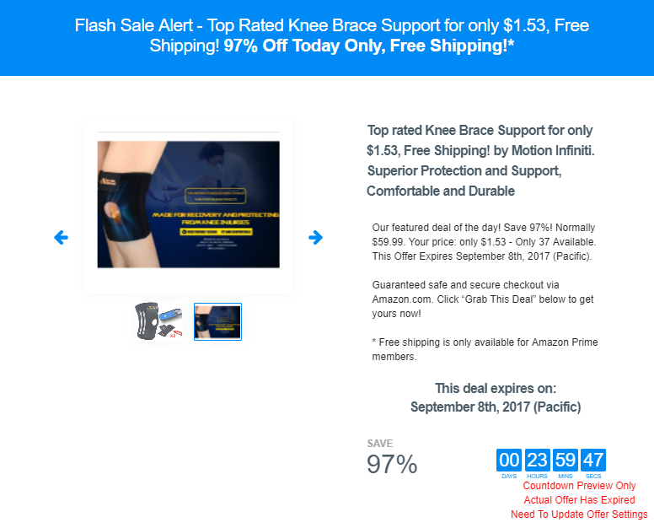

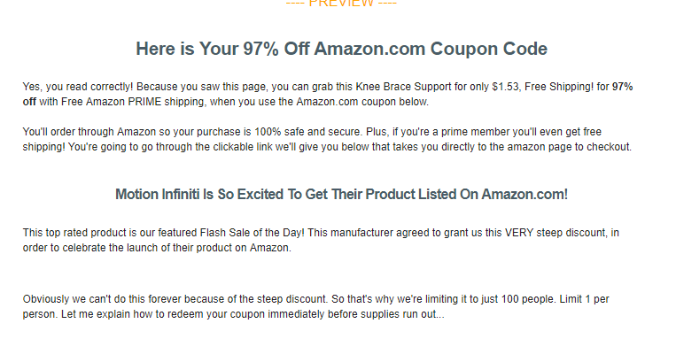

Search and buy
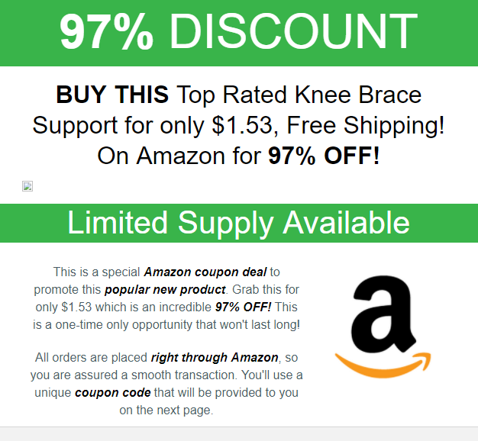

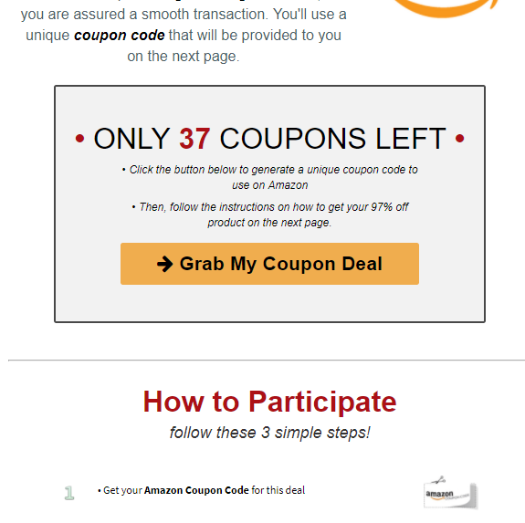

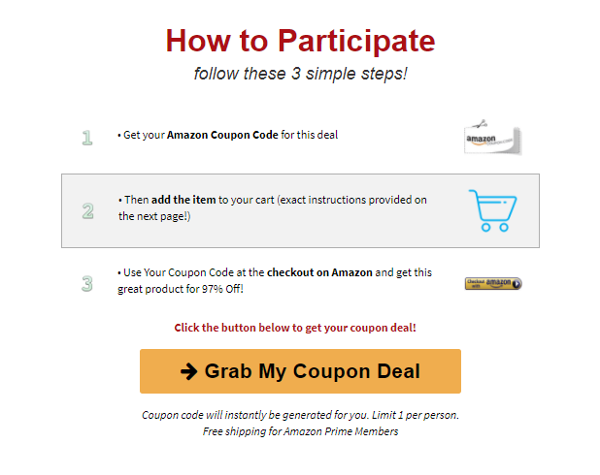

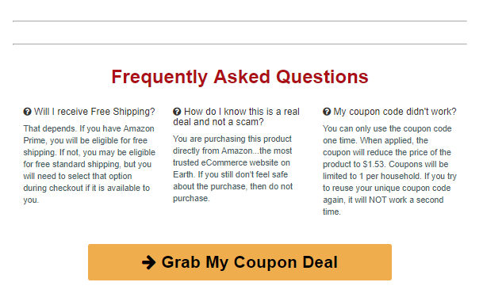

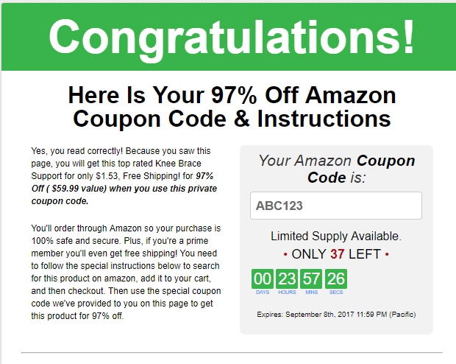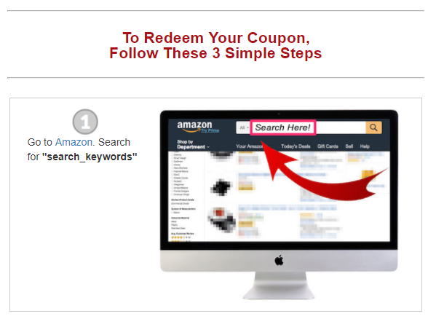
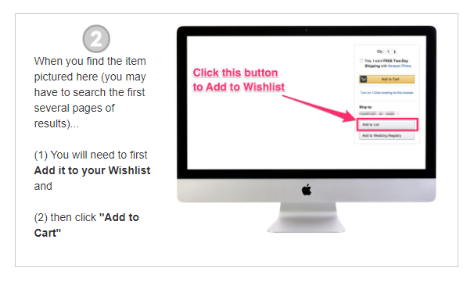

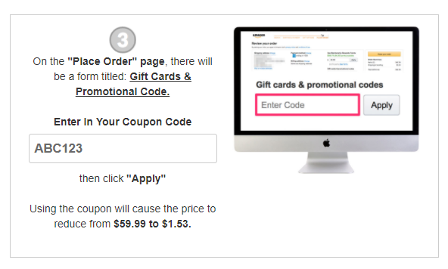

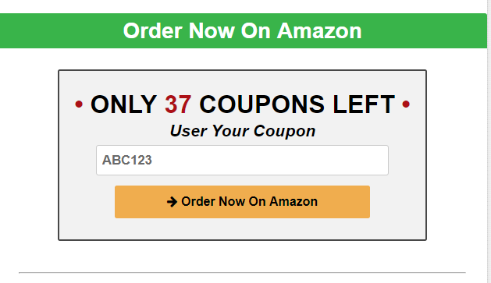
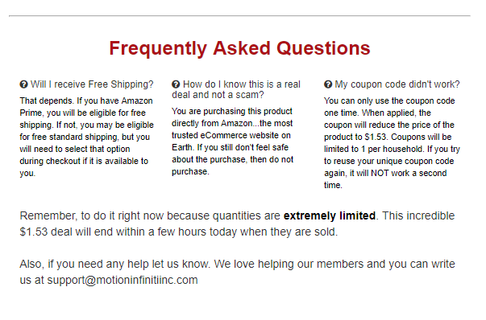

Contest
