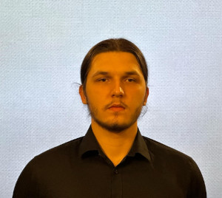 **Jonatan Kisielewicz**

Nationality: Polish Date of birth: 17.05.2006 Gender : Male_

Phone number : + 48 797 983 558

Email address: _JonKis14@outlook.com_

Home: Grabik 54, 68 – 200 Żary_

PREFERRED INTERNSHIP POSITION______________________________________________________

I would like to work as a basic IT support or programmer Trainee.

## ABOUT ME____________________________________________________________________________

I am a ambitious young student, who enjoys working in group projects. I am very creative, reliable and communicative. After high school I want go to a university where I want to study IT.

## EDUCATION AND TRAINING___________________________________________________________

2021 – until now – Zespół Szkoł Ekonomicznym in Żary (Programming technician)

2024 april – Euroweek (English course)

Technician Qualification:

Kwalifikacja INF 03 - Creating and Administering Websites, Web Applications, and Databases.

## WORK EXPERIENCE_________________________________________________________________________

I participated in a monthly internship as a Programmer at Lervana Katarzyna Dadek in Sucha, Zielona Góra as a IT/programming support. I was doing C++ assignments and I was learning about basic requirements about a programmer's work. I worked a summer job as an logistic assistant in a company called Swiss Krono located in Żary, my main task was office work like organizing documents, handling correspondence and provide basic it Support.

**WORK RELATED SKILLS_____________________________________________________________________**

I can create basic programmer scripts, website, desktop and mobile application, also I can work on and create databases. I can also assist with basic office tasks such as organizing documents, organizing correspondence in office or providing basic IT support.

**DIGITAL SKILLS_________________________________________________________________________**

I can work in following programs and programmers languages:

|  |  |
| --- | --- |
| programs:   * + Ms office   + Visual Stuido / Visual Studio code   + Android Studio   + PyCharm   + Ms Acess | Programming Languages:   * + C#/C++   + Java Script   + HTML   + CSS   + Python |

**HOBBIES AND INTERESTS______________________________________________________________**

I am passionate about football, both playing and following matches, as it combines teamwork and strategy. Music is another important part of my life, as I enjoy discovering new genres and attending live performances. Fitness is my way of staying active and maintaining a healthy lifestyle. Additionally, I love traveling, exploring new cultures, and gaining fresh perspectives on the world.

**LANGUAGE SKILLS____________________________________________________________________**

My native language is Polish.

