Dynamic Models in Biology

HW 10

Jonathan Levine

Fall 2023

**Reaction Diffusion system**

**(a)**  
  
Simulating the Reaction-Diffusion system with baseline parameters. With constant influx from the x=0 boundary, it reaches steady state quickly in time, and concentration decays in space:

Looking at the distribution of concentration, *C*, over the position, *x*, at t=10:

**(b)**

Varying D we get slightly different dynamics:

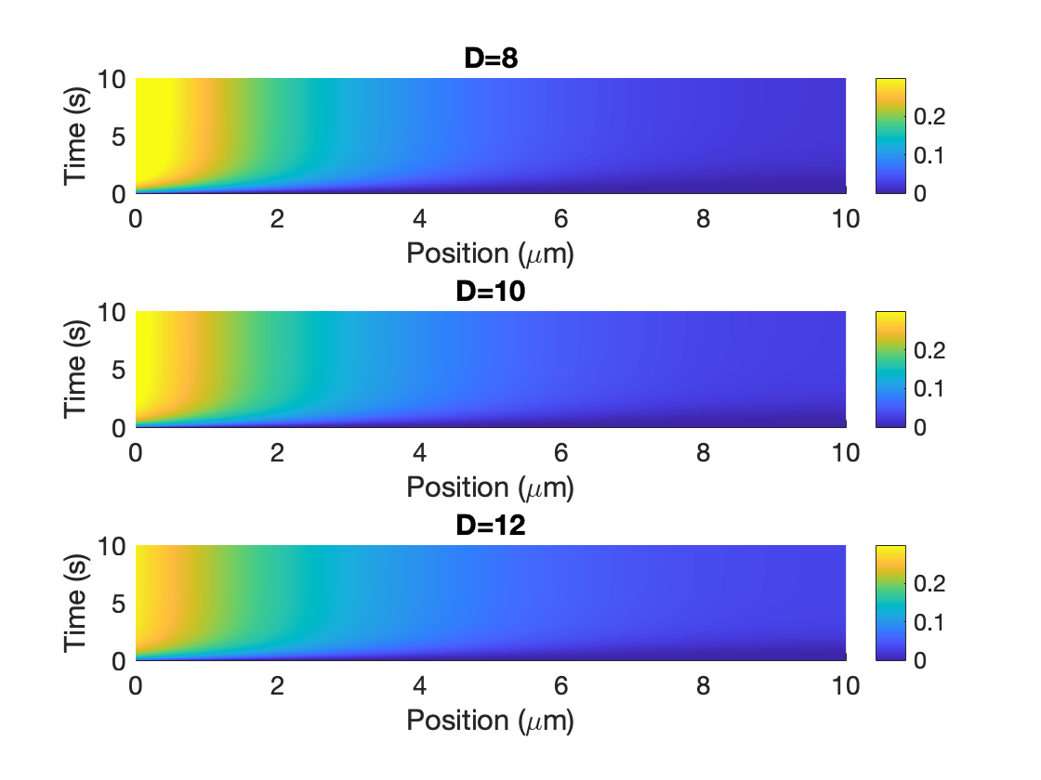

Again, looking at steady state C(x) (at t=10), gives us distinct shaped decay patterns:

At the left boundary (at x=0): the steady-state concentration is larger for smaller values of D, since there is less diffusion away from the source influx.

At the right boundary (x=L=10), the steady-state concentration is larger for larger values of D, since there is more diffusion towards from the influx to the far end of the system in x.

**(c)**Varying the length scale L:

At first, when L increases, the space spread at steady state changes significantly. After a certain threshold though, additional increases in L doesn’t change the spread C(x,t=end) much. Specifically, looking at the C(0,10) and C(L,10) for each trace:

You can see that increasing L has diminishing effects on the boundary concentrations at steady state. At the left boundary (source influx boundary), the concentration never dips below a/sqrt(kD), plotted below with the dotted red line:

**Problem 2: Spatial model**In the spirit of reaction diffusion models, I decided to add a diffusion component to the reactions studied in HW4 for glycolysis. In that model, we had concentrations of F6P and ADP as the state variables S and P respectively. The model, based on mass action kinetics of the underlying chemical reactions was:

$$\dot{S}=V_{0}-cSP^{2} \\ \dot{P}=cSP^{2}-kP$$

Let’s say we want to also model this cytoplasmic reaction in space, introducing 3 spatial variables x,y,z representing location in the cell. While the above equation relies on the approximation of glycolysis that it is well-mixed, we can also model cytoplasmic hot spots of metabolic activity and relatively “cold” spots by introducing the spatial dependence. S and P are now functions of t and x, y, and z, and we can add diffusion terms to the ordinary differential equations and turn them into partial differential equations:

$$\frac{∂S}{∂t}=D_{S} ∆S+V_{0}-cSP^{2} \\ \frac{∂P}{∂t}=D_{P}∆P+cSP^{2}-kP$$

Where the Laplacian $∆=∇^{2}$, which generalizes the second derivative with respect to the spatial dimensions.