Dynamic Models in Biology

HW 8

Jonathan Levine

Fall 2023

**Problem 1: Stochastic FHN Model**

In the excitable regime of the FHN model, adding a gaussian white noise to the x differential of varying intensities, but below a noise threshold that would induce additional spontaneous action potentials:

You can see that the stochastic model’s time trace for x and y still have the same approach to the fixed point as in the deterministic regime, but now have noisier traces. The noise is more apparent in the x term where it affects the differential directly, and less in the y term where it only affects it indirectly via x.

You can quantify the noisiness by looking at the non-transient dynamics (t>20), and looking at the distributions of each of the traces’ deviations about the fixed point:

You can clearly see that as the noise levels increase (D increases), the time traces x(t) and y(t) deviate more around their fixed points x* and y*, with deviation around x* being more drastic than the deviation around y* based on where the noise was added.

When D increases even more, there can be noise of a high enough magnitude as to induce additional action potentials:

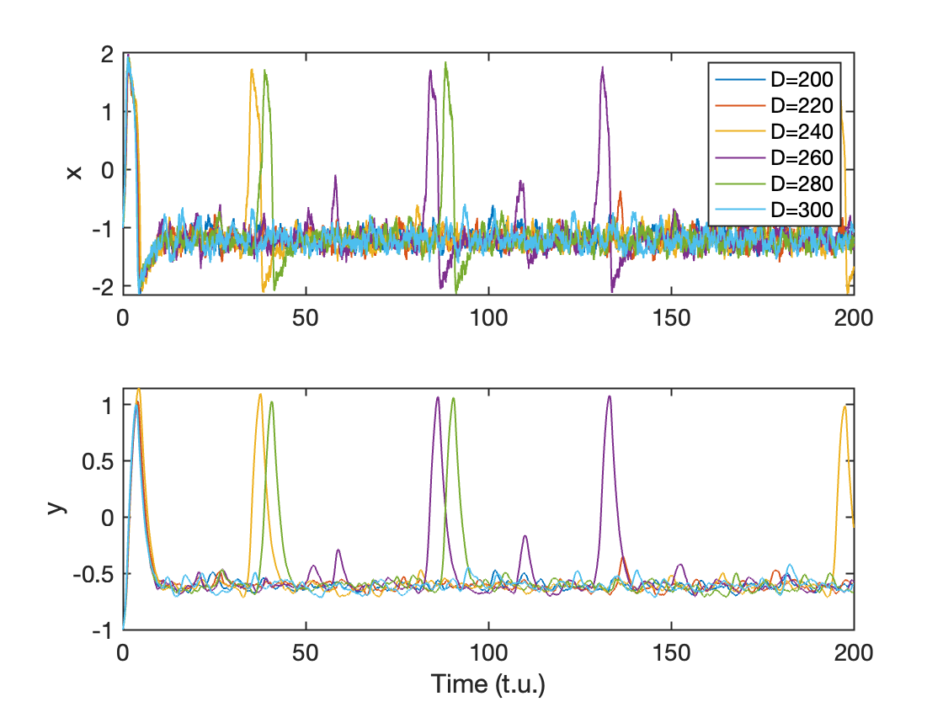

It seems like noise levels at around D=250-300 are enough to induce spontaneous action potentials during non-transient dynamics. This is a range since each individual simulation is non-deterministic, and the spontaneous action potentials are probabilistic events that are more common with larger D. Seeing a spontaneous action potential in a trace also depends on the length of time the simulation is run, since with more time there is a higher chance of seeing a large enough positive noise event that happens with some probability at each time step.

Inserting the noise into the y differential instead of the x differential, we see similar deviations from the fixed point in the low noise regime:

Again, the magnitude of these deviations scale with the noise intensity, *D*

For noise in the y differential, the value of D for which spontaneous action potentials appear in the non-transient dynamics is a lot lower than it was for noise in the x differential. You can get spontaneous action potentials at D values as low as ~25:

In the FHN model when the parameter *a* is set to 0, you observe fixed cycle dynamics with repeated oscillations. Adding Gaussian white noise to x differential like before, the waveforms are slightly distorted by the noise. This can influence the time between spikes, known as the interspike interval. For example, at a noise level of 5000:

The time between spikes varies along the simulation, and can be shown in this histogram for this specific noise level:

We can ask the question, how does this distribution change as a function of the noise level?

As D increases, the average ISI decreases (ρ=-0.92, p<1x10^-5). Additionally, as D increases the variance of the ISI distribution increases as well (ρ=0.68, p<1e-03).

This is because the noise intensity can occasionally help speed up the up phase of an action potential by contributing additional depolarization due to positive noise contributions and the down phase of an action potential due to negative noise contributions. This means that the refractory period can be shortened due to contributions from noise. However, the contributions themselves are stochastic and thus as noise increases the variance in the ISI increases as well, as sometimes the ISI can be longer due to noise in the opposite direction.

**Pink Noise**

I now simulated adding pink noise (scaled by 1/std in order to get std = 1 like the white noise before) to the x differential with a=0.7:

With pink noise, spontaneous action potentials occur at lower noise intensities (D=8-10) than with white noise. This is because the noise is taken from lower frequencies more than higher frequencies, and is thus more autocorrelated, and thus much more likely to build constructively in consecutive steps of the integration.

The same effect is observed when adding pink noise to the y differential, where very small noise intensities (as low as D=0.5) can induce action potentials:

For both differentials, the noise thresholds for pink noise to induce action potentials can be as low as ~2-4% of the thresholds needed for white noise. (10:250 or 0.5:25).

**Problem 2: Random linear systems**

I build a matrix A that describes a two-dimensional linear system with entries X1, X2, X3 and X4, where each entry is a random variable coming from a specific distribution:

$A= \left(\begin{matrix}X1 & X2 \\ X3 & X4\end{matrix}\right)$

I then created 100000 such matrices and computed their eigenvalues and classified the hypothetical fixed point at the origin of the 2D system described by that matrix. I did so for both the uniform random distribution on the interval 1 to -1 and the standard normal distribution.

For each distribution, the fixed point is a saddle ~50% of the time. When not a saddle, the fixed point is stable around 50% of the time (either a spiral or node) and is a node around ~20% of the time and a spiral about 30% of the time. Compared to the uniform distribution, the normal distribution leads to mostly the same distribution of types of fixed points, although the ratio of nodes to spirals is slightly higher.