Dynamic Models in Biology

HW9

Jonathan Levine

Fall 2023

**Stochastic Gene Expression Model**

Modelling gene expression using Gillespie’s Algorithm, I keep track of a 2-dimensional state vector [Nm, Np] and simulate the 4 reactions corresponding to creation/degradation of mRNA and protein. With set values for kr=10; kp=6; dr=dp=1, I get the following time traces:

Looking at the non-transient dynamics, we get the following distributions of steady state values for Nm and Np:

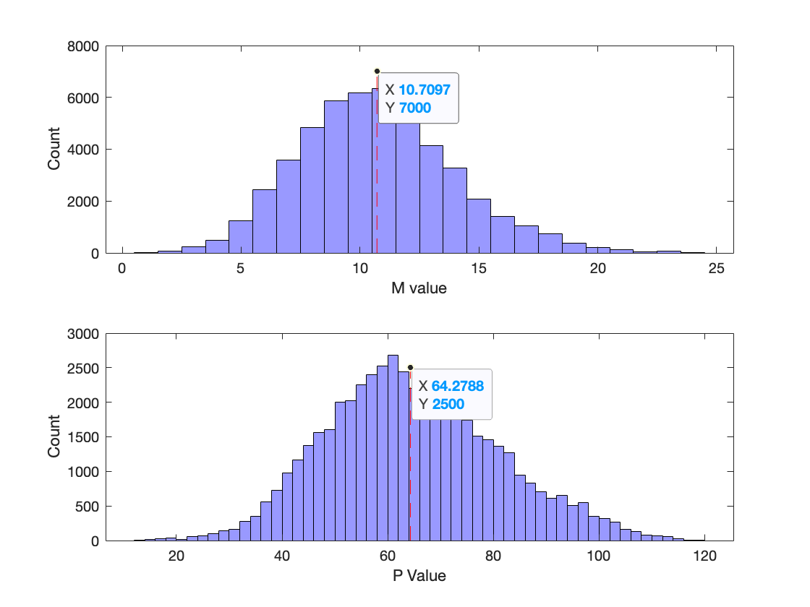

(a) The mean M value is **10.7** and the mean P value is **64.3**. We can compare this to the determinist model, by first computing the fixed point:

$$\dot{M}=k_{r}-δ_{r}M \\ \dot{P}= k_{p}M-δ_{p}P \\ \dot{M}=0=> k_{r}=δ_{r}M=>M^{*}=\frac{k_{r}}{δ_{r}} \\ \dot{P}=0=> k_{p}M=δ_{p}P=>P^{*}=\frac{k_{p}}{δ_{p}}\frac{k_{r}}{δ_{r}}$$

Thus, the deterministic model’s fixed point, $M^{*},P*=(\frac{k_{r}}{δ_{r}}, \frac{k_{p}}{δ_{p}}\frac{k_{r}}{δ_{r}})$

(b) For our parameter sets, **this corresponds to (10, 60).**

Thus the average non-transient M and P values from the stochastic simulation are similar to the deterministic fixed point values for M and P.

**Varying Kr**

(c) Since both M* and P* are linearly proportional to kr, I expect to see that as kr increases, the mean non-transient values for M and P should increase linearly:

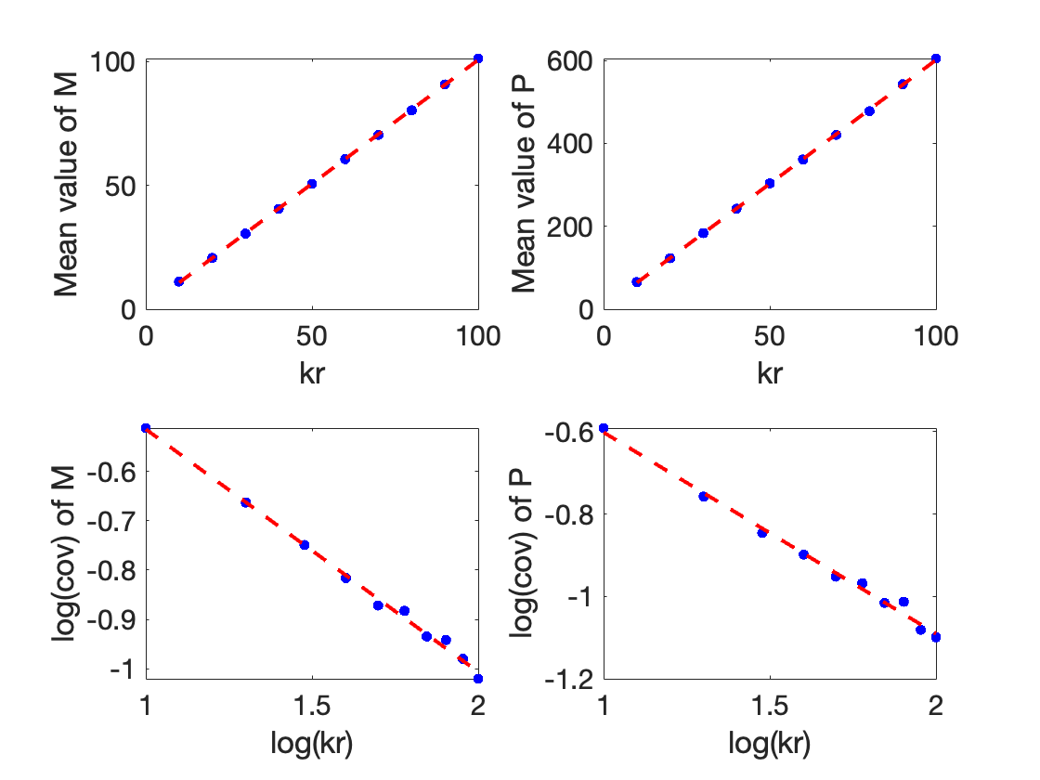

The mean does in fact increase linearly with kr, and the coefficient of variation (cov) is inversely proportional to kr on a log-log scale with a slope of -1/2, indicating it scales like 1/sqrt kr.

However, kr has a stronger effect on the mean value of P than it does on the mean value of M. The slope of the line connecting kr to mean(M) (top left) is around 1 while the slope of the best fit line between kr and mean(P) (top right) is around 6. This is also consistent with the fixed-point analysis in the deterministic case. Since with dr=dp=1, M* = kr, but P*=kr*kp, so when kp is set to 6, kr leads to changes in P* but modulated by a factor of 6, matching the slope.

In terms of variance, the relationship between kr and the coefficient of variation of M and P are the same, and scale with a -1/2 slope on the loglog scale, implying a 1/sqrt relationship.

(d) In my simulations, I was simulating as many time steps as it took to get to t=700. As kr increases, the simulation takes longer to get to that point (more time steps), since the average timestep dt decreases as kr increases. This is because the timestep dt is calculated using the sum of propensities. Specifically, dt is proportional to 1/propensities, and is thus proportional to 1/kr. This can easily be visualized on a loglog plot:

Where log(kr) is inversely proportional log(<dt>) with slope -1, indicating that dt is proportional to 1/kr.