Dynamic Models in Biology

Lab 11

Jonathan Levine

Fall 2023

**Baseline Run**

From the baseline run, we can see the action potential propagating in space, over time. The first trace shows the time delay to spike at different positions, and the second figure shows the voltage “traveling” in space and time. How far the action potential gets in this case is dependent on the amount of time the simulation is run for, which in this case is 200 ms.

**Excitability and propagation**

Varying the initial voltage amplitude at the spatial source does not have an effect on the action potential propagation dynamics. Biologically, this is because the “thresholded” response leads to the same dynamics as long as the initial pulse is enough to trigger an action potential. This can be visualized by comparing the propagations for varying amplitude initial voltages:

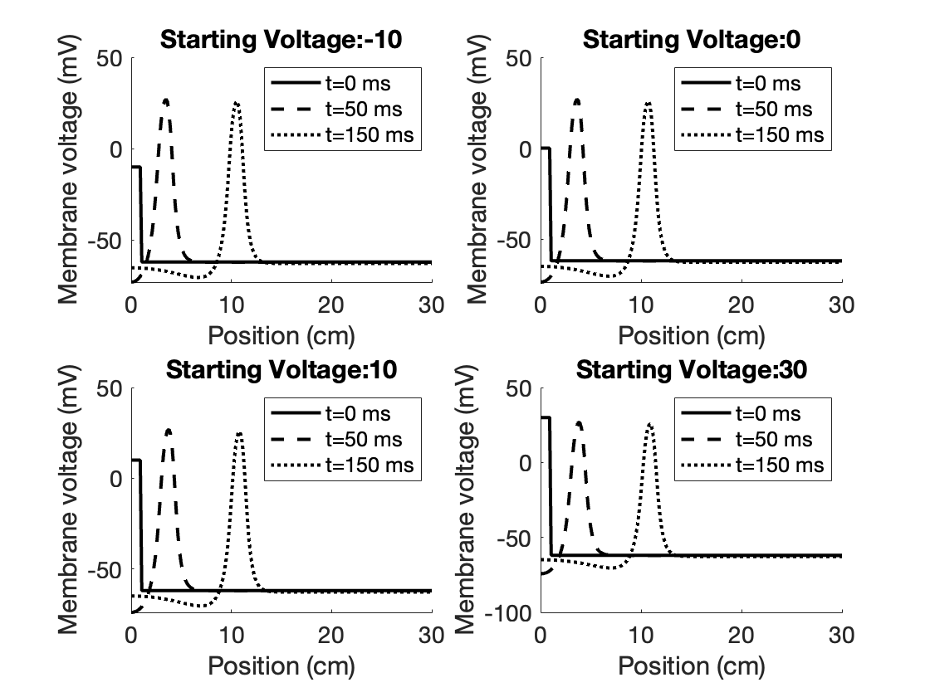

You can see that the waveforms are the same and occur at the same position and time, independent of the starting voltage. You can also visualize this by looking at the space-time grid and tracking the voltage wave in this color plot:

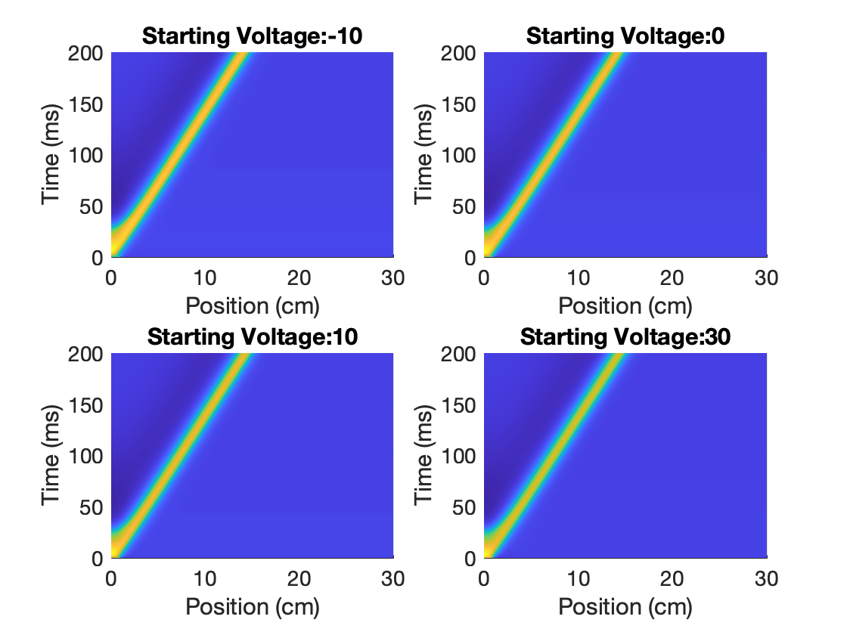

You can clearly see each plot has the same trajectory in the space-time grid, and thus the action potential propagation in this model is independent of starting voltage (if it is above triggering threshold).

This threshold is between -19 and -19.5 mV:

If you add starting voltage uniformly everywhere in space:

You can see that now the threshold for an action potential is lower. You can get an action potential with starting voltages as low as -27. Since it is uniform in space, you can also visualize this by looking at the voltage time trace for a single point in space:  
  
  
  
  
  
  
  
  
  
  
  
  
  
  
  
  
  
  
The reason an action potential can be reached at lower thresholds without diffusion is because the voltage decay over space is eliminated. This means that the voltage dependent conductance increases can now be triggered without the voltage decay due to in diffusion over space. Therefore, since there is no net diffusion the voltage does not decay in space and is more “concentrated” and able to trigger the threshold-ed conductance increases to trigger an action potential at lower thresholds.

**Wave speed and conductivity**

Varying the diffusion D, the action potential propagates at varying speeds. It would make sense that the action potential would propagate faster as the diffusion is faster. Estimating the speed by looking at the distance traveled in 200ms, you can see below that as D increases, the distance also increases:

Specifically, we can compute the distance traveled/200 ms as an average speed, and look at the relationship between the speed and D, which is clearly positive and monotonic:

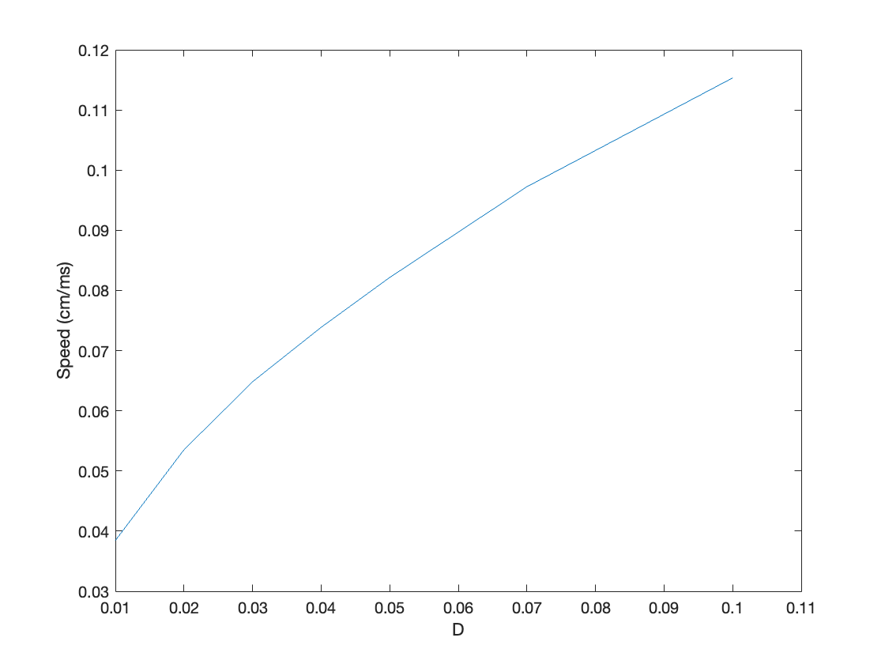

**Wave speed and ionic conductances**

Changing the ion conductances should affect the shape of the action potential, which could affect the overall propagation speed. Increasing gk should decrease the speed, since the depolarization is harder to achieve when potassium conductance is higher. Increasing gCa should increase the speed, since depolarization is easier to achieve. This is what is observed:

Increasing g-CA has the opposite effect:

**Two propagating Action Potentials**

When two action potentials start on either side of the model neuron, they propagate towards each other, combine into one large spike, and then collide and collapse each other back down to resting potential:

