Dynamic Models in Biology
HW4
Jonathan Levine
Fall 2023

Problem 1
I simulated the delay differential equation, and plotted the time trajectories for a variety of starting conditions, to confirm the oscillations/fixed cycle do not depend on the starting conditions (although the phase changes slightly):
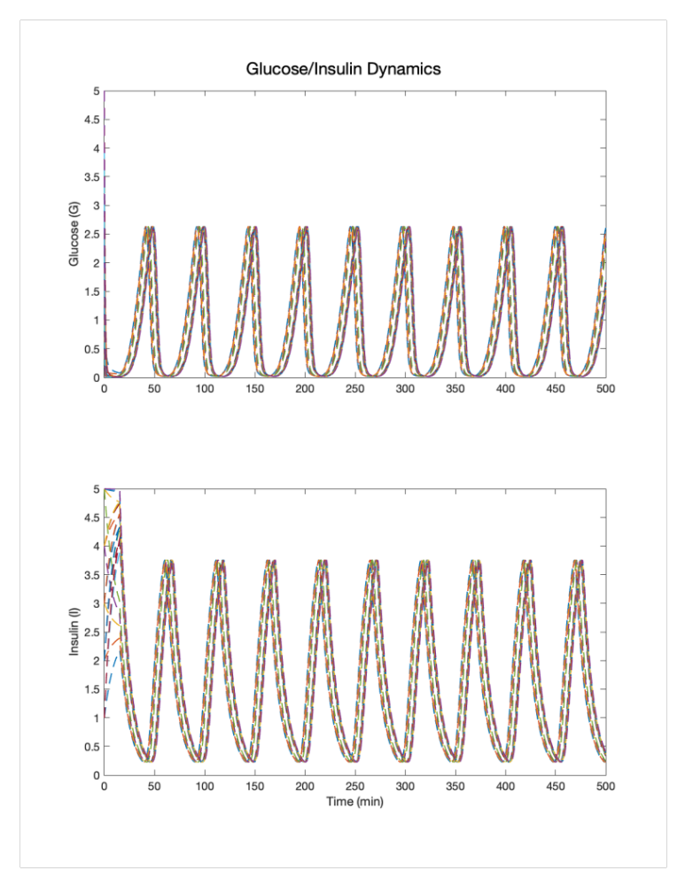

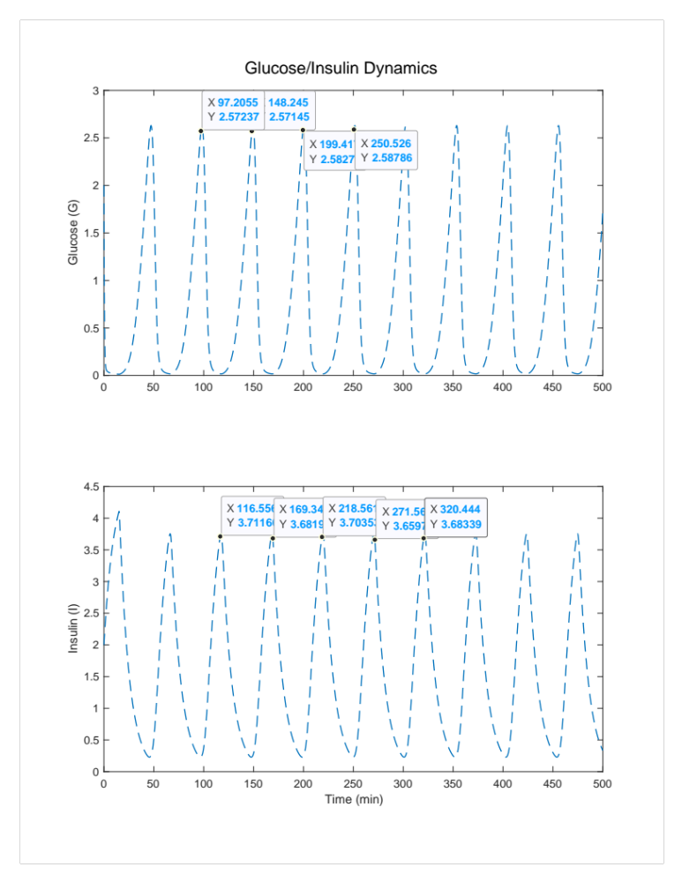
If we choose one sample trace and focus on the oscillation, we can see that the period is approximately 50 minutes for the two oscillations, with Glucose peaking at ~2.58 and Insulin peaking at ~3.7:

We can see which combinations of n and tau create oscillations by varying those and checking for oscillatory behavior vs. approaching a fixed value. This is shown below for a range of n and tau values:
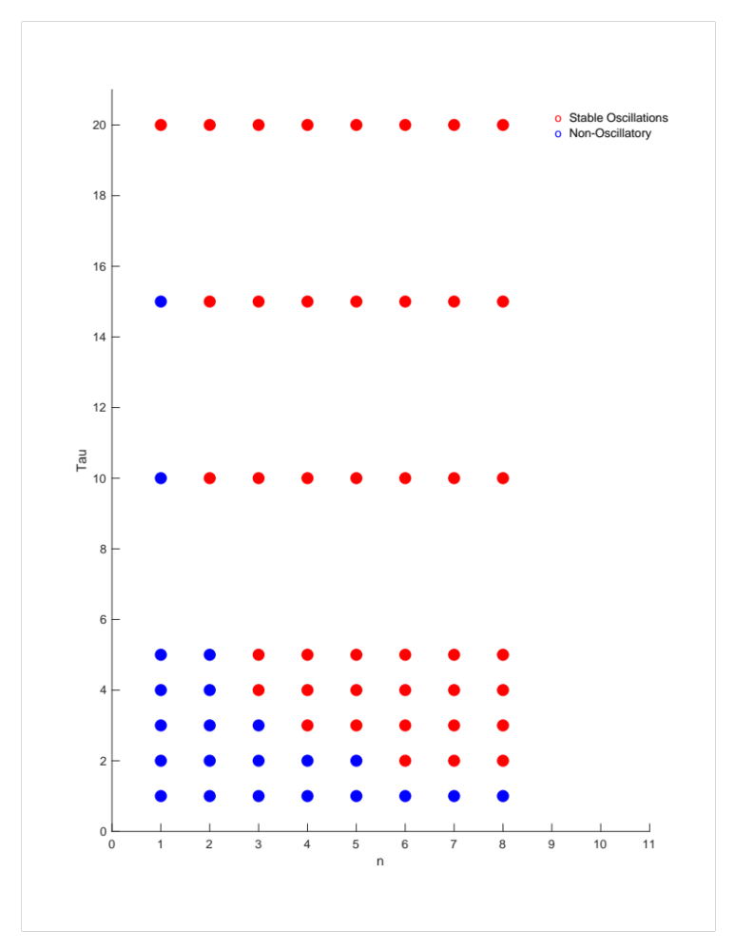

Problem 2

The coupled differential equations are a way to model the chemical reaction using the law of mass action.
For the F6P rate equation:
$$\dot{S}=V_{0}-cSP^{2}$$
The creation of F6P (positive term) from earlier mechanisms is assumed to be constant, with a rate set to $V_{0}$. For the negative term, we model $F6P+2ADP \overset{→}{c}3ADP$ using the law of mass action, yielding $cSP^{2}$, where P is squared since there are 2 ADP in the reaction.

The ADP equation:

$$\dot{P}=cSP^{2}-kP$$
The positive term is just the opposite side of the reaction shown above (using mass action), since now we are talking about the product and not the reactant. The negative term assumes a constant degradation/transformation into something else, proportional to the amount that exists (technically also a form of law of mass action, but only assuming P as a reactant downstream)

Nullclines:
$$\dot{S}=V_{0}-cSP^{2}=0 \\ V_{0}=cSP^{2} \\ S=\frac{V_{0}}{cP^{2}}$$and
$$\dot{P}=cSP^{2}-kP=0 \\ kP=cSP^{2} \\ P=0 or S= \frac{k}{cP}$$
If we use V0 = 1, c = 0.9, and k = 1, then we get the nullclines are
$\left(1\right) S=\frac{1}{0.9P^{2}}$ , (2) $P=0$ , and $\left(3\right) S= \frac{1}{0.9P}$

If we plot these on the P/S axis:

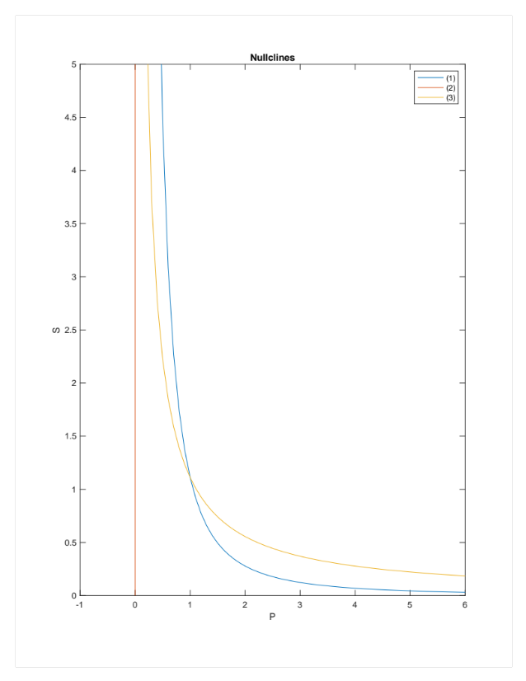
The fixed point(s) are where the P nullclines and S nullclines meet. The P=0 nullcline never meets the S nullcline, so the only nullcline is where (1) and (3) meet, which is at (1,10/9).
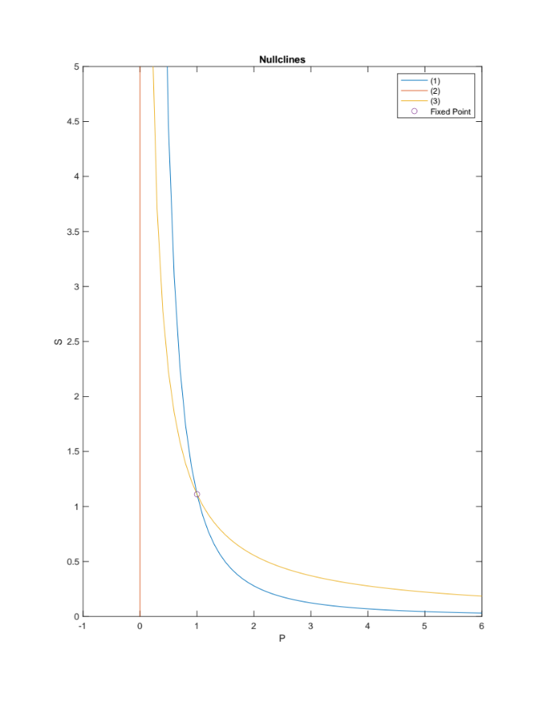

To classify the fixed point, we calculate the Jacobian at the fixed point:

$$J=\left[\begin{matrix}\frac{∂\dot{P}}{∂P} & \frac{∂\dot{P}}{∂S} \\ \frac{∂\dot{S}}{∂P} & \frac{∂\dot{S}}{∂S}\end{matrix}\right]=\left[\begin{matrix}2cSP-k & cP^{2} \\ -2cSP & -cP^{2}\end{matrix}\right] \\ J\left(1,\frac{10}{9}\right)= \left[\begin{matrix}1 & 0.9 \\ -2 & -0.9\end{matrix}\right]$$

That matrix has eigenvalues 0.0500 +/- 0.9474i, which indicates an unstable spiral point.

Phase portrait:

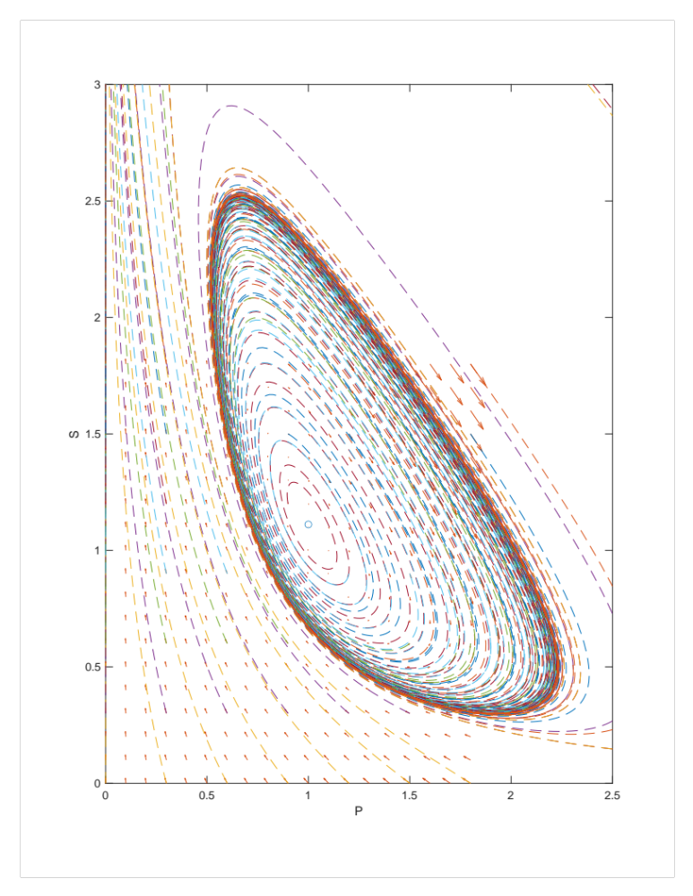
You can see that some trajectories hit this fixed cycle of oscillations, and some grow exponentially instead without any cycles.

We can try to simulate different initial conditions and see the different basins of attraction:

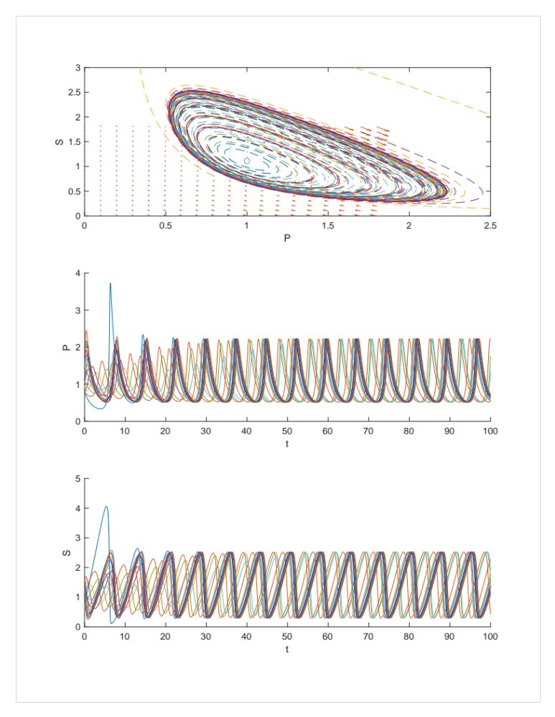
First, starting values between 0.8 and 1.8, we do see the cycle:
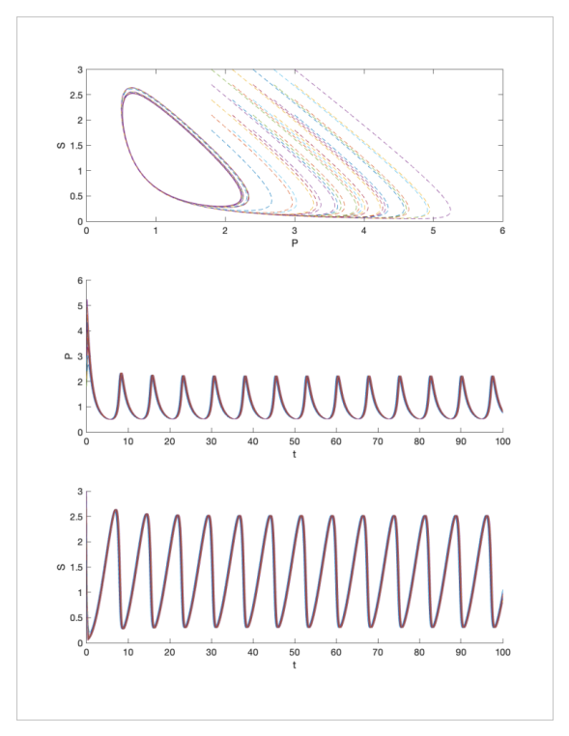
For initial values even larger, the dynamics also reach a fixed cycle:
However, for smaller values, we have a different dynamic where P goes to 0 and S goes to infinity:
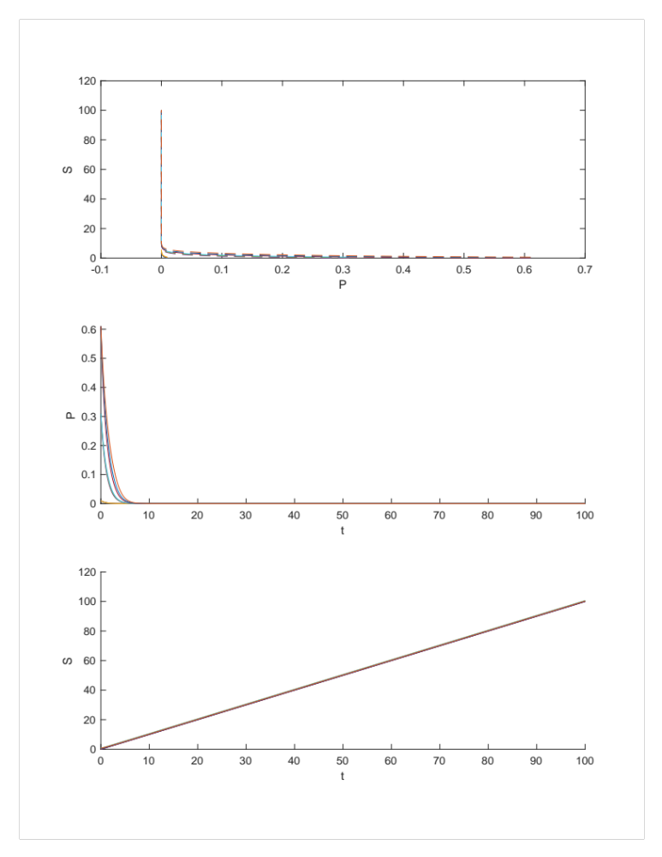
In summary, I would say that there is bistability in the system, where initial conditions towards the origin tend towards P 0 while S infinity , and for initial condition past a critical threshold away from the origin, the dynamics instead reach a limit cycle.

