Dynamic Models in Biology
HW 5
Jonathan Levine
Fall 2023

Problem 1
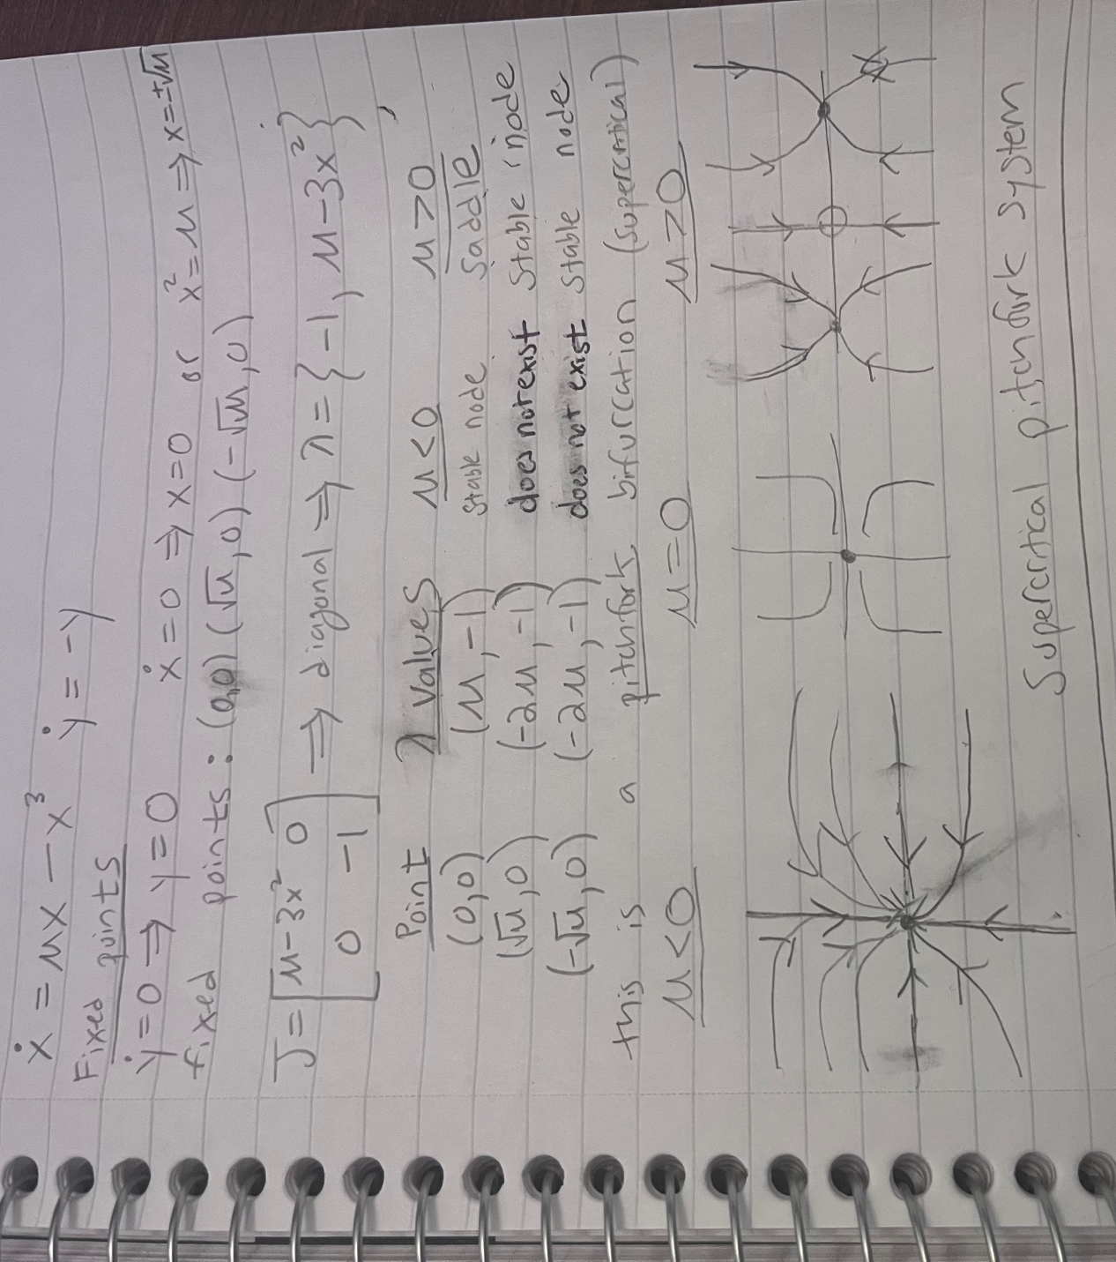
Supercritical pitchfork bifurcation

Problem 2
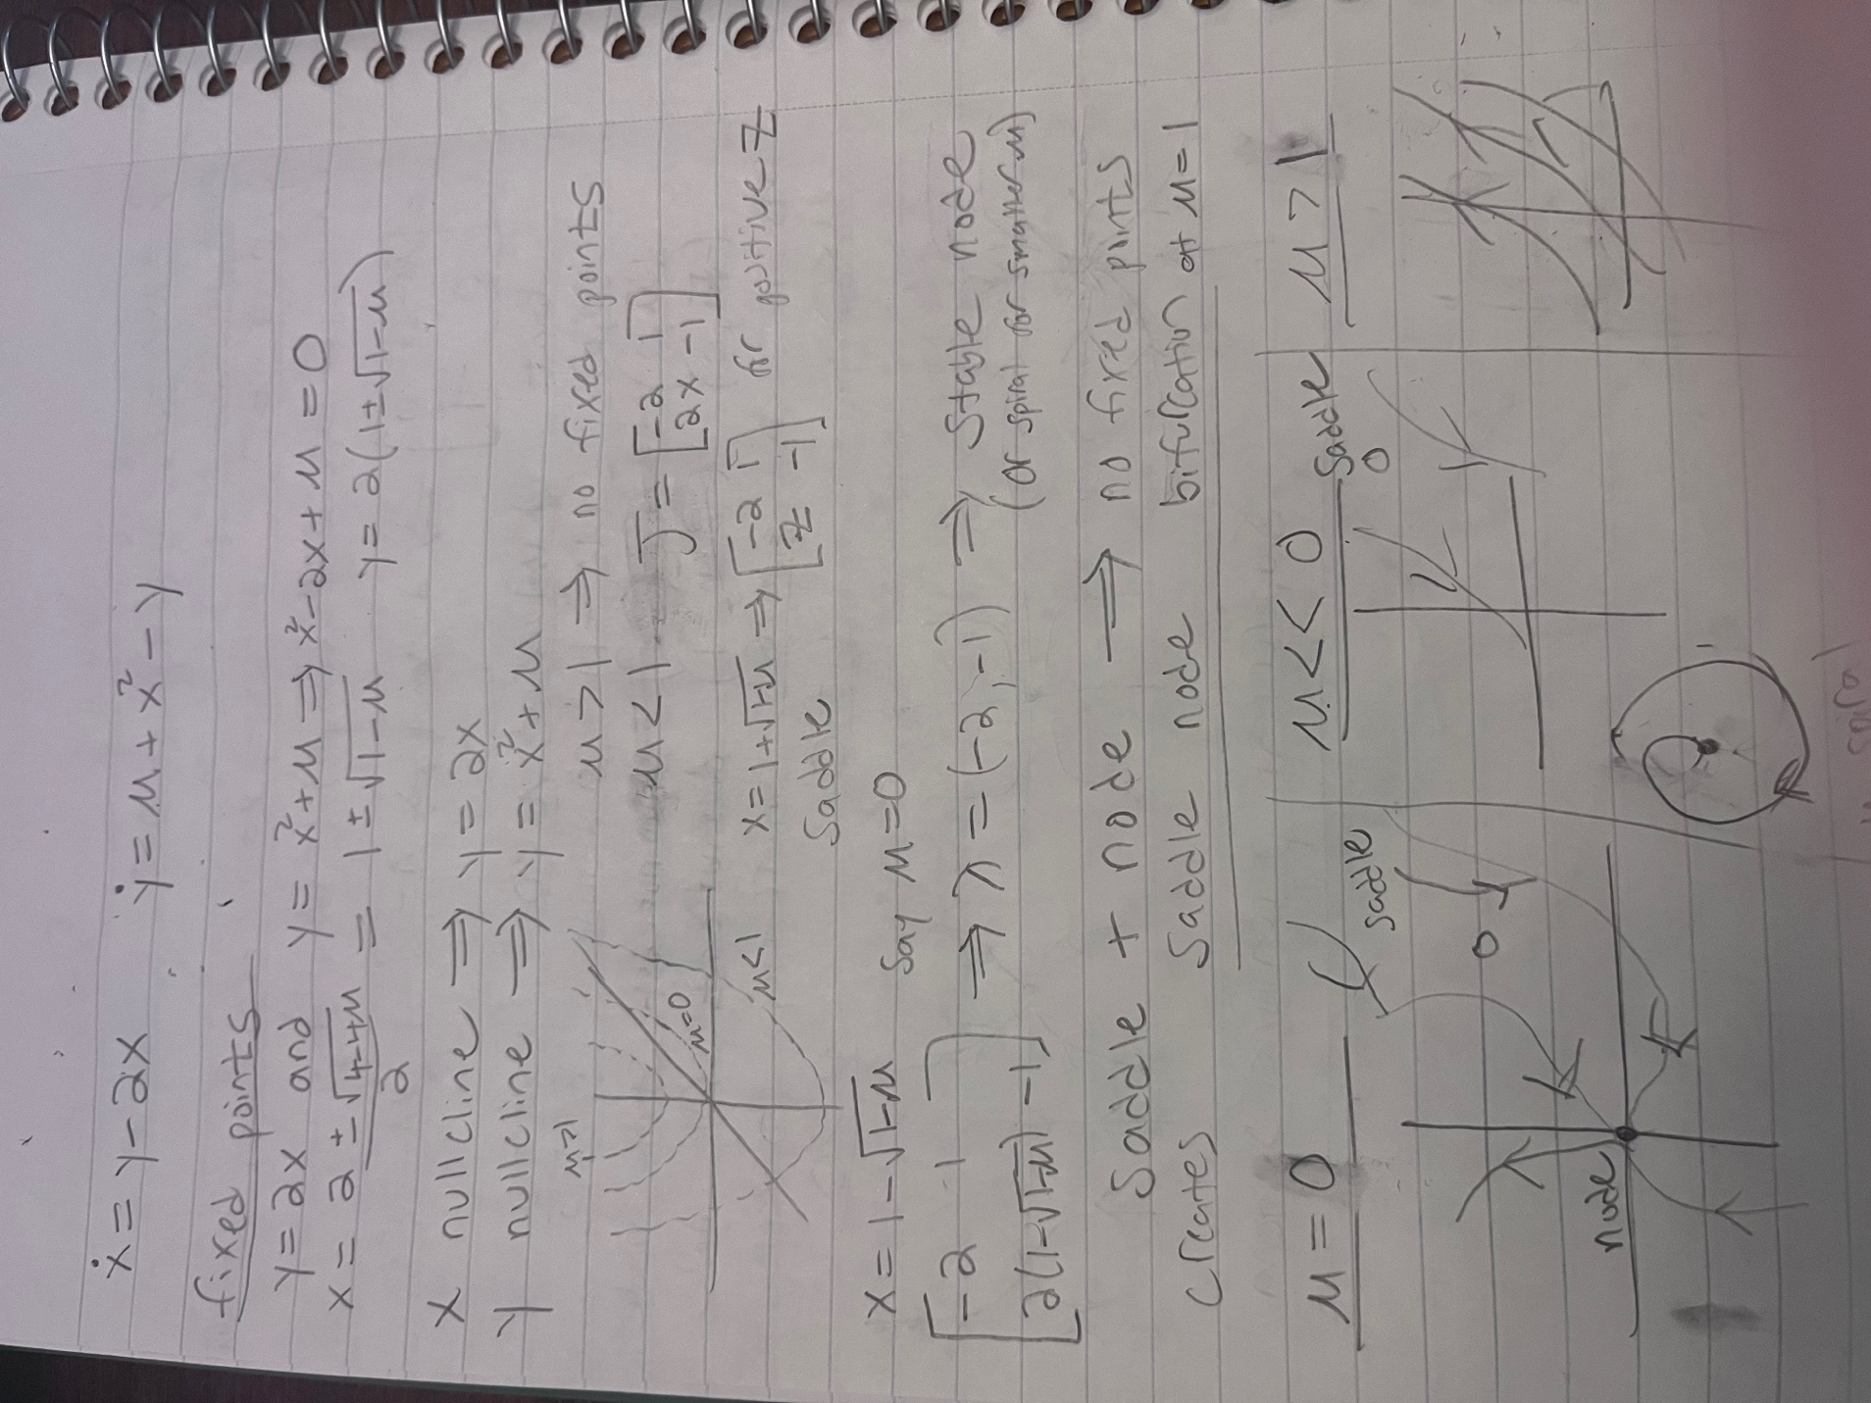
saddle-node bifurcation

Problem 3

This is a subcritical Hopf bifurcation. This is because for mu less than 0, we see that there is a stable limit cycle for some initial conditions, and a stable node for other initial conditions. This indicates subcritical, because for a supercritical for mu < bifurcation point, there is no point for which there is both a stable point and a limit cycle.

Problem 4

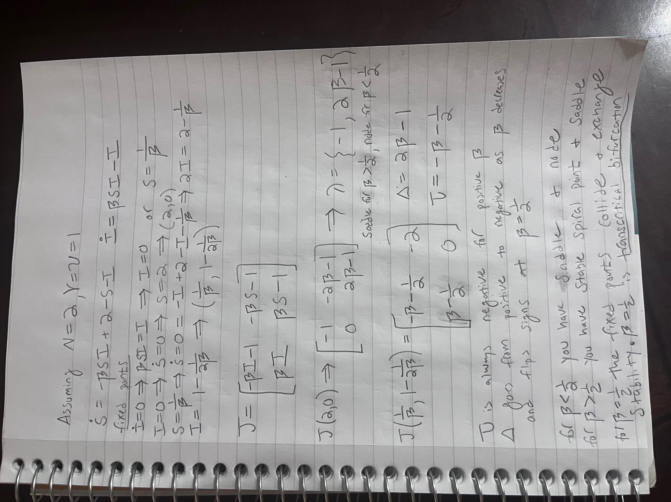
There is a transcritical bifurcation for beta = ½ (assuming N=2, gamma=nu=1). We can see that the 2 fixed points collide at beta=(1/2), where (2,0) and (1/beta, 1-1/2beta) are the same. They then flip stability as you can see from the Jacobian eigenvalues for (2,0) and for the determinant flipping signs for (and (1/beta, 1-1/2beta)

