Dynamic Models in Biology
HW 6
Jonathan Levine
Fall 2023

Problem 1: Lorenz Model

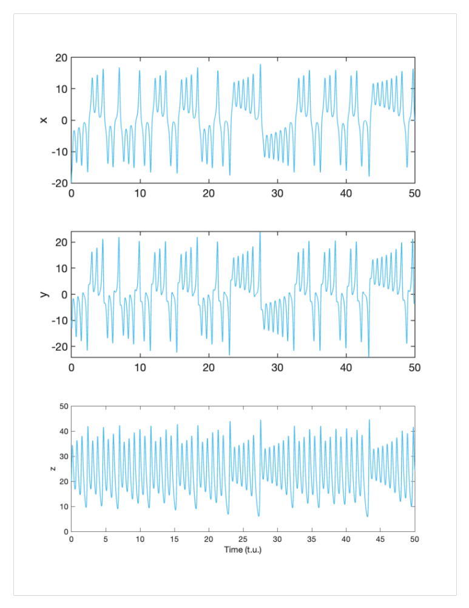
(a) I implemented the Lorenz model in matlab for one initial condition. You can see an aperiodic response in time traces (left) and a strange 3D attractor in phase space (right).

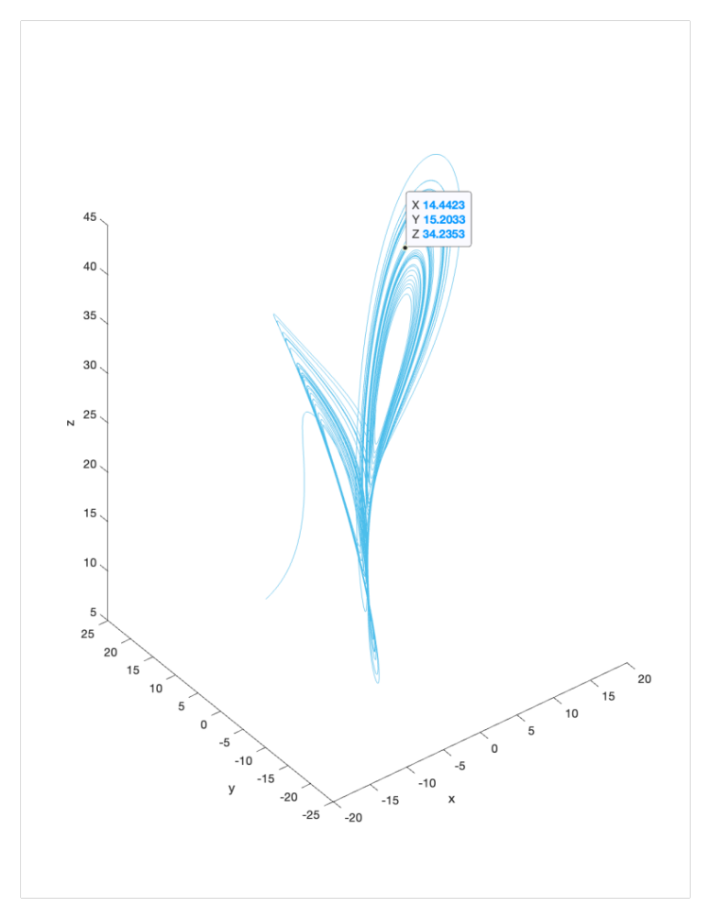
I confirmed that the strange attractor exists for a large variety of initial conditions. (The phase portrait looks slightly different based on the distorting effects of the 2D projection of the 3D plot, you can see the axes displayed differently here vs. above)

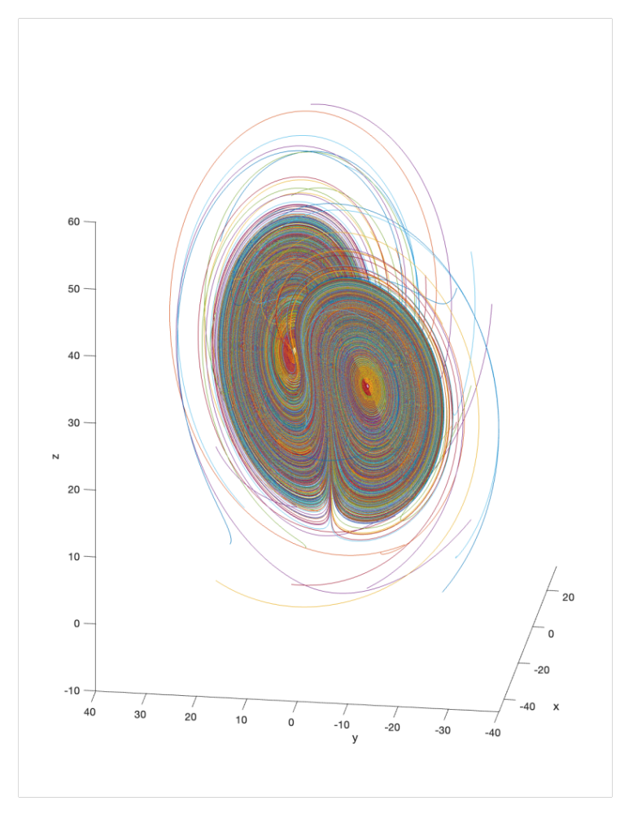
(b) I simulated the equation for an arbitrary starting condition, and grabbed the final point in (x,y,z) space in order to get a point on the attractor
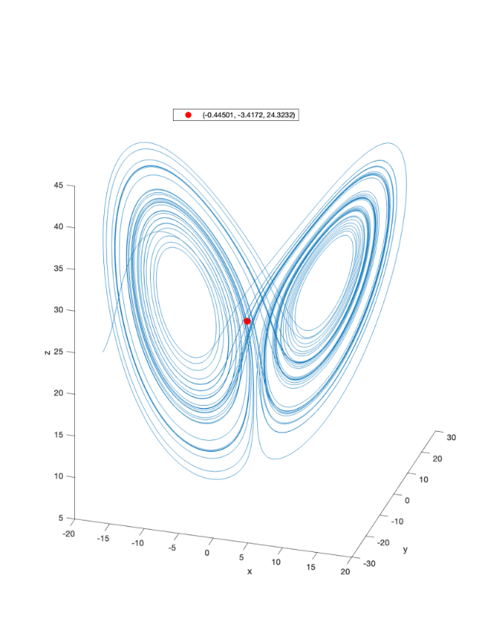
I then use this final point (-.445, -3.42, 24.32) as the starting point for the next simulation:
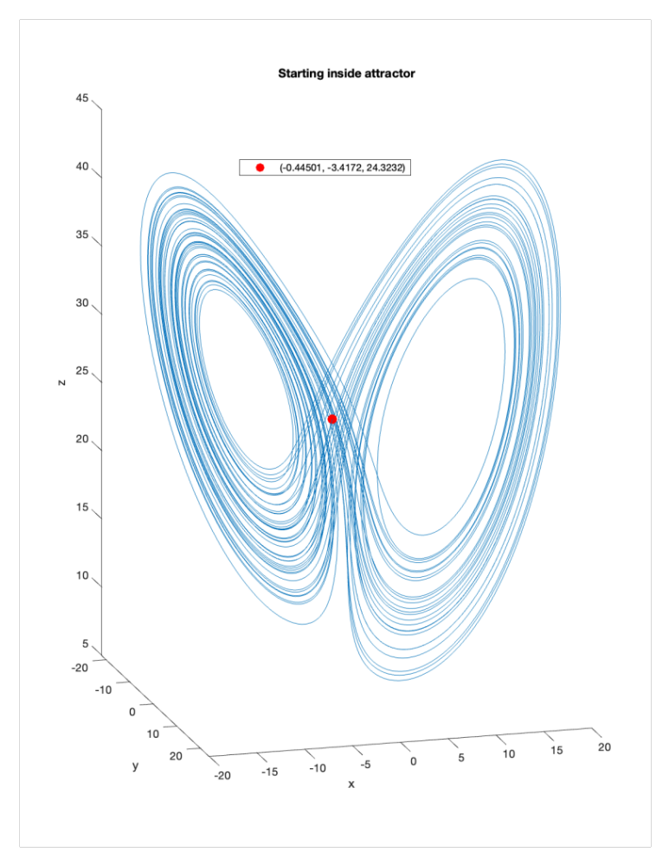

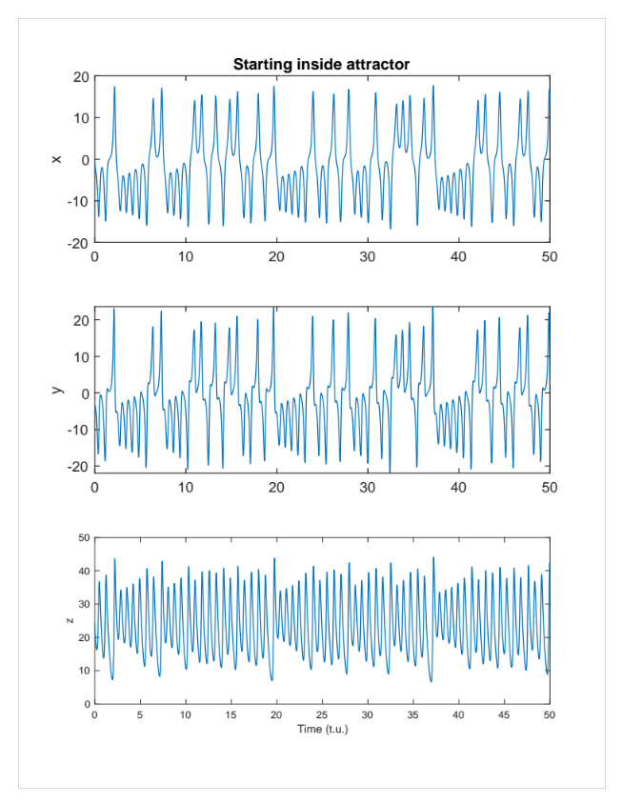
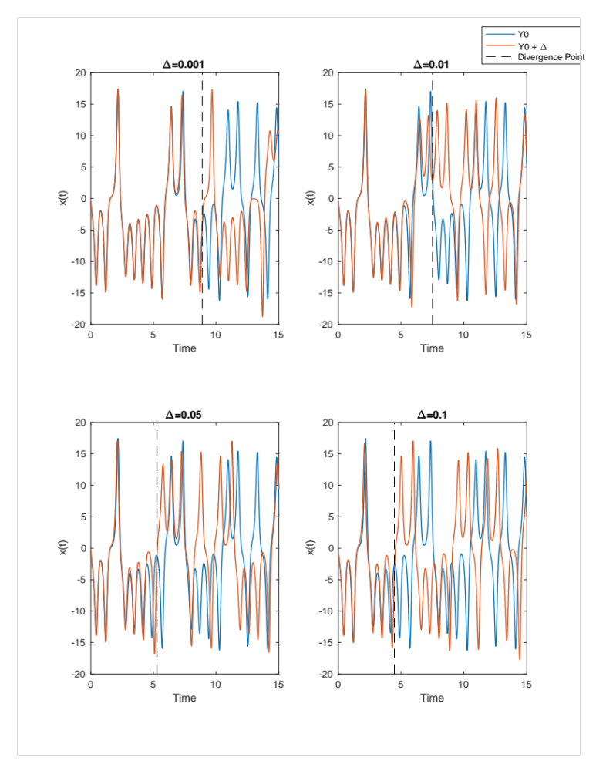
(c) If you modify the initial condition (-.445, -3.42, 24.32) to be (-.445+Δ, -3.42+Δ, 24.32+Δ) for varying values of Δ, you can see that the x(t) solutions diverge quite dramatically even with small changes in the initial conditions. [Note that the actual distance between y0 and y0+Δ would be sqrt(3Δ^2)]
I plotted 4 such examples of deltas below and marked the point at which the two x(t) trajectories diverge significantly using a dotted line:
You can see that as Δ increases, the time until divergence decreases. You can see this more clearly if you compare the location in time of the dotted lines in the 4 plots above (bar graph shown below). You can clearly see that the larger the deviation in initial conditions, the more quickly the trajectories diverge/deviate from each other.
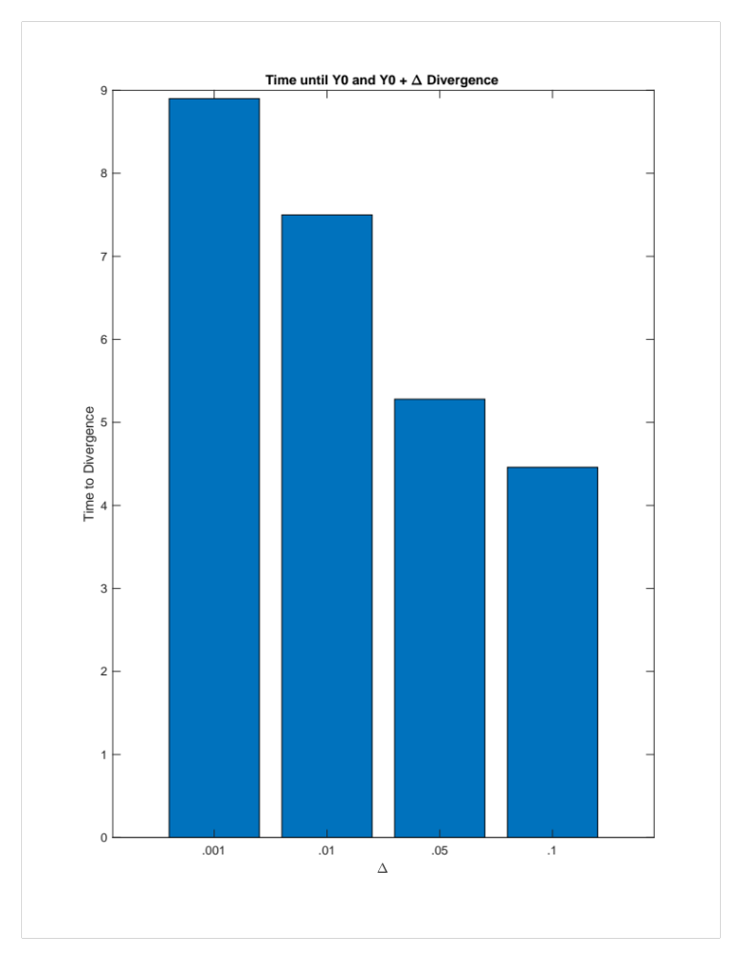

Problem 2: FitzHugh-Nagumo model

Injecting a hyperpolarizing pulse into the FHH model neuron can cause a rebound action potential when the pulse is lifted. Biologically this has to do with the different time trajectories of voltage dependent gating mechanisms. Sodium inactivation has slower kinetics than sodium deactivation, thus when the voltage returns to rest after the pulse is lifted the conductance for sodium is temporarily much higher, thus lowering the effective threshold temporarily. In this model we see this effect:
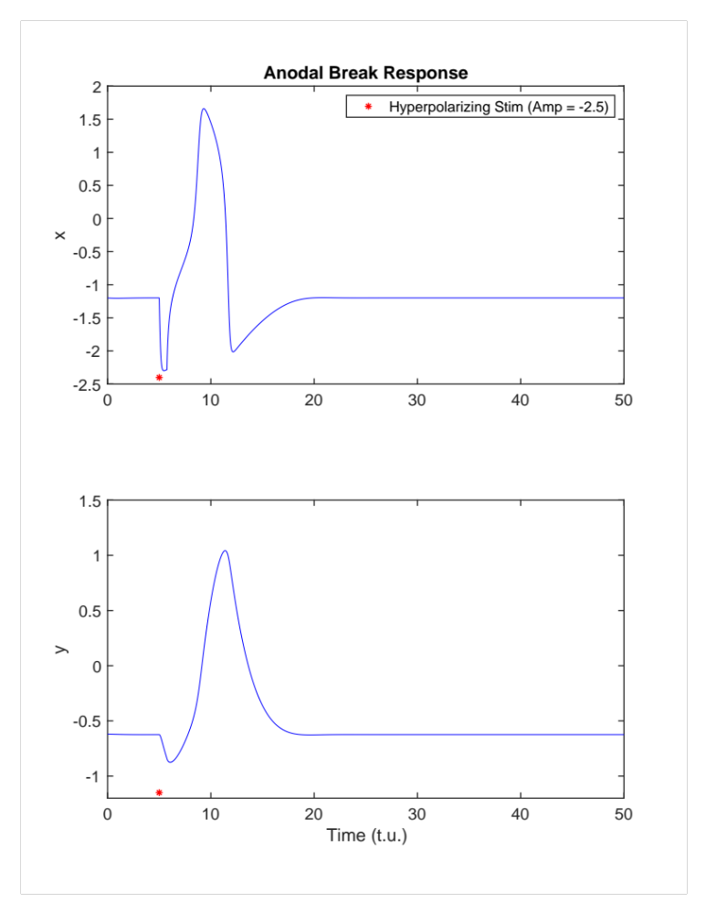
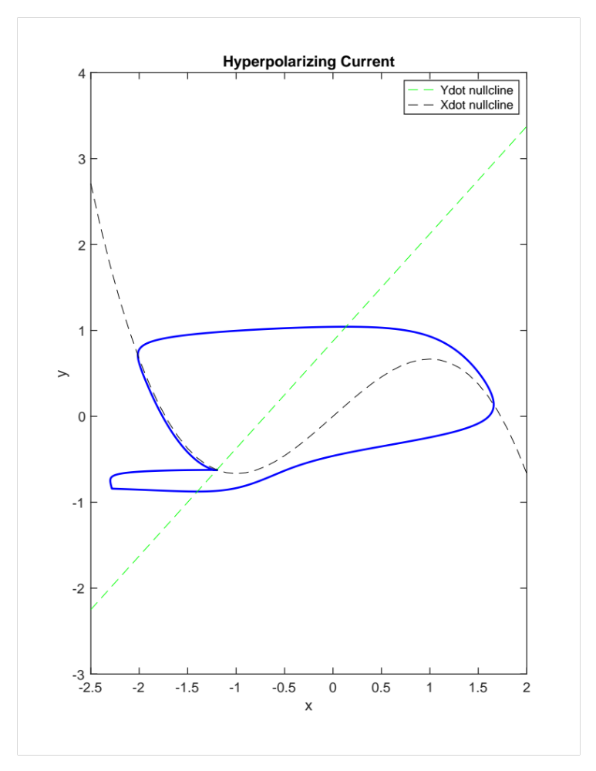
Mathematically, this effect is also evident from looking at model trajectories in phase space. A hyperpolarizing current moves x away (leftward) from the xdot nullcline, which allows it to enter a different trajectory due to the vector field there having larger magnitudes in the x direction. This creates a temporarily lower threshold that can lead to a single spike before returning to the original fixed point.
Automaticity (a=0)
With a=0, we see that the stable attractor is a limit cycle (which could be interpreted as constant firing of action potentials):
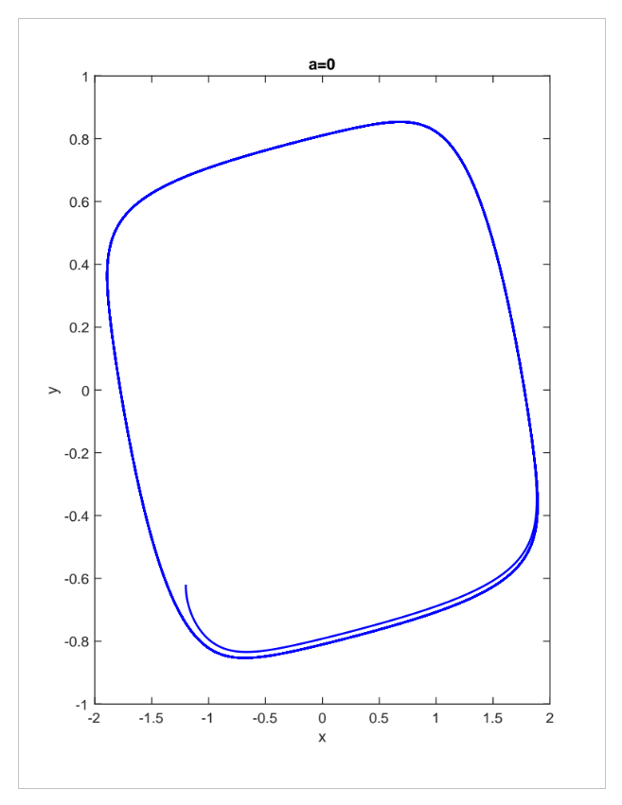
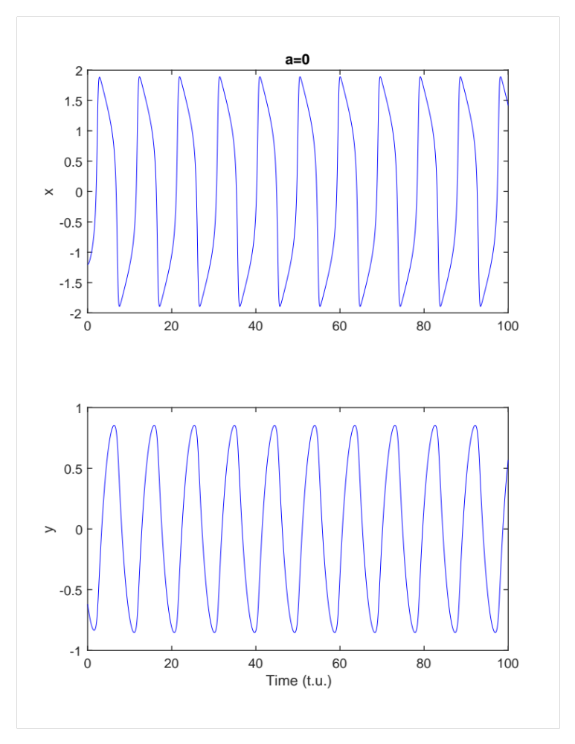
Varying parameter a

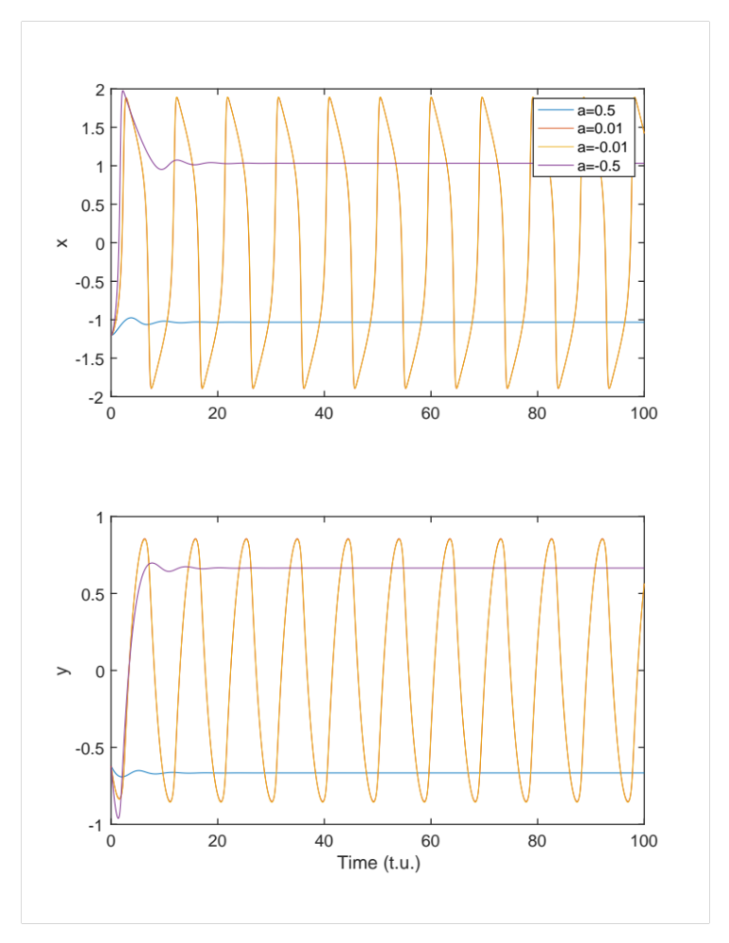
When varying a, you see that for very small a value (both positive and negative) there is a limit cycle, but above a specific absolute value the limit cycle disappears:
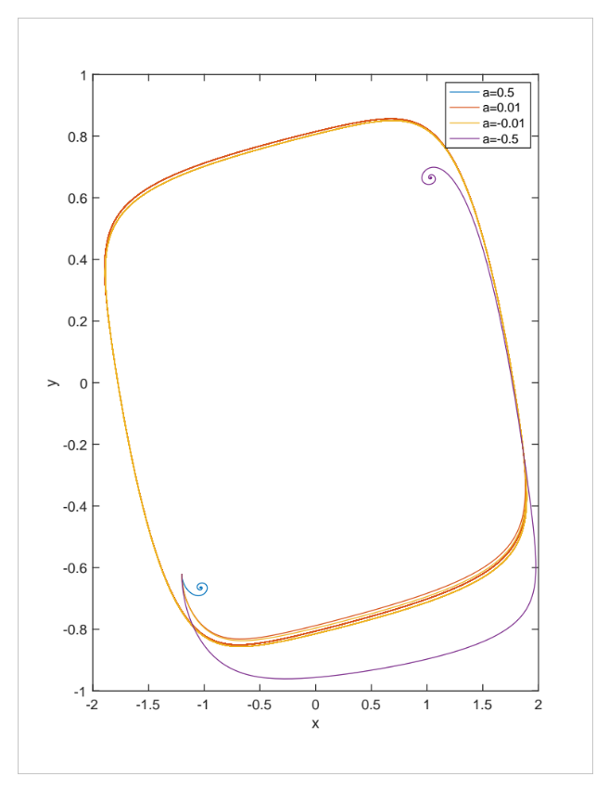

Looking at an even narrower range for only positive a values, we see a bifurcation around .425:
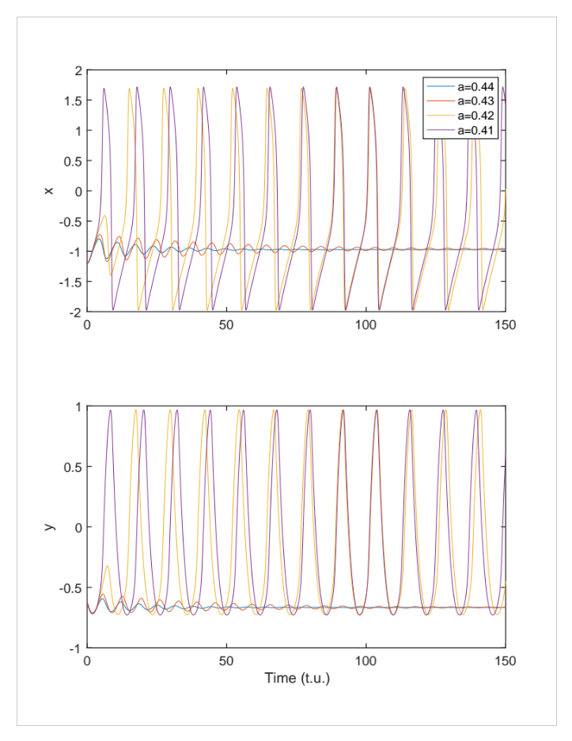
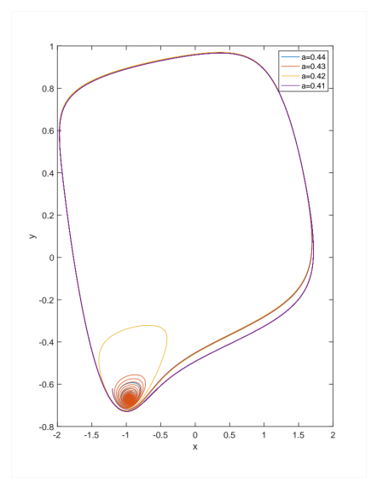

We can find the fixed points and their stabilities for these varying alphas:
$$\dot{x}=3\left(x-\frac{x^{3}}{3}-y\right) \\ \dot{\begin{aligned}\dot{x}=0=>y=\frac{-x^{3}}{3}+x \\ \dot{y}=\frac{1}{3}\left(x+a-0.8y\right) \\ \dot{y}=0=>y= \frac{1}{0.8}(x+a)\end{aligned}}$$

The Jacobian does not depend (directly) on alpha, though it does have an x term, so we need to re-calculate the fixed point for every alpha, and then classify it using:
$$J=\left[\begin{matrix}3-3x^{2} & -3 \\ \frac{1}{3} & \frac{-0.8}{3}\end{matrix}\right]$$

a = 0.43
fixed point at (-0.96, -0.67)
J(-0.96, -0.67) => complex eigenvalues with negative Re => stable spiral

a = 0.42
fixed point at (-0.95, -0.66)

J(-0.95, -0.66) => complex eigenvalues with positive Re => unstable spiral

Thus, this system has a bifurcation where, in the linearization, a pair of complex conjugate eigenvalues go from having negative Real part to Positive real part. This indicates a stable spiral turning into an unstable spiral. This is therefore a Hopf Bifurcation (it appears to be supercritical but I would have to double check with more simulations).

