Dynamic Models in Biology
Lab 2 Report
Jonathan Levine
Fall 2023

Part 1

Quiver plots for various values of a in a linear system $\left[\begin{matrix}A & 0 \\ 0 & -1\end{matrix}\right]$
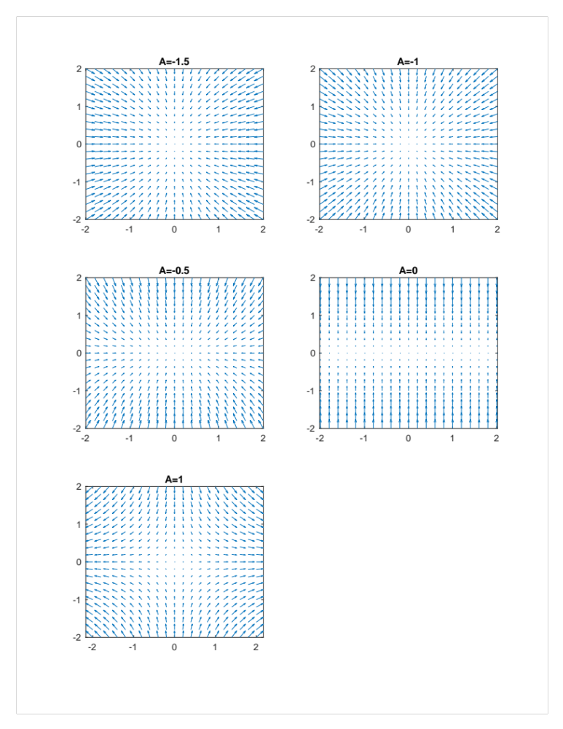
You can start from any point (x,y) in the space and follow the vector field to simulate the trajectory over time from that starting point

Part 2
Numerical integration of system from part 1. For each condition, the first two graphs show the individual state variables’ solutions as a function of time (x-axis time, y-axis state variables). The last graph shows some trajectories starting at a variety of starting conditions, overlaid on the quiver plot showing the vector field.

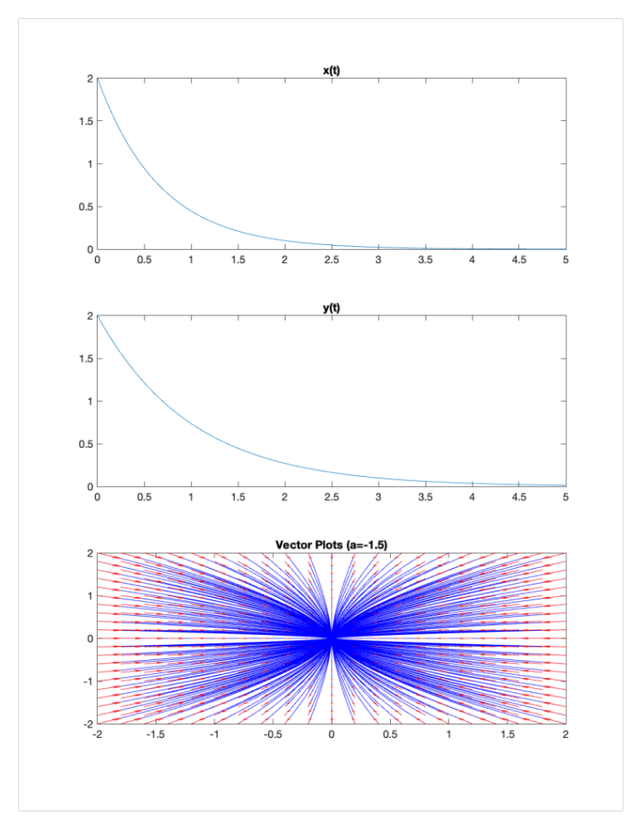

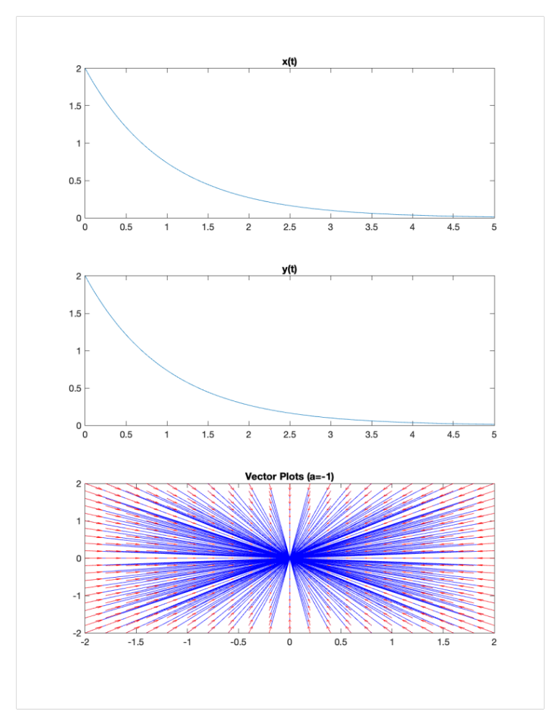

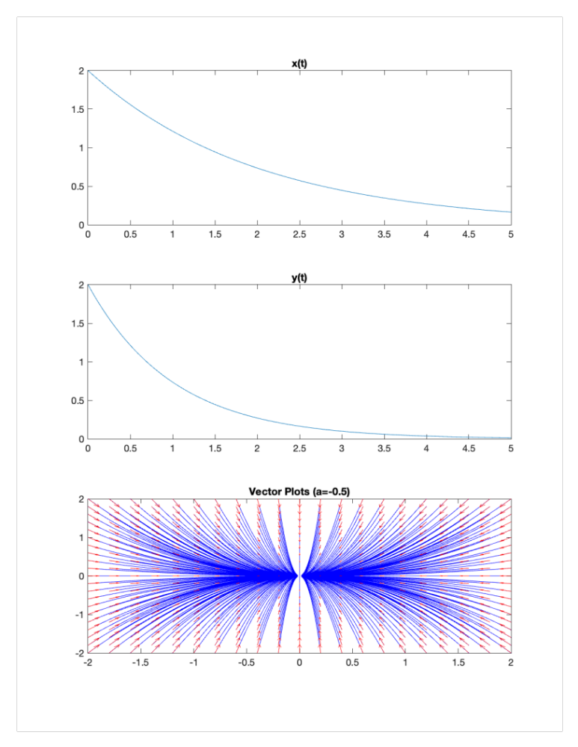
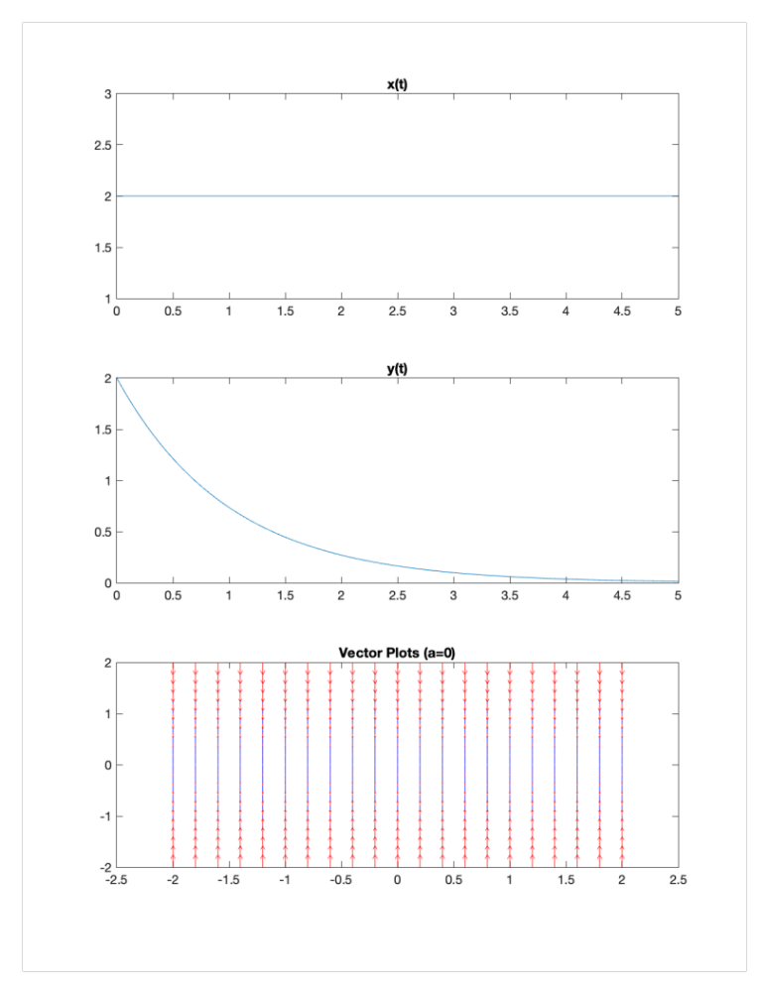

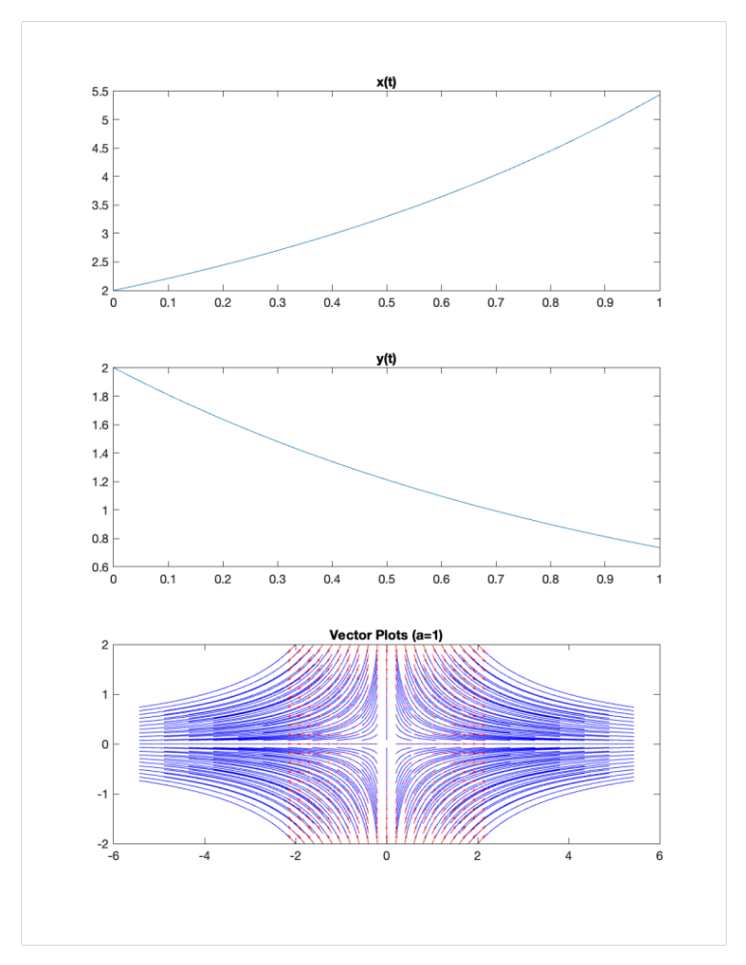

Part 3
Love Affair Model described by $\left[\begin{matrix}0 & 1 \\ -1 & 1\end{matrix}\right]$

This seems to describe a model in which Romeo’s love/hate for Juliet varies proportionally with her love/hate for him, but he does not change his love based on his own love trajectory, only based on her love.
Conversely, her love for him is a complex combination of matching his feelings for her, but then sharply changing her feelings to the opposite as feedback for her feelings themselves.

$\left[\begin{matrix}0 & 1 \\ -1 & 1\end{matrix}\right]$ has $τ=1>0 and Δ=1>0$. $τ^{2}-4Δ<0$
This indicates an unstable spiral node (i.e growing oscillation), which would indicate that they have a very messy relationship with all sorts of epochs of mutual love, mutual hatred and one-sided love and hatred. And the magnitude of these feelings grows exponentially over time, as shown in the quiver plot.
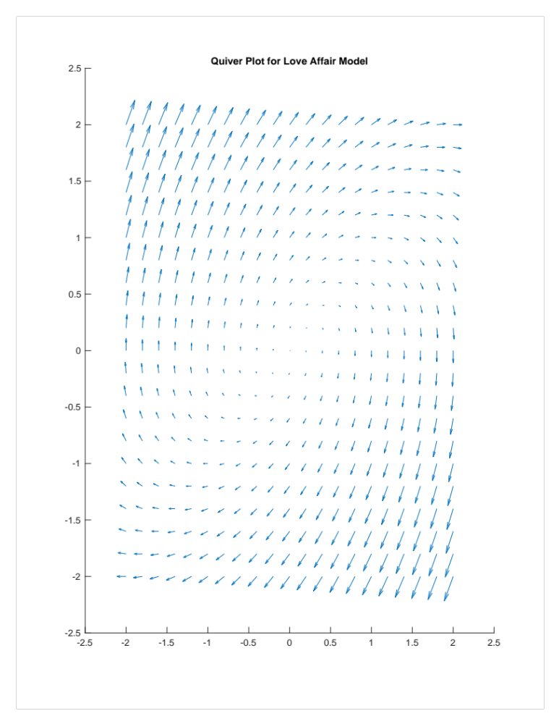

As the simulation shows, we do get an unstable spiral node with a growing oscillation. You can also see from the individual state variable plots that they are periodic as well, and Romeo (x) starts to mirror Juliet’s (y) feelings with some time delay, as expected.
