Dynamic Models in Biology
Lab 5
Jonathan Levine
Fall 2023

Saddle Node

Pre-Bifurcation

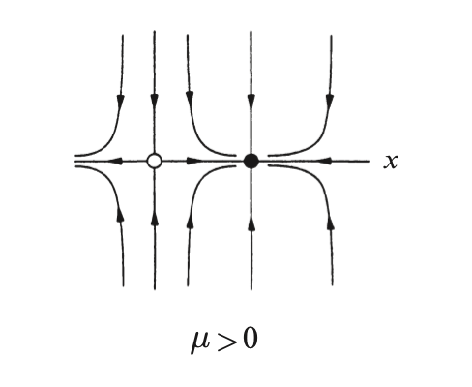
Values of mu above 0, pre-bifurcation. My phase portrait looks similar to the textbook, although the relative speed of approach in the x and y direction is slightly different, based on the magnitude of the mu value chosen.

Bifurcation
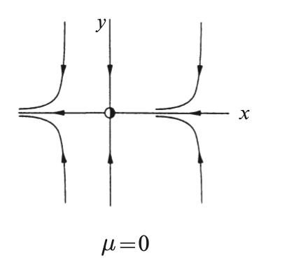
Mu= 0, the bifurcation point. My phase portrait looks exactly like the textbook’s (but with more trajectories drawn)

Post-Bifurcation
Values of mu above 0, pre-bifurcation. My phase portrait looks similar to the textbook, although the relative speed of approach in the x and y direction is slightly different, based on the magnitude of the mu value chosen. I also don’t know if my xrange is long enough to really see the full extent of the pattern. The ghost will be easier to see in the time trace anyway.
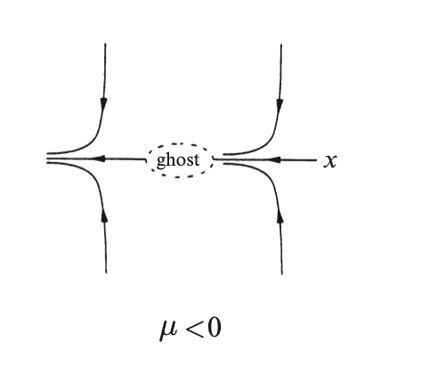
Time traces x(t) and y(t) shown on the right here for
two different initial conditions. You can see that in
the x direction, the trajectory slows down around
the old bifurcation point, i.e. the ghost, and then
speeds back up after on its way to -infinity.
Homoclinic Bifurcation
To start, we can find the nullclines for each sate variable, and plot them overlaid onto the phase portraits for varying mu, with the nullcline intersection points as the fixed points.

The leftmost fixed point transitions from a stable spiral to an unstable spiral, and the rightmost fixed point (only shown in mu > -2) is a saddle node. It appears that for very small mu values we find a limit cycle, and we will investigate that further in the next plots. Mu=0 is a special case where one nullcline is undefined due to division by zero

Looking at these same plots with their time trajectories, we can see that for negative mu values there is a stable fixed point that is reached and or mu values too large the unstable spiral grows to infinity. There is a small range of mu values where a stable fixed cycle oscillation occurs. In this plot, that occurs for positive mu < 0.2.
If we try to narrow this exact bifurcation point down a bit, we can simulate with more granularity around those mu values and get more detailed phase portraits and time trajectories (shown on the next 3 pages). You can see that right around .065 < mu < .07 the fixed cycle collides with the saddle node and turns into an unstable spiral.

