Dynamic Models in Biology
Lab 8
Jonathan Levine
Fall 2023

One-at-a-time non-local parameter analysis
Here I plot the effect of changing each parameter (while fixing the other two) on the output of the model (Gmax, Gmin, and Gmax-Gmin). For these plots, the x-axis is the scaled value, so the value at x=1 is the baseline and the values outside of that range are the baseline value scaled by x.
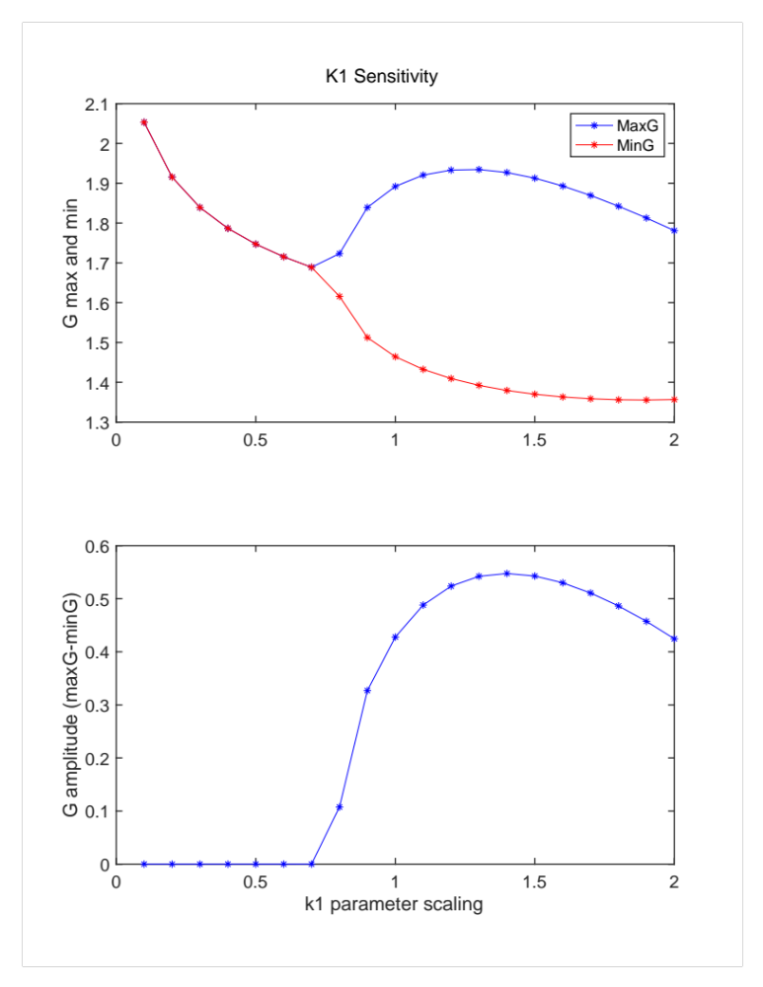

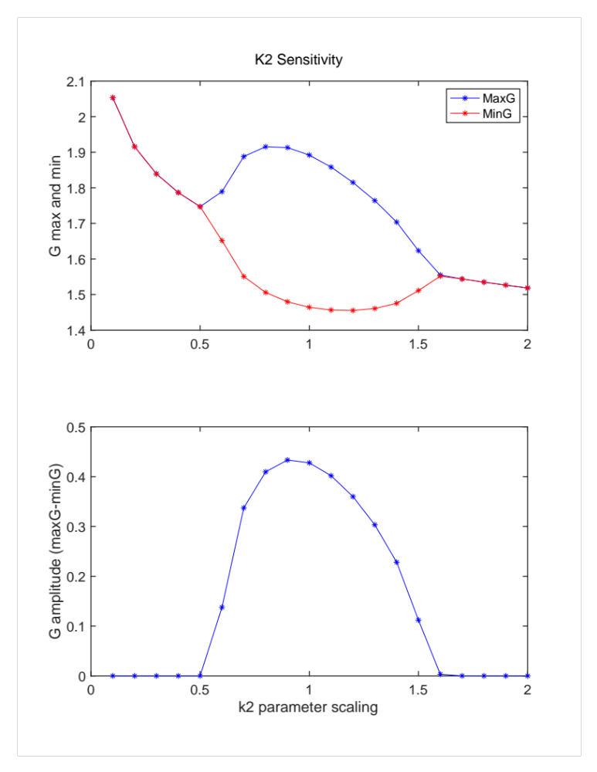

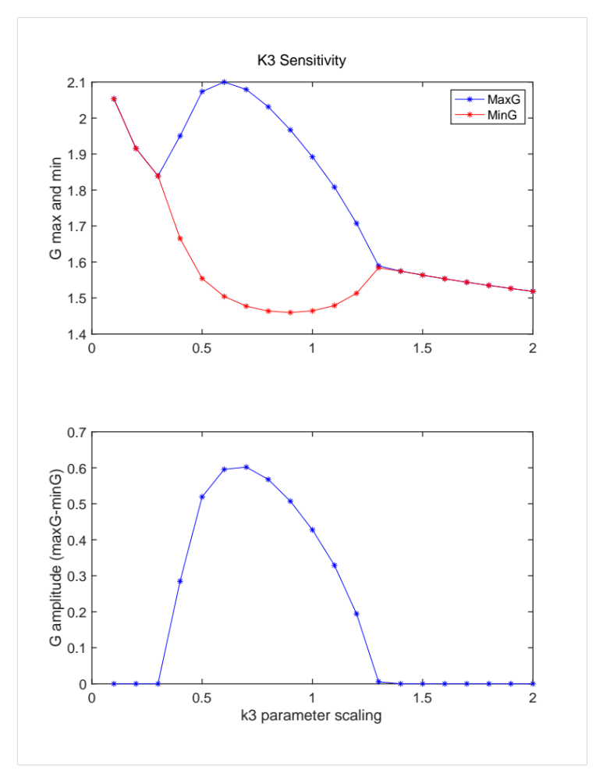

From the slope of these plots in the local area around the baseline (around x=1), k1 seems to have a large positive sensitivity, k2 seems to have close to zero sensitivity, and k3 has a large negative sensitivity. We can calculate the exact local sensitivity ($S_{local}$) by using the formula $S_{local}= \frac{p}{S}\frac{dp}{dS}$, where p is the parameter, dp is the change in parameter value, S is the model output (ampG in this case) and dS is the change in model output based on the change in parameter.

Relative Local Sensitivity Analysis (+/ .05 around baseline value)

Using the formula for $S_{local}$ above, I calculated the local sensitivities for each of the parameters for +/.05% around baseline value:

K1 | K2 | K3
1.81 | -0.39 | -2.07
This matches the plots above, where the slopes around x=1 match the sign and magnitude noted above. This means that K1 and K3 have strong (and opposite directional) effects on the output of the model near baseline parameter conditions, while the model output is largely unaffected by K2.

Global Sensitivity

By varying 2 parameters at the same time, you get surf/3d plots where the (x,y) axes are the varying parameter values and the z/color axis is the output (ampG). The surf plots for each pair of parameters are attached at the end. If you look at the scaled coordinates where each surf plot reaches maximal ampG you can find the actual parameter values that maximize the amplitude in each surf plot. This table below shows each surf plot’s maximal value, and the scaled and unscaled coordinates for which parameter values give that maximal value.

 | K1&K2 | K1&K3 | K2&K3
Scaling Coordinates | (1.5, 1.1) | (1.2, 0.7) | (0.9, 0.7)
Actual Params | (0.23, 0.22) | (0.18, 0.14) | (0.18, 0.18)
AmpG | 0.55 | 0.63 | 0.72

Over all parameter combinations tested, you can see that (k2,k3)=(0.18,0.18) maximizes ampG. If you look at the local sensitivity plots for k2 and k3 you can see that the amplitude is maximized for roughly the same values in those plots as the values here (x=.9 and x=.7 respectively). For the most part the maximal parameter values in the local plots are the same as in the global plots, but the relationship is obviously not 1:1 since there is a complex interplay between parameters. In order to actually understand the full picture you need to covary them. While you might have an educated guess (i.e. the amplitude for that parameter couldn’t be zero), you cannot fully predict which parameter set will maximize the model output without full simulations over parameter space.
