Jonathan Levine
Dynamic Models in Biology
Fall 2023
The Effects of DDT in a Model Ecological System

Model Formulation
I will describe each of the parts of the model, and the assumptions made in order to get this model:
For mosquito population (M) growth/death:

$\dot{M}=r_{M}M\left(1-\frac{M}{K_{M}}\right)-\frac{a_{M}M}{1+b_{M}M}S- d_{M}M$

Here I assume that mosquitoes grow with logistic growth to a carrying capacity $K_{m}$, and die with a linear rate $d_{m}$. For the predator-prey relationship between small birds (S) and mosquitoes (M), I use the Holling-Tanner predator-prey type model, which is often useful to model predator-prey interactions in which the predator eats the prey with a saturating curve, as this has been used to model pest predation in the past. I opted to use this more complex function rather than the mass-action like terms I use below, because there is an imbalance between the number of birds and mosquitoes in the ecosystem, and a single bird would also need to eat a large number of mosquitoes at a time. Those factors would make the mass-action term less realistic.
For the small bird (S) population dynamics:

$\dot{S}=q_{s}\frac{a_{M}M}{1+b_{M}M}S-αLS - d_{s}S={S(q}_{s}\frac{a_{M}M}{1+b_{M}M}-αL - d_{s})$
Here, I assume that that the small bird population is far from its carrying capacity and thus that term can be assumed to me close to 1 and removed. The limiting step of the bird population growth is the availability of mosquitoes to eat. Therefore, the growth term is simply the same as the mosquito predation term, scaled by $q_{s}$ which is a measure of the food quality that the prey provides for conversion into predator births. I include a more typical predator-prey law of mass action term for the large birds preying on small birds, as their populations are usually more similar. Finally, I assume a linear death term for this population with rate $d_{s}$.

For the large birds (L):

$\dot{L}=αLS + βLR- d_{L}L=L(αS + βR- d_{L})$

Here again I assume that the large bird population is far from its carrying capacity, and that its growth is linearly related via mass-action like terms to availability of its prey, the small birds (S) and the rats (R).

Finally, for the rat population (R):

$\dot{R}=r_{R}R\left(1-\frac{R}{K_{R}}\right)-βLR- d_{R}R$

I assume that the rat population is close to its carrying capacity $K_{R}$. In the absence of predators, the rat population grows with logistic growth and dies with a linear death rate $d_{R}$. The extra term for predator-prey interaction comes from the L differential equation above, using a mass-action like term for large birds preying on rats.

Altogether the model is:
$\dot{M}=r_{M}M\left(1-\frac{M}{K_{M}}\right)-\frac{a_{M}M}{1+b_{M}M}S- d_{M}M$
$\dot{S}={S(q}_{s}\frac{a_{M}M}{1+b_{M}M}-αL - d_{s})$
$\dot{L}=L(αS + βR- d_{L})$
$\dot{R}=r_{R}R\left(1-\frac{R}{K_{R}}\right)-βLR- d_{R}R$

Model Parameters

For the model parameters, I tested the values or range of values shown in the table below, and used the values shown. A sensitivity analysis for these parameters is included later. If the parameter range, or order of magnitude of the parameter, was taken from the literature, the citation is noted in the rightmost column. For parameters that I was not able to identify suitable literature for, I used realistic values based on the other parameters in the model and the ecological interpretation of the various terms (e.g. mosquitoes should die more quickly than rats, but also have a larger carrying capacity).

Parameter | Range of Values Tested | Baseline Value Used | Source from Literature
$$r_{M}$$ | 0.2-0.7 | 0.35 | Thomas, Diana, et al.
$$K_{M}$$ | 2-8 x 10⁵ | 2 x 10⁵ | Fasano, A. et al.
$$a_{M}$$ | 0.15-0.50 | 0.35 | Yang, Jin et al.¹
$$b_{M}$$ | 0.5 - 1 | 0.5 | Yang, Jin et al.¹
$$d_{M}$$ | 0.05 | 0.05 | Thomas, Diana, et al.²
$$q_{s}$$ | 0.5-1 | 0.75 | Yang, Jin et al.¹
$$α$$ | 2x10⁻⁵ - 2x10⁻³ | 0.00002 | Henson, SM, et al.
$$d_{s}$$ | 0.001 | 0.001 | Thomas, Diana, et al.²
$$β$$ | 2x10⁻⁶ - 2x10⁻⁴ | 0.000002; | None
$$d_{L}$$ | 0.001 | 0.008 | Thomas, Diana, et al.²
$$r_{R}$$ | 0.22 - 0.29 | 0.25 | Mello, JH, et al.
$$K_{R}$$ | 200-2000 | 500 | Mello, JH, et al.⁵
$$d_{R}$$ | 0.05-0.185 | 0.05 or 0.18 | None

Stable Attractors
Under baseline conditions, this set of ODEs converge to a stable fixed point in all 4 dimensions. Each population reaches a stable number, and the value of that number depends on the initial conditions. Specifically, there exist two basins of attraction leading to two distinct stable fixed points depending on the initial mosquito population, shown in the time traces below:
Some initial conditions (red, blue) lead to the top attractor while others (green) lead to the bottom attractor
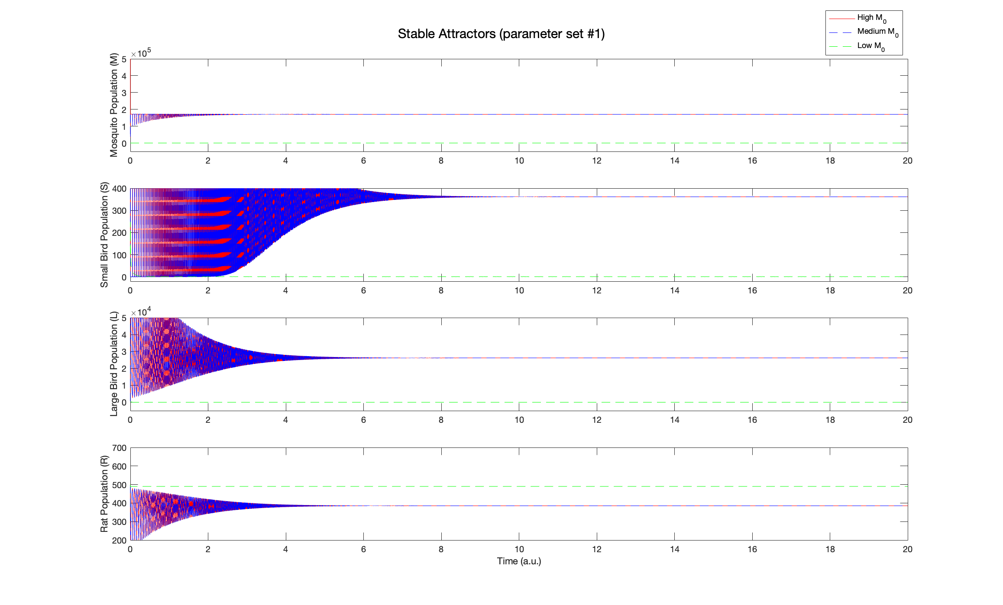

In this system, which attractor is reached (i.e. the separatrix) depends almost exclusively on the initial mosquito population, and does not depend on any of the other initial population values:
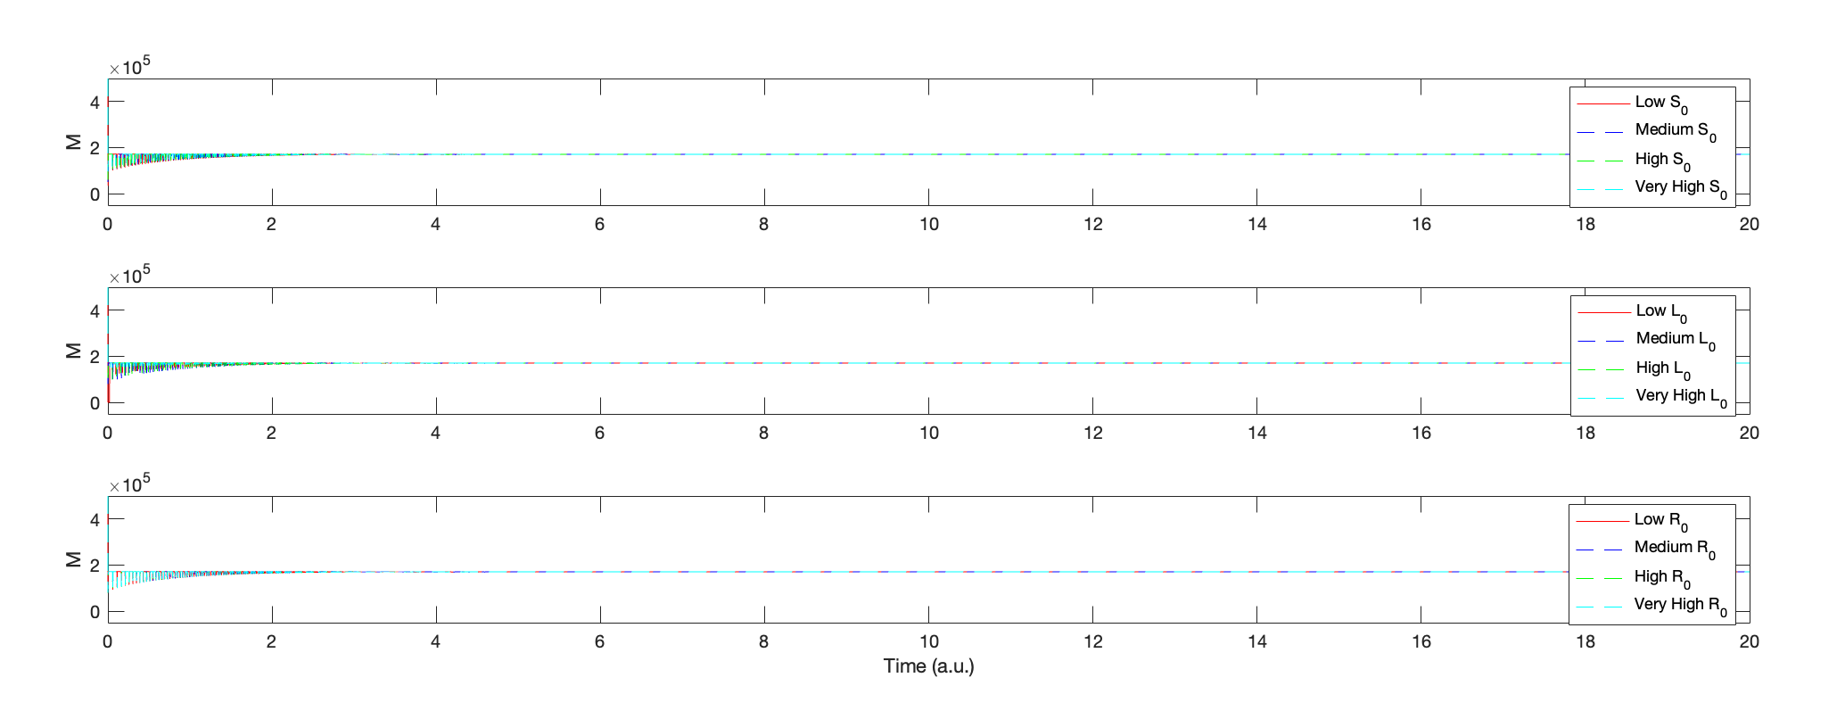

In the figure above, the fixed point (shown as just the steady-state M value) largely does not depend on the initial starting populations of S, L, or R. This suggests a separatrix that is one-dimensional (only in M). Within the family of non-zero starting populations, this suggests that the system is very sensitive to temporary perturbations to the population of mosquitoes, and less sensitive to temporary perturbations in the other populations. Under a certain critical threshold of mosquitoes, the system can enter a different attractor, and plummet to a different fixed point which has values M=low, S=low, L=low, $R≅K_{R}$.

Modelling DDT Exposure as a Single Perturbation
The analysis above suggests one possible ecological effect of DDT, if we were to model a one-time application DDT exposure an instantaneous knockdown of the mosquito (M) population at a specific time point. I simulate this in the same way that one can simulate injecting a hyperpolarizing pulse into an action potential model, by introducing a decrease in the M population at t=10. At certain critical thresholds, a one-time eradication of a critical number of mosquitoes can knock the system down to the other attractor, leading to devastating ecological effects by disrupting the entire food chain.
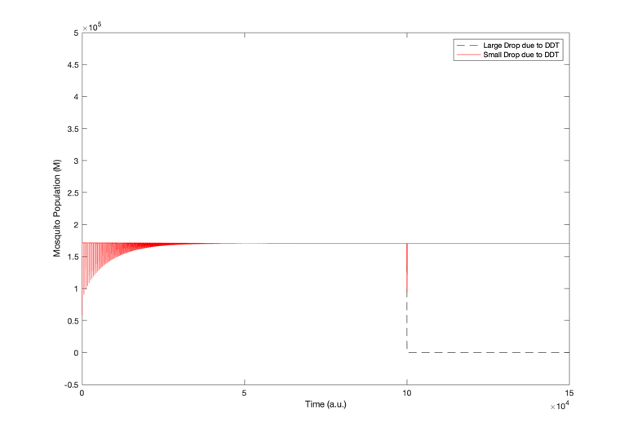

Oscillatory Dynamics

While the baseline conditions described above led to stable fixed-point dynamics, there are also other dynamics observed with different parameter sets. Specifically, after varying the parameter $d_{R}$, a Hopf Bifurcation appears where the stable fixed point (red) turns into a small amplitude limit cycle (blue), with high frequency oscillations in all 4 state variables. The amplitude of the oscillations grows quickly as $d_{R}$ is increased more (black), indicating a supercritical Hopf.
The oscillations above still represent a normal, healthy ecological system, as the populations of the species are still relatively balanced and neither the mosquito nor rat populations (which carry disease) are exploding fully to their carrying capacities. One can imagine that the natural death rate of rats, which is the parameter that causes this bifurcation, might depend on the temperature, rainfall, or other aspects of the climate or environment. Therefore, one might imagine that the stable fixed-point dynamics in the first section and the stable oscillatory dynamics shown in this section both represent plausible steady states for this system during different seasons or in response to climate events such as storms or fires.
Modelling DDT Exposure as a Continuous Perturbation

I now want to model how a more complex DDT term might affect the dynamics of the system, both in the realm of stable fixed-points ($d_{R}=0.05$) and stable limit cycles ($d_{R}=0.18)$. To do this, I model continuous DDT exposure as an increase in the death rates of the species affected by DDT. Specifically, there is a large increase the mosquito death term parameter $d_{M}$, representing the main effect insecticide, and a smaller increase in the death terms of the birds $d_{L}$ and $d_{S}$, as birds might also directly be affected (e.g. DDT in drinking water), albeit to a lesser extent.
Formally, we can introduce an exposure parameter $ω$ that influences the death rates of these 3 populations such that:
$$d_{L,DDT}={ω*d}_{L,baseline} \\ d_{S,DDT}={ω*d}_{S,baseline} \\ d_{M,DDT}=δ{*ω*d}_{M,baseline} \\ where ω, δ>1$$
$ω$ represents the amount of DDT exposed to the system, while $δ$ represents how much more potent DDT is in killing mosquitoes than birds. A $δ$ value of 2 would mean that DDT kills mosquitoes twice as much as it kills birds. For this analysis, I assume here that the effect of DDT on mosquitoes is 100x the effect of DDT on birds ($δ=100)$, although I also tested values of 50 and 1000 and saw similar qualitative results. I then simulate the system for varying levels of $ω$, and look at now they diverge from the baseline dynamics described above.

Looking at the stable fixed-point dynamics (figure on the next page), we see that as the DDT exposure increases slightly, corresponding to increasing $ω$ (blue), the fixed-point shifts slightly towards lower M, and has small effects on the other species’ populations. However, as DDT exposure increases more (black), the dynamics hit a Hopf bifurcation (the bifurcation point is based on tuning three parameters simultaneously) and the populations exhibit large amplitude oscillations:

Unliked the oscillations shown earlier, these oscillations are much higher amplitude, where the populations reach critically low numbers in troughs and unnaturally high numbers in the crests of the oscillations (Note the difference in y-axis limits in this figure vs. in the figure before). In the low number phases (troughs), this could lead to devastating consequences if any further perturbations (e.g. a disease affecting large birds) completely eliminate the small population. In the high number phases (crests), the overpopulation of rats could lead to additional diseases that would negate any perceived effects of curbing the mosquito population. Additionally, the waveforms for the bird populations exhibit sharp peaks and broader troughs. This would exacerbate the risk described above, where the populations exist in critically low numbers for longer periods of time compared to the population spikes. The waveform for R exhibits the opposite trend, with longer peaks, and could exacerbate the risk of diseases carried by the rat population. This indicates that the levels of DDT do not linearly map to the harm caused by DDT, and that is important to understand the cascading effect of causing a bifurcation like this to happen when introducing changes to an ecosystem.
Adding the same continuous DDT exposure parameter to the model in the realm of stable oscillations dynamics ($d_{R}=0.18)$, we see that as $ω$ increases, the oscillations get larger and more frequent:
While the mosquito population does decrease significantly in response to DDT exposure, the pesticide leads to an increase in the frequency and amplitude of existing oscillations in the other 3 populations, which could lead to unintended consequences in the ecosystem.

Taken altogether, we see that DDT can have destabilizing effects on the dynamics of the animal populations. DDT can induce new oscillations or change the intensity of existing oscillations in the system, which can bring prolonged trough periods of species endangerment and sharp spikes of overpopulation that could lead to diseases.

Sensitivity Analysis
The main outputs of the model that were important for this analysis are (1) the steady state mosquito population and (2) the amplitude and period of the steady-state oscillations in the rat population. In order to probe the importance of each parameter listed in the parameter table above, I computed non-local sensitivity curves of these two model outputs to each parameter, scaling the parameter value up to 2 times its baseline value. First, looking at the steady state mosquito population as a function of parameter scaling:

We can see that the steady-state value is largely unaffected by parameters outside of the M differential equation (right). This model output is most sensitive to the carrying capacity $K_{M}$ (left, orange), as the growth rate of mosquitoes is largely capped by that value in the absence of a DDT term. Additionally, the growth rate (left, blue) and death rate (left, green) parameters affect the steady-state value of M, albeit to a lesser extent. Below, I calculate local sensitivities for each parameter for +/- 10% around the baseline (scaled 1.1x and 0.9x), using the formula
$S_{local}=\frac{p}{S}\frac{dp}{dS}$ and the results match the trends in the graphs.

Parameter | Local Sensitivity of Steady-State M population
$$r_{M}$$ | 0.1753
$$K_{M}$$ | 1.0051
$$a_{M}$$ | -0.0053
$$b_{M}$$ | 0.0053
$$d_{M}$$ | -0.1684
$$q_{s}$$ | -1.451e-04
$$α$$ | 0.0053
$$d_{s}$$ | 3.1437e-07
$$β$$ | 2.6312e-04
$$d_{L}$$ | -0.0055
$$r_{R}$$ | 2.8587e-04
$$K_{R}$$ | 4.0795e-04
$$d_{R}$$ | -1.3816e-04

Next, I want to explore the oscillations in the rat population (in the stable limit cycle dynamics). For each oscillation, I capture the period and amplitude of that oscillation by examining the waveform during the steady state, as shown here for the baseline case:

With this framework in place, I then analyze the effect of changing the parameters in the model on the period and amplitude of the oscillations:

The oscillations in the rat population are sensitive to changes in certain key parameters. Parameters that directly affect the R differential (such as $β$) significantly help shape the waveform, while the model is less sensitive to some other parameters that do not directly affect R or L. Interestingly, the oscillations are very sensitive to $q_{s}$, which would not have jumped out directly from the model equations.

Given the waveform’s sensitivity to $β$and $q_{s}$, I decided to also check the sensitivity of both of those parameters being varied simultaneously:

These complex spaces topologies the importance of tuning the parameters correctly with actual data, which was not possible in this project.

Conclusion

I attempted to model how the pesticide DDT might affect an idealized ecosystem consisting of mosquitoes, small birds, large birds, and rats. Interestingly, the model describes two potential steady-state systems: (1) near-constant populations whose equilibrium values depend on the bottom of the food chain (mosquito) population and (2) fixed oscillations with complex waveforms that are sensitive to the parameters in the system and to the environment. Introducing DDT to these systems highlighted several ways in which the pesticide could disrupt the animal populations. DDT might knock the animal populations out of their primary attractor into permanently lower populations. DDT introduction could also introduce new oscillations or intensify existing oscillations and lead to dramatic seasonality in the animal populations, which could lead to periods of extremely high numbers of disease-carrying rats without necessarily reducing the mosquito population to levels that would render any benefit.
Due to the complexity of actual ecosystems and predator-prey interactions, this model is largely a toy example and does not represent actual data. The model makes several simplifying assumptions about how species interact in this idealized ecosystem and about how an introduction of DDT might affect the animal populations. Additionally, while the parameters were somewhat inspired by previous literature, I took a lot of liberties in tuning the model in the absence of any real data. Actual data that could help tune of some of the model’s most important parameters, as determined by the sensitivity analyses, would go a long way in adding to the model’s interpretability and usefulness.

Jin Yang, Guangyao Tang, Sanyi Tang, "Holling-Tanner Predator-Prey Model with State-Dependent Feedback Control", Discrete Dynamics in Nature and Society, vol. 2018, Article ID 3467405, 18 pages, 2018. https://doi.org/10.1155/2018/3467405
Thomas, Diana, et al. “When to Spray: A Time-Scale Calculus Approach to Controlling the Impact of West Nile Virus.” Ecology and Society, vol. 14, no. 2, 2009. JSTOR, http://www.jstor.org/stable/26268307. Accessed 18 Oct. 2023.
Fasano, A., Riccetti, N., Angelou, A. et al. An epidemiological model for mosquito host selection and temperature-dependent transmission of West Nile virus. Sci Rep 12, 19946 (2022). https://doi.org/10.1038/s41598-022-24527-5
Henson, SM, Desharnais, RA, Funasaki, ET, Galusha, JG, Watson, JW, Hayward, JL. Predator–prey dynamics of bald eagles and glaucous-winged gulls at Protection Island, Washington, USA. Ecol Evol. 2019; 9: 3850–3867. https://doi.org/10.1002/ece3.5011
Mello JH, Moulton TP, Raíces DS, Bergallo HG. About rats and jackfruit trees: modeling the carrying capacity of a Brazilian Atlantic Forest spiny-rat Trinomys dimidiatus (Günther, 1877) - Rodentia, Echimyidae - population with varying jackfruit tree (Artocarpus heterophyllus L.) abundances. Braz J Biol. 2015 Jan-Mar;75(1):208-15. doi: 10.1590/1519-6984.11613. PMID: 25945639.

