19 August 2026

[First Name] [Last Name]
C/- Texco
1 Hall Street
HAWTHORN EAST VIC 3123

182-184 Bourke Road
ALEXANDRIA NSW 2015

Dear [Preferred Name]

FY27 REMUNERATION REVIEW AND FY26 EMPLOYEE BONUS AWARD

Thank you for the part you have played in our success this year. It has been another solid year for Texco, one that has reinforced the importance of consistency, sound delivery and continuing to support each other as we maintain our edge in a competitive market. Your contribution to that effort has not gone unnoticed.
FY27 Remuneration Review
[Increase]We are pleased to inform you that your annual full-time equivalent remuneration package will increase to [Amount] (gross), including superannuation, effective from 1 July 2026. This adjustment will be reflected the in the pay run due to take place on 30 September 2026 and will include a back payment from 1 July 2026.
[No Increase]As part of this year’s remuneration review, consideration has been given to your role, delivery, and external market benchmarks. Following this review, your annual full-time equivalent salary package will remain at [Amount] (gross) including superannuation for FY27.
FY26 Employee Bonus Scheme Award
We're pleased to advise that you will receive a bonus of [Amount] (gross), including superannuation, under Texco's Employee Bonus Scheme for the period 1 July 2025 to
30 June 2026. This bonus will be paid to you on or before 30 September 2026.
[Preferred Name], we appreciate the consistent effort and care you bring to your work. Strong businesses are built on people who continue to deliver great results year in and year out, and we’re grateful to have you as part of the team. Here’s to a productive year ahead.

Kind regards

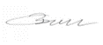
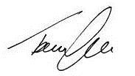
Tom Bull Jack Bull
Director Director, New Business
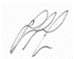
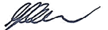

Clint Cassar Jonathan Glick
Director Delivery Manager, VIC

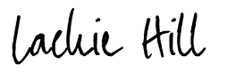


Jack Bull Lachie Hill
Director, New Business New Business Manager

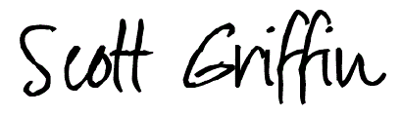

Scott Griffin
Director, NSW
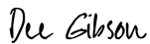

Dee Gibson
Chief Financial Officer
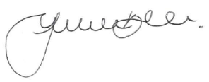

Jenilee Bell
People and Performance Manager

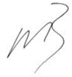

Matthew Barker Tom Bull
Director Director

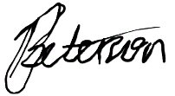


Jack Bull Bill Petersen
Director, New Business Architectural Design Lead
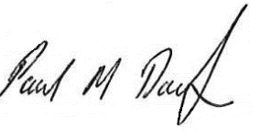
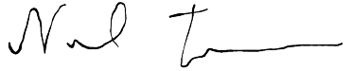

Paul Darby Neil Timms
Construction Manager Construction Manager

