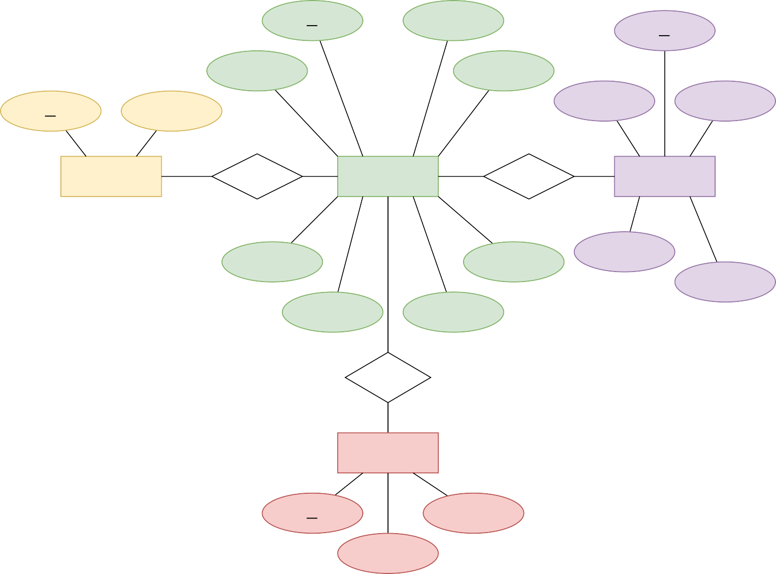

**id**

1

name 1

**id**

1

date

1

quantity 1

**id**

1

Name 1

date

1

product_id 1

CATEGORIES

**1 : N**

ASSIGN

PRODUCTS

**1 : N**

BUY

SALES

media_id

buy_price

price

qty

categorie_id

sale_price

**N : 1**

SUBMIT

MEDIA

**id**

file_type

file_name

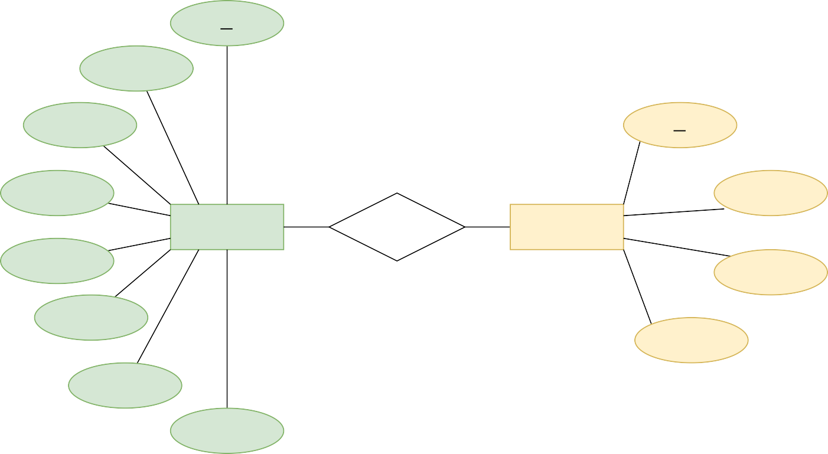

**id**

1

name 1

username

1

1

**id**

password 1

1 group_name

USERS

**N : 1**

ASSIGN

USER_GROUPS

user_level 1

group_level

image

1

group_status

status

last_login