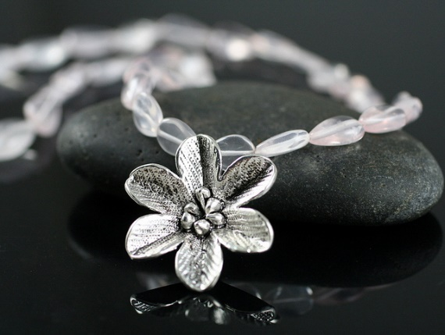

Copyright 2017

Purchase

Gallery

About Carolina

Carolina Francisca