# Hammerhead C++ Unit Test Framework GUI Help Index

Here is a screen shot of the current Hammerhead C++ Unit Test Framework GUI:

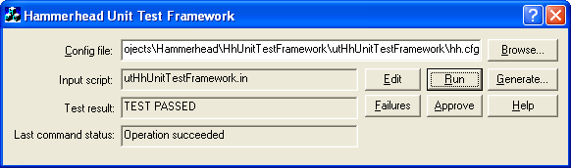

The Hammerhead Unit Test framework graphical User Interface provides a convenient platform from which to interactively run your unit tests.

To edit your unit test input script:
- Click the Edit button.

To run your unit test:
- Enter a path to your configuration file or browse to it via the Browse… button.
- Click the Run button.

To view a unit test failure:
- Enter a path to your configuration file or browse to it via the Browse… button.
- Click the Failures button.

To approve a unit test:
- Enter a path to your configuration file or browse to it via the Browse… button.
- Click the Approve button.

To generate a default configuration file:
- Click the Generate… button.
- Select a target folder.
- Click OK.

Thank you for your support.

Jon Marinello

HIDD_HHGUI_DIALOG

