Economic Incentives for Reducing Peak Power Utilization in Electric Vehicle Charging Stations

Jonathan Marty

Stanley Pietrowicz

Vencore Labs

Red Bank, NJ, USA

jmarty@vencorelabs.com

*Abstract*— This paper examines the economic utility of a method to reduce peak grid load from Personal Electric Vehicles by employing distributed battery storage at charging stations. We introduce a system to cache power at PEV charging stations using batteries to smooth charging station peak loads, replenishing batteries when station load is low, without relying on centralized control. We perform comprehensive large-scale simulations to show that its adoption reduces average daily peak power levels by between 14% and 24% for typical urban and suburban grids. We propose a method for discharging and charging batteries that is driven by economic incentives for charging station operators based on differentiated peak and nonpeak power prices. We find utility operators can influence charging station owners to invest in batteries by differentiating peak and nonpeak power prices, and achieve peak power reductions without increasing aggregate charging station energy costs.

*Index Terms*—Charging Stations, Personal Electric Vehicles, Differentiated Pricing, Power Demand, Microeconomics

# Introduction

The rate of adoption of Personal Electric Vehicles (PEVs) is increasing. In a 2016 report [1], OPEC increased its 2040 forecast of PEVs from 46 Million to 266 Million; the International Energy Agency (IEA) more than doubled its 2030 forecast [2], and ExxonMobil, BP, and New Energy Finance [3] increased forecasts by similar amounts. While this rapid adoption of PEVs brings the promise of reduced greenhouse gases [4], it also brings challenges in charging these vehicles from the US power grid during peak intervals. While it is expected that the majority of PEV charging will occur in homes during off-peak hours, the proliferation of electric vehicle charging stations suggest that significant charging will occur during peak power times [5], [6]. This contribution to load during peak power times will stress grid infrastructure and may necessitate costly increases in power generation, transmission, and distribution infrastructure.

In this paper, we introduce a system for caching power at PEV charging stations using batteries like those used in PEVs. The purpose of this distributed storage is to smooth charging station peak loads by using stored power when the charging station is heavily loaded, and replenishing batteries when station load is low. We propose a method for sizing batteries and a method for discharging and charging batteries that is driven by economic incentives in the form of differentiated peak and nonpeak power prices. In this system charging stations act autonomously, controlling the use of stored energy without relying on centralized control. We perform comprehensive large-scale simulations of this system and show that it is adoption reduces average daily peak power levels by between 14% and 24% for typical urban and suburban grids. We suggest an optimization that will drive differential pricing of power suppliers to appropriate levels to achieve these peak power reductions without increasing aggregate charging station energy costs.

Other work has been focused on the economics and incentives of PEV charging. For example [7] and [8] examine the behavior of differentiated pricing on incentivizing PEV owners to change charging behaviors, and [9] and [10] examine the dynamics of allowing PEV owners to act as both consumers and suppliers to the power grid. This work differs from prior related work in that it uses economic incentives to motivate infrastructure investment by PEV charging station operators to help alleviate grid capacity issues, rather than using economic incentives to influence the behavior of PEV owners.

The remainder of this paper is organized as follows. Section II proposes a basic stochastic model for charging station occupancy, section III introduces a method for using batteries to effectively cache power in PEV charging stations, section IV introduces an economic utility function for differentiated pricing, section V describes the simulation framework used, Section VI presents results, and Section VII summarizes conclusions and suggests future work.

# Charging Station Model

For the purpose of evaluating this system, we adopt a simple Markov finite state model for charging station occupancy. Our model is consistent with models presented in [11] and [12], however we make the simplifying assumption that PEVs will not queue when all charging bays are occupied. Note that while we believe that, in general, PEVs will not queue at charging stations, we also believe this model is robust to different assumptions in charging station occupancy model, assuming the model has periods of high usage and periods of low usage.

The charging station occupancy is modeled as a Markov birth-death process (Figure 1) where, at discrete time intervals, the occupancy can increase by one with probability λ (if there is an empty charging bay), decrease by one with probability µ (if at least one car is charging), or remain constant.

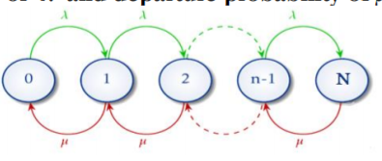

Figure 1 - Birth Death Process

The use of charging stations will vary throughout the day. We use the arrival probability as a function of time of day shown in Figure 2. This pattern with peaks in morning and afternoon occupancy is consistent with various studies including [5] and [6].

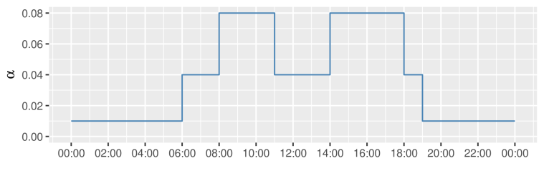

Figure 2 - Car Arrival Probability by Time of Day

Given the above time-of-day profile, we calculate arrival probability *λt* as:

$λ_{t}=\left\{\begin{aligned}1-{\left(1-α_{t}\right)}^{N},n<N \\ 0 ,n=N\end{aligned}\right.$ (1)

Where *N* is the number of bays in the charging station, *n* is the current number of occupied bays, and *αt*is the per-minute probability that a PEV will arrive at a charging bay at time of day *t*. Thus *(1- αt)N* is the probability no cars arrive at an *N* bay charging station at time *t*. We set *λt = 0* when the charging station is full (*n=N*) to reflect our assumption that PEV owners will not wait for an opening at a fully occupied charging station.

We model the departure probability µ as:

$$μ=1-{\left(\frac{γ-1}{γ}\right)}^{n} (2)$$

Where γ is the average charging time in minutes, and ((γ-1)/ γ)n is the per-minute probability that none of the *n* charging PEVs depart.

# Energy Storage System

The goal of our charging station storage system is to smooth the stations power draw from the grid by using stored power from batteries to reduce grid power load when the charging station is under heavy load and replenishing batteries when the charging station is experiencing low usage.

While battery technology is continually improving, batteries remain expensive, and their capacity limited. As such they must be used effectively to be economically feasible. To properly harness the battery’s potential to reduce charging station peak power requirements, we introduce the concept of charge and discharge levels as follows. When a charging station is drawing more power than the discharge level (high usage), batteries discharge to provide power. When the charging station is drawing less power than the charge level (low usage), power from the grid is used to replenish batteries. More concisely:

$P_{batt,t}=\left\{\begin{matrix}P_{cs,t}-L_{D}, & P_{cs,t}>L_{D},E_{batt,t}>0 \\ 0, & L_{D}>P_{cs,t}>L_{C} \\ P_{cs,t}-L_{C}, & P_{cs,t}<L_{C},E_{batt,t}<E_{batt,max}\end{matrix}\right.$ (3)

Where Pbatt,t is the battery output power at time t, Pcs,t is the aggregate charging station power usage at time t, Ebatt,t is the battery energy level at time t, Ebatt,max is the battery energy capacity, and LC and LD are the charge and discharge levels. Negative output indicates that the battery is charging, positive output indicates that the battery is discharging.

Figure 3 demonstrates simulated energy flows over a 1-week period in a typical 16-bay charging station. The upper horizontal line is the discharge level, i.e., if the charging station power load exceeds this line we consider the charging station to be in high usage mode and the batteries discharge to supplement power from the grid. The lower horizontal line is the charge level. If the charging station load is below this line we consider the station to be in low usage mode and the batteries charge from grid power.

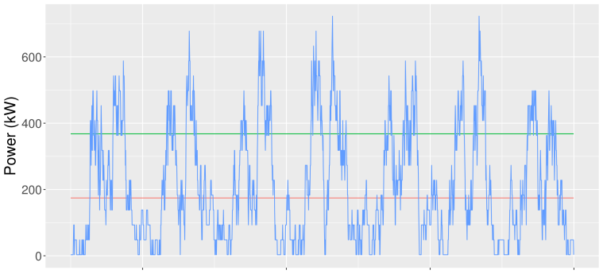

Figure 3 - Charging Station Energy Draw

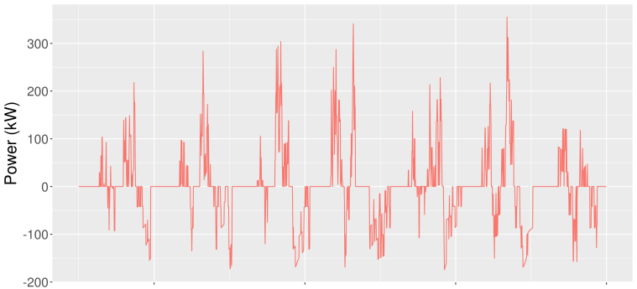

Figure 4 - Batter Power Supplied

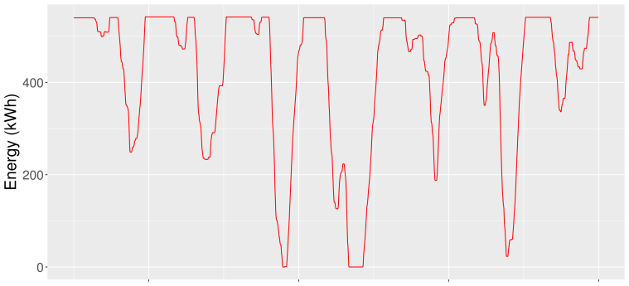

Figure 5 - Battery Energy Level

Figure 4 represents the output of the battery, where negative output indicates that the battery is charging. This shows the battery effectively moving grid power usage from times of high load to times of low load.

Figure 5 shows the energy remaining in the batteries. Setting the discharge level too low will cause the batteries to fully discharge while demand is still low, leaving them unavailable during peak loads, while setting the level too high will make the battery ineffective in reducing peak loads. This example represents a good, but not necessarily optimal, discharge level and battery size; power is available during most times but the battery is not over specified such that it never runs out of power.

# Differentiated Price Optimization

While Section III demonstrates the use of batteries to reduce peak power, energy storage is expensive and charging station owners must be incentivized to make an investment in batteries. We propose incentivizing charging station operators to invest in load-shifting battery infrastructure by differentiating peak and nonpeak power prices.

Figure 6 shows the utility table for a sample charging station. The utility function is driven by the size of the battery (in kWh) and the discharge level (charging station load at which the battery begins to supply power, in % of max charging station load). This example assumes a price of $150 per kWh of battery capacity, a battery lifetime of 5 years, an interest rate of 5% on capital, a $0.60 per kWh peak power price, and a $0.09 per kWh nonpeak price. We evaluated battery sizes up to 50 kWh per charging bay. 50 kWh is roughly the size of a battery in a PEV, which allows access to commodity battery sources while minimizing infrastructure and space considerations at charging stations.

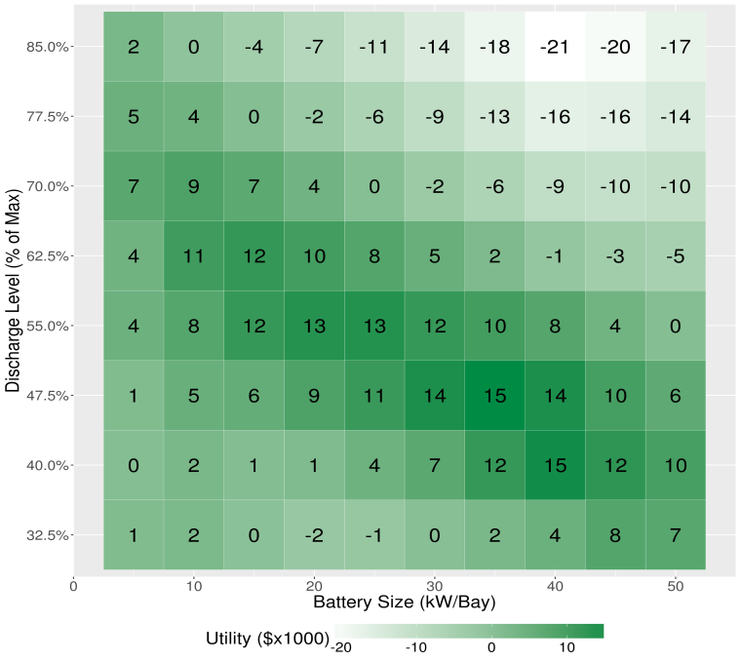

Figure 6 - Charging Station Cost Benefit

Large batteries are more effective in reducing peak charging station grid load by actively supplementing more peak power (lower discharge level). However large battery costs are a significant capital investment, limiting overall profitability for the charging station operator. This effect is shown in Figure 6, which has a downward sloping band of profitability from left to right, where battery costs are offset by the benefits they provide.

Charging station owners will seek to maximize profit by choosing battery size Bcs and discharge level Dcs in the following way:

$\begin{aligned}minimize \\ (B_{cs},D_{cs})\end{aligned}\left\{\begin{aligned}P_{p,cs}\left(B_{cs},D_{cs}\right)×C_{p}+ \\ P_{np,cs}\left(B_{cs},D_{cs}\right)×C_{np}+B_{cs}×C_{battery}\end{aligned}\right\} (4)$

Where Cp is the cost ($/kWh) of power at peak times, Cnp is the cost ($/kWh) of power at nonpeak times, and Cbattery is the cost ($/kWh) of battery storage, Pp,cs is the charging station power consumed (kWh) during peak time, Pnp,cs is the charging station power consumed (kWh) during nonpeak times. Based on the difference between peak and nonpeak prices, charging stations will choose to invest in batteries of different sizes.

Power grid operators want to reduce the aggregate time spent at peak power. Batteries redistribute power demands, limiting the amount of time that the grid spends at peak power. Accordingly, power grid operators will want to incentivize charging stations to adopt batteries to affect a reduction in the total time the grid spends at peak power. Power grid operators can influence charging station owners to invest in energy storage by differentiating peak and nonpeak prices. The following equation describes the utility function of the grid operator:

$$U_{grid}=\begin{aligned}minimize \\ (C_{p},C_{np})\end{aligned} \left\{ T_{p}^{*}(C_{p},C_{np}) \right\} (5)$$

$$Subject to: P_{p}^{Total}C_{p}+ P_{np}^{Total}C_{np} ={(P}_{p}^{Total}+ P_{np}^{Total})C_{prior}$$

Where $T_{p}^{*}$ is the time spent in peak episodes as a function of differentiated power cost, $P_{p}^{Total} and P_{np}^{Total}$ are the aggregate peak and nonpeak power supplied by the grid (kWh), and *Cprior* is the price ($/kWh) of power prior to implementing differentiated pricing. More directly, power utilities are regulated such that their profits are a return on infrastructure deployed and not power sold. The goal of this work is to allow for the adoption of large numbers of electric vehicles without infrastructure changes so a constraint is added that the aggregate weighted price grid operators charge is unchanged.

# Simulation Design

Simulations were performed using Gridlab-D from the Pacific Northwest National Laboratory. Gridlab-D was enhanced to support the charging station model detailed in Section II and the energy storage system model detailed in Section III.

The charging station model was implemented as a new type of Gridlab-D *loadshape* object. This *loadshape* object consumed a Gridlab-D *schedule* object containing car arrival probabilities and could be configured with number of charging bays, mean charging time, and charging power per bay. The *loadshape* objects were used to drive a Gridlab-D three phase load object that represented the aggregate power draw of the charging station. The battery implementation in Gridlab-D has a POWER_DRIVEN mode that had many of the features needed, though we modified the charge/discharge logic and fixed several subtle bugs. The Feeder_Generator Matlab script was modified to identify locations for charging station placement and sizing, and add necessary infrastructure components to represent charging stations at those locations.

Simulations were run on grid models provided by the US Department of Energy [13]. Sample grids were chosen to span different climates, rurality, and population density. Each grid includes a feeder network and associated households, commercial buildings, and industrial loads.

|  |  |  |  |  |
| --- | --- | --- | --- | --- |
| Grid Name | City | Temp | Rurality | % Power for PEV Charging |
| R1_1247_4 | San Francisco | Moderate | Suburban | 13% |
| R2_1247_1 | Chicago | Mixed | Urban | 20% |
| R2_2500_1 | Chicago | Mixed | Suburban | 63% |
| R3_1247_1 | Phoenix | Hot | Urban | 19% |
| R5_1247_1 | Miami | Hot | Suburban | 16% |
| R5_1247_2 | Miami | Hot | Urban | 24% |

Table 1 - Test Power Grids

Simulations were run for a full year and used Typical Meteorological Year 3 (TMY3) [14] weather data to drive heating and cooling power cycles. This was critical to get a realistic approximation of peak power loads.

Charging station locations were selected to satisfy two conditions. A location must have 3-phase power and at least 12 commercial buildings, where a commercial building is roughly defined as 10,000 ft2 of commercial or industrial space. Each charging station was allocated a charging bay for every 3 commercial buildings it supports thus the minimum charging station size was 4 bays.

For our simulations we chose a charging station bay power of 45kW and a charging time of 30 minutes based on a review of current EV charger standards. The most common standard is the SAE J1772 three phase AC charger with power capped at 22kW, though there are competing fast charging DC Standards such as Tesla Supercharger and CCS that offer more rapid charging, with the Tesla Supercharger peaking at 120kW [2]. CHAdeMO, a European consortium with a charging standard of their own, estimates diminishing returns on charger cost for units past 45kW [15]. At 45kW power output, 30 minutes of charging will power a Tesla model S and Nissan Leaf (the two bestselling PEVs) for 67 miles and 80 miles respectively.

Simulations were run with different battery sizes and discharge levels. For pairs of peak and nonpeak energy prices, each charging station chose the battery configuration that was best able to increase profitability. Based on the individual charging station battery configuration choices, the power with and without batteries was evaluated and peak episodes were analyzed. Peak prices were varied from $0.10/kWh to $0.60/kWh. For each peak price a corresponding nonpeak price was chosen such that the average price for all power consumed was $0.10/kWh.Peak power is defined as the top 5% of power loads between 9am and 6pm over the entire simulated year.

# Results

Figure 7 shows the mean percent reduction of daily peak power demand and Figure 8 shows the percent reduction of maximum peak power for each energy model over the full year.

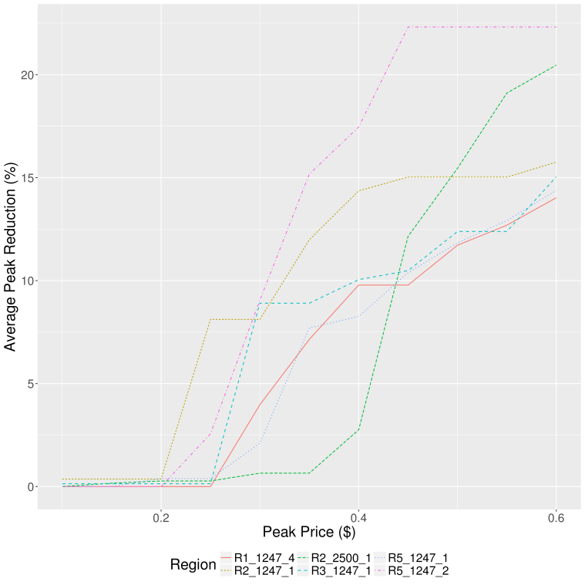

Figure 7 – Average Peak Power Reduction

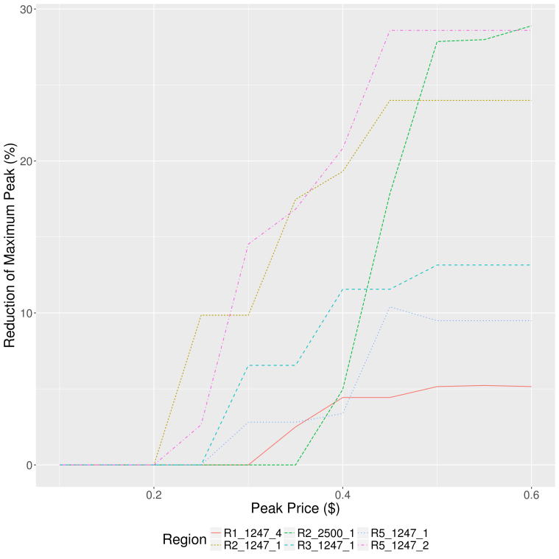

Figure 8 – Reduction of Maximum Peak

Power models tested achieved a reduction in average peak power loads between 14% and 25%, and maximum peak reductions of 6% to 29%. As predicted, the benefits increased as the spread between peak and nonpeak prices increased.

# Conclusion

This simple model demonstrates the power of economic incentives in the form of differentiated pricing to influence the infrastructure in PEV charging stations to help reduce peak grid power load events. Based on this model, we conclude that distributed battery storage at charging stations can be an effective means to reduce peak power by redistributing power load. Due to battery price, judicious battery sizing and operation is needed to make the system most profitable. This model also shows that power grid operators can influence charging station owners to invest in batteries by differentiating peak and nonpeak power prices, and the results of these incentives can significantly reduce peak power demand.

As the PEV charging station market evolves and matures, the addition of renewable energy sources will play a major role in reshaping traditional load curves. Future work on this system will include a comprehensive evaluation of the impacts of solar and wind power.

##### References

1. World Oil Outlook, Organization of the Oil Exporting Countries (OPEC), Vienna, Austria, Oct 2016 [Online]. Available: [http://www.opec.org/opec_web/static_files_project/media/downloads/publications/WOO%202016.pdf](http://www.opec.org/opec_web/static_files_project/media/downloads/publications/WOO%25202016.pdf)
2. Global EV Outlook 2017. Organization for Economic Co-operation and Development/International Energy Agency, Paris, France, 2017 [Online]. Available: <https://www.iea.org/media/topics/transport/Global_EV_Outlook_2017_Leaflet.pdf>
3. N. Albanese and C McKerracher, “Comparison of long-term EV adoption forecasts," Bloomberg New Energy Finance, New York, NY, Tech. Rep., Jul. 2017.
4. T. R. Hawkins, B. Singh, G. Majeau-Bettez, and A.H. Strømman, “Comparative Environmental Life Cycle Assessment of Conventional and Electric Vehicles,” *Journal of Industrial Ecology*, vol. 17, pp. 53–64, Jan 2013.
5. M.H. Amini, A. Kargarian, O. Karabasoglu, “ARIMA-based decoupled time series forecasting of electric vehicle charging demand for stochastic power system operation,” *Electric Power Systems Research*, vol. 140, pp 378-390, Nov. 2016.
6. A.R. Gopal, C. Sheppard, R. Waraich, A. Campbell, and A. Pozdnukov, “Modeling plug-in electric vehicle charging demand with BEAM, the framework for behavior energy autonomy mobility,” Lawrence Berkeley National Laboratory, Berkeley, CA., May 2017, [Online]. Available: <https://eta.lbl.gov/publications/modeling-plug-electric-vehicle>
7. J. de Hoog, T. Alpcan, M. Brazil, D. A. Thomas and I. Mareels, "A Market Mechanism for Electric Vehicle Charging Under Network Constraints," *IEEE Transactions on Smart Grid*, vol. 7, no. 2, pp. 827-836, March 2016.
8. S. I. Vagropoulos, G. A. Balaskas and A. G. Bakirtzis, "An Investigation of Plug-In Electric Vehicle Charging Impact on Power Systems Scheduling and Energy Costs," *IEEE Transactions on Power Systems*, vol. 32, no. 3, pp. 1902-1912, May 2017.
9. E. L. Karfopoulos and N. D. Hatziargyriou, "Distributed Coordination of Electric Vehicles Providing V2G Services," *IEEE Transactions on Power Systems*, vol. 31, no. 1, pp. 329-338, Jan. 2016.
10. J. J. Q. Yu, Junhao Lin, A. Y. S. Lam and V. O. K. Li, "Maximizing aggregator profit through energy trading by coordinated electric vehicle charging," *2016 IEEE International Conference on Smart Grid Communications*, Sydney, NSW, pp. 497-502.
11. S. Kumar and R. Y. Udaykumar, "Markov chain based stochastic model of electric vehicle parking lot occupancy in vehicle-to-grid," *2015 IEEE International Conference on Computational Intelligence and Computing Research (ICCIC),* Madurai, pp. 1-4.
12. C. Farkas, L. Prikler, “Stochastic Modeling of EV Charging at Charging Stations,” 2012 International Conference on Renewable Energies and Power Quality, Santiago de Compostela, Spain, pp. 1046-1051
13. K. Schneider, C. Yousu, D. Chassin, R. Pratt, D. Engel, and S. Thompson, “Modern Grid Initiative Distribution Taxonomy Final Report”. United States Departement of Energy, Nov. 2008 [Online]. Available: <http://www.osti.gov/scitech/servlets/purl/1040684>.
14. S. Wilcox, W. Marion, Typical Meteorological Year 3 (TMY3) Data Sets, Technical Report NREL/TP-581-43156, National Renewable Energy Laboratory, Golden, Colorado, Apr. 2008
15. CHAdeMO Association, “Characteristics of CHAdeMO Quick Charging System”, Paris, France, [Online]. Available: http://www.chademo.com/pdf/characteristics.pdf