PAR-Q+

The Physical Activity Readiness Questionnaire for Everyone
The health benefits of regular physical activity are clear; more people should engage in physical activity every day of the week. Participating in physical activity is very safe for MOST people. This questionnaire will tell you whether it is necessary for you to seek further advice from your doctor OR a qualified exercise professional before becoming more physically active.

GENERAL HEALTH QUESTIONS
Please read the 7 questions below carefully and answer each one honestly: check YES or NO. | YES | NO
1) Has your doctor ever said that you have a heart condition OR high blood pressure ?
2) Do you feel pain in your chest at rest, during your daily activities of living, OR when you do physical activity?
3) Do you lose balance because of dizziness OR have you lost consciousness in the last 12 months?
Please answer NO if your dizziness was associated with over-breathing (including during vigorous exercise).
4) Have you ever been diagnosed with another chronic medical condition (other than heart disease or high blood pressure)? PLEASE LIST CONDITION(S) HERE:
5) Are you currently taking prescribed medications for a chronic medical condition?
PLEASE LIST CONDITION(S) AND MEDICATIONS HERE:
6) Do you currently have (or have had within the past 12 months) a bone, joint, or soft tissue
(muscle, ligament, or tendon) problem that could be made worse by becoming more physically active? Please answer NO if you had a problem in the past, but it does not limit your current ability to be physically active. PLEASE LIST CONDITION(S) HERE:
7) Has your doctor ever said that you should only do medically supervised physical activity?
If you answered NO to all of the questions above, you are cleared for physical activity.
Please sign the PARTICIPANT DECLARATION. You do not need to complete Pages 2 and 3.
Start becoming much more physically active – start slowly and build up gradually.
Follow Global Physical Activity Guidelines for your age (https://www.who.int/publications/i/item/9789240015128).
You may take part in a health and fitness appraisal.
If you are over the age of 45 yr and NOT accustomed to regular vigorous to maximal effort exercise, consult a qualified exercise professional before engaging in this intensity of exercise.
If you have any further questions, contact a qualified exercise professional.
PARTICIPANT DECLARATION
If you are less than the legal age required for consent or require the assent of a care provider, your parent, guardian or care provider must also sign this form.
I, the undersigned, have read, understood to my full satisfaction and completed this questionnaire. I acknowledge that this physical activity clearance is valid for a maximum of 12 months from the date it is completed and becomes invalid if my condition changes. I also acknowledge that the community/fitness center may retain a copy of this form for its records. In these instances, it will maintain the confidentiality of the same, complying with applicable law.
NAME ____Jon Mishael R Undug________________________________________________ DATE _______9/10/26___________
SIGNATURE ________________________________________________ WITNESS _____________________________________

SIGNATURE OF PARENT/GUARDIAN/CARE PROVIDER ____________________________________________________________ If you answered YES to one or more of the questions above, COMPLETE PAGES 2 AND 3.
Delay becoming more active if:
You are currently experiencing a temporary illness, such as a cold or fever. It is best to wait until you feel better.
You are pregnant. In this case, talk with your health care practitioner, physician, qualified exercise professional, and/or complete the ePARmed-X+ at www.eparmedx.com before becoming more physically active.
Your health changes. Answer the questions on Pages 2 and 3 of this document and/or talk to your health care practitioner, physician, or qualified exercise professional before proceeding with any physical activity program.
Copyright © 2024 PAR-Q+ Collaboration 1 / 4
01-11-2023

FOLLOW-UP QUESTIONS ABOUT YOUR MEDICAL CONDITION(S)
- Do you have Arthritis, Osteoporosis, or Back Problems?
If the above condition(s) is/are present, answer questions 1a-1c If NO go to question 2
1a. Do you have difficulty controlling your condition with medications or other physician-prescribed therapies? YES NO
(Answer NO if you are not currently taking medications or other treatments)
1b. Do you have joint problems causing pain, a recent fracture or fracture caused by osteoporosis or cancer,
displaced vertebra (e.g., spondylolisthesis), and/or spondylolysis/pars defect (a crack in the bony ring on the YES NO back of the spinal column)?
1c. Have you had steroid injections or taken steroid tablets regularly for more than 3 months? YES NO
- Do you currently have Cancer of any kind?
If the above condition(s) is/are present, answer questions 2a-2b If NO go to question 3
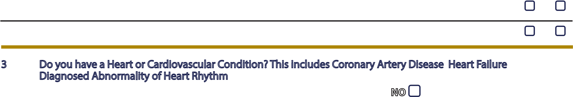
2a. Does your cancer diagnosis include any of the following types: lung/bronchogenic, multiple myeloma (cancer of YES NO plasma cells), head, and/or neck?
2b. Are you currently receiving cancer therapy (such as chemotheraphy or radiotherapy)? YES NO
- Do you have a Heart or Cardiovascular Condition? This includes Coronary Artery Disease, Heart Failure,
Diagnosed Abnormality of Heart Rhythm
If the above condition(s) is/are present, answer questions 3a-3d If NO go to question 4
3a. Do you have difficulty controlling your condition with medications or other physician-prescribed therapies? YES NO (Answer NO if you are not currently taking medications or other treatments)
3b. Do you have an irregular heart beat that requires medical management? YES NO
(e.g., atrial fibrillation, premature ventricular contraction)
3c. Do you have chronic heart failure? YES NO
3 d. activity in the last 2 months?Do you have diagnosed coronary artery (cardiovascular) disease and have not participated in regular physical _{YES} NO
- Do you currently have High Blood Pressure?
If the above condition(s) is/are present, answer questions 4a-4b If NO go to question 5
4a. Do you have difficulty controlling your condition with medications or other physician-prescribed therapies? YES NO (Answer NO if you are not currently taking medications or other treatments)
4b. Do you have a resting blood pressure equal to or greater than 160/90 mmHg with or without medication?YES if you do not know your resting blood pressure) _{YES} NO
(Answer
- Do you have any Metabolic Conditions? This includes Type 1 Diabetes, Type 2 Diabetes, Pre-Diabetes If the above condition(s) is/are present, answer questions 5a-5e If NO go to question 6
5a. Do you often have difficulty controlling your blood sugar levels with foods, medications, or other physician- YES NO prescribed therapies?
5b. Do you often suffer from signs and symptoms of low blood sugar (hypoglycemia) following exercise and/or
during activities of daily living? Signs of hypoglycemia may include shakiness, nervousness, unusual irritability, YES NO abnormal sweating, dizziness or light-headedness, mental confusion, difficulty speaking, weakness, or sleepiness.
5c. Do you have any signs or symptoms of diabetes complications such as heart or vascular disease and/or YES NO complications affecting your eyes, kidneys, OR the sensation in your toes and feet?
5d. Do you have other metabolic conditions (such as current pregnancy-related diabetes, chronic kidney disease, or YES NO liver problems)?
5e. Are you planning to engage in what for you is unusually high (or vigorous) intensity exercise in the near future? YES NO
2 / 4
- Do you have any Mental Health Problems or Learning Difficulties? This includes Alzheimer’s, Dementia,
Depression, Anxiety Disorder, Eating Disorder, Psychotic Disorder, Intellectual Disability, Down Syndrome
If the above condition(s) is/are present, answer questions 6a-6b If NO go to question 7
6a. Do you have difficulty controlling your condition with medications or other physician-prescribed therapies? YES NO (Answer NO if you are not currently taking medications or other treatments)
6b. Do you have Down Syndrome AND back problems affecting nerves or muscles? YES NO
- Do you have a Respiratory Disease? This includes Chronic Obstructive Pulmonary Disease, Asthma,
Pulmonary High Blood Pressure
If the above condition(s) is/are present, answer questions 7a-7d If NO go to question 8
7a. Do you have difficulty controlling your condition with medications or other physician-prescribed therapies? NO if you are not currently taking medications or other treatments) _{YES} NO
(Answer
7b. Has your doctor ever said your blood oxygen level is low at rest or during exercise and/or that you require _{YES} NO supplemental oxygen therapy?
7c. If asthmatic, do you currently have symptoms of chest tightness, wheezing, laboured breathing, consistent cough _{YES} NO (more than 2 days/week), or have you used your rescue medication more than twice in the last week?
7d. Has your doctor ever said you have high blood pressure in the blood vessels of your lungs? YES NO
- Do you have a Spinal Cord Injury? This includes Tetraplegia and Paraplegia
If the above condition(s) is/are present, answer questions 8a-8c If NO go to question 9
8a. Do you have difficulty controlling your condition with medications or other physician-prescribed therapies? YES NO (Answer NO if you are not currently taking medications or other treatments)
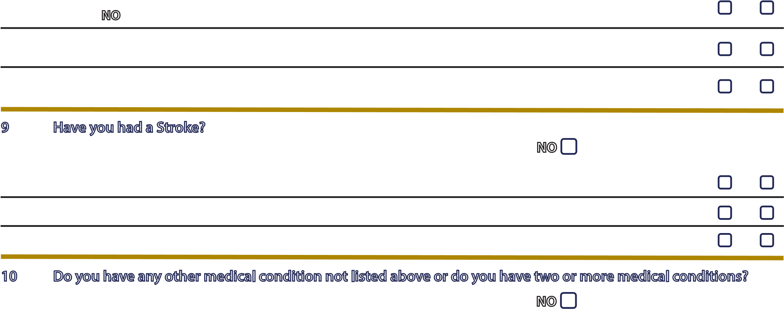
8 b. Do you commonly exhibit low resting blood pressure significant enough to cause dizziness, light-headedness, and/or fainting? _{YES} NO
8c. Has your physician indicated that you exhibit sudden bouts of high blood pressure (known as Autonomic _{YES} NO Dysreflexia)?
- Have you had a Stroke? This includes Transient Ischemic Attack (TIA) or Cerebrovascular Event
If the above condition(s) is/are present, answer questions 9a-9c If NO go to question 10
9a. Do you have difficulty controlling your condition with medications or other physician-prescribed therapies?
(Answer NO if you are not currently taking medications or other treatments) YES NO
9b. Do you have any impairment in walking or mobility? YES NO
9c. Have you experienced a stroke or impairment in nerves or muscles in the past 6 months? YES NO
- Do you have any other medical condition not listed above or do you have two or more medical conditions?
If you have other medical conditions, answer questions 10a-10c If NO read the Page 4 recommendations
10a. Have you experienced a blackout, fainted, or lost consciousness as a result of a head injury within the last 12 YES NO months OR have you had a diagnosed concussion within the last 12 months?
10b. Do you have a medical condition that is not listed (such as epilepsy, neurological conditions, kidney problems)? YES NO
10c. Do you currently live with two or more medical conditions? YES NO

PLEASE LIST YOUR MEDICAL CONDITION(S) AND ANY RELATED MEDICATIONS HER E:
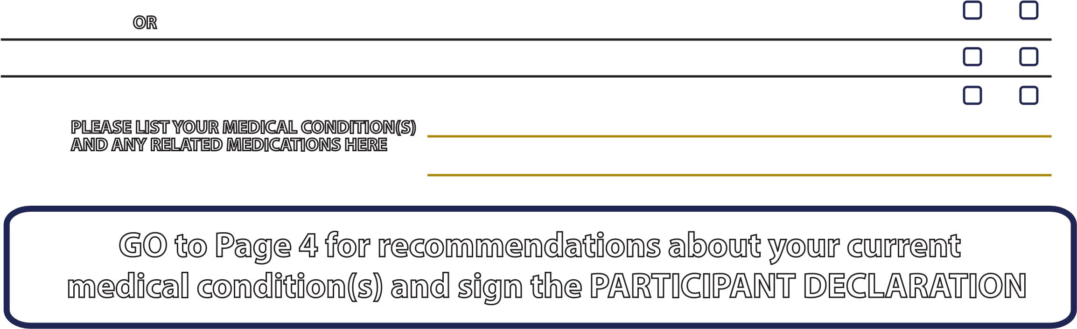
GO to Page 4 for recommendations about your current medical condition(s) and sign the PARTICIPANT DECLARATION.
3/ 4
If you answered NO to all of the FOLLOW-UP questions (pgs. 2-3) about your medical condition, you are ready to become more physically active - sign the PARTICIPANT DECLARATION below:
It is advised that you consult a qualified exercise professional to help you develop a safe and effective physical activity plan to meet your health needs.
You are encouraged to start slowly and build up gradually - 20 to 60 minutes of low to moderate intensity exercise, 3-5 days per week including aerobic and muscle strengthening exercises.
As you progress, you should aim to accumulate 150 minutes or more of moderate intensity physical activity per week. If you are over the age of 45 yr and NOT accustomed to regular vigorous to maximal effort exercise, consult a qualified exercise professional before engaging in this intensity of exercise.
If you answered YES to one or more of the follow-up questions about your medical condition:
You should seek further information before becoming more physically active or engaging in a fitness appraisal. You should complete the specially designed online screening and exercise recommendations program - the ePARmed-X+ at www.eparmedx.com and/or visit a qualified exercise professional to work through the ePARmed-X+ and for further information.
Delay becoming more active if:
You are currently experiencing a temporary illness, such as a cold or fever. It is best to wait until you feel better.
You are pregnant. In this case, talk to your health care practitioner, physician, qualified exercise professional, and/or complete the ePARmed-X+ at www.eparmedx.com before becoming more physically active.
Your health changes. Talk to your health care practitioner, physician, or qualified exercise professional before continuing with any physical activity program.
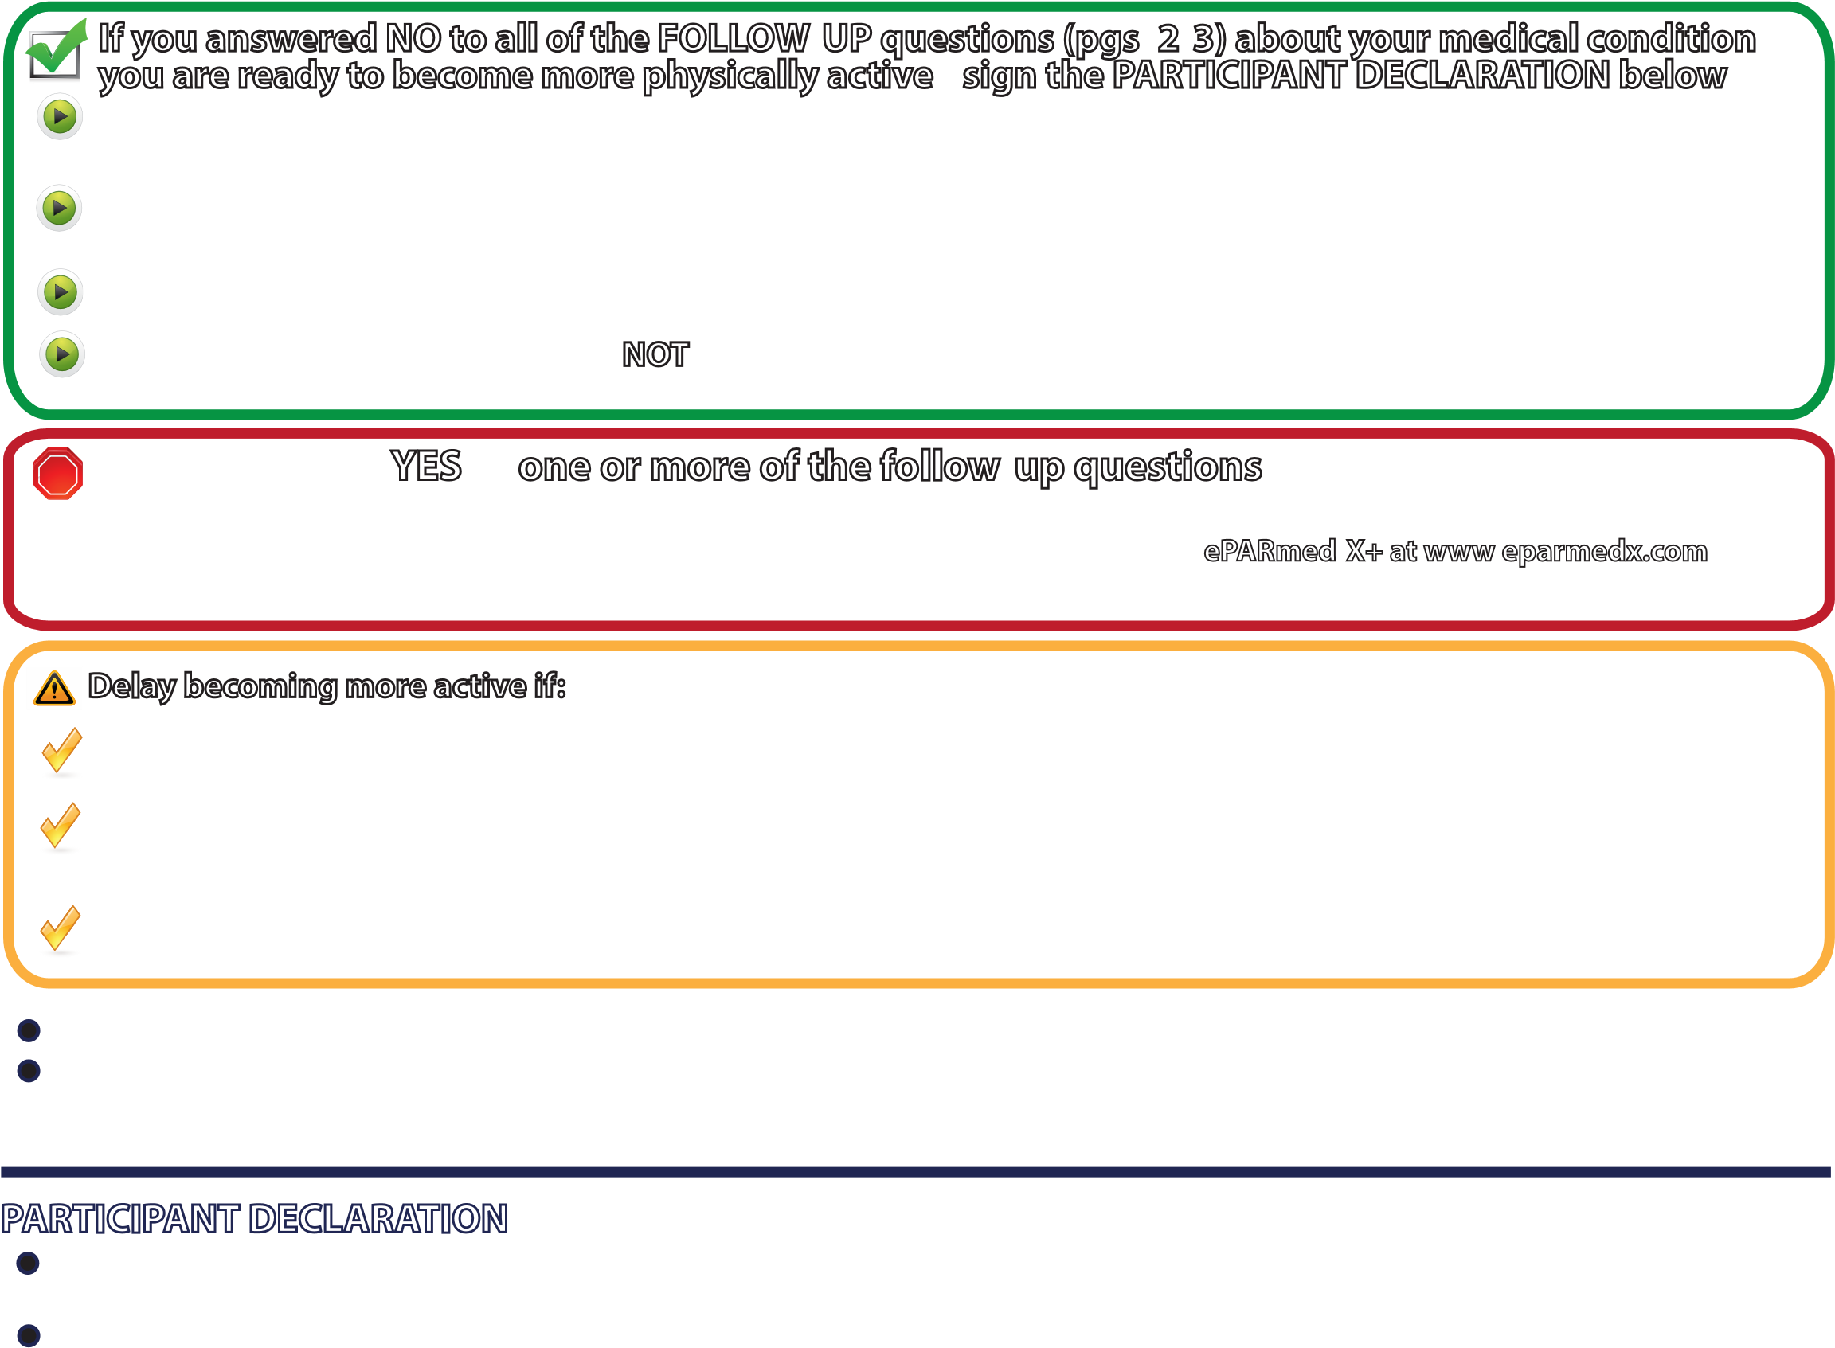
You are encouraged to photocopy the PAR-Q+. You must use the entire questionnaire and NO changes are permitted. The authors, the PAR-Q+ Collaboration, partner organizations, and their agents assume no liability for persons who undertake physical activity and/or make use of the PAR-Q+ or ePARmed-X+. If in doubt after completing the questionnaire, consult your doctor prior to physical activity.

PARTICIPANT DECLARATION
All persons who have completed the PAR-Q+ please read and sign the declaration below.
If you are less than the legal age required for consent or require the assent of a care provider, your parent, guardian or care provider must also sign this form.
I, the undersigned, have read, understood to my full satisfaction and completed this questionnaire. I acknowledge that this physical activity clearance is valid for a maximum of 12 months from the date it is completed and becomes
invalid if my condition changes. I also acknowledge that the community/fitness center may retain a copy of this
form for records. In these instances, it will maintain the confidentiality of the same, complying with applicable law.
NAME _Jon Mishael R Undug___________________________________________________ DATE _9/10/26__________
SIGNATURE ________________________________________________ WITNESS _____Myra Rajel___________________
SIGNATURE OF PARENT/GUARDIAN/CARE PROVIDER ____________________________________________________________________
For more information, please contact The PAR-Q+ was created using the evidence-based AGREE process (1) by the PAR-Q+
www.eparmedx.com Collaboration chaired by Dr. Darren E. R. Warburton with Dr. Norman Gledhill, Dr. Veronica
Email: eparmedx@gmail.com Jamnik, and Dr. Donald C. McKenzie (2). Production of this document has been made possible
CWarburton DER, Jamnik VK, Bredin SSD, and Gledhill N on behalf of the PAR-Q+ Collaboration.itation for PAR-Q+ through financial contributions from the Public Health Agency of Canada and the BC Ministry
Readiness Medical Examination (ePARmed-X+). Health & Fitness Journal of Canada 4(2):3-23, 2011.The Physical Activity Readiness Questionnaire for Everyone (PAR-Q+) and Electronic Physical Activity of Health Services. The views expressed herein do not necessarily represent the views of the
Key References Public Health Agency of Canada or the BC Ministry of Health Services.
- Jamnik VK, Warburton DER, Makarski J, McKenzie DC, Shephard RJ, Stone J, and Gledhill N. Enhancing the effectiveness of clearance for physical activity participation; background and overall process. APNM 36(S1):S3-S13, 2011.
- Warburton DER, Gledhill N, Jamnik VK, Bredin SSD, McKenzie DC, Stone J, Charlesworth S, and Shephard RJ. Evidence-based risk assessment and recommendations for physical activity clearance; Consensus Document. APNM36(S1):S266-s298, 2011.
- Chisholm DM, Collis ML, Kulak LL, Davenport W, and Gruber N. Physical activity readiness. British Columbia Medical Journal. 1975;17:375-378.
- Thomas S, Reading J, and Shephard RJ. Revision of the Physical Activity Readiness Questionnaire (PAR-Q). Canadian Journal of Sport Science 1992;17:4 338-345.
4/ 4

