Red Hat JBoss Fuse Proof of Technology
Lab Exercises

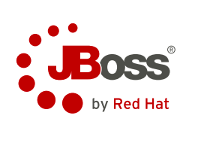

Contents
Lab 1 Installing Fuse 4
1.1 Environment and downloads 4
1.2 Installing the server 5
1.3 Installing Fuse IDE 6
1.4 Summary 8
Lab 2 Creating Camel Routes 9
2.1 Create a Fuse project 9
Lab 3 Transforming Data 11
3.1 Supporting section [Heading 2 (Alt+2)] 11
List Bullet 2 (Alt+C) 11
List Bullet 2 (Alt+C) 11
Lab 4 Using Beans 12
Lab 5 Error Handling 13
Lab 6 Testing your Routes 14
Lab 7 Introduction to Fuse Fabric 15
Appendix A. Troubleshooting 16
Appendix B. Notices 17
Appendix C. Trademarks and copyrights 19

Overview
The objective of this Proof of Technology is to give you hands-on experience with JBoss Fuse in order to better see how it could fit into your own environment and make your integration projects much easier.
By the end of this sessions you should have a good appreciation of the ability of Fuse to help you create integration routes between almost anything
This is not intended to provide training on the technology and we will not be covering the product in the same depth as our JBoss Fuse training courses.
Audience
This is aimed at Java Developers and Architects who have an understanding of Java, including Java development tools (i.e. Maven and Eclipse), the Spring Framework and Apache Maven.

Introduction
JBoss Fuse is an open source Enterprise Service Bus (ESB) with an elastic footprint that supports integration beyond the data center. The lack of license fees and the ability to deploy JBoss Fuse in several different configurations advances intelligent integration to all facets of your business – on premise or in the Cloud.
JBoss Fuse combines Apache Camel, Apache CXF, Apache ActiveMQ, Apache Karaf and Fuse Fabric in a single integrated distribution. Core messaging is provided by Apache ActiveMQ, services framework (SOAP, XML/HTTP, RESTful HTTP) is provided by Apache CXF and integration framework is provided by Apache Camel. Apache Karaf provides a lightweight OSGI-based runtime container. Fuse IDE is available along with JBDS to provide an easy-to-use integration development environment.

Icons
The following symbols appear in this document at places where additional guidance is available.
Icon | Purpose | Explanation
 | Important! | This symbol calls attention to a particular step or command. For example, it might alert you to type a command carefully because it is case sensitive.
 | Information | This symbol indicates information that might not be necessary to complete a step, but is helpful or good to know.
 | Trouble-shooting | This symbol indicates that you can fix a specific problem by completing the associated troubleshooting information.

Installing Fuse
In this lab you will be checking your environment and then installing the JBoss Fuse server and IDE. You will see how quickly and easily it can be setup.

Environment and downloads
Before installing JBoss Fuse you will need to have Java set up in your environment if it isn't already.
The minimum hardware requirements to install JBoss Fuse are:
- 100MB of free disk space
- 2GB of RAM

Install a Java Runtime
JBoss Fuse requires a JDK version 1.6 or 1.7 from either Oracle, IBM or OpenJDK.
- Download and install a suitable JDK
Important!
Do not install the Java runtime under a directory that includes whitespace. For example, the path, C:\Program Files\Java\jdk7, is not an acceptable path and will lead to unpredictable errors in JBoss Fuse at run time.
- Set your JAVA_HOME environment variable to be the Java install path
- Open a command prompt and run java -version to verify that it has installed properly.

Download the JBoss Fuse installation files
There are three different installations that you can choose from that contain different feature sets:
- Minimal – installs Apache Karaf, Apache Camel core, and select Apache Camel components
- Medium – installs Apache Karaf, Apache Camel, and Apache ActiveMQ
- Full – installs Apache Karaf, Apache Camel, Apache ActiveMQ, Apache CXF and the JBI components
For this workshop we will download and install the full version of JBoss Fuse.
- Browse to https://www.jboss.org/products/fuse
- Download Red Hat JBoss Fuse i.e. jboss-fuse-full-6.0.0.redhat-024.zip
- Download the Fuse IDE for your operating system

Installing the server
JBoss Fuse is installed by unpacking the archive file. This provides an easy way for a developer to get up and running.
- Using a suitable archive tool, unpack JBoss Fuse into a directory to which you have access.

Important!
Do not unpack the archive file into a directory that includes whitespace. For example, do not unpack into, C:\Documents and Settings\Greco Roman\Desktop\fuse.

- Add a remote control user
  - Open InstallDir/etc/users.properties in your favourite text editor
  - Locate the line #admin=admin,admin
  - Remove the leading # to uncomment the line
  - Save the changes
  - To access the container's JMX port and to use the ActiveMQ web console, you must specify the credentials for them. To do so, open InstallDir/etc/system.properties in your favourite text editor
  - Locate the following lines
# Authentication – must match an entry in users.properties with the admin privilege
#
#activemq.jmx.user=admin
#activemq.jmx.password=admin
  - Uncomment the user and password lines by removing the leading #

- Check JBoss Fuse has installed properly
  - Open a command prompt at InstallDir/bin
  - Run either fuse.bat or ./fuse depending on your OS
  - If all is well you should see the following

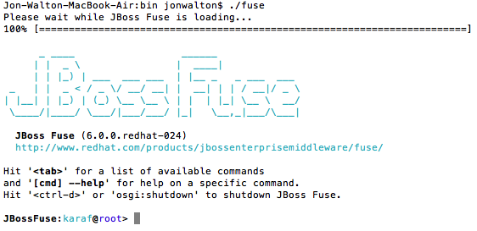

  - Type in help at the Fuse command prompt to see the large list of available commands
  - Type in shutdown and enter yes when asked to confirm

Installing Fuse IDE
The JBoss Fuse IDE is also a simple case of unpacking of a zip file and can be installed on the following x86 platforms:
- Red Hat Desktop
- MacOS 10.6 and later
- Windows 7 and later
It will use the same JDK that has been installed for the JBoss Fuse server we installed and tested earlier.
The minimum hardware requirements for installing the JBoss Fuse IDE are:
- 300MB of free disk space
- 2GB of RAM
- Using a suitable archive tool, unpack the JBoss Fuse IDE into a directory to which you will have full access
- Launch the JBoss Fuse IDE from within the installation directory. It should have the following icon:
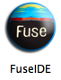

- Switch to a new workspace for this workshop
  - Select File > Switch workspace > Other...
  - Enter a new workspace path. For example:

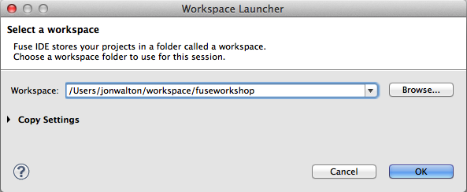

  - Click OK
  - You should be presented with the Welcome page
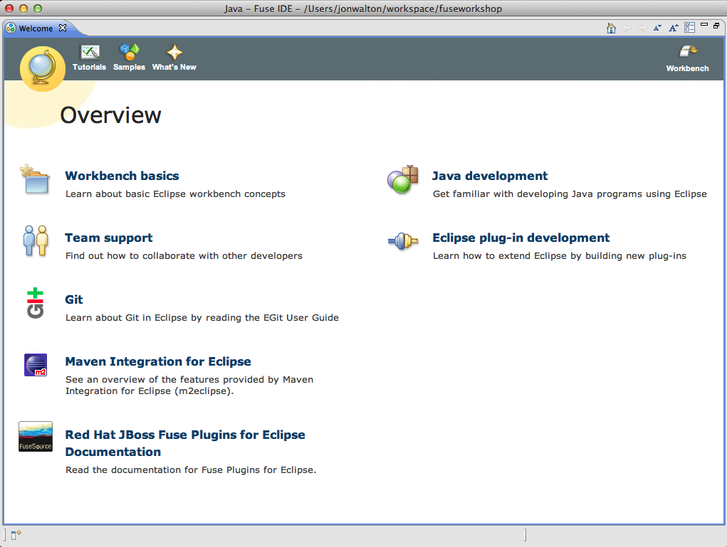

  - Close the Welcome page
  - Select Window > Open Perspective > Fuse Integration

Summary
In this lab we have downloaded and installed JBoss Fuse server and IDE and seen just how quick and easy it was to get up and running with a development environment!

Creating Camel Routes
In this lab you are going to create your first Camel route from scratch using the Fuse IDE. The basic steps you will cover are:
- Create a Fuse project
- Why they are going to do it
- What they will see when they are done

Create a Fuse project
For supporting sections, use this format. Replace the heading above with your own title, and then add an introduction. If you need to add steps, copy and paste the step list below. Press Alt+2 to add more supporting sections.

- Select File > New > Fuse project
- Leave the default project location settings and click Next
- Select the camel-archetype-spring

Project Archetype
Fuse projects are based on Apache Maven projects and therefore supports the use of project templates (archetypes) to speed up the creation of your project. The wizard only shows Camel archetypes.
- Enter com.redhat in the Group Id field
- Leave camel-spring in the Artifact Id field
- Leave 1.0.0-SNAPSHOT in the Version field
- Leave com.redhat.camel.spring in the Package field
- Click Finish
- Expand the newly created project. It should look like this:

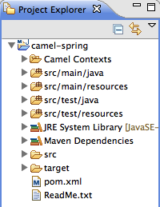

- Explore the contents of the project. You will see that it has all of the relevant structure, dependencies, Maven project file and even a ready-to-use Camel Context in the form of Spring XML

Camel Context
The Camel context is an instance of the Camel runtime environment, which manages Routes, Components, Endpoints, Messages, JMX and Tracing. In the sample project we have just created it has been defined via a Spring configuration file, but it can also be defined programmatically in Java.

- Double-click src/main/resources/META-INF/spring/camel-context.xml to open it in the Camel editor

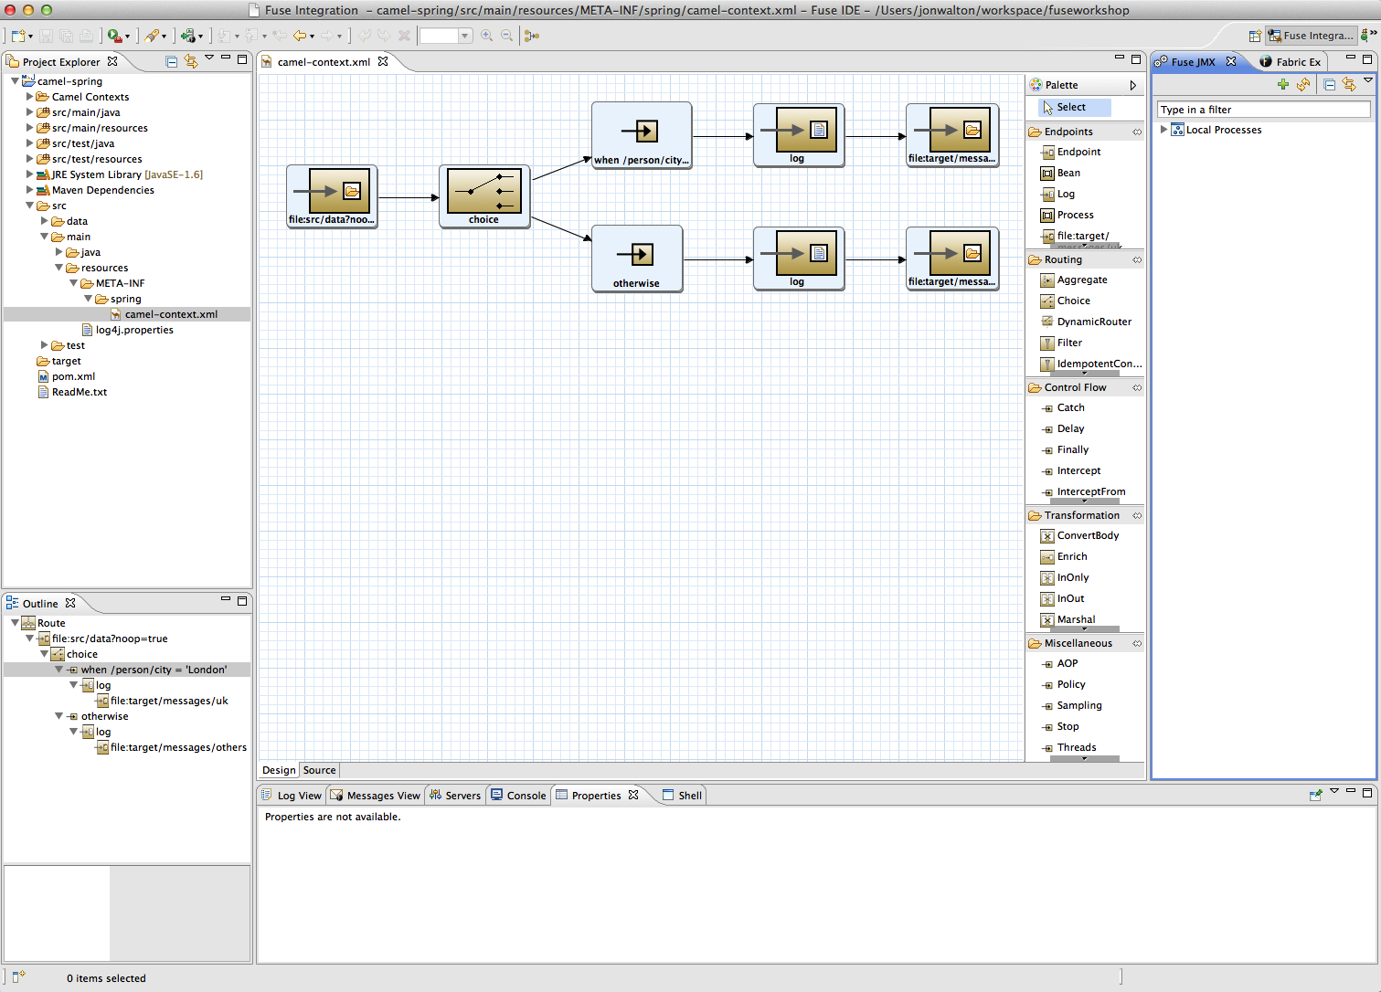

- Organise your Eclipse workspace as above to ensure an optimal experience. You may need to do the following:
  - Select Window > Show > View > Outline and drag it to the bottom left corner
  - Drag the Properties view to join the bottom panel
- Let's examine the example Camel route that has been created
  - Select the Properties tab
  - Click on the first element of the route
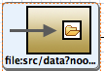

  - Click on the Documentation tab inside the Properties view

Documentation
The Properties view gives you access to very useful documentation for any element selected in the canvas. This makes it much easier to learn how to use any given element in your Camel route.
  - The Fuse IDE gives you access to context sensitive documentation for any element you select in the canvas.

Transforming Data
Provide an introductory paragraph or sentence. Provide content that helps demonstrate the business value of the product or process. Write an introduction to each lab that explains:
- What students are going to do in this lab
- Why they are going to do it
- What they will see when they are done

Supporting section [Heading 2 (Alt+2)]
For subsections, use this format. Replace the heading above with your own title, and then add an introduction. If you need to add steps, copy and paste the step list below. Press Alt+2 to add more supporting sections.

Subsection [Heading 3 (Alt+3)]
To break out the information into a third-level heading and subsection, use this format. Add a title and content. Press Alt+3 to add more subsections.
- Step List (Alt+A)
Step List Cont. (no #) (Alt+S)
- List Bullet (Alt+X)
- List Bullet (Alt+X)
  - Step List (Alt+A and press Tab one time)
Step List Cont. (no #) (Alt+S and press Tab one time)
  - List Bullet 2 (Alt+C)
  - List Bullet 2 (Alt+C)
    - Step List (Alt+A and press Tab two times).
Avoid nesting lists deeper than three levels.
Step List Cont. (no #) (Alt+S and press Tab two times)
    - List Bullet 3 (Alt+V)
    - List Bullet 3 (Alt+V)

Using Beans

Error Handling

Testing your Routes

Introduction to Fuse Fabric
- Troubleshooting
[Include this section IF APPLICABLE. Remove this section if you do not need it—subsequent appendixes will automatically renumber. Remove this bracketed information when you are finished.]

Additional appendices if applicable:
Appendix B FAQs
Appendix C Sources
- Notices
This information was developed for products and services offered in the U.S.A.
IBM may not offer the products, services, or features discussed in this document in other countries. Consult your local IBM representative for information on the products and services currently available in your area. Any reference to an IBM product, program, or service is not intended to state or imply that only that IBM product, program, or service may be used. Any functionally equivalent product, program, or service that does not infringe any IBM intellectual property right may be used instead. However, it is the user's responsibility to evaluate and verify the operation of any non-IBM product, program, or service.
IBM may have patents or pending patent applications covering subject matter described in this document. The furnishing of this document does not grant you any license to these patents. You can send license inquiries, in writing, to:
IBM Director of Licensing
IBM Corporation
North Castle Drive
Armonk, NY 10504-1785
U.S.A.
For license inquiries regarding double-byte (DBCS) information, contact the IBM Intellectual Property Department in your country or send inquiries, in writing, to:
IBM World Trade Asia Corporation
Licensing
2-31 Roppongi 3-chome, Minato-ku
Tokyo 106-0032, Japan
The following paragraph does not apply to the United Kingdom or any other country where such provisions are inconsistent with local law: INTERNATIONAL BUSINESS MACHINES CORPORATION PROVIDES THIS PUBLICATION "AS IS" WITHOUT WARRANTY OF ANY KIND, EITHER EXPRESS OR IMPLIED, INCLUDING, BUT NOT LIMITED TO, THE IMPLIED WARRANTIES OF NON-INFRINGEMENT, MERCHANTABILITY OR FITNESS FOR A PARTICULAR PURPOSE. Some states do not allow disclaimer of express or implied warranties in certain transactions, therefore, this statement may not apply to you.
This information could include technical inaccuracies or typographical errors. Changes are periodically made to the information herein; these changes will be incorporated in new editions of the publication. IBM may make improvements and/or changes in the product(s) and/or the program(s) described in this publication at any time without notice.
Any references in this information to non-IBM Web sites are provided for convenience only and do not in any manner serve as an endorsement of those Web sites. The materials at those Web sites are not part of the materials for this IBM product and use of those Web sites is at your own risk.
IBM may use or distribute any of the information you supply in any way it believes appropriate without incurring any obligation to you.
Any performance data contained herein was determined in a controlled environment. Therefore, the results obtained in other operating environments may vary significantly. Some measurements may have been made on development-level systems and there is no guarantee that these measurements will be the same on generally available systems. Furthermore, some measurements may have been estimated through extrapolation. Actual results may vary. Users of this document should verify the applicable data for their specific environment.
Information concerning non-IBM products was obtained from the suppliers of those products, their published announcements or other publicly available sources. IBM has not tested those products and cannot confirm the accuracy of performance, compatibility or any other claims related to non-IBM products. Questions on the capabilities of non-IBM products should be addressed to the suppliers of those products.
All statements regarding IBM's future direction and intent are subject to change or withdrawal without notice, and represent goals and objectives only.
[Use the following text in all documents that contain examples that use fictitious names. Any examples that use real company names require written permission. Remove this bracketed information when you are finished.]
This information contains examples of data and reports used in daily business operations. To illustrate them as completely as possible, the examples include the names of individuals, companies, brands, and products. All of these names are fictitious and any similarity to the names and addresses used by an actual business enterprise is entirely coincidental. All references to fictitious companies or individuals are used for illustration purposes only.
[Use the following text in all documents that contain code samples. If each code sample has an IBM Copyright, those notices are to be retained. Ensure that IBM really owns the code and that the owner (even if an IBM employee) knows that code is in the book. Remove this bracketed information when you are finished.]
COPYRIGHT LICENSE:
This information contains sample application programs in source language, which illustrate programming techniques on various operating platforms. You may copy, modify, and distribute these sample programs in any form without payment to IBM, for the purposes of developing, using, marketing or distributing application programs conforming to the application programming interface for the operating platform for which the sample programs are written. These examples have not been thoroughly tested under all conditions. IBM, therefore, cannot guarantee or imply reliability, serviceability, or function of these programs.
- Trademarks and copyrights
[This section is REQUIRED. Remove this bracketed information when you are finished.]
[The following list is a sample. Add any other IBM trademarks that are used in the workbook. The editor who performs the legal review of the workbook will also check this list to ensure that it is complete. Remove bracketed information when you are finished.]
The following terms are trademarks of International Business Machines Corporation in the United States, other countries, or both:
IBM | AIX | CICS | ClearCase | ClearQuest | Cloudscape
Cube Views | DB2 | developerWorks | DRDA | IMS | IMS/ESA
Informix | Lotus | Lotus Workflow | MQSeries | OmniFind
Rational | Redbooks | Red Brick | RequisitePro | System i
System z | Tivoli | WebSphere | Workplace | System p
Adobe, Acrobat, Portable Document Format (PDF), and PostScript are either registered trademarks or trademarks of Adobe Systems Incorporated in the United States, other countries, or both.
Cell Broadband Engine is a trademark of Sony Computer Entertainment, Inc. in the United States, other countries, or both and is used under license therefrom.
Java and all Java-based trademarks and logos are trademarks of Sun Microsystems, Inc. in the United States, other countries, or both. See Java Guidelines
Microsoft, Windows, Windows NT, and the Windows logo are registered trademarks of Microsoft Corporation in the United States, other countries, or both.
Intel, Intel logo, Intel Inside, Intel Inside logo, Intel Centrino, Intel Centrino logo, Celeron, Intel Xeon, Intel SpeedStep, Itanium, and Pentium are trademarks or registered trademarks of Intel Corporation or its subsidiaries in the United States and other countries.
UNIX is a registered trademark of The Open Group in the United States and other countries.
Linux is a registered trademark of Linus Torvalds in the United States, other countries, or both.
ITIL is a registered trademark and a registered community trademark of the Office of Government Commerce, and is registered in the U.S. Patent and Trademark Office.
IT Infrastructure Library is a registered trademark of the Central Computer and Telecommunications Agency which is now part of the Office of Government Commerce.
Other company, product and service names may be trademarks or service marks of others.



© Copyright IBM Corporation 2011.
The information contained in these materials is provided for informational purposes only, and is provided AS IS without warranty of any kind, express or implied. IBM shall not be responsible for any damages arising out of the use of, or otherwise related to, these materials. Nothing contained in these materials is intended to, nor shall have the effect of, creating any warranties or representations from IBM or its suppliers or licensors, or altering the terms and conditions of the applicable license agreement governing the use of IBM software. References in these materials to IBM products, programs, or services do not imply that they will be available in all countries in which IBM operates. This information is based on current IBM product plans and strategy, which are subject to change by IBM without notice. Product release dates and/or capabilities referenced in these materials may change at any time at IBM’s sole discretion based on market opportunities or other factors, and are not intended to be a commitment to future product or feature availability in any way.
IBM, the IBM logo and ibm.com are trademarks or registered trademarks of International Business Machines Corporation in the United States, other countries, or both. If these and other IBM trademarked terms are marked on their first occurrence in this information with a trademark symbol (® or ™), these symbols indicate U.S. registered or common law trademarks owned by IBM at the time this information was published. Such trademarks may also be registered or common law trademarks in other countries. A current list of IBM trademarks is available on the Web at “Copyright and trademark information” at ibm.com/legal/copytrade.shtml
Other company, product and service names may be trademarks or service marks of others.


