Creating and running your first Camel Route
The example you are going to be building is based on a fictional motorcycle parts business used throughout the Camel in Action book. The final solution implements Orders from customers coming in via a web service or a file based endpoint, which are sent to a 'incoming orders' JMS queue. A separate bundle takes the incoming orders and normalizes them from the possible order formats (XML, CSV or CSL) to a POJO format. Processed orders end up in the 'orders' JMS queue.
Here is a diagram of what the final solution will look like once you have completed all of the labs in this PoT:
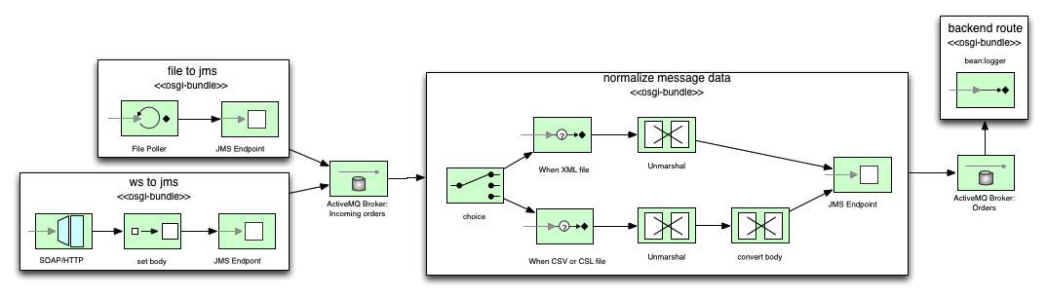
The following Enterprise Integration Patterns will be used:
Endpoint, Bean, Choice, When, Unmarshal, Convertbody, SetBody, InOnly, Transform
In this lab you are going to create your first Camel route, which will be the “file to jms” part of the above diagram.
The basic steps you will cover are:
- Importing the starter Fuse project
- Create the “file to jms” route
- Check the route by running the unit tests
- Run the route

Import the starter Fuse project
We have provided a starting project that you can import into the Fuse IDE. It has the necessary project structure, Maven pom, empty Camel route XML and some unit tests that will fail until you have completed the necessary Camel route correctly.

 | Using Project Archetypes  If you were going to create a new project instead of importing an existing one you can make use of the built in project templates (Maven archetypes) to speed up the creation of new projects.

- Download the starter project from https://github.com/jonmwalton/Fuse-PoT/tree/master/Lab2/Starting%20Project
- Extract the zip file into your workspace
- Launch the Fuse IDE if it isn't already running
- Select File > Import
- Select Maven > Existing Maven Projects
- Click Next
- Click Browse and select the root folder of the project you just unzipped

Create Camel Route
- Double-click rider-auto-file/src/main/resources/OSGI-INF/blueprint/camel-context.xml to open it in the Camel editor

Camel Context
The Camel context is an instance of the Camel runtime environment, which manages Routes, Components, Endpoints, Messages, JMX and Tracing. In the sample project we have just imported it has been defined via a Blueprint configuration file, but it can also be defined programmatically in Java or in Spring.

- Double-click src/main/resources/META-INF/spring/camel-context.xml to open it in the Camel editor
- The editor provides both a Design and Source view of the Camel Context. In Design mode you have a canvas and a palette of items that can be used to construct your routes
- Drag and drop an Endpoint onto the canvas
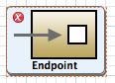

- Notice the red cross that indicates an error that we need to fix
- Select the Properties view and see that the error is due to this endpoint requiring a Uri
- Camel has many built-in Components at your disposal for building your routes. We can see a table of available Components in the help
  - Select Help > Help Contents
  - Expand Red Hat Fuse IDE > Endpoint Reference > Table of Components
  - Have a look at the numerous components that can be used in Endpoints
- This first route we are building needs to be able to read in files and forward them as messages to ActiveMQ
- You can see what the Uri should be in order to use the File component
- Enter file://target/placeorder in the Uri field
- The File endpoint is now configured to poll the specified directory and consume any files contained within it
- Notice that a folder icon appears inside the Endpoint on the canvas so you can visually see what Component is being used
- Click on the Documentation tab in the Properties view and look at the various options that can be specified with the File component. Note that this component has different options depending on whether it is a Consumer or a Producer. Camel knows that as we are using this component at the start of our route that it is to behave as a Consumer
- Drag and drop another Endpoint onto the canvas
- We want orders to be passed onto ActiveMQ and as you would expect, Fuse comes with ActiveMQ built in and therefore has a Component we can use
- Enter activemq:incomingOrders into the Uri field for this second Endpoint
- Now we just need to connect these two Endpoints together
  - Hover your mouse of the first File endpoint
  - Click on the Create Connection arrow and drag it on top of the second endpoint
- Your Camel route should now look like this:

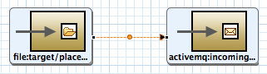

Line bendpoints
You can drag the line's bendpoint (orange dot) to change the angle of the line's segments. Doing so creates two new bendpoints, one on either side of the original. This behaviour enables you to easily adjust your diagram to accommodate increasingly complex routes.
- Select File > Save to save the route
- Click the Source tab at the bottom left of the canvas. You will see the route now in the form of simple to read XML

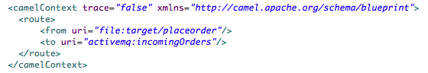

Running the route

