Installing Fuse
In this lab you will be checking your environment and then installing the JBoss Fuse server and IDE. You will see how quickly and easily it can be setup.

Environment and downloads
Before installing JBoss Fuse you will need to have Java set up in your environment if it isn't already.
The minimum hardware requirements to install JBoss Fuse are:
- 100MB of free disk space
- 2GB of RAM

Install a Java Runtime
JBoss Fuse requires a JDK version 1.6 or 1.7 from either Oracle, IBM or OpenJDK.
- Download and install a suitable JDK
 | Important!  Do not install the Java runtime under a directory that includes whitespace. For example, the path, C:\Program Files\Java\jdk7, is not an acceptable path and will lead to unpredictable errors in JBoss Fuse at run time.
- Set your JAVA_HOME environment variable to be the Java install path
- Open a command prompt and run java -version to verify that it has installed properly.

Download the JBoss Fuse installation files
There are three different installations that you can choose from that contain different feature sets:
- Minimal – installs Apache Karaf, Apache Camel core, and select Apache Camel components
- Medium – installs Apache Karaf, Apache Camel, and Apache ActiveMQ
- Full – installs Apache Karaf, Apache Camel, Apache ActiveMQ, Apache CXF and the JBI components
For this workshop we will download and install the full version of JBoss Fuse.
- Browse to https://www.jboss.org/products/fuse
- Download Red Hat JBoss Fuse i.e. jboss-fuse-full-6.0.0.redhat-024.zip
- Download the Fuse IDE for your operating system

Installing the server
JBoss Fuse is installed by unpacking the archive file. This provides an easy way for a developer to get up and running.
- Using a suitable archive tool, unpack JBoss Fuse into a directory to which you have access.

Important!
Do not unpack the archive file into a directory that includes whitespace. For example, do not unpack into, C:\Documents and Settings\Greco Roman\Desktop\fuse.

- Add a remote control user
  - Open InstallDir/etc/users.properties in your favourite text editor
  - Locate the line #admin=admin,admin
  - Remove the leading # to uncomment the line
  - Save the changes
  - To access the container's JMX port and to use the ActiveMQ web console, you must specify the credentials for them. To do so, open InstallDir/etc/system.properties in your favourite text editor
  - Locate the following lines
# Authentication – must match an entry in users.properties with the admin privilege
#
#activemq.jmx.user=admin
#activemq.jmx.password=admin
  - Uncomment the user and password lines by removing the leading #

- Check JBoss Fuse has installed properly
  - Open a command prompt at InstallDir/bin
  - Run either fuse.bat or ./fuse depending on your OS
  - If all is well you should see the following

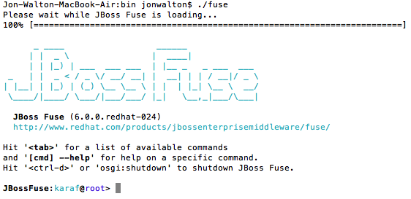

  - Type in help at the Fuse command prompt to see the large list of available commands
  - Type in shutdown and enter yes when asked to confirm

Installing Fuse IDE
The JBoss Fuse IDE is also a simple case of unpacking of a zip file and can be installed on the following x86 platforms:
- Red Hat Desktop
- MacOS 10.6 and later
- Windows 7 and later
It will use the same JDK that has been installed for the JBoss Fuse server we installed and tested earlier.
The minimum hardware requirements for installing the JBoss Fuse IDE are:
- 300MB of free disk space
- 2GB of RAM
- Using a suitable archive tool, unpack the JBoss Fuse IDE into a directory to which you will have full access
- Launch the JBoss Fuse IDE from within the installation directory. It should have the following icon:


- Switch to a new workspace for this workshop
  - Select File > Switch workspace > Other...
  - Enter a new workspace path. For example:

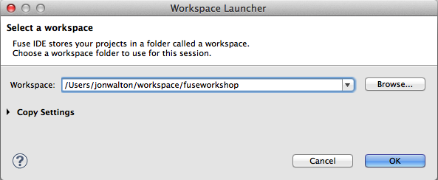

  - Click OK
  - You should be presented with the Welcome page
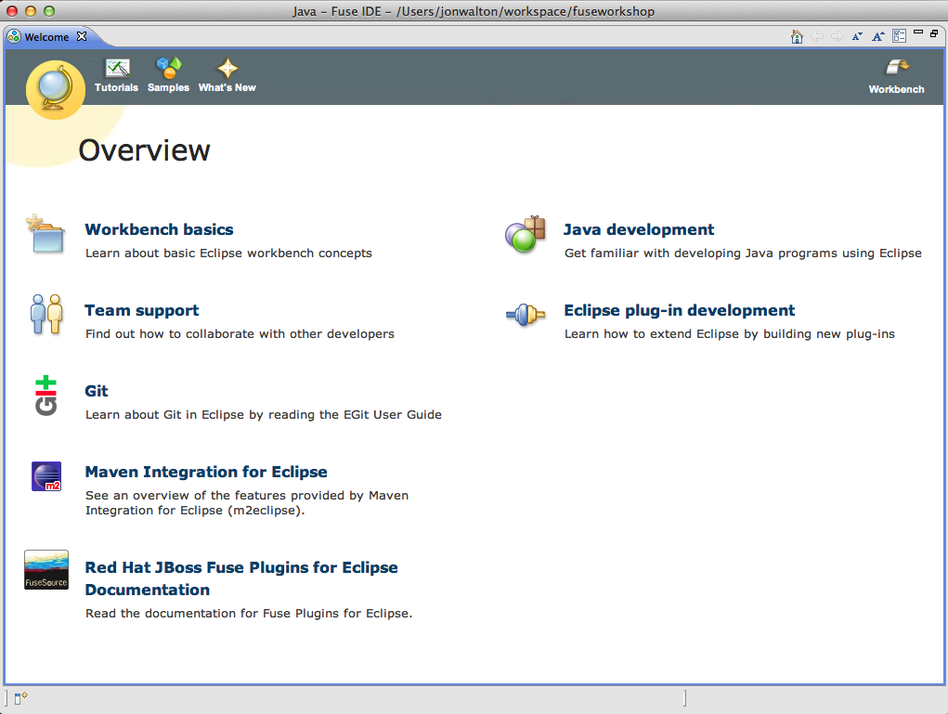

  - Close the Welcome page
  - Select Window > Open Perspective > Fuse Integration

Summary
In this lab we have downloaded and installed JBoss Fuse server and IDE and seen just how quick and easy it was to get up and running with a development environment!

