Are explanations less reliable when the model is wrong? Post-hoc explanation quality on misclassified instances
Son menos fiables las explicaciones cuando el modelo se equivoca? Calidad de las explicaciones post hoc en instancias mal clasificadas
Author information omitted for double-blind review.

Abstract
Explanations of machine-learning predictions are consulted most when a prediction is in doubt, yet explainers are evaluated on averages over all instances. This study asks whether post-hoc explanations are less reliable when the model is wrong. On the UCI Adult Income dataset, the analysis compares fidelity, stability and faithfulness gap between correctly and incorrectly classified instances for SHAP, LIME, Anchors and DiCE across five model families, with the run as the unit of analysis (265 runs, 122,529 explained instances), Wilcoxon signed-rank tests with Holm correction and a control for the prediction margin; the Statlog German Credit dataset serves for external validation. Explanations were less stable on misclassified instances for all four explainers, and the deficit was large for SHAP (median difference −0.076, $d_{z}=$ −1.36) and DiCE (−0.210, $d_{z}=$ −2.15). The prediction margin explained most of the DiCE deficit but not the SHAP deficit, and at equal margin the features SHAP ranked first carried less of an erroneous prediction. Both SHAP results held on instances outside the models’ training data. Fidelity changed little and in opposite directions across explainers. The pattern depended on the model family; external validation reproduced it for Anchors but not for SHAP stability. Quality reported as an average can therefore overstate how far an explanation of a wrong prediction should be trusted; audits should report explanation quality separately for correct and incorrect predictions.
Keywords: explainable artificial intelligence; post-hoc explanations; misclassification; explanation reliability; SHAP; LIME.

Resumen
Las explicaciones de las predicciones de aprendizaje automático se consultan sobre todo cuando una predicción es dudosa, pero los explicadores se evalúan con promedios sobre todas las instancias. Este estudio examina si las explicaciones post hoc son menos fiables cuando el modelo se equivoca. Sobre el conjunto de datos UCI Adult Income, se comparan fidelidad, estabilidad y brecha de borrado entre instancias bien y mal clasificadas para SHAP, LIME, Anchors y DiCE en cinco familias de modelos, con la ejecución como unidad de análisis (265 ejecuciones, 122,529 instancias), pruebas de Wilcoxon con corrección de Holm, y un control del margen de predicción; el conjunto Statlog German Credit sirve de validación externa. Las explicaciones fueron menos estables en las instancias mal clasificadas para los cuatro explicadores, y el déficit fue grande para SHAP (diferencia mediana −0.076, $d_{z}=$ −1.36) y DiCE (−0.210, $d_{z}=$ −2.15). El margen de predicción explicó la mayor parte del déficit de DiCE, pero no el de SHAP; con el margen fijo, las variables que SHAP situó primero sostuvieron una parte menor de la predicción errónea. Ambos resultados de SHAP se mantuvieron fuera de los datos de entrenamiento. El patrón dependió de la familia de modelos; la validación externa lo reprodujo para Anchors, pero no para la estabilidad de SHAP. La calidad promedio puede exagerar la confianza que merece la explicación de una predicción errónea; las auditorías deberían informarla por separado para predicciones correctas e incorrectas.
Palabras clave: inteligencia artificial explicable; explicaciones post hoc; errores de clasificación; fiabilidad de las explicaciones; SHAP; LIME.

Introduction
Post-hoc explainers such as SHAP [1], LIME [2], Anchors [3] and DiCE [4] are the usual way to inspect the predictions of an opaque classifier. Their quality is measured with proxies: whether the features an explanation ranks first are those that move the prediction [5], [6], [7], and whether similar inputs receive similar explanations [8]. Benchmarks report these metrics as averages over instances [9].
An average hides one split that matters: whether the prediction was right. Explanations are consulted when a decision is contested, when an auditor examines a failure, or when a user decides whether to accept a recommendation, situations in which the prediction is disproportionately likely to be wrong. Explanations can raise acceptance of a recommendation whether or not it is correct [10], and they can be unreliable in ways their appearance does not reveal [11], [12]. If they are also less faithful or less stable on errors, an explanation can look most convincing where it deserves the least trust [13].
The closest line of work relates explanations to model uncertainty. A recent survey of uncertainty-aware XAI finds that the stability of explanations is reported inconsistently [14]; uncertainty in inputs and model parameters propagates into explanation variance, and not all methods propagate it reliably [15]; counterfactual explanations are highly sensitive to model uncertainty, even when accuracy is high [16]; and SHAP can be used to explain the uncertainty itself rather than the prediction [17]. These studies vary uncertainty; whether explanation quality differs between a model’s correct and wrong predictions is a separate question.
This study tests this with a pre-specified re-analysis of an existing benchmark that explained balanced samples of true positives, true negatives, false positives and false negatives for four explainers and five model families, and asks: does explanation quality differ between correct and misclassified instances (RQ1), does the difference depend on the model family (RQ2), do false positives and false negatives differ (RQ3), and is the difference explained by proximity to the decision boundary, where errors tend to lie (RQ4)?

Materials and methods

Datasets and experimental runs
Two tabular datasets are used: UCI Adult Income [18] (primary) and Statlog German Credit [19] (external validation). The explanation runs come from a benchmark whose protocol is described in [9]. That study, and a later analysis of the same runs, compare explainers by their average quality; the present analysis reports none of their results and compares each explainer with itself, between correct and misclassified instances of the same run.
Five classifiers were explained: logistic regression, random forest [20], XGBoost [21], a support vector machine and a multilayer perceptron, all trained once on the seed-42 partition of the data. Each run crossed one model, one explainer, one seed (42, 123, 456, 789 or 999), which fixed the partition sampled, and $n=50$, $100$ or $200$ instances per error quadrant (TP, TN, FP, FN), so correct and misclassified instances are about equally represented. Of the 299 runs, 265 were analysed (Anchors and DiCE runs without explanations, and SHAP runs with fewer than ten instances in a group, were excluded). They contain 122,529 explained instances, of which 70,788 belong to the training data (Section 3.4); 278 instances without a quadrant were excluded. On German Credit, random forest and XGBoost were explained by SHAP and Anchors with three seeds each (12 runs, 13 to 37 errors per quadrant). Breast Cancer was excluded in advance, with one to four errors per quadrant.

Quality metrics
SHAP (TreeExplainer for tree models, KernelExplainer otherwise) and LIME (ten features) return an attribution vector $e(x)∈R^{M}$; Anchors is represented as a binary vector of the features in its rule, and DiCE as $|x−x^{′}|$ for its counterfactual $x^{′}$. With $f(x)$ the predicted probability of the positive class and masking a feature meaning replacing it with its training mean, the benchmark [9] computes per instance the stability [8], the mean cosine similarity of explanations of $T$ noisy copies of $x$,
S=2T(T−1)a<b​cose(a),e(b),
the fidelity [5], the correlation across features between attribution size and the effect of masking that feature,
$$F=ρ\left({\left\{|e_{j}(x)|\right\}}_{j=1}^{M}, {\left\{|f(x)−f({\tilde{x}}^{(j)})|\right\}}_{j=1}^{M}\right),$$
and the faithfulness gap [6], [7], the effect of masking the $k=5$ top-ranked features together,
$$G=\left|f(x)−f\left({\tilde{x}}^{(\text{top-}k)}\right)\right|.$$
Higher is better for all three. Sparsity was a secondary metric and explanation time was described.

Statistical analysis
The analysis plan was committed to the project repository before any result was computed. Instances are nested in runs, so the run is the unit of inference. For run $r$ and metric $Q$,
$$Δ_{r}={\overset{‾}{Q}}_{r,mis}−{\overset{‾}{Q}}_{r,cor},$$
so a negative $Δ$ means lower quality on errors. RQ1 uses a two-sided Wilcoxon signed-rank test per explainer and metric [22], Holm-corrected across the 12 tests [23] at $α=0.05$, with $d_{z}$ [24]; an effect is practically relevant if also $|d_{z}|≥0.5$ and $|\text{median} Δ|≥0.05$. It was repeated with $Δ$ averaged over $n$ within model and seed. RQ2 uses Kruskal–Wallis tests across families [25] and RQ3 the RQ1 test on ${\overset{‾}{Q}}_{FP}−{\overset{‾}{Q}}_{FN}$, both Holm-corrected. For RQ4 the margin $m=|\hat{p}−0.5|$ was recomputed from the stored models and, per explainer and metric, the analysis fitted
$$Q_{ir}=α_{r}+β {mis}_{ir}+γ m_{ir}+ε_{ir},$$
with run fixed effects and standard errors clustered by run [26]; a difference is explained by the margin if $β$ more than halves and its interval includes zero. German Credit, with six runs per explainer, is reported descriptively.
Deviations from the plan: (1) for random-forest runs made first, the stored model reproduces only part of the recorded predictions, so RQ4 uses the 223 of 274 runs it reproduces (99% or more), including 9 of 60 random-forest runs; RQ1–RQ3 are unaffected, as their labels come from the model that ran. (2) For the SVM, $\hat{p}$ is Platt-scaled [27] and disagrees with the predicted class for 404 of 22,426 instances, which were kept. Two post-hoc analyses were added: (3) RQ1 and RQ4 without training instances, and RQ1 on seed 42 alone; (4) a check of the mechanism proposed for RQ3.

Results

Correct versus misclassified instances (RQ1)
Stability was lower on misclassified instances for all four explainers (Table 1, Figure 1). The deficit was large for SHAP, in all 65 runs, and DiCE, in 67 of 68. For LIME it was consistent (73 of 75 runs) but small, as LIME’s stability on these data is near zero. For Anchors most runs had stability near zero in both groups, so the median is close to zero, yet the difference was negative in 49 of 57 runs. Fidelity was lower on errors for DiCE and Anchors, higher for LIME, and not significant for SHAP, whose positive mean comes from a minority of random-forest and SVM runs while its median is near zero. The faithfulness gap was lower on errors for SHAP and DiCE only. Of the 12 tests, 9 were significant and 3 practically relevant (SHAP stability, DiCE stability and fidelity); the model–seed analysis agreed for 10. Sparsity differences were within 0.005 of zero; only Anchors was slower on errors.
Per-run difference in quality, misclassified minus correct instances (UCI Adult). $n$: runs; CI: 95% confidence interval of the mean; $p_{Holm}$: Wilcoxon signed-rank, Holm-corrected across the 12 tests.
Metric | Explainer | $n$​ | Median $Δ$ | Mean $Δ$ [95% CI] | $d_{z}$​ | $p_{Holm}$​
Stability | SHAP | 65 | −0.076 | −0.117 [−0.138, −0.095] | −1.36 | <0.001
 | LIME | 75 | −0.003 | −0.007 [−0.009, −0.006] | −1.06 | <0.001
 | Anchors | 57 | 0.000 | −0.016 [−0.032, −0.001] | −0.28 | <0.001
 | DiCE | 68 | −0.210 | −0.198 [−0.221, −0.176] | −2.15 | <0.001
Fidelity | SHAP | 65 | +0.007 | +0.021 [+0.009, +0.033] | +0.42 | 0.057
 | LIME | 75 | +0.032 | +0.028 [+0.020, +0.035] | +0.82 | <0.001
 | Anchors | 57 | −0.022 | −0.025 [−0.040, −0.010] | −0.45 | 0.013
 | DiCE | 68 | −0.053 | −0.047 [−0.061, −0.033] | −0.82 | <0.001
Faithfulness | SHAP | 65 | −0.023 | −0.024 [−0.029, −0.018] | −1.07 | <0.001
gap | LIME | 75 | 0.000 | +0.001 [−0.007, +0.008] | +0.02 | 0.992
 | Anchors | 57 | 0.000 | −0.003 [−0.012, +0.007] | −0.08 | 0.954
 | DiCE | 68 | −0.022 | −0.018 [−0.029, −0.007] | −0.41 | 0.013
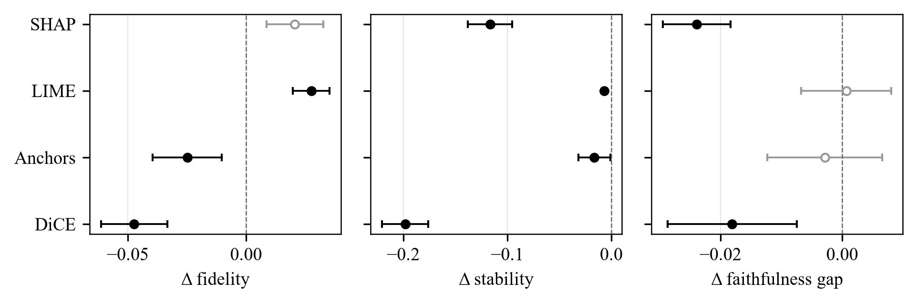
Mean per-run difference in quality between misclassified and correct instances, with 95% confidence intervals (UCI Adult). Filled markers: significant after Holm correction; open markers: not significant (the Wilcoxon test concerns the median; for SHAP fidelity the median is near zero while the mean is not). Negative values mean lower quality on errors.

Model families and error types (RQ2, RQ3)
The size, and for fidelity and faithfulness gap the sign, of the difference depended on the family (Figure 2); the Kruskal–Wallis test was significant for 10 of 12 combinations, all but LIME and Anchors stability. The SHAP stability deficit was largest for the multilayer perceptron (−0.216) and XGBoost (−0.168); the DiCE deficit appeared in every family.
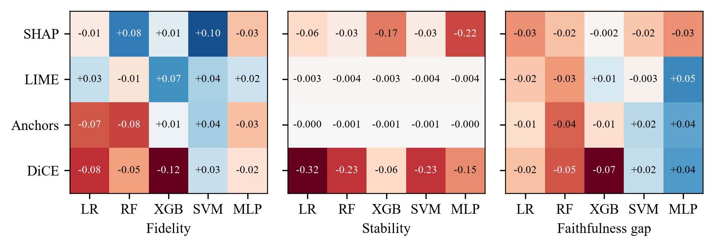
Median per-run difference (misclassified minus correct) by explainer and model family. LR: logistic regression; RF: random forest; XGB: XGBoost; SVM: support vector machine; MLP: multilayer perceptron. Red: lower quality on errors; blue: higher. LIME and Anchors stability differences are small on this scale.
Among errors, the faithfulness gap was much larger for false positives than for false negatives for every explainer (Table 2). This follows the predicted class, not the error: between correct predictions the gap was far larger for true positives than for true negatives (SHAP +0.597, positive in every run), and errors fell between them (false positives below true positives, SHAP −0.142; false negatives above true negatives, +0.078). Masking to the training mean plausibly pushes instances towards the majority, negative class, so the gap is not comparable across predicted classes.
Per-run difference, false positives minus false negatives: median $Δ$ ($p_{Holm}$, Wilcoxon signed-rank, Holm-corrected across the 12 tests).
Explainer | Fidelity | Stability | Faithfulness gap
SHAP | +0.022 (<0.001) | +0.015 (0.705) | +0.353 (<0.001)
LIME | +0.003 (0.315) | +0.004 (<0.001) | +0.239 (<0.001)
Anchors | +0.027 (0.002) | 0.000 (0.705) | +0.172 (<0.001)
DiCE | −0.019 (0.276) | −0.269 (<0.001) | +0.046 (<0.001)

The role of the decision boundary (RQ4)
Errors lay closer to the boundary (median margin 0.18 against 0.43 in the SHAP runs), and stability rose with the margin (Figure 3). With the margin controlled (Table 3), the DiCE stability deficit almost vanished: near the boundary a counterfactual needs only a small change, which varies more under noise. The SHAP stability deficit shrank but remained, and is visible in every margin bin of Figure 3. The faithfulness gap, which near the boundary is inflated because any deletion moves the prediction, became lower on errors for SHAP, LIME and Anchors. The fidelity differences were largely margin effects (LIME’s advantage fell from +0.039 to +0.014; DiCE’s deficit reversed).
Coefficient of misclassification $β$ for stability and faithfulness gap in run fixed-effects regressions: without the margin, with the margin (95% CI), and with the margin on instances outside the training data (95% CI). Standard errors clustered by run; runs whose recorded predictions the stored model reproduces.
Metric | Explainer | Without margin | With margin | With margin, held out
Stability | SHAP | −0.146 | −0.042 [−0.057, −0.027] | −0.040 [−0.059, −0.021]
 | LIME | −0.008 | −0.003 [−0.004, −0.002] | −0.001 [−0.002, 0.000]
 | Anchors | −0.030 | −0.025 [−0.058, +0.008] | −0.017 [−0.042, +0.007]
 | DiCE | −0.191 | −0.014 [−0.031, +0.004] | −0.027 [−0.052, −0.002]
Faithfulness | SHAP | −0.024 | −0.064 [−0.075, −0.054] | −0.031 [−0.054, −0.008]
gap | LIME | +0.008 | −0.031 [−0.045, −0.018] | −0.011 [−0.037, +0.015]
 | Anchors | +0.003 | −0.017 [−0.025, −0.008] | −0.008 [−0.021, +0.006]
 | DiCE | −0.013 | −0.007 [−0.014, 0.000] | −0.005 [−0.016, +0.006]
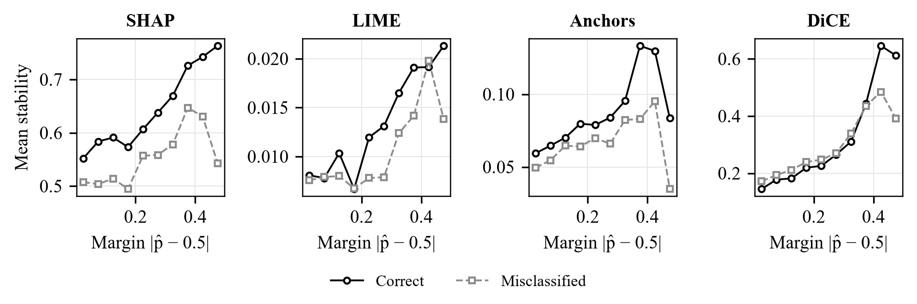
Mean stability by prediction margin $|\hat{p}−0.5|$ for correct and misclassified instances (UCI Adult; bins of width 0.05 with at least 30 instances).

Robustness and external check
Errors were less often training instances than correct predictions (for SHAP, 0.59 against 0.81 outside seed 42). On held-out instances the stability deficit remained significant for all four explainers (SHAP −0.068, DiCE −0.212), and on seed 42 alone, which has no training instances, for SHAP, LIME and DiCE. The raw faithfulness-gap deficits of SHAP and DiCE fell to medians close to zero, but the margin-adjusted SHAP deficit remained, unlike those of LIME and Anchors, and DiCE stability kept a small margin-adjusted residual (Table 3).
On German Credit, Anchors reproduced the Adult pattern, with fidelity and faithfulness gap lower on errors in all six runs (medians −0.084 and −0.017). SHAP did not: its stability was higher on errors in 4 of six runs (+0.025). These runs use only tree models, but on Adult the SHAP deficit was also large for XGBoost, so the reason for the reversal remains unknown.

Discussion
The answer to the title question is a qualified yes. Explanations of wrong predictions were less stable for every explainer, also outside the training data, and markedly so for SHAP and DiCE. Averages hide this, and would hide it further in deployment, where errors are rarer than in this balanced sample. The margin control separates two causes. For DiCE the deficit is mainly geometric: errors lie near the boundary, where explanations are less stable whether or not the prediction is right, consistent with the sensitivity of counterfactuals to model uncertainty [16]. For SHAP it remains at equal margin, and there its top features also carry less of an erroneous prediction.
Three consequences follow for practice: explanation quality should be reported separately for correct and misclassified instances; the stability of an explanation used to contest or justify a decision should be checked for that instance; and deletion metrics with a mean baseline should be reported per predicted class.
Limits: one tabular benchmark, with an external check of six runs per explainer that did not reproduce the SHAP stability deficit; fixed explainer settings, under which LIME’s stability is near zero and the absolute relevance threshold cannot be met; Anchors and DiCE runs missing not at random (removing units, not biasing within-run contrasts); part of the random-forest runs in RQ4; a post-hoc treatment of the training overlap; and proxy metrics, so whether users are misled needs a user study.

Conclusions
Post-hoc explanations were less reliable when the model was wrong. In 265 benchmark runs, stability was lower on misclassified instances for SHAP, LIME, Anchors and DiCE, also outside the training data. The DiCE deficit is mostly explained by the proximity of errors to the boundary; the SHAP deficit is not, and at equal margin SHAP’s top features carry less of an erroneous prediction. Explanation quality should be reported separately for correct and incorrect predictions, because an average describes the explanations that are needed least.

Data availability
Both datasets are public [18], [19]. The code, trained models, per-instance run outputs and analysis results are in a public repository and a versioned archive, with instructions to regenerate every reported value from the stored runs; their addresses are withheld for double-blind review.

References
[1] S. M. Lundberg and S.-I. Lee, “A unified approach to interpreting model predictions,” in Advances in neural information processing systems, 2017, pp. 4765–4774.
[2] M. T. Ribeiro, S. Singh, and C. Guestrin, “Why should I trust you?: Explaining the predictions of any classifier,” in Proceedings of the 22nd ACM SIGKDD international conference on knowledge discovery and data mining, 2016, pp. 1135–1144. doi: 10.1145/2939672.2939778.
[3] M. T. Ribeiro, S. Singh, and C. Guestrin, “Anchors: High-precision model-agnostic explanations,” in Proceedings of the thirty-second AAAI conference on artificial intelligence, 2018, pp. 1527–1535. doi: 10.1609/aaai.v32i1.11491.
[4] R. K. Mothilal, A. Sharma, and C. Tan, “Explaining machine learning classifiers through diverse counterfactual explanations,” in Proceedings of the 2020 conference on fairness, accountability, and transparency, 2020, pp. 607–617. doi: 10.1145/3351095.3372850.
[5] U. Bhatt, A. Weller, and J. M. F. Moura, “Evaluating and aggregating feature-based model explanations,” in Proceedings of the twenty-ninth international joint conference on artificial intelligence (IJCAI), 2020, pp. 3016–3022.
[6] W. Samek, A. Binder, G. Montavon, S. Lapuschkin, and K.-R. Müller, “Evaluating the visualization of what a deep neural network has learned,” IEEE Transactions on Neural Networks and Learning Systems, vol. 28, no. 11, pp. 2660–2673, 2017.
[7] S. Hooker, D. Erhan, P.-J. Kindermans, and B. Kim, “A benchmark for interpretability methods in deep neural networks,” in Advances in neural information processing systems, 2019, pp. 9737–9748.
[8] D. Alvarez-Melis and T. S. Jaakkola, “On the robustness of interpretability methods,” in ICML workshop on human interpretability in machine learning (WHI 2018), 2018. Available: https://arxiv.org/abs/1806.08049
[9] J. Herrera-Vásquez and M. Herrero-Uceda, “A framework for rigorous evaluation of model-agnostic explainability methods: Multi-metric statistical benchmarking, operational protocol, and reproducibility,” Revista de Investigación Multidisciplinaria Iberoamericana (RIMI), no. 3, 2026.
[10] G. Bansal et al., “Does the whole exceed its parts? The effect of AI explanations on complementary team performance,” in Proceedings of the CHI conference on human factors in computing systems, 2021, pp. 1–16.
[11] J. Adebayo, J. Gilmer, M. Muelly, I. Goodfellow, M. Hardt, and B. Kim, “Sanity checks for saliency maps,” in Advances in neural information processing systems, 2018, pp. 9505–9515.
[12] D. Slack, S. Hilgard, E. Jia, S. Singh, and H. Lakkaraju, “Fooling LIME and SHAP: Adversarial attacks on post hoc explanation methods,” in Proceedings of the AAAI/ACM conference on AI, ethics, and society, 2020, pp. 180–186.
[13] C. Rudin, “Stop explaining black box machine learning models for high stakes decisions and use interpretable models instead,” Nature Machine Intelligence, vol. 1, no. 5, pp. 206–215, 2019.
[14] H. Löfström, T. Löfström, A. Hjort, and F. R. Yapicioglu, “Concerning uncertainty—a systematic survey of uncertainty-aware XAI,” Philosophical Transactions of the Royal Society A, vol. 384, no. 2327, p. 20250079, 2026.
[15] T. Chiaburu, F. Bießmann, and F. Haußer, “Uncertainty propagation in XAI: A comparison of analytical and empirical estimators,” in Explainable Artificial Intelligence (xAI 2025), in Communications in Computer and Information Science, vol. 2580. Springer, 2026, pp. 390–411. doi: 10.1007/978-3-032-08333-3_18.
[16] L. Christodoulou and C. Sun, “The impact of machine learning uncertainty on the robustness of counterfactual explanations,” Expert Systems with Applications, vol. 309, p. 131198, 2026, doi: 10.1016/j.eswa.2026.131198.
[17] X. Cheng, T. Wang, D. Zhu, and J. Ma, “Uncertainty explanation of artificial intelligence models by SHAP,” Knowledge-Based Systems, vol. 337, p. 115437, 2026, doi: 10.1016/j.knosys.2026.115437.
[18] B. Becker and R. Kohavi, “Adult [dataset].” UCI Machine Learning Repository, 1996.
[19] H. Hofmann, “Statlog (German credit data) [dataset].” UCI Machine Learning Repository, 1994.
[20] L. Breiman, “Random forests,” Machine Learning, vol. 45, no. 1, pp. 5–32, 2001.
[21] T. Chen and C. Guestrin, “XGBoost: A scalable tree boosting system,” in Proceedings of the 22nd ACM SIGKDD international conference on knowledge discovery and data mining, 2016, pp. 785–794.
[22] F. Wilcoxon, “Individual comparisons by ranking methods,” Biometrics Bulletin, vol. 1, no. 6, pp. 80–83, 1945.
[23] S. Holm, “A simple sequentially rejective multiple test procedure,” Scandinavian Journal of Statistics, vol. 6, no. 2, pp. 65–70, 1979.
[24] D. Lakens, “Calculating and reporting effect sizes to facilitate cumulative science: A practical primer for t-tests and ANOVAs,” Frontiers in Psychology, vol. 4, p. 863, 2013.
[25] W. H. Kruskal and W. A. Wallis, “Use of ranks in one-criterion variance analysis,” Journal of the American Statistical Association, vol. 47, no. 260, pp. 583–621, 1952, doi: 10.1080/01621459.1952.10483441.
[26] A. C. Cameron and D. L. Miller, “A practitioner’s guide to cluster-robust inference,” Journal of Human Resources, vol. 50, no. 2, pp. 317–372, 2015, doi: 10.3368/jhr.50.2.317.
[27] J. C. Platt, “Probabilistic outputs for support vector machines and comparisons to regularized likelihood methods,” in Advances in large margin classifiers, A. J. Smola, P. Bartlett, B. Schölkopf, and D. Schuurmans, Eds., MIT Press, 1999, pp. 61–74.

Declaration on the Use of Artificial Intelligence (AI)
The author declares the use of the AI tool Claude (Anthropic), under the author’s direction, to help write the analysis and figure code, edit the English text, translate the abstract into Spanish and format the references. The research questions, analysis plan, design and interpretation are the author’s. All contents were thoroughly reviewed by the author to ensure accuracy and coherence.

