Do Explainers Agree on Which Features Matter? Instance-Level Agreement between SHAP and LIME

Açıklayıcılar Hangi Özniteliklerin Önemli Olduğu Konusunda Uzlaşıyor mu? SHAP ile LIME Arasında Örnek Düzeyinde Uyum

Jonathan HERRERA-VÁSQUEZ ^{1,}*

¹ Universidad Americana de Europa (UNADE), Department of Computer Science, Cancún, Quintana Roo, Mexico; jonnabio@gmail.com; ORCID 0000-0002-7149-6635

Abstract

Post-hoc explainers are often treated as interchangeable, yet two explainers may name different features for the same prediction. This study measures how much SHAP and LIME agree on single instances. Both methods explained the same instances of the same models on three tabular datasets (Adult, German Credit and Breast Cancer Wisconsin), giving 31,411 paired explanations in 86 runs; LIME used a fixed kernel width and no discretisation. The analysis plan was committed before any agreement statistic was computed; runs, not instances, are the unit of summary. The mean overlap of the five most important features (Jaccard index) was 0.393 on Adult, 0.387 on German Credit and 0.714 on Breast Cancer. Part of this overlap does not depend on the instance: the SHAP list of one instance and the LIME list of another instance of the same run overlapped by 0.203, 0.287 and 0.648 (post hoc). In a post hoc experiment, neither method fully reproduced its own list when run again (Adult: 0.690 for LIME, 0.782 for SHAP), and agreement between the methods was below this self-agreement for every model tested. Agreement varied between models and datasets, not visibly with the number of explained instances, and was not consistently lower for misclassified instances. Sign agreement followed the predicted class, because LIME without discretisation returns local slopes while SHAP returns contributions; after conversion to contributions (post hoc), the signs of the shared top features agreed in 0.945 to 0.990 of the cases, a level one fixed direction per feature also reaches.

Keywords: Explainable artificial intelligence; post-hoc explanations; disagreement problem; feature attribution; SHAP; LIME.

1. Introduction
Post-hoc explanation methods describe a prediction of a trained model in terms of its input features. SHAP (SHapley Additive exPlanations) [1] and LIME (Local Interpretable Model-agnostic Explanations) [2] are the most used for tabular data: each returns, for one instance, a signed weight per feature. In practice the two are treated as alternatives, and the choice between them is made on cost or habit. That practice assumes that the explanation a user sees does not depend much on the method.
The assumption has been questioned. Krishna et al. [3] named the disagreement problem: explanation methods often identify different top features for the same prediction, and practitioners have no principled way to resolve the conflict. Similar observations were made for text models [4] and for defect prediction [5]. If the features shown to a user change with the explainer, an explanation is a property of the pair (model, explainer), not of the model alone, and conclusions drawn from it need the same caution [6], [7].
Most evidence on disagreement comes from a small number of models per dataset and treats the explained instances as independent observations. Two points remain open for tabular classifiers. The first is how much agreement varies with the model family, the dataset and the number of explained instances when the same instances are explained by both methods. The second is whether disagreement is related to two properties that practitioners care about: whether the prediction is correct, and how good each explanation is by the usual quality measures.
This study addresses both points with instance-paired explanations from an existing benchmark cohort and a new, instance-aligned cohort produced for this purpose. The research questions (RQ) are:
• RQ1. For the same instance and model, how much do SHAP and LIME agree on the most influential features and on their order?
• RQ2. How does this agreement vary with the model family, the sampling intensity and the dataset?
• RQ3. Is agreement different for correctly classified and misclassified instances?
• RQ4. Is disagreement on an instance associated with the fidelity or the stability of either explanation?
A secondary, descriptive question is how the features used by two explainers of a different kind, Anchors [8] and DiCE (Diverse Counterfactual Explanations) [9], overlap with those of SHAP and LIME.
The contributions are: (i) estimates of SHAP–LIME agreement on 31,411 paired explanations across five model families and three datasets, with the run as the unit of summary; (ii) two references that earlier comparisons lack (post hoc): the overlap between explanations of different instances, which isolates the agreement that depends on the instance, and the agreement of each method with itself when it is run again, which separates the variability of a method from the difference between methods; (iii) evidence that agreement varies between models and datasets, not visibly with the number of explained instances, and is not consistently related to prediction correctness, also when training instances are excluded (post hoc); (iv) an association between disagreement and the fidelity of the LIME explanation on two datasets; and (v) a methodological finding (post hoc): the sign agreement between SHAP and LIME without discretisation is determined mostly by the predicted class, because the two methods return different quantities.

2. Related Work
Disagreement between explainers. Krishna et al. [3] formalised disagreement with measures of feature agreement, rank agreement, sign agreement and rank correlation over the top-$k$ features, and reported frequent disagreement across datasets and models, together with interviews showing that practitioners resolve it with ad hoc rules. Neely et al. [4] found low rank correlation between attribution methods for text classifiers and argued that agreement should not be used to validate a method. Roy et al. [5] compared LIME and SHAP on defect prediction models with measures of feature, rank and sign agreement, and reported that the two methods disagree, more often on the rank of the features than on their sign.
Why methods differ. Han et al. [10] showed that several attribution methods are local function approximations of the model that differ in the neighbourhood and the loss they use, so that no method is best for every neighbourhood. Garreau and von Luxburg [11] analysed LIME for tabular data in its default form, which discretises the features, and showed that, for a linear model, its coefficients are proportional to the gradient of the model. SHAP values, in contrast, distribute the difference between the prediction and an expected prediction among the features [1], [12]. This difference of meaning matters for the sign analysis in Section 4.4.
Reliability of explanations. Explanations can change under small perturbations of the input [13] and can be manipulated [14]. Stability and fidelity are therefore common quality criteria. This study relates them to disagreement at the level of the instance, which, to the author’s knowledge, earlier work on tabular data has not reported with a clustered design.

3. Materials and Methods

3.1. Datasets, Models and Runs
Three public binary classification datasets were used: Adult [15] (108 encoded features), German Credit [16] (61 encoded features) and Breast Cancer Wisconsin, diagnostic [17] (30 numeric features). Numeric features were standardised and categorical features were one-hot encoded; each encoded column is one feature in every analysis.
On Adult, five model families were explained: logistic regression (LR), a support vector machine with probability outputs (SVM), a multilayer perceptron (MLP), a random forest (RF) [18] and gradient boosting (XGB) [19]. Each explainer was run with five random seeds and three sampling intensities ($n=50$, $100$ and $200$ test instances per quadrant of the confusion matrix), so that correct and incorrect predictions are both represented. Each Adult model was trained once, on the partition of the data given by seed 42; the seed of a run fixes the partition from which its instances are drawn. For the four seeds other than 42 that partition differs from the one used in training, so part of the explained instances belong to the training data of the model. On German Credit and Breast Cancer, RF and XGB models were trained with three seeds each, on the partition of the same seed, and explained with one intensity (up to 100 instances per quadrant).
The Adult runs and the SHAP and Anchors runs of the other two datasets belong to a benchmark cohort described in [20]. That work compares explainers by quality measures; no result of it is repeated here. Two companion manuscripts use the same cohort: one proposes a taxonomy of evaluation metrics and compares LIME and SHAP by quality measures, and the other studies explanation quality on correct and incorrect predictions. Neither studies agreement between explainers, and no result of either is repeated here.
The earlier LIME runs on German Credit and Breast Cancer explained a different sample of instances and stored only averages. A new LIME cohort was therefore produced for this study: for each dataset, model and seed, LIME explained exactly the instances stored in the corresponding SHAP run. The model binaries were regenerated from the training recipe in the repository, and the run was allowed only after the regenerated model reproduced the stored training metrics, the feature order and the stored label and prediction of every target instance.

3.2. Explainers
SHAP. TreeSHAP [12] was used for RF and XGB, in its interventional form and on the probability scale, and KernelSHAP [1] for LR, SVM and MLP, both with 50 background instances drawn from the training data. The stored value of a feature is its signed contribution to the predicted probability of class 1, relative to the expected probability on the background data.
LIME. The tabular explainer [2] was used with 1000 perturbed samples, kernel width 3, ten selected features and without discretisation of continuous features. The kernel width was the same for the three datasets; it is smaller than the default of the package, three quarters of the square root of the number of features (between about four and eight here). With these settings, LIME draws its perturbed samples from a normal distribution with the mean and the standard deviation of the training data, weights them by their distance to the instance, and standardises each feature; all encoded columns, including the one-hot columns, are treated as continuous. It first fits a linear model on all features and keeps the ten with the largest product of coefficient and standardised value of the instance, and then fits the final model on those ten. The stored value of a feature is its coefficient in that final model for the probability of class 1, that is, a slope on the standardised scale. The ten LIME features are therefore selected by the size of their contribution and ordered, in the stored list, by the size of their slope.
Anchors and DiCE (Adult, secondary analysis). Anchors [8] returns a rule; its feature set is the set of features in the rule. DiCE [9] returns counterfactual instances; its feature set is the set of features whose value changes. Neither is a signed attribution, so only feature sets are compared.
For each instance, a run stores the ten features with the largest absolute value, in that order (for LIME, the ten selected features). All measures below use these stored lists.

3.3. Agreement Measures
Let $S_{k}$ and $L_{k}$ be the sets of the $k$ features with the largest absolute SHAP and LIME values for one instance. The primary measure is the top-5 Jaccard overlap [21]:
$J_{5}=\frac{|S_{5}∩L_{5}|}{|S_{5}∪L_{5}|}.$ (1)
Three shared features out of five give $J_{5}=3/7$, and four give $J_{5}=4/6$. The top-10 overlap $J_{10}$ is a sensitivity measure.
Rank concordance is Kendall’s $τ_{b}$ [22] computed on the union of the two top-10 lists; a feature absent from a list receives rank 11, and ties use midranks. A feature present in only one list lowers this coefficient, so the measure combines the overlap of the lists with the order within them, and zero is not its value for unrelated orders. As a sensitivity analysis (post hoc), $τ_{b}$ was also computed on the features present in both lists only.
Sign agreement is the fraction of the features in $S_{5}∩L_{5}$, with both values different from zero, whose SHAP and LIME values have the same sign. For the post hoc analysis of Section 4.4, the LIME slope $w_{j}$ of feature $j$ was converted into a contribution relative to the training mean $m_{j}$:
$c_{j}=w_{j} \frac{x_{j}-m_{j}}{s_{j}},$ (2)
where $x_{j}$ is the value of the feature for the instance and $s_{j}$ the standard deviation used by LIME. This is the term of feature $j$ in the local linear model of LIME, so $c_{j}$ and the SHAP value are both contributions relative to a reference. The sign agreement was then recomputed with the sign of $c_{j}$.
Three references for the overlap were added post hoc. The first is the expected value of $J_{k}$ for two independent random sets of $k$ features out of $p$, computed exactly from the hypergeometric distribution. For $k=5$ it is 0.026 on Adult, 0.047 on German Credit and 0.099 on Breast Cancer. The second is a permutation reference: within each run, the SHAP list of every instance was compared with the LIME list of another instance of the same run, drawn at random (20 draws per instance). It measures the overlap that comes from a ranking of the features common to the instances of a run; the paired overlap minus this value is the instance-specific part. The third is the self-agreement of each method: a subsample of the paired instances (20 per run on Adult at $n=100$ and 30 per run on the other datasets) was explained twice by LIME and twice by SHAP with the settings of the stored runs, the two repetitions differing only in the random state (the perturbed samples of LIME; the background sample of SHAP and the coalition sampling of KernelSHAP). The same measures were computed between the two repetitions, between the new SHAP and LIME runs and, as the permutation reference of this experiment, between every instance and the other instances of its run. Each instance was also explained twice by LIME with the default kernel width, all other settings unchanged. An instance entered only if the loaded model reproduced its stored prediction; this excluded 32 candidates of the Adult random forest, whose stored binary does not reproduce all the recorded predictions, and none of the other models. The SVM was left out, because KernelSHAP on it is too slow for repeated runs and its stored runs are incomplete.

3.4. Pairing and Quality Control
Explanations were paired by dataset, model, seed, intensity and instance identifier. Only instances with a valid explanation from both methods and the same stored label and prediction entered the analysis. The source runs contained 278 records with an error and no explanation, mostly KernelSHAP on the SVM; these were excluded, and one SVM block had no usable SHAP run. The SHAP runs of the SVM are incomplete: they hold explanations for 2,064 of the 7,000 instances explained by LIME (29.5%), and these are not balanced between the predicted classes. The SVM estimates rest on this subset and are less reliable than those of the other families, whose coverage is complete. Of the 87 blocks, 76 had identical sets of valid instances for the two methods; in the others the intersection was used, which left 4,936 valid records unpaired. No paired record had a different label or prediction in the two runs. The result is 31,411 paired explanations in 86 runs: 29,667 on Adult (74 runs), 1,060 on German Credit and 684 on Breast Cancer (six runs each). Kendall’s $τ_{b}$ was undefined for 0 pairs and sign agreement for 516 pairs without a shared non-zero feature.

3.5. Statistical Summary
The same test instances recur across models, seeds and intensities, so instances are not independent replicates. Each measure was first averaged within a run (dataset, model, seed, intensity). The point estimate of a group is the mean of its run means. The 95% interval is a percentile bootstrap with 2000 resamples in which random seeds, not instances, are resampled with replacement, and all runs of a sampled seed are kept together [23], [24]. There are five seeds on Adult and three on the other datasets. With three seeds the limits of this interval are the smallest and the largest seed mean, and with five they are close to them; the intervals are therefore reported as a description of the variation between seeds, not as intervals with a known coverage, and they are not used as tests. On Adult each model family is one fitted model, so its interval reflects the partition, the sampled instances and the randomness of the explainers, not the variation between fits.
For RQ3, the difference between the mean $J_{5}$ of misclassified and of correctly classified instances was computed within each run that had at least ten instances in each group, averaged over intensities for each model and seed, and summarised by model. On Adult the contrast was repeated (post hoc) on the instances that are not rows of the training data of the model.
For RQ4, the Spearman correlation between disagreement ($1-J_{5}$) and each of four quality values of the instance (fidelity and stability of the SHAP and of the LIME explanation) was computed within each run and averaged by seed. Fidelity, a single-feature variant of the faithfulness measure of [25], is the Pearson correlation, across features, between the absolute value of the attribution and the absolute change in the predicted probability when that feature alone is replaced by its training mean. Stability, in the spirit of [13], is the mean pairwise cosine similarity between the explanations of 15 copies of the instance with small Gaussian noise added to every encoded column. Both were computed and stored with each explanation when the runs were made.
No hypothesis test was planned and no $p$-value is reported. The estimates for RQ2 to RQ4 are exploratory.

3.6. Pre-specification and Deviations
The analysis plan, with the measures, the unit of analysis, the exclusion rules and the bootstrap settings, was written and committed to the project repository before any agreement statistic was computed and before the new LIME cohort was run. It is a time-stamped commit in the author’s repository (7726bb0a9), not an entry in an independent registry. Two refinements made before the analysis are recorded in the plan. The plan assumed that SHAP and LIME both return signed contributions; for LIME as configured this was wrong, which the analysis of signs revealed.
The following analyses are post hoc, were added after the planned results were inspected or in response to an independent review of the manuscript, and are recorded in the plan as dated deviations: the three references for the overlap (chance, permutation and self-agreement), with the repetition of LIME at the default kernel width and the description of the kernel weights and of the stored LIME stability; the breakdown of sign agreement by predicted class, the constancy of the sign of each feature, and the conversion of the LIME slopes into contributions with its baseline (Section 4.4); the two sensitivity analyses of the rank measure; and the correctness contrast on held-out instances. The feature values needed for the conversion were reloaded with the code that produced the runs; the stored label of every paired instance matched the reloaded data.

4. Results

4.1. Agreement on the Top Features (RQ1)
Table 1 and Figure 1 give the agreement estimates. On Adult, the mean top-5 overlap was 0.393 (95% interval 0.377 to 0.410); on German Credit it was 0.387 (0.343 to 0.426). The mean number of shared features with a non-zero value in both lists was 2.70 and 2.67 out of five. On Breast Cancer the overlap was 0.714 (0.671 to 0.792), with 4.05 shared features on average. The medians of the run means were 0.393, 0.416 and 0.712. In all three datasets the overlap was several times the expected overlap of random sets.
A large part of the overlap, however, does not depend on the instance (post hoc; Table 1, column Other). The SHAP list of an instance and the LIME list of another instance of the same run overlapped by 0.203 on Adult, 0.287 on German Credit and 0.648 on Breast Cancer. The instance-specific part was thus 0.191 on Adult (0.184 to 0.195), 0.100 on German Credit and 0.066 on Breast Cancer, and it was positive in every run. Most of the high overlap on Breast Cancer is thus agreement on a ranking common to the instances; the instance-specific part was largest on Adult.
The rank measure, which combines overlap and order, was low on two datasets. Kendall’s $τ_{b}$ was 0.126 on Adult and 0.122 on German Credit, and 0.517 on Breast Cancer. Extending the lists to ten features raised the overlap on Adult and German Credit (0.507 and 0.480) and lowered it slightly on Breast Cancer (0.669). Restricted to the features present in both top-10 lists, $τ_{b}$ was 0.193, 0.243 and 0.613: the order of the shared features is positively but weakly related on Adult and German Credit.
Because LIME orders its ten features by slope and SHAP by contribution (Section 3.2), the LIME lists were also re-ordered by the absolute contribution of Eq. (2). The top-5 overlap was then 0.416 on Adult, 0.393 on German Credit and 0.633 on Breast Cancer, close to the planned estimates on the first two and lower on the third. The low overlap is thus not produced by ordering slopes against contributions.

4.2. Agreement of Each Method with Itself (Post Hoc)
Table 2 gives the overlap between two runs of the same method on the same instances and the SHAP–LIME overlap between the new runs, each with its permutation reference. Neither method reproduced its own top-5 list. On Adult the overlap between two LIME runs was 0.690 and between two SHAP runs 0.782; on German Credit 0.642 and 0.708; on Breast Cancer 0.836 and 0.939. The SHAP–LIME overlap was below the self-agreement of both methods for every model in the table. This holds between the new runs (Adult: 0.383; its random forest: 0.353) as between the stored explanations of the same instances (0.393 and 0.356).
The permutation reference shows that the same holds for the instance-specific part. On Adult, explanations of different instances overlapped by 0.195 for two LIME runs, 0.376 for two SHAP runs and 0.209 for SHAP and LIME, so each method is far more specific to the instance with itself than with the other method. On Breast Cancer the overlap between different instances is high for all three (0.709, 0.675 and 0.659), so a large part of the self-agreement, like most of the agreement between the methods, belongs there to a ranking common to the instances.
Two consequences follow. First, identity is not the right upper reference for agreement between the methods: a second run of LIME, with 1000 perturbed samples for up to 108 features, already changes part of the list, and so does a second run of SHAP with another background sample of 50 instances. Second, self-agreement differs between models: the multilayer perceptron had the lowest self-agreement of LIME and the lowest SHAP–LIME overlap, but the other three Adult models show no such relation. The subsample is small and the experiment was not planned; it bounds the question and does not give a precise decomposition.
Kernel width. The experiment was repeated for LIME with the default kernel width. Its lists changed: on Adult the top-5 overlap between LIME at width 3 and LIME at the default width was 0.370, as low as between SHAP and LIME; it was 0.590 on German Credit and 0.889 on Breast Cancer. The overlap of SHAP with default-width LIME was higher on Adult (0.456 against 0.383), with models moving in both directions (from 0.353 to 0.533 for the random forest, from 0.346 to 0.286 for the multilayer perceptron), and about the same on the other two datasets. Default-width LIME was also less specific to the instance: on Adult two of its explanations of different instances overlapped by 0.589, against 0.195 at width 3. The kernel width thus changes the LIME explanation as much as the change of explainer does, and the narrow kernel gives the explanations that depend more on the instance.

Table 1. Agreement between SHAP and LIME: mean of run means and seed-clustered 95% interval (the spread of the seed means, Section 3.5). Other: top-5 overlap of the SHAP list of an instance with the LIME list of another instance of the same run (post hoc). Adult rows pool the three sampling intensities; the SVM row rests on 29.5% of its instances.
Dataset | Model | Runs | Pairs | Top-5 Jaccard | Other | Top-10 Jaccard | Kendall $τ_{b}$
Adult | LR | 15 | 7,000 | 0.485 [0.464, 0.505] | 0.261 | 0.617 [0.584, 0.640] | 0.263 [0.221, 0.304]
 | SVM | 14 | 2,064 | 0.395 [0.388, 0.404] | 0.206 | 0.516 [0.489, 0.539] | 0.171 [0.148, 0.187]
 | MLP | 15 | 7,000 | 0.335 [0.326, 0.341] | 0.128 | 0.441 [0.435, 0.448] | 0.043 [0.029, 0.054]
 | RF | 15 | 6,603 | 0.389 [0.360, 0.415] | 0.199 | 0.560 [0.530, 0.590] | 0.129 [0.090, 0.168]
 | XGB | 15 | 7,000 | 0.363 [0.328, 0.399] | 0.219 | 0.404 [0.384, 0.422] | 0.028 [$-$0.020, 0.071]
 | All | 74 | 29,667 | 0.393 [0.377, 0.410] | 0.203 | 0.507 [0.487, 0.525] | 0.126 [0.100, 0.153]
German Credit | RF | 3 | 523 | 0.464 [0.450, 0.471] | 0.339 | 0.542 [0.519, 0.572] | 0.237 [0.212, 0.251]
 | XGB | 3 | 537 | 0.309 [0.235, 0.381] | 0.235 | 0.419 [0.395, 0.440] | 0.008 [$-$0.101, 0.096]
 | All | 6 | 1,060 | 0.387 [0.343, 0.426] | 0.287 | 0.480 [0.457, 0.506] | 0.122 [0.055, 0.172]
Breast Cancer | RF | 3 | 342 | 0.738 [0.678, 0.790] | 0.651 | 0.665 [0.643, 0.691] | 0.526 [0.494, 0.571]
 | XGB | 3 | 342 | 0.690 [0.612, 0.795] | 0.646 | 0.673 [0.666, 0.681] | 0.507 [0.457, 0.551]
 | All | 6 | 684 | 0.714 [0.671, 0.792] | 0.648 | 0.669 [0.654, 0.682] | 0.517 [0.475, 0.561]

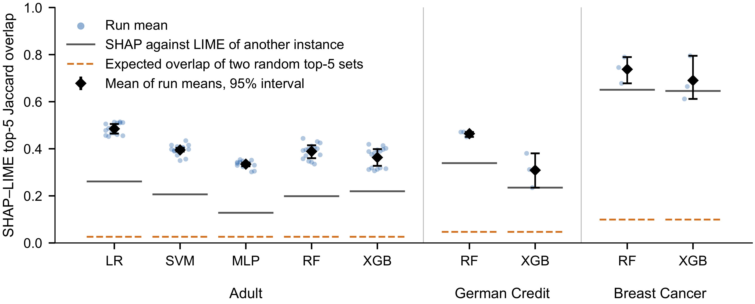
Figure 1. Top-5 overlap between SHAP and LIME by dataset and model family. Each point is the mean of one run; intervals are the spread of the seed means (Figure is in color in the on-line version of the paper).

Table 2. Top-5 Jaccard overlap between two runs of the same method with different random states, and between the new SHAP and LIME runs, on the same subsample of instances: mean of run means and seed-clustered interval (spread of the seed means). Other: the same pair between an instance and the other instances of its run. Post hoc.
 |  |  | LIME vs. LIME | SHAP vs. SHAP | SHAP vs. LIME
Dataset | Model | Inst. | Same instance | Other | Same instance | Other | Same instance | Other
Adult | LR | 100 | 0.774 [0.736, 0.805] | 0.269 | 0.759 [0.710, 0.804] | 0.359 | 0.475 [0.448, 0.495] | 0.264
 | MLP | 100 | 0.526 [0.508, 0.549] | 0.116 | 0.728 [0.685, 0.775] | 0.246 | 0.346 [0.317, 0.372] | 0.140
 | RF | 100 | 0.783 [0.753, 0.808] | 0.182 | 0.887 [0.840, 0.933] | 0.449 | 0.353 [0.337, 0.367] | 0.204
 | XGB | 100 | 0.676 [0.633, 0.706] | 0.211 | 0.754 [0.709, 0.807] | 0.452 | 0.360 [0.326, 0.397] | 0.226
 | All | 400 | 0.690 [0.670, 0.706] | 0.195 | 0.782 [0.743, 0.828] | 0.376 | 0.383 [0.366, 0.403] | 0.209
German Credit | RF | 90 | 0.642 [0.621, 0.674] | 0.405 | 0.708 [0.689, 0.730] | 0.311 | 0.461 [0.437, 0.475] | 0.339
 | XGB | 90 | 0.643 [0.609, 0.665] | 0.371 | 0.709 [0.660, 0.792] | 0.291 | 0.309 [0.256, 0.394] | 0.243
 | All | 180 | 0.642 [0.615, 0.664] | 0.388 | 0.708 [0.682, 0.749] | 0.301 | 0.385 [0.347, 0.432] | 0.291
Breast Cancer | RF | 90 | 0.825 [0.754, 0.937] | 0.685 | 0.952 [0.933, 0.967] | 0.682 | 0.733 [0.660, 0.857] | 0.655
 | XGB | 90 | 0.847 [0.770, 0.956] | 0.733 | 0.927 [0.911, 0.948] | 0.667 | 0.696 [0.619, 0.807] | 0.662
 | All | 180 | 0.836 [0.762, 0.946] | 0.709 | 0.939 [0.922, 0.957] | 0.675 | 0.715 [0.651, 0.832] | 0.659

4.3. Model Family, Sampling Intensity and Dataset (RQ2)
On Adult, agreement differed between the five fitted models. The overlap was highest for logistic regression (0.485) and lowest for the multilayer perceptron (0.335); the first was above the second in each of the five seeds. The rank measure was lowest for the multilayer perceptron (0.043) and for gradient boosting (0.028). Each family is represented by one fitted model, and the self-agreement of LIME was also lowest for the multilayer perceptron (Table 2), so these differences cannot be attributed to the model family as such. On German Credit the overlap was higher for the random forest (0.464) than for gradient boosting (0.309); on Breast Cancer the two families were close.
The sampling intensity had no visible effect: pooled over models, the top-5 overlap on Adult was 0.395, 0.394 and 0.390 for 50, 100 and 200 instances per quadrant.
The dataset changed the estimates most, but not in one direction. Adult and German Credit, with many one-hot encoded features, gave similar and low overlap; Breast Cancer, with 30 numeric features, gave much higher overlap for the same two model families. The permutation reference reverses this order for the instance-specific part, which was largest on Adult and smallest on Breast Cancer (Table 1). Two things differ together between the datasets: the kind of features, and the weight that the fixed kernel of LIME gives to its perturbed samples, which falls as the number of features grows (Section 5). Three datasets do not allow the difference to be attributed to either.

4.4. Agreement of Signs (Post Hoc)
The planned sign agreement on shared top-5 features was 0.717 on Adult (0.687 to 0.747), 0.511 on German Credit (0.481 to 0.528) and 0.374 on Breast Cancer (0.357 to 0.385). It is defined on the shared features only, whose mean number was given above. The last value is below one half, on the dataset where the two methods agree most on which features matter. This led to the post hoc analysis in Table 3 and Figure 2.
Sign agreement depended strongly on the predicted class. On Breast Cancer it was 0.977 for instances predicted as class 0 and 0.036 for instances predicted as class 1. On Adult it was 0.875 for class 1 and 0.506 for class 0, and the same pattern appeared in four of the five model families; the multilayer perceptron was the exception.
The reason is that the two methods return different quantities (Section 3.2). The LIME coefficient of a continuous feature is a local slope. The slope of a feature with a monotone effect has the same sign for most instances. A SHAP value is a contribution relative to the expected output: for the same feature it is positive for instances on one side of the reference and negative on the other. The two signs therefore coincide for the instances of one predicted class and differ for the other. The constancy measure confirms it: on Breast Cancer, a feature kept its majority sign in 0.993 of its LIME explanations and in 0.621 of its SHAP explanations (0.912 and 0.679 on German Credit; 0.850 and 0.757 on Adult, where most features are one-hot indicators).
The conversion of Eq. (2) removes this difference. When each LIME slope was converted into a contribution, the sign agreement rose to 0.945 on Adult (95% interval 0.941 to 0.949), 0.960 on German Credit (0.953 to 0.964) and 0.990 on Breast Cancer (0.983 to 0.997), and the dependence on the predicted class disappeared: on Breast Cancer it was 0.991 for class 0 and 0.989 for class 1, and on Adult 0.927 and 0.958. It exceeded nine tenths for every model family (Table 3).
This high value must be read with its baseline. The conversion multiplies the slope by the deviation of the feature from its mean, and the sign of a SHAP value for a feature with a monotone effect carries the same factor. What is left to agree is one direction per feature. A baseline that uses no instance-level information from LIME shows this: when the sign of every LIME slope was replaced by the majority sign of that feature in the same run, the agreement with SHAP after conversion was 0.951 on Adult, 0.978 on German Credit and 0.990 on Breast Cancer, as high as with the slopes of each instance.
Sign agreement between SHAP and LIME without discretisation is thus not a measure of disagreement about the direction of an effect; it measures mostly on which side of the reference the instance lies. After conversion, the two methods imply the same direction for nearly all the features that both place among the five most important, and this direction is a global one per feature. The result does not show that the two methods agree on instance-specific directions, which these data cannot test.

Table 3. Sign agreement on shared top-5 features, overall and by predicted class (Cl.), with the LIME value as stored (slope) and after conversion into a contribution. The column All of the slope block is the prespecified estimate; the rest is post hoc.
 |  | Slope | Contribution
Dataset | Model | All | Cl. 0 | Cl. 1 | All | Cl. 0 | Cl. 1
Adult | LR | 0.696 | 0.527 | 0.864 | 0.947 | 0.947 | 0.948
 | SVM | 0.829 | 0.332 | 0.956 | 0.952 | 0.918 | 0.960
 | MLP | 0.689 | 0.706 | 0.672 | 0.951 | 0.940 | 0.962
 | RF | 0.696 | 0.418 | 0.975 | 0.948 | 0.913 | 0.984
 | XGB | 0.682 | 0.443 | 0.916 | 0.925 | 0.911 | 0.939
 | All | 0.717 | 0.506 | 0.875 | 0.945 | 0.927 | 0.958
German Credit | RF | 0.470 | 0.608 | 0.430 | 0.985 | 0.990 | 0.983
 | XGB | 0.553 | 0.716 | 0.494 | 0.934 | 0.933 | 0.934
 | All | 0.511 | 0.662 | 0.462 | 0.960 | 0.962 | 0.959
Breast Cancer | RF | 0.377 | 0.975 | 0.041 | 0.997 | 1.000 | 0.995
 | XGB | 0.371 | 0.979 | 0.032 | 0.983 | 0.983 | 0.983
 | All | 0.374 | 0.977 | 0.036 | 0.990 | 0.991 | 0.989

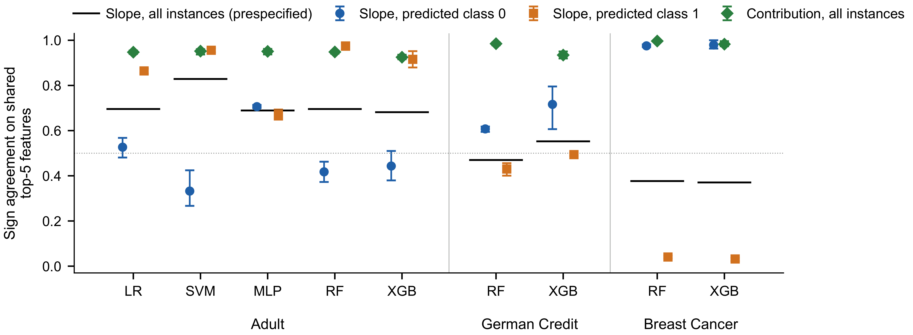
Figure 2. Sign agreement between SHAP and LIME. Circles and squares: LIME value as stored (slope), by predicted class, with seed-clustered 95% intervals (spread of the seed means). Diamonds: all instances after the slopes were converted into contributions. The dotted line marks one half (Figure is in color in the on-line version of the paper).

4.5. Correct and Misclassified Instances (RQ3)
Table 4 and Figure 3 give the difference in top-5 overlap between misclassified and correctly classified instances. The direction was not consistent. For the multilayer perceptron, agreement was lower on misclassified instances (difference $-$0.059, interval $-$0.069 to $-$0.049, same direction in all five seeds). For the random forest it was higher (0.045, 0.029 to 0.064, all five seeds), and slightly higher for gradient boosting (0.014). For logistic regression and the support vector machine the difference was near zero. On German Credit the differences were small and negative, with three seeds. On Breast Cancer no run had ten misclassified instances, so the contrast could not be estimated. The largest difference in absolute value was that of the multilayer perceptron, small compared with the differences between models.
On Adult this contrast is entangled with membership in the training data. For the four seeds other than 42, 0.707 of the paired instances are rows of the training data, and for the random forest 0.840 of the correctly classified instances are training rows against 0.006 of the misclassified ones. The contrast was therefore repeated on held-out instances only. The pattern remained: for the multilayer perceptron the difference was $-$0.042 ($-$0.058 to $-$0.024, negative in all five seeds), for the random forest 0.049 (0.032 to 0.066, positive in all five seeds), and for logistic regression and gradient boosting 0.000 and $-$0.004, with seeds of both signs. For the support vector machine only 5 of 14 runs had ten held-out instances in each group; the difference was 0.028, with seeds of both signs. The differences of the multilayer perceptron and the random forest are thus not produced by the training instances, and their opposite signs remain.

Table 4. Top-5 overlap for correctly classified (C) and misclassified (M) instances. Diff. is M minus C, with the spread of the seed means; Neg. is the number of seeds with a negative difference; GC is German Credit. The SVM row rests on incomplete runs.
Data | Model | C | M | Diff. | 95% interval | Neg.
Adult | LR | 0.486 | 0.483 | $-$0.003 | [$-$0.023, 0.012] | 2/5
Adult | SVM | 0.388 | 0.387 | $-$0.001 | [$-$0.017, 0.020] | 3/4
Adult | MLP | 0.364 | 0.305 | $-$0.059 | [$-$0.069, $-$0.049] | 5/5
Adult | RF | 0.367 | 0.412 | 0.045 | [0.029, 0.064] | 0/5
Adult | XGB | 0.356 | 0.370 | 0.014 | [0.003, 0.022] | 1/5
GC | RF | 0.469 | 0.452 | $-$0.017 | [$-$0.036, 0.001] | 2/3
GC | XGB | 0.311 | 0.305 | $-$0.005 | [$-$0.010, $-$0.001] | 3/3

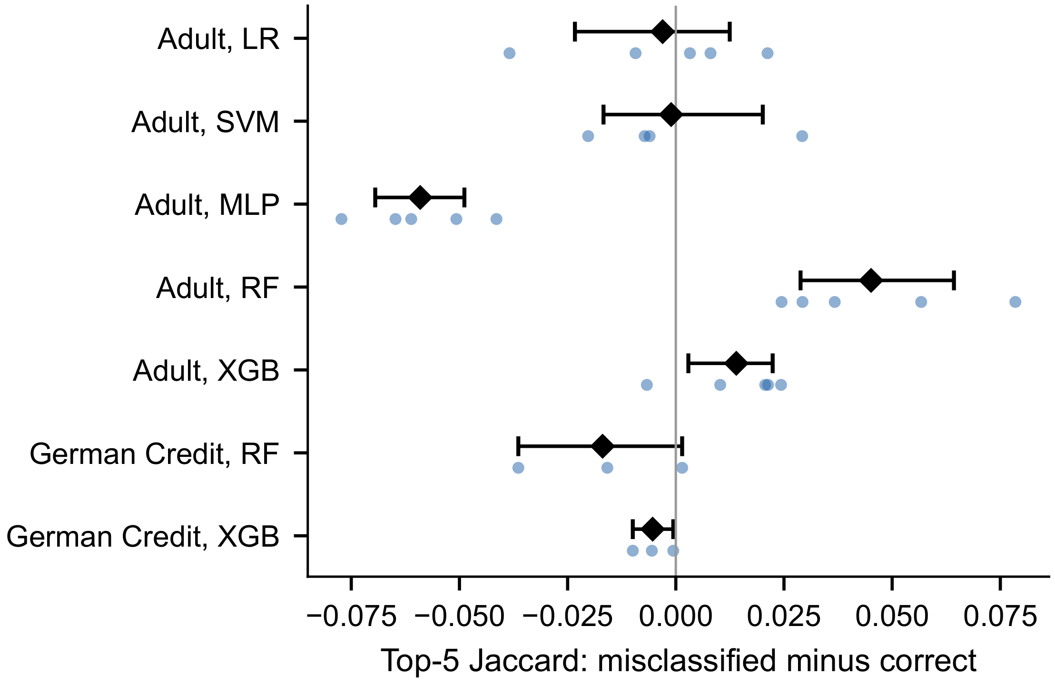
Figure 3. Difference in top-5 overlap, misclassified minus correct. Points are seeds; diamonds are means with seed-clustered 95% intervals (spread of the seed means) (Figure is in color in the on-line version of the paper).

4.6. Disagreement and Explanation Quality (RQ4)
Table 5 and Figure 4 give the within-run Spearman correlation between disagreement and the four quality values. The clearest pattern concerns the fidelity of LIME: on Adult the correlation was negative for all five model families (from $-$0.45 to $-$0.19), and it was negative on German Credit ($-$0.26 and $-$0.24); on Breast Cancer it was negative for the random forest ($-$0.28) and near zero for gradient boosting. The two methods disagreed more on the instances where the sizes of the LIME attributions followed less closely the effect of masking each feature. The correlations with the fidelity of SHAP were closer to zero and of mixed sign.
For stability there was no common pattern. On Adult the correlations were small and mostly positive, except for the multilayer perceptron. For LIME on Adult they cannot be interpreted: the stored stability of LIME has almost no range there (its median by model lies between 0.001 and 0.009, against 0.793 to 0.865 on German Credit and 0.943 to 0.955 on Breast Cancer; post hoc). On Breast Cancer, disagreement was higher for instances with less stable explanations of either method, for the random forest ($-$0.56 and $-$0.54) and less so for gradient boosting ($-$0.34 and $-$0.27), with three runs each. These are associations within runs; they do not show that low fidelity causes disagreement. The fidelity measure rewards attributions whose size follows the effect of replacing a feature by its mean, which is a contribution; a vector of slopes is at a disadvantage by construction, so part of this association may reflect how far the slopes of an instance are from its contributions.

Table 5. Mean within-run Spearman correlation between disagreement ($1-J_{5}$) and explanation quality. Fid.: fidelity; Stab.: stability. On Adult the stored LIME stability has almost no range, so the last column cannot be interpreted for that dataset.
 |  | SHAP | LIME
Dataset | Model | Fid. | Stab. | Fid. | Stab.
Adult | LR | $-$0.01 | 0.09 | $-$0.40 | 0.12
 | SVM | $-$0.05 | 0.06 | $-$0.45 | 0.12
 | MLP | $-$0.06 | $-$0.24 | $-$0.19 | $-$0.07
 | RF | $-$0.22 | 0.23 | $-$0.27 | 0.10
 | XGB | $-$0.15 | 0.14 | $-$0.40 | 0.11
German Credit | RF | $-$0.05 | $-$0.06 | $-$0.26 | $-$0.10
 | XGB | $-$0.04 | 0.02 | $-$0.24 | $-$0.15
Breast Cancer | RF | $-$0.06 | $-$0.56 | $-$0.28 | $-$0.54
 | XGB | 0.22 | $-$0.34 | 0.01 | $-$0.27

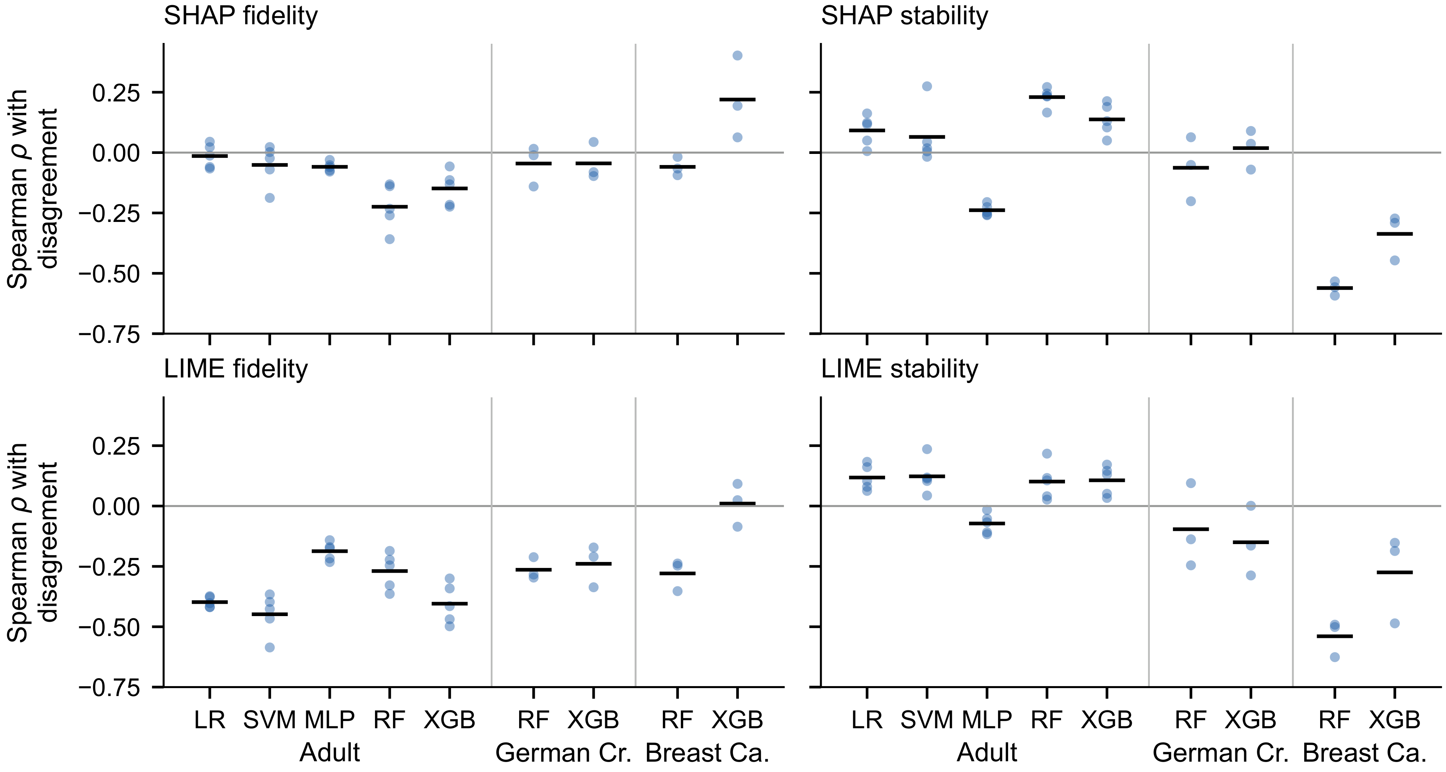
Figure 4. Within-run Spearman correlation between disagreement and four quality values. Points are seeds; bars are means over seeds (Figure is in color in the on-line version of the paper).

4.7. Feature Sets of Anchors and DiCE (Secondary)
Table 6 gives the overlap between feature sets on Adult. The features in an Anchors rule overlapped more with the SHAP top-5 set (0.348) than with the LIME top-5 set (0.240). The features changed by DiCE overlapped little with any other set (at most 0.078). These methods answer different questions, a sufficient condition and a minimal change, so a low overlap is not an error of either method; it shows that their features cannot be substituted for those of an attribution method.

Table 6. Jaccard overlap between feature sets on Adult (SHAP, LIME: top-5 features; Anchors: rule features; DiCE: changed features): mean of run means and seed-clustered 95% interval (spread of the seed means).
Feature sets | Runs | Pairs | Mean | 95% int.
SHAP vs. Anchors | 56 | 14,584 | 0.348 | [0.340, 0.356]
LIME vs. Anchors | 57 | 19,095 | 0.240 | [0.234, 0.247]
SHAP vs. DiCE | 67 | 25,248 | 0.078 | [0.068, 0.087]
LIME vs. DiCE | 68 | 29,830 | 0.078 | [0.074, 0.085]
Anchors vs. DiCE | 53 | 18,578 | 0.068 | [0.062, 0.075]

5. Discussion
The choice of explainer changes the explanation, and so does a second run. On two of the three datasets, SHAP and LIME shared on average fewer than three of their five most important features. A user who reads a top-5 list would often see a different list with the other method. This agrees with the disagreement reported by Krishna et al. [3]. The self-agreement experiment qualifies it: the user would also see a partly different list from the same method with another random state. Disagreement between methods was larger than this within-method variability for every model, so it is real, but a comparison of two explainers that ignores their repeatability overstates how much they differ. For LIME, more perturbed samples would raise the repeatability; the 1000 used here are fewer than the default of the package.
Agreement varies with the model and the data. The differences between models and between datasets were larger than every other effect measured here. One reading is that the methods approximate the model in different neighbourhoods [10] and coincide more where the model is close to linear; another is that the repeatability of the explainers itself changes with the model, as for the multilayer perceptron (Table 2). These data do not separate the two, and on Adult each family is a single fitted model. The high overlap on Breast Cancer is mostly agreement on a ranking of the features that is nearly the same for every instance; the overlap that depends on the instance was small on the three datasets and smallest there. A high overlap is therefore not evidence that two explainers agree about the individual prediction. A report of explainer agreement should state the model, the dataset, the configuration and the repeatability of each method and the overlap between explanations of different instances, and should not be generalised from one of them.
Signs need the same quantity. The sign analysis shows a risk for any study that compares the direction of attributions between methods. A LIME coefficient without discretisation is a slope; a SHAP value is a contribution relative to a reference [1], [11]. Their signs differed for almost every instance of one class on Breast Cancer, while the two methods implied the same global direction for the feature: after the slope was multiplied by the deviation of the feature from the training mean, the signs agreed for more than nine shared features out of ten on every dataset and model. Before signs are compared, the two explanations should be brought to the same quantity in this way, or LIME should be used with discretisation, whose weights refer to the value of the instance. Roy et al. [5] also found sign disagreement to be the smaller part of the problem. In these data, the disagreement between SHAP and LIME concerns which features are ranked first; on the direction of the features they share, the two methods give no evidence of conflict, although a fixed direction per feature would give the same agreement. The measures of overlap and rank used for RQ1 to RQ4 depend on absolute values and are not affected by this difference of sign. A slope and a contribution also differ in size, but re-ordering the LIME lists by contribution changed the overlap little.
Disagreement and correctness. Agreement was not consistently lower when the model was wrong. The direction depended on the model, also on held-out instances, and the differences were small. No consistent association between disagreement and a wrong prediction was found in these data.
Disagreement and LIME fidelity. On Adult and, more weakly, on German Credit, disagreement was higher where the fidelity of the LIME explanation was lower, that is, where the sizes of its attributions followed the single-feature masking effects less closely. Since that measure favours contributions over slopes, the association may indicate the instances where the slope and the contribution of LIME differ most. It is an association within runs, on a proxy measure.
Limitations. The study covers three tabular binary datasets and one configuration of each explainer. LIME was used with a kernel width of 3, chosen without a technical reason and smaller than the default of the package. With this width the 999 perturbed samples of an explanation, drawn around the training mean, together receive a median weight of 0.26 on Adult, 2.3 on German Credit and 83.6 on Breast Cancer, against a weight of one for the instance itself (post hoc), and the stored stability of LIME on Adult is close to zero. Section 4.2 shows how much the width changes the LIME lists; other sample sizes or discretisation settings may change the estimates as well. There are five seeds on Adult and three on the other datasets; the intervals describe the spread of seed means and the analyses of RQ2 to RQ4 are exploratory. On Adult each model family is one fitted model, so nothing here separates a family from that fit. The self-agreement experiment used a small subsample and one pair of random states. Only the ten largest features of each explanation were stored, which limits the rank measure to that list. One-hot columns were treated as separate features; an analysis by original variable would give higher overlap. Fidelity and stability are proxy measures computed without ground-truth explanations. On Adult, each model was trained once, and for four of the five seeds about seven in ten of the explained instances belong to its training data; the mean top-5 overlap for seed 42, whose evaluation partition is disjoint from the training data, lies within the range of the other four seeds, and the correctness contrast was repeated on held-out instances. LIME, as configured, also treats one-hot columns as continuous, so its slopes are only loosely local. The conversion of slopes into contributions uses the training mean as reference, while SHAP uses the expected output on a background sample, so the two references are close but not identical. The SHAP runs of the SVM are incomplete, so that family has fewer pairs, unevenly distributed between the predicted classes. The models of the two smaller datasets were regenerated from the training recipe and validated against stored metrics and predictions, not compared byte by byte with the original binaries. For the Adult random forest, the stored binary does not reproduce all the predictions recorded in the runs; the agreement analyses use only the recorded outputs, and the paired SHAP and LIME records agree on every label and prediction. The self-agreement experiment, which needs the binary, kept only the instances whose recorded prediction it reproduces. The sign analysis, including the conversion into contributions, is post hoc.

6. Conclusions and Future Work
For the same instance and model, SHAP and LIME agreed only partly on the most important features: the mean top-5 overlap was 0.393 on Adult, 0.387 on German Credit and 0.714 on Breast Cancer. Much of this overlap, and most of it on Breast Cancer, was also found between explanations of different instances, so it reflects a ranking of the features common to the instances; the part specific to the instance was 0.191 on Adult and smaller on the other two datasets (post hoc). Each method also agreed only partly with itself when run again, and the agreement between the methods was below that self-agreement for every model tested (post hoc). Agreement varied with the model and the dataset, not visibly with the number of explained instances, and it was not consistently lower for misclassified instances. The sign agreement between SHAP and LIME without discretisation followed the predicted class, because one method returns slopes and the other contributions (post hoc). After conversion to contributions the signs of the shared top features agreed in 0.945 to 0.990 of the cases, the level that one fixed direction per feature reaches. Sign agreement should not be used as a measure of disagreement unless both explanations are first expressed as the same quantity.
Three practical consequences follow. An explanation shown to a user should name the explainer, since another explainer would often show other features. A comparison of explainers should report how well each one reproduces itself and how much two explanations of different instances overlap, since these set the levels against which their agreement can be judged. And it should check, before any measure is computed, what each stored value means.
Future work will measure self-agreement on the full cohort, with more LIME samples and with other kernel widths, compare the methods on a common quantity, repeat the analysis by original variable, and add models and datasets to separate the effect of the model family from that of a single fit.

Data Availability
The three datasets are public [15]-[17]. The code, the per-instance run outputs, the new LIME cohort, the pre-specified analysis plan and every result file are available at https://github.com/jonnabio/xai-eval-framework (release paper-e-cys-2026-10-04-r2), archived at https://doi.org/10.5281/zenodo.23142429. Every number, table and figure in this article is generated from those files by the scripts described in docs/reports/paper_e/README.md.

Ethics Statement
No ethics committee permission was required: the study uses three public datasets and involves no human participants and no personal data collected by the author.

Declaration of interest
The author declares that there is no conflict of interest.

Nomenclature
$c_{j}$ contribution of feature $j$ derived from its LIME slope (-)
$J_{k}$ Jaccard overlap of the top-$k$ feature sets of two explanations (-)
$k$ number of top-ranked features compared (-)
$L_{k}$ set of the $k$ features with the largest absolute LIME values (-)
$m_{j}$ training mean of feature $j$ (-)
$n$ test instances explained per quadrant of the confusion matrix (-)
$p$ number of encoded features of a dataset (-)
$S_{k}$ set of the $k$ features with the largest absolute SHAP values (-)
$s_{j}$ standard deviation of feature $j$ used by LIME (-)
$w_{j}$ LIME slope of feature $j$ (-)
$x_{j}$ value of feature $j$ for the explained instance (-)

Greek symbols
$τ_{b}$ Kendall rank correlation coefficient with ties (-)

Abbreviations
DiCE Diverse Counterfactual Explanations
LIME Local Interpretable Model-agnostic Explanations
LR logistic regression
MLP multilayer perceptron
RF random forest
RQ research question
SHAP SHapley Additive exPlanations
SVM support vector machine
XGB gradient boosting (XGBoost)

References
[1] Lundberg SM, Lee SI. “A unified approach to interpreting model predictions”, In: Advances in Neural Information Processing Systems, vol. 30, (2017) 4765–4774. Available: https://proceedings.neurips.cc/paper/2017/hash/8a20a8621978632d76c43dfd28b67767-Abstract.html.
[2] Ribeiro MT, Singh S, Guestrin C. “Why should I trust you?: Explaining the predictions of any classifier”, In: Proceedings of the 22nd ACM SIGKDD International Conference on Knowledge Discovery and Data Mining, (2016) 1135–1144; doi: https://doi.org/10.1145/2939672.2939778.
[3] Krishna S, Han T, Gu A, Wu S, Jabbari S, Lakkaraju H. “The disagreement problem in explainable machine learning: A practitioner’s perspective”, Transactions on Machine Learning Research (2024); doi: https://doi.org/10.48550/arXiv.2202.01602.
[4] Neely M, Schouten SF, Bleeker MJR, Lucic A. “Order in the court: Explainable AI methods prone to disagreement”, ICML Workshop on Theoretic Foundation, Criticism, and Application Trend of Explainable AI, (2021); doi: https://doi.org/10.48550/arXiv.2105.03287.
[5] Roy S, Laberge G, Roy B, Khomh F, Nikanjam A, Mondal S. “Why don’t XAI techniques agree? Characterizing the disagreements between post-hoc explanations of defect predictions”, In: 2022 IEEE International Conference on Software Maintenance and Evolution (ICSME), (2022) 444–448; doi: https://doi.org/10.1109/ICSME55016.2022.00056.
[6] Rudin C. “Stop explaining black box machine learning models for high stakes decisions and use interpretable models instead”, Nature Machine Intelligence 1(5) (2019) 206–215; doi: https://doi.org/10.1038/s42256-019-0048-x.
[7] Doshi-Velez F, Kim B. “Towards a rigorous science of interpretable machine learning”, arXiv preprint arXiv:1702.08608, (2017); doi: https://doi.org/10.48550/arXiv.1702.08608.
[8] Ribeiro MT, Singh S, Guestrin C. “Anchors: High-precision model-agnostic explanations”, In: Proceedings of the Thirty-Second AAAI Conference on Artificial Intelligence, (2018) 1527–1535; doi: https://doi.org/10.1609/aaai.v32i1.11491.
[9] Mothilal RK, Sharma A, Tan C. “Explaining machine learning classifiers through diverse counterfactual explanations”, In: Proceedings of the 2020 Conference on Fairness, Accountability, and Transparency, (2020) 607–617; doi: https://doi.org/10.1145/3351095.3372850.
[10] Han T, Srinivas S, Lakkaraju H. “Which explanation should I choose? A function approximation perspective to characterizing post hoc explanations”, In: Advances in Neural Information Processing Systems, vol. 35, (2022) 5256–5268; doi: https://doi.org/10.52202/068431-0380.
[11] Garreau D, von Luxburg U. “Explaining the explainer: A first theoretical analysis of LIME”, In: Proceedings of the 23rd International Conference on Artificial Intelligence and Statistics (AISTATS), vol. 108, (2020) 1287–1296. Available: https://proceedings.mlr.press/v108/garreau20a.html.
[12] Lundberg SM, Erion G, Chen H, DeGrave A, Prutkin JM, Nair B, Katz R, Himmelfarb J, Bansal N, Lee SI. “From local explanations to global understanding with explainable AI for trees”, Nature Machine Intelligence 2(1) (2020) 56–67; doi: https://doi.org/10.1038/s42256-019-0138-9.
[13] Alvarez-Melis D, Jaakkola TS. “On the robustness of interpretability methods”, In: ICML Workshop on Human Interpretability in Machine Learning (WHI 2018), (2018); doi: https://doi.org/10.48550/arXiv.1806.08049.
[14] Slack D, Hilgard S, Jia E, Singh S, Lakkaraju H. “Fooling LIME and SHAP: Adversarial attacks on post hoc explanation methods”, In: Proceedings of the AAAI/ACM Conference on AI, Ethics, and Society, (2020) 180–186; doi: https://doi.org/10.1145/3375627.3375830.
[15] Becker B, Kohavi R. “Adult [dataset]”, UCI Machine Learning Repository, (1996); doi: https://doi.org/10.24432/C5XW20.
[16] Hofmann H. “Statlog (German credit data) [dataset]”, UCI Machine Learning Repository, (1994); doi: https://doi.org/10.24432/C5NC77.
[17] Wolberg W, Mangasarian O, Street N, Street W. “Breast cancer Wisconsin (diagnostic) [dataset]”, UCI Machine Learning Repository, (1993); doi: https://doi.org/10.24432/C5DW2B.
[18] Breiman L. “Random forests”, Machine Learning 45(1) (2001) 5–32; doi: https://doi.org/10.1023/A:1010933404324.
[19] Chen T, Guestrin C. “XGBoost: A scalable tree boosting system”, In: Proceedings of the 22nd ACM SIGKDD International Conference on Knowledge Discovery and Data Mining, (2016) 785–794; doi: https://doi.org/10.1145/2939672.2939785.
[20] Herrera-Vásquez J, Herrero-Uceda M. “A framework for rigorous evaluation of model-agnostic explainability methods: multi-metric statistical benchmarking, operational protocol, and reproducibility”, Revista de Investigación Multidisciplinaria Iberoamericana (RIMI), No. 3 (2026); doi: https://doi.org/10.69850/rimi.vi3.307.
[21] Jaccard P. “The distribution of the flora in the alpine zone”, New Phytologist 11(2) (1912) 37–50; doi: https://doi.org/10.1111/j.1469-8137.1912.tb05611.x.
[22] Kendall MG. “The treatment of ties in ranking problems”, Biometrika 33(3) (1945) 239–251; doi: https://doi.org/10.1093/biomet/33.3.239.
[23] Efron B, Tibshirani RJ. “An Introduction to the Bootstrap”, Chapman & Hall, New York, 1993; doi: https://doi.org/10.1201/9780429246593.
[24] Cameron AC, Miller DL. “A practitioner’s guide to cluster-robust inference”, Journal of Human Resources 50(2) (2015) 317–372; doi: https://doi.org/10.3368/jhr.50.2.317.
[25] Bhatt U, Weller A, Moura JMF. “Evaluating and aggregating feature-based model explanations”, In: Proceedings of the Twenty-Ninth International Joint Conference on Artificial Intelligence (IJCAI), (2020) 3016–3022; doi: https://doi.org/10.24963/ijcai.2020/417.

