**Application Deployment Automation:**

**Code Pipeline**:

AWS Code Pipeline is a fully managed continuous delivery service that helps you automate your release pipelines for fast and reliable application and infrastructure updates. Code Pipeline automates the build, test, and deploy phases of your release process every time there is a code change, based on the release model you define. This enables you to rapidly and reliably deliver features and updates

**Architecture**:



To move the application from code repository to EKS cluster, implement AWS code pipeline integrated with Code Build and ECR. One can deploy a complete code pipeline with a cloud formation template.

**NOTE**: For the template please replace the placeholders with appropriate parameter values

**buildspec.yml.** file will build the docker image from the tenant github code repository ,push the built image to ECR repository and deploy the same on the deployed EKS cluster.

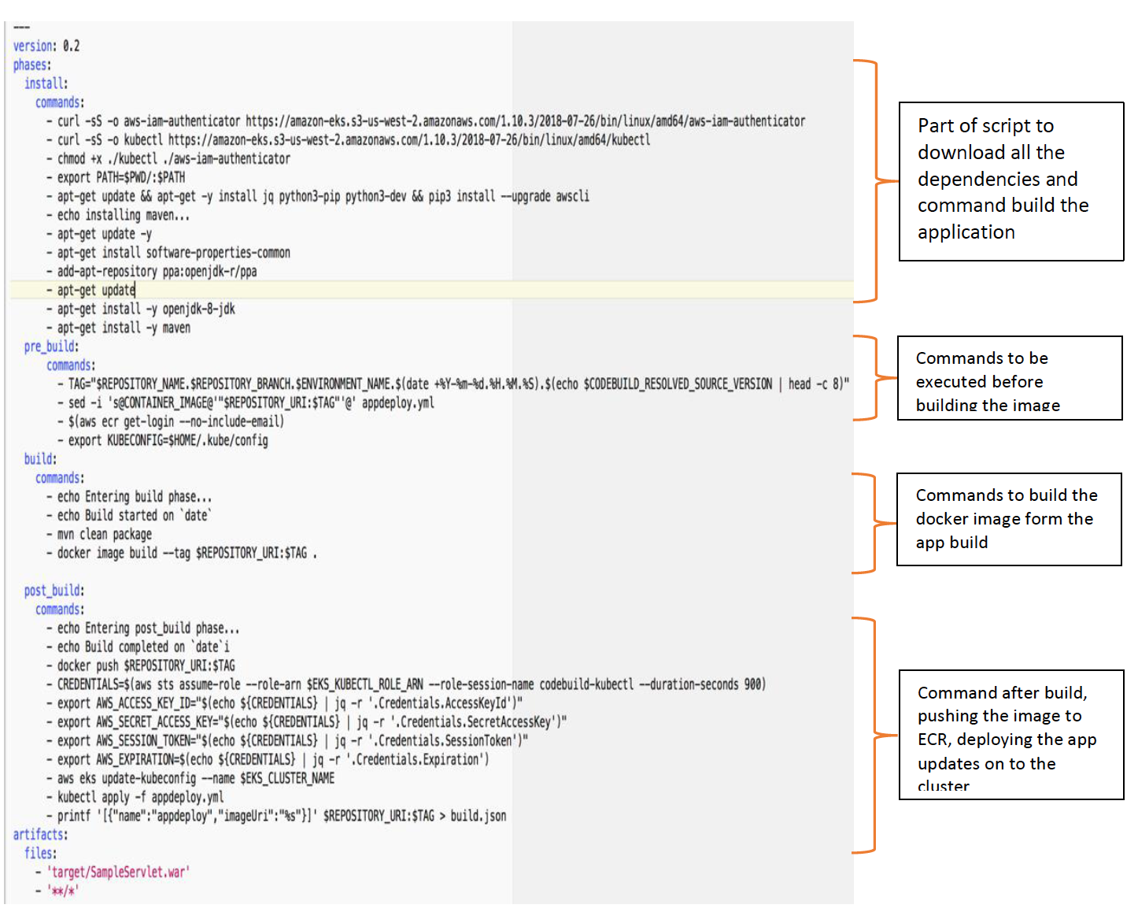

**NOTE:** Update **“EKS_KUBECTL_ROLE_ARN”** with tenant role arn created by tenant authorization script.