ONLINE AUCTION & BIDDING SYSTEM
A Java console application - Project Report
PRESENTED BY
Sriram Reddy - Roll No: 2620030135
Sri Vyshnavi - Roll No: 2620030114

1. Abstract
A console-based auction where the highest valid bid wins.
- A Java-based online auction platform where sellers list items and buyers place live bids.
- Automates bid validation, highest-bid tracking, auction closing and winner selection.
- Built with the six course modules: foundations, control flow, methods, OOP, file I/O and collections.
- Replaces manual, error-prone auctions with a fast, fair and transparent system.

2. Understanding the Problem Statement
Why an automated bidding system is needed.
- Traditional auctions need physical presence, are slow and are hard to audit.
- Manual bid tracking causes errors, disputes and unfair winner selection.
- Need: validate bids, enforce the increment rule, handle invalid input and keep records.
- Goal: a reliable console application for users, items, bids and results.

3. Module 1: Computational Thinking & Java Foundations
Algorithm design, data types, Scanner input and the main() skeleton.
WHAT is used
- Data types: int (item id), double (prices), boolean (running / open flag), String (names).
- Scanner for keyboard input, System.out.printf for formatted output.
- Algorithm: register > list item > place bids > close > winner.
- main() entry point with a loop that keeps the program running.
WHY it is used
- Decomposing the problem first keeps the design simple: users, items, bids, winner.
- Correct data types avoid rounding and logic errors (money needs double, flags need boolean).
- Scanner/printf give a clear, aligned console interface without any GUI.

4. Module 2: Control Flow
switch, if / else and loops drive the menu and validation.
WHAT is used
- switch statement to route each menu choice to a feature.
- if / else to validate roles, item ids and empty lists.
- while loop to keep showing the menu until Exit.
- for loop to print every item in the table.
WHY it is used
- switch is cleaner and faster to read than many if-else chains for a fixed menu.
- if / else stops invalid requests before they change auction data.
- Loops let users do many actions in one run and avoid repeating code.

5. Module 3: Methods, Recursion & Arrays
Methods, recursion and arrays split the work into reusable pieces.
WHAT is used
- Methods: register(), listItem(), placeBid(), closeAuction() each do one job.
- Recursion: readPrice() calls itself until a valid positive number is entered.
- Overloading: findItem(int id) and findItem(String name).
- Array: CATEGORIES = {Art, Electronics, Books, Other}.
WHY it is used
- Small methods are reusable, easier to test and easier to debug.
- Recursion gives simple retry-on-bad-input without a messy loop.
- Overloading lets one concept (find an item) work with different inputs.
- A fixed array suits a short list of categories that never changes.

6. Module 4: OOP & Exception Handling
Classes, inheritance, encapsulation and custom exceptions.
WHAT is used
- Classes: User (abstract), Seller, Bidder, Bid, Item.
- Inheritance and abstract role() with polymorphism.
- Encapsulation: private name with getName().
- Custom checked exceptions: AuctionException, InvalidBidException, AuctionClosedException.
WHY it is used
- Classes model real-world objects, so the code mirrors the auction.
- Inheritance shares common user code; polymorphism lets each role behave differently.
- Encapsulation protects data from accidental change.
- Custom exceptions enforce bid rules (minimum increment, closed auction) and give clear error messages.

7. Module 5: Strings, Algorithms & File I/O
Regex validation, insertion sort and saving data to a file.
WHAT is used
- String.matches() with regex [A-Za-z][A-Za-z0-9_]{2,15} to validate usernames.
- Insertion sort to rank items by highest bid.
- File I/O: PrintWriter / FileWriter to save, BufferedReader / FileReader to load auction.txt.
- try-with-resources to close files automatically.
WHY it is used
- Regex rejects bad or unsafe names in a single line.
- Sorting shows the hottest items first; insertion sort is simple for small lists.
- File I/O keeps data after the program exits, so the auction is not lost.
- try-with-resources prevents resource leaks even when an error occurs.

8. Module 6: Collections, Functional Programming & Streams
Maps, streams, lambdas and Optional pick the winner.
WHAT is used
- LinkedHashMap for items (keeps listing order) and HashMap for users (fast lookup by name).
- Streams + Comparator.max() to find the winning bid.
- Collectors.groupingBy, lambdas and merge() for statistics.
- Optional to handle items that have no bids.
WHY it is used
- Maps give fast lookup by id or name instead of scanning lists.
- Streams and lambdas make the winner and statistics short and readable.
- Optional avoids NullPointerException when nobody bid - shows "unsold" safely.

9. Complete Program Code
The whole auction system in one small, runnable Java file (AuctionSystem.java). Run it with: java AuctionSystem.java
import java.util.*;
public class AuctionSystem {
static Scanner sc = new Scanner(System.in);
static ArrayList<Item> items = new ArrayList<>();
static class Item {
String name, bidder = "nobody";
double price;
boolean open = true;
Item(String n, double p) { name = n; price = p; }
}

static void addItem() {
System.out.print("Item name: ");
String name = sc.next();
System.out.print("Starting price: ");
double price = sc.nextDouble();
items.add(new Item(name, price));
System.out.println("Added. Item id = " + items.size());
}

static Item getItem() {
System.out.print("Item id: ");
int id = sc.nextInt();
if (id < 1 || id > items.size()) {
System.out.println("No such item");
return null;
}
return items.get(id - 1);
}

static void placeBid() {
Item item = getItem();
if (item == null) return;
if (!item.open) { System.out.println("Auction is closed"); return; }
System.out.print("Your name: ");
String who = sc.next();
System.out.print("Your bid: ");
double bid = sc.nextDouble();
if (bid > item.price) {
item.price = bid;
item.bidder = who;
System.out.println("Bid accepted!");
} else
System.out.println("Bid must be higher than " + item.price);
}
static void showItems() {
for (int i = 0; i < items.size(); i++) {
Item it = items.get(i);
System.out.println((i + 1) + ". " + it.name + " price: "
+ it.price + " " + (it.open ? "OPEN" : "CLOSED"));
}
}

static void closeAuction() {
Item item = getItem();
if (item == null) return;
item.open = false;
if (item.bidder.equals("nobody"))
System.out.println("No bids - item unsold");
else
System.out.println("Winner: " + item.bidder + " with " + item.price);
}

public static void main(String[] args) {
while (true) {
System.out.print("\n1.Add 2.Bid 3.Show 4.Close 0.Exit: ");
int choice = sc.nextInt();
switch (choice) {
case 1: addItem(); break;
case 2: placeBid(); break;
case 3: showItems(); break;
case 4: closeAuction(); break;
case 0: return;
default: System.out.println("Invalid choice");
}
}
}
}

10. Code Output Screenshots
The program was compiled and run (Java 21). The screenshots below show the actual terminal output for the main features.

Output 1 - Adding items and showing the item list
Three items are added (ids 1 to 3). Menu option 3 lists every item with its current price and OPEN status.
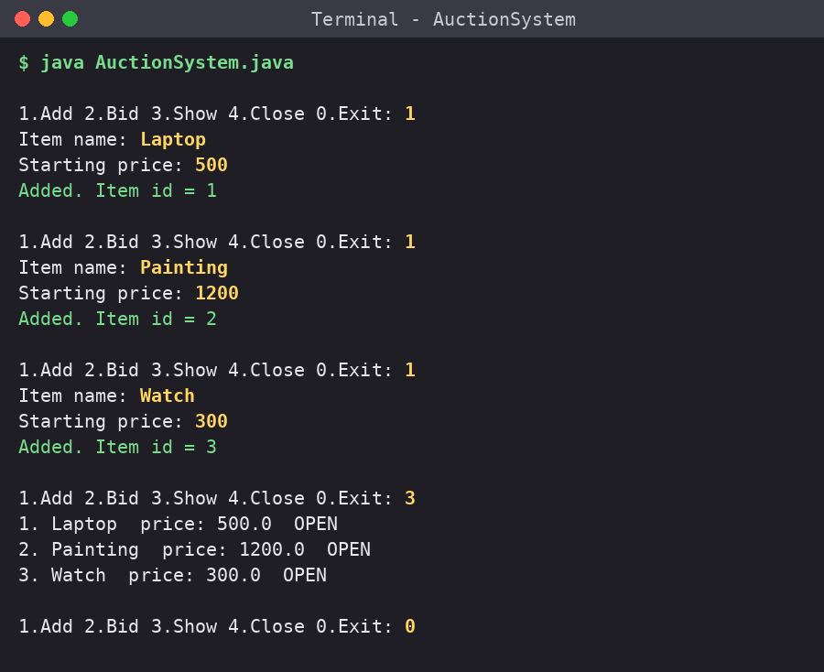

Output 2 - Placing bids
A bid of 450 on a 500 item is rejected. Bids of 600 and 750 are accepted, each becoming the new highest bid. An unknown item id (9) is reported as "No such item".
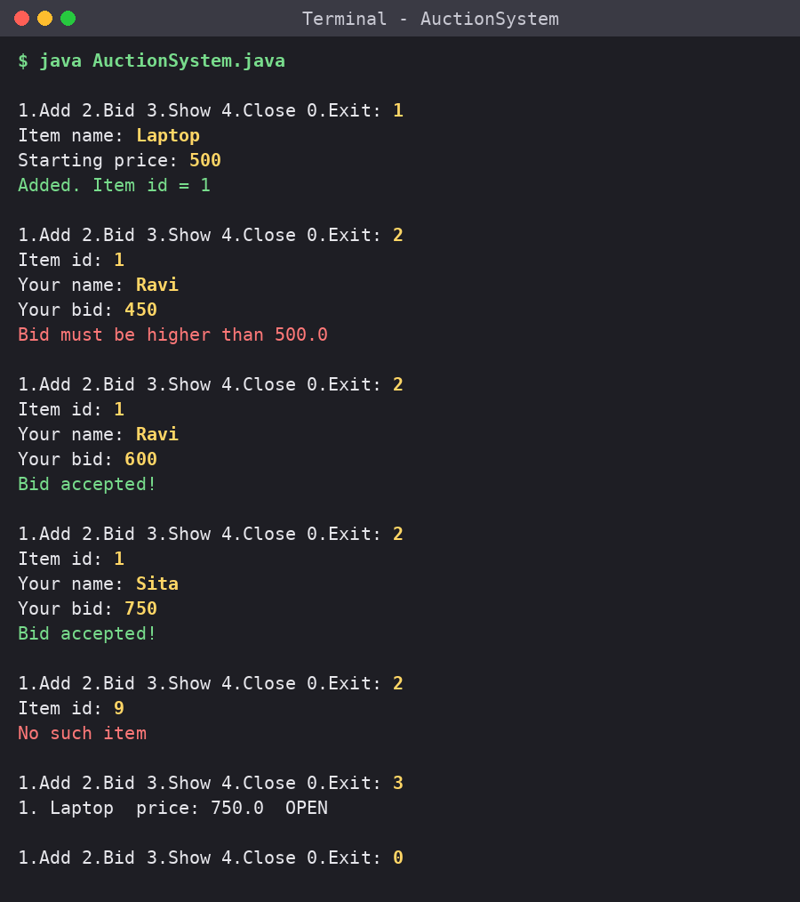

Output 3 - Closing auctions
Closing item 1 announces the winner (Sita with 750.0). Bidding on a closed item is blocked, an item with no bids is reported unsold, and an invalid menu choice is handled.
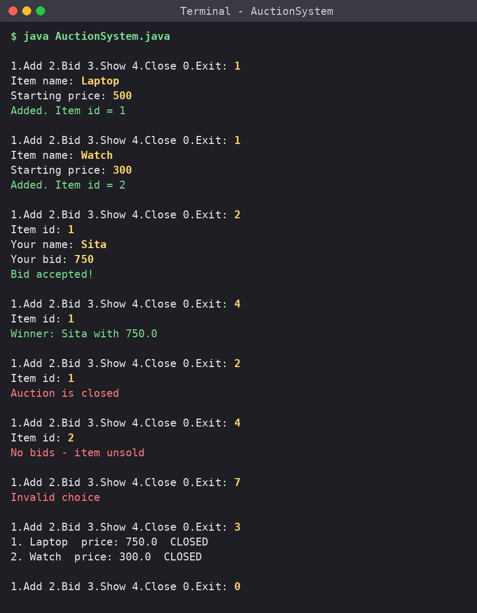

11. Conclusion
What was achieved and where it can go next.
- Delivered a working online auction and bidding system in Java.
- Applied all six modules, from fundamentals to collections and streams.
- Future scope: GUI or web front end, database storage, payments, real-time notifications.

