1. Transition systems and CCS

Reactive system
System that reatcs on some stimuli. It then processes some output that may effect the system.
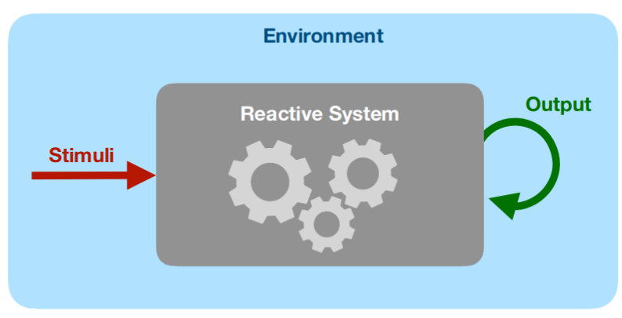
The input is a state containing variables which is then proccessed and output in a new state containing the changes.
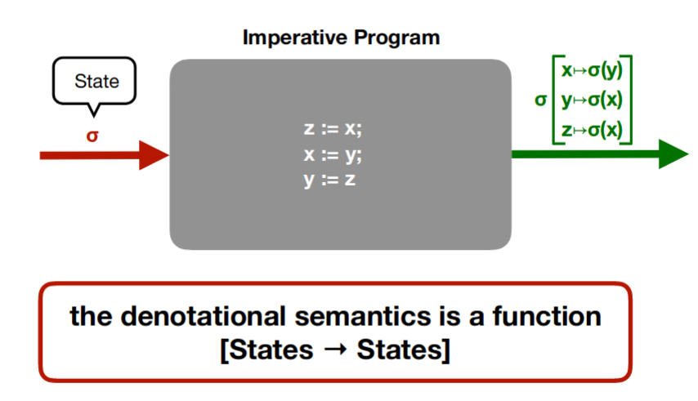

Labelled Transition System
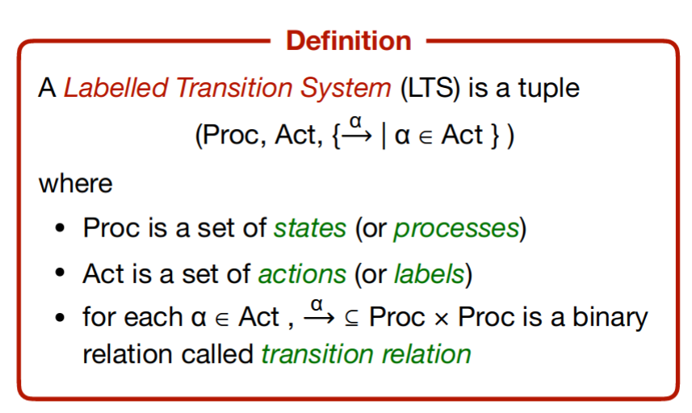
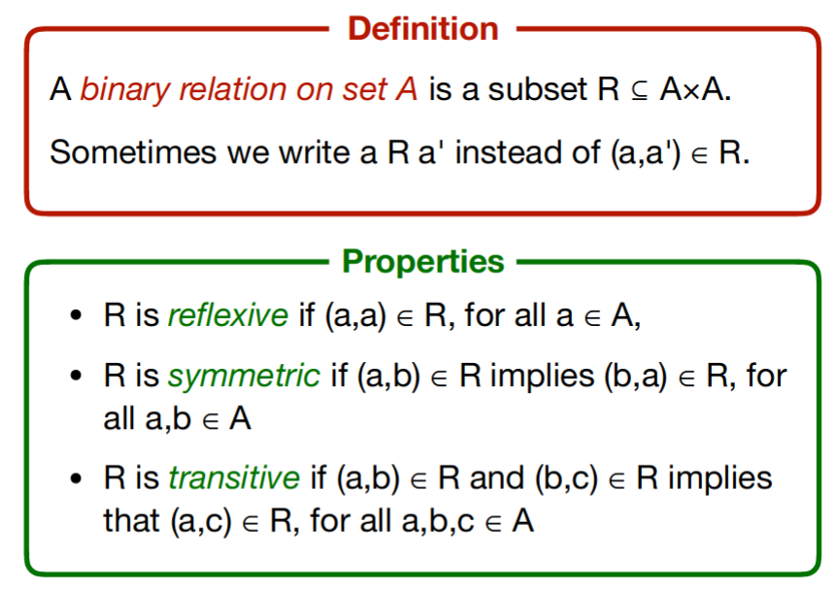

Process Algebra
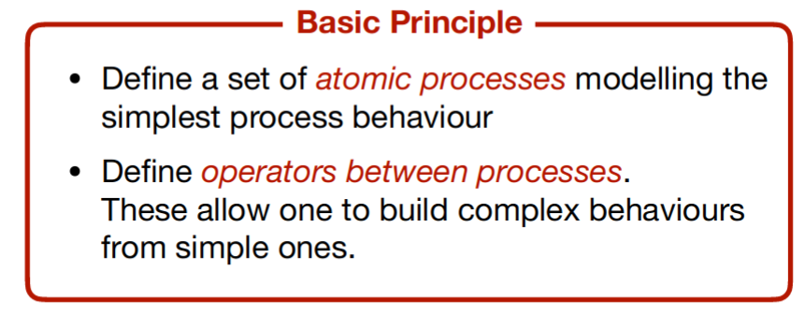
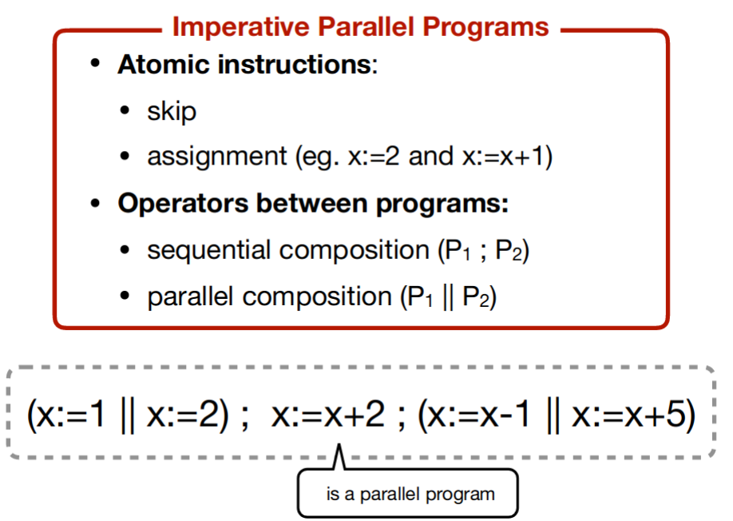
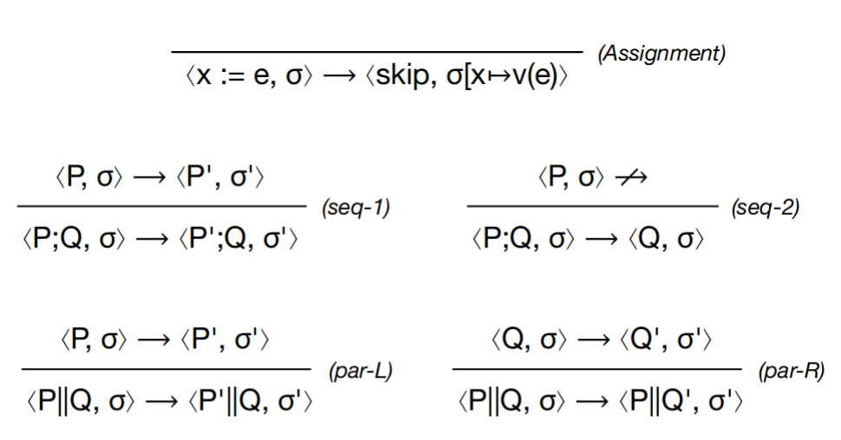

Parallel composition
The parallel composition offers the possibility of making the processes P and Q interacting with each other through synchronous communication
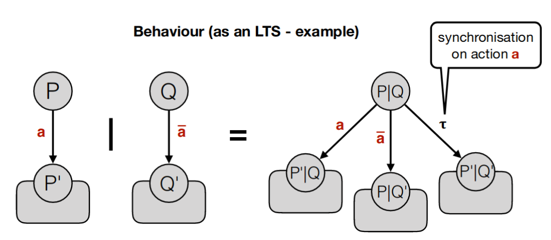

Restriction
The restriction operator allows one to restrict the visibility of specific communication ports (public vs private)
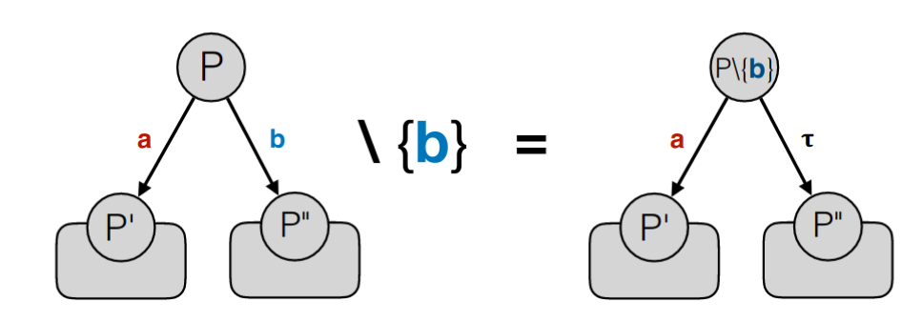

Relabelling
Relabelling gives the programmer an easy way to define "generic" process procedures
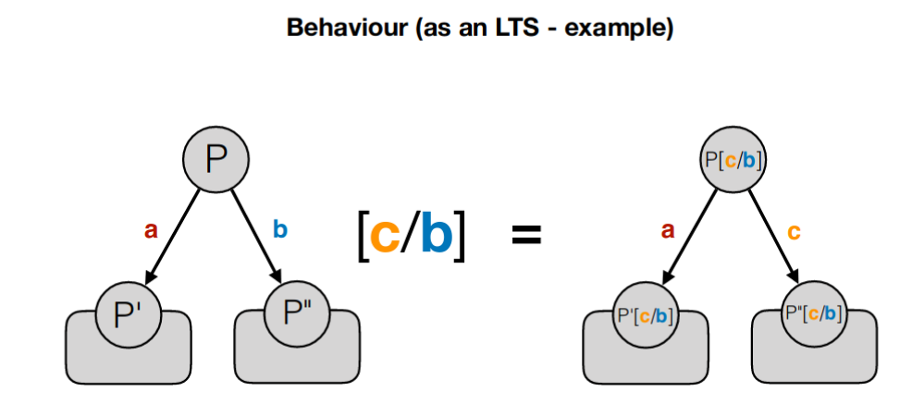

Choice
The choice operator acts as non-deterministic combinator. The process P+Q has the capabilities of both P and Q.
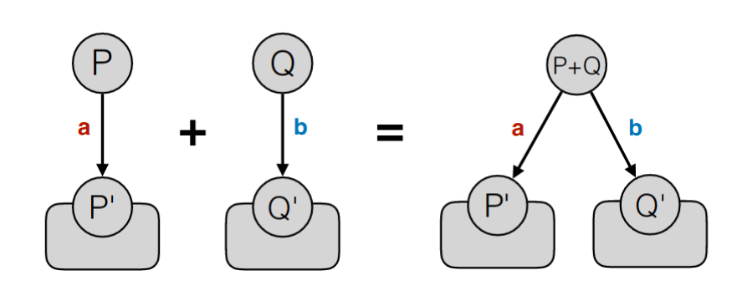
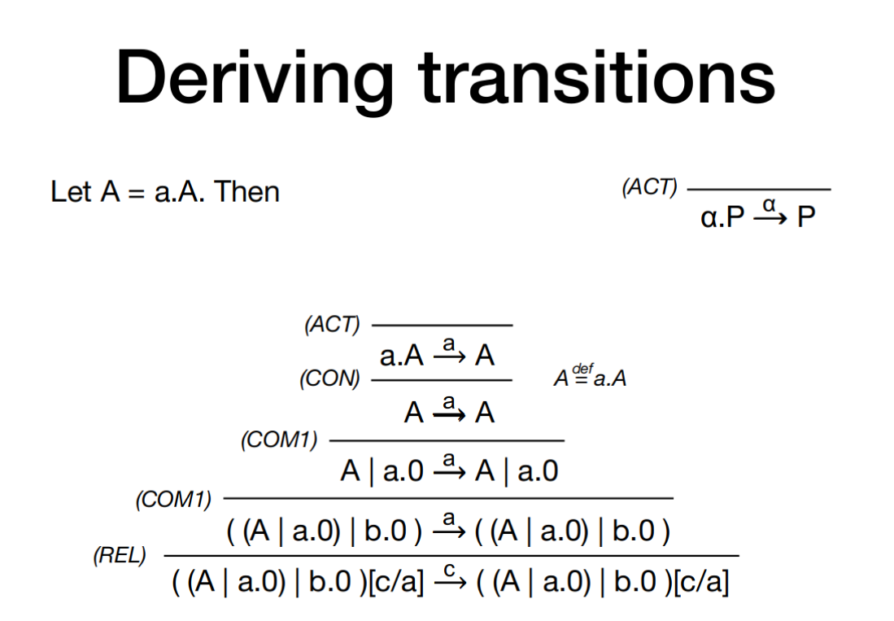

CCS Sequential Fragment
