Tarski’s fixed-point theorem and Hennessy-Milner logic with one recursive formula

Tarski’s fixed-point theorem
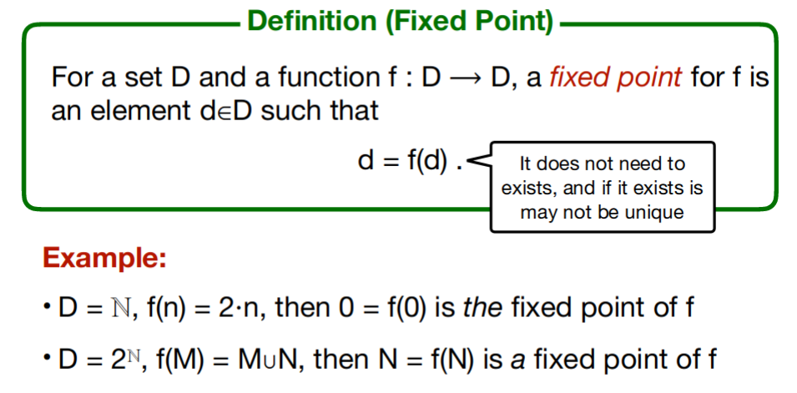
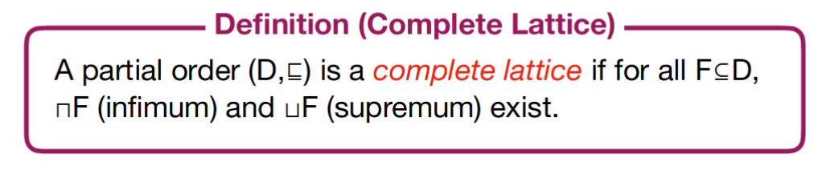
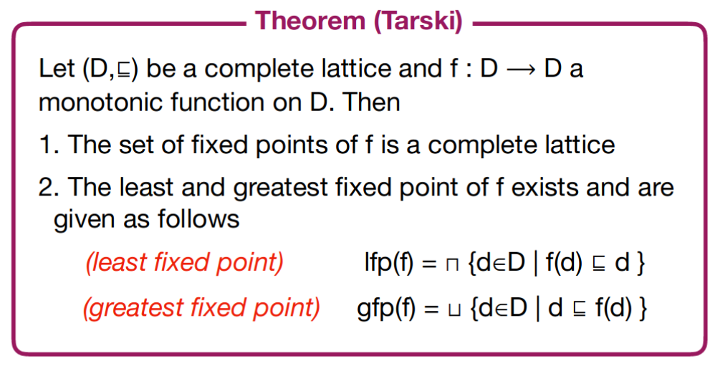

Hennessy-Milner logic with one recursive formula
