Timed CCS and Bisimilarity

Time transition systems
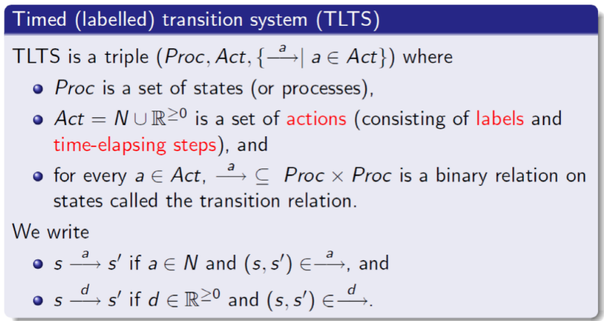
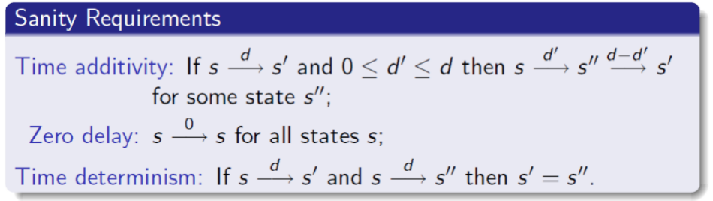

Syntax and semantics of timed CCS
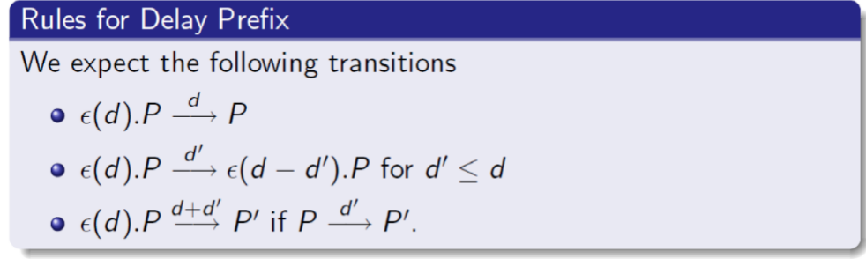
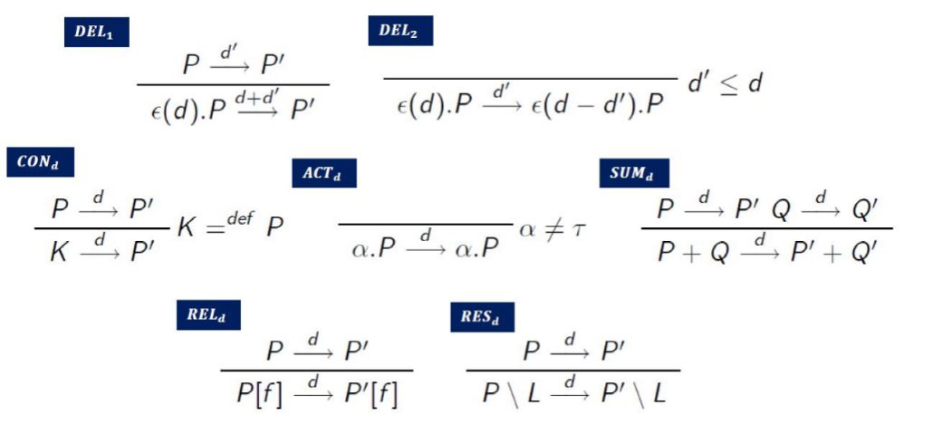

Example
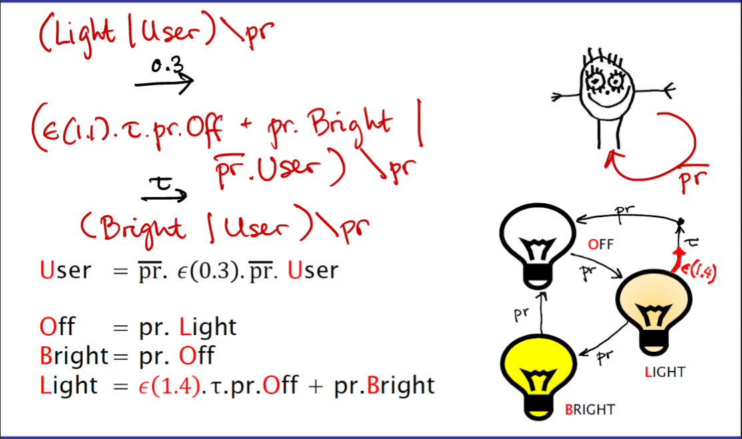

Timed/untimed bisimilairty
Timed we do focus on delay
When untimed they do not have to have same delay
