Quality Management: How is quality defined - agile versus plan driven approaches
- What is quality
  - Design to forfill some specific requriments e.g. a no spilling coffee pot
- Explain some software qualities
  - Usability
  - Integrity
  - Efficiency
  - Correctness
  - Reliability
  - Maintainability
  - Testability
  - Flexibility
  - Reuseability
  - Transferability
  - Interoperability
- What is a trade-off
  - You want one thing which will have a negative influence on something else e.g.
Testability != Efficiency
- What is total cost of quality and cost of correction?
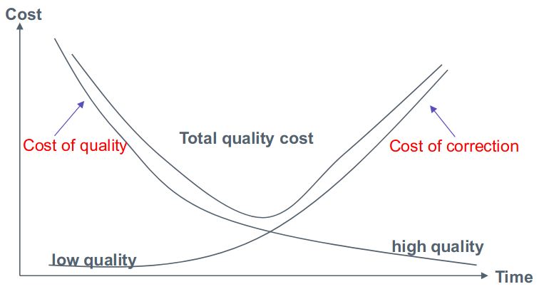
- What do we mean by subjective versus objective quality in Quality Management?
  - Quality Management assumes good process good --> product, or same process delivers same quality
- What is a quality culture?
  - all team members feel responsible for software quality and take actions to ensure that quality is maintained.
- Hvad er quality review
  - peer review
- How is quality ensured in Agile?
  - Agile builds quality in to the product through a combination of practices from Agile Project Monitoring and Control and Agile Project Execution.
  - The team is trying to build software that meet’s the Product Owner’s intent, so in the Agile world the Product Owner becomes part of the team and guides development
  - Each Timebox is meant to result in releasable code.
  - Unscheduled Product Reviews
  - Scheduled Product Reviews
  - Frequent Status Meetings
  - Many different kindes of tests e.g. Automated Unit Tests and Acceptance Tests
- What is pair programming in XP and what are the results?
  - two developers team together and work on one computer
  - Writing tests while programming
  - find errors early
  - knowledge sharing
- What is verification and validation?

