Risk Management
- What is a risk?
  - Something that may happen and causes a loss
- Example on risk categories
  - Catastrophic
  - Critical
  - Marginal
  - Negligible
  - Uncertainty, project, technical, business
    - Keyperson from team dies, a supplier is not delivering as promissed
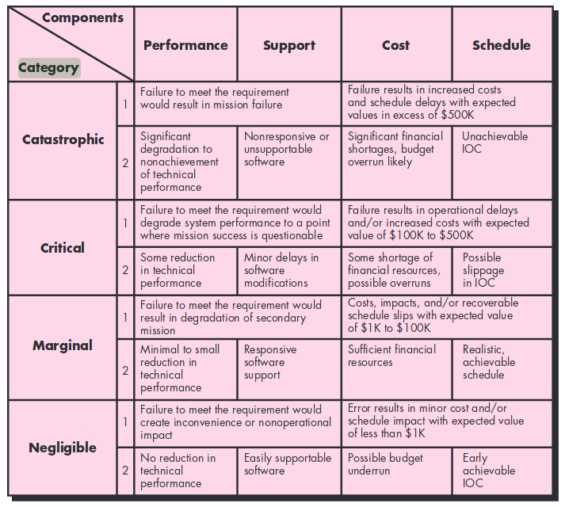
- How do you do risk analysis
  - Identify risks and calculate risk exposure and describe consequence
    - Risk exposure = probability * loss, describe consequence
  - Prioritize according to risk exposure, establish cut-line
  - Establish for each risk above the cut-line (RMMM: risk mitigatation, monitor, management)
    - mitigation (prevention) plan – how can we prevent risk to happen
    - contigency plan (management) plan – if it happens anyway, what do then do
    - how to monitor development of the risk – called RMMM plan
- How are risk management part of project management
  - Waterfall / plan driven
    - Risk and risk plans are part of the plans in project management
    - Development of other plans contribute to identification of risk
    - It is planned how
  - Agile – inspect and adapt is reduction to produce the right product
    - Daily Scrum: Do you have any impediments
    - Sprint review: Inspects risk related to product and stakeholder
    - Sprint retrospective: Adresses risks related to how the team work
- What is the spiral model and how is it related to risk management?
  - Risk-driven software development process model
  - The Radius of the spiral at any point represents the expenses(cost) of the project so far, and the angular dimension represents the progress made so far in the current phase.
  - Identify and resolve Risks: During the second quadrant all the possible solutions are evaluated to select the best possible solution. Then the risks associated with that solution is identified and the risks are resolved using the best possible strategy. At the end of this quadrant, Prototype is built for the best possible solution.
- What are Boehms primary risks (See spiral model article)
  - Personel shortcomings, unrealistic schedule, wrong function,

