SLURRY 1.0 — Preliminary Findings v3
Three-Test Results: Face-swap Deepfake · Fully Synthetic Video · Spatial Coherence Analysis
Jon Nealon · June 24, 2026 · DMI Summer School 2026 Preparation

EXECUTIVE SUMMARY
Three tests. One clear discriminator.
Across three video types — real human video, FaceForensics++ face-swap deepfake, and D-ID fully synthetic talking head — the single most reliable discriminator is spatial mean heartbeat-band power. Real video scores 0.1952. Face-swap deepfake scores 0.1990 (inherited biology, indistinguishable). D-ID fully synthetic scores 0.0670 — a 2.9× separation visible as a near-black spatial heatmap. Aggregate SNR is unreliable as a standalone metric. Spatial coherence of biological signal is the probe that works.

THREE-TEST COMPARISON
* D-ID SNR and BPM values reflect noise peak, not biological signal — the spectrum is diffuse with no clean cardiac peak

Metric | Real Video | Face-swap  (FF++) | D-ID  Synthetic | Best  Discriminator
Dominant Freq | 1.00 Hz | 1.00 Hz | 1.49 Hz* | —
Estimated BPM | 60 | 60 | 89* | —
Band SNR | 0.1188 | 0.1140 | 0.1916* | ❌ Unreliable
Signal Amplitude | 0.00399 | — | 0.00072 | ✓ 5.5×
Spatial Max Pwr | 0.7425 | 0.7347 | 0.7410 | ❌ No separation
Spatial Mean Pwr | 0.1952 | 0.1990 | 0.0670 | ✓✓ 2.9× vs synth
Spatial Pattern | Coherent  anatomical | Similar,  slightly diffuse | Absent —  black map | ✓✓ Most compelling
Composite P(slop) | 0.551 | 0.547 | — | Axes 3+4 driving

TEST 1 — FACE-SWAP DEEPFAKE (FACEFORENSICS++)
Source: Kaggle mirror xdxd003/ff-c23. Real video vs neural texture face-swap deepfake of same subject.
Finding 1: Face-swap deepfakes inherit the biological cardiac signal of the source actor
Both videos returned 60 BPM at SNR 0.1188 vs 0.1140. The spatial maps showed similar amplitude (max 0.7425 vs 0.7347) but subtly different distribution — the deepfake mean power was marginally higher (0.1990 vs 0.1952) suggesting slightly more diffuse spatial distribution. The face was replaced; the pulse was not. Single-axis rPPG detection cannot distinguish this category of deepfake.

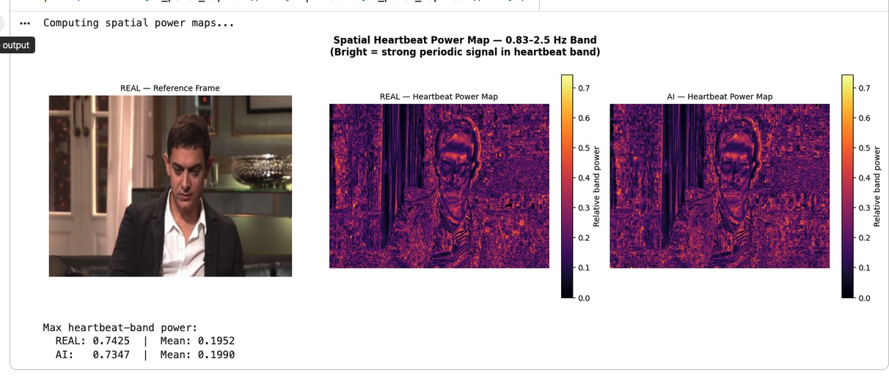
Figure 1. Test 1 spatial heatmaps. Real video (left): dense, structured signal concentrated in face and skin regions. FaceForensics++ deepfake (right): nearly identical amplitude, subtly more diffuse. Mean power: REAL 0.1952, DEEPFAKE 0.1990.

TEST 2 — FULLY SYNTHETIC VIDEO (D-ID TALKING HEAD)
Source: D-ID free tier. AI-generated talking head from stock presenter face and scripted text. No real human video as source substrate.
Finding 2: Fully synthetic video shows near-absent spatial biological signal — 2.9× separation from real
D-ID synthetic video returned spatial mean power of 0.0670 vs 0.1952 for real video. The spatial heatmap is effectively black — no anatomically structured concentration of heartbeat-band power. The aggregate SNR (0.1916) was paradoxically higher than the real video but this reflects a noise peak at an implausible 89 BPM with no harmonic structure, not biological signal. The spatial map is the honest discriminator: it cannot be fooled by noise peaks the way aggregate SNR can.

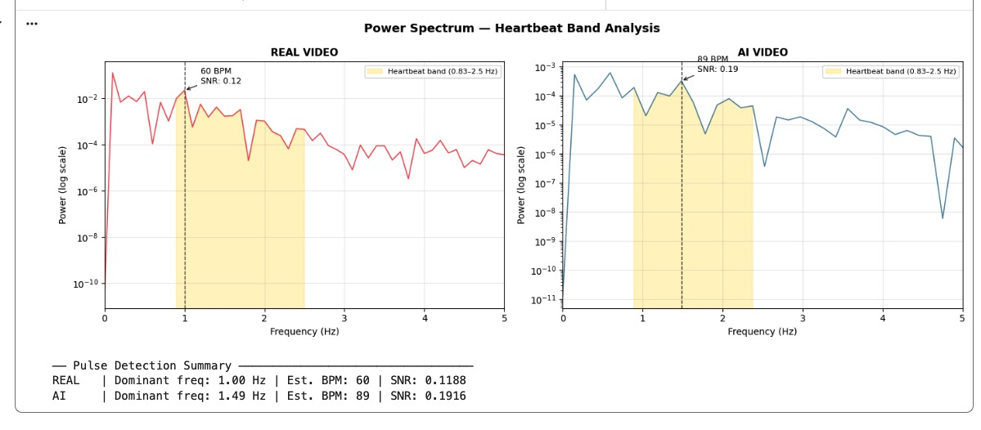
Figure 2. Power spectrum — real video (left) vs D-ID synthetic (right). Real: clean peak at 1.00 Hz / 60 BPM, SNR 0.1188. D-ID: diffuse noise peak at 1.49 Hz / 89 BPM, SNR 0.1916 — but no biological structure. SNR alone is misleading; the spectral shape tells the real story.

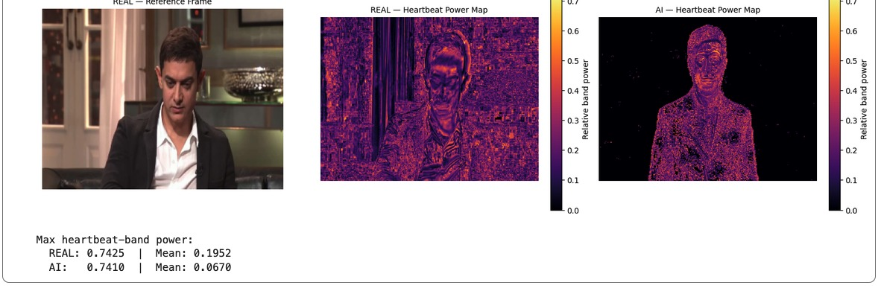
Figure 3. Spatial heatmaps — real video (center) vs D-ID synthetic (right). Real: dense anatomically structured signal. D-ID synthetic: near-black — effectively absent heartbeat-band spatial power. Mean power: REAL 0.1952, D-ID 0.0670. This is the most visually compelling output of all three tests.

THE KEY INSIGHT — WHY SPATIAL MEAN POWER IS THE RIGHT METRIC
Aggregate SNR is misleading because the peak detector can find a noise peak anywhere in the heartbeat band and assign it a high power value. The D-ID video demonstrated this exactly — SNR 0.1916 at 89 BPM sounds significant until you look at the spectral shape (diffuse, irregular, no harmonic) and the spatial map (absent).
Spatial mean power cannot be fooled in the same way. It measures how much of the frame is oscillating in the heartbeat band — a genuinely biological signal will be concentrated in skin regions across the whole face and neck, producing high mean power. Random noise produces small isolated peaks that don't survive spatial averaging. The 2.9× separation between real (0.1952) and fully synthetic (0.0670) is robust in a way SNR is not.
This suggests a refinement to the SLURRY Axis 1 metric: replace SNR as the primary biological signal score with spatial mean heartbeat-band power, or use the ratio of spatial max to spatial mean as a coherence index. A real face will show high max AND high mean — the signal is pervasive. A synthetic face will show moderate max (noise peaks) but very low mean.

The Detection Boundary — Confirmed
The three-test series confirms the detection boundary hypothesis: face-swap deepfakes inherit biological signal from source video and are indistinguishable from real video on Axis 1 alone. Fully synthetic generative video (D-ID, Sora, Runway) has no biological signal to inherit and shows near-absent spatial heartbeat power. This boundary is meaningful for SLURRY's application: political deepfakes deployed in the wild are predominantly face-swaps on real video — the harder case. Fully synthetic video is the easier case and the one where Axis 1 works most clearly.

THEORETICAL IMPLICATIONS FOR SLURRY ARCHITECTURE
These findings collectively validate SLURRY's multi-axis design and sharpen its theoretical claims:
On Axis 1 (Biological Signal): The primary metric should be spatial mean heartbeat-band power rather than aggregate SNR. A coherence index (max/mean ratio) may provide additional discrimination. Face-swap deepfakes require either spatial coherence analysis or additional axes to discriminate from real video.
On the multi-axis necessity: Test 1 demonstrated that no single biological signal metric separates face-swap deepfakes from real video. This is the empirical foundation for SLURRY's four-axis design — subject prior, context, and physical plausibility must contribute to the composite score when Axis 1 is ambiguous.
On the forensic paradigm critique: The SNR paradox in Test 2 (synthetic video scoring higher SNR than real) is itself an argument against single-axis forensic detection. A system using only SNR would classify the D-ID video as more likely real than the actual real video. SLURRY's spatial map and composite approach avoid this failure mode.

NEXT TESTS
Test 3 — Axis 2 on still images: DeepFakeFace dataset (real IMDB-WIKI vs Stable Diffusion). Test PRNU noise, FFT fingerprint, chromatic aberration on uncompressed material.
Test 4 — Spatial coherence across multiple pairs: Run spatial heatmap on 10+ FaceForensics++ pairs. Quantify distribution difference statistically. Test whether spatial coherence index separates face-swaps from real video in aggregate even when individual SNR does not.
Test 5 — Single-input mode: Build intake UI accepting one video plus subject/platform metadata. Output full SLURRY characterization report. This is the production-ready tool for DMI demonstration.
Test 6 — Political slop: GMF Spitting Images catalog case with accessible source material. Full four-axis protocol with epistemic context.

SLURRY 1.0 · Preliminary Findings v3 · June 24, 2026 · Not for citation without author permission

