Project timeline - Memory Leak 2

Samantha Au, Daniel Li, Julia Zeng, Jon Ngo, Victor Hui

**Initial meeting (16/11/19)**

* Decided that we wish to do an android application
* decided that it would be a game
* project alternatives
  + clothes changing app
  + anxiety app
  + day planner
  + etc
* decided that an android called memory leak will be created, objective is to delete/ destroy falling blocks of code that would break/ damage applications, a shooter will be used to destroy blocks containing “broken” code.
  + Pros
    - interactive
    - fun
    - applicable to the class
    - interesting to code
  + Cons
    - higher level of difficulty
    - a lot to do basically
* meeting ended at 12:00 am.

**Meeting number 2 (3/12/19)**

* Sorted out roles between members
  + Project Lead: Victor Hui
  + Specification Lead: Daniel Li
  + Interface Lead: Julia Zeng
  + Technical Lead: Jonathan Ngo
* decided that the next meeting would be Friday 6/12/19, in order to check progress on the different members
* Separated tasks in between different team members
* 2 team members will work on the Boss level
  + Sam Au would be responsible for the sound portion of the game, the HP bar of the bosses, and the timer between each choice during the quiz
  + Victor Hui would be responsible for the Quiz mechanics part of the game, and the face/ animation of the question
* 3 team members will work on the Normal Levels
  + Daniel and Julia will be responsible for the front end, while Jon will be responsible for
* 2 team members will work on the Quiz/Boss level
  + Victor and Sam would work on the Boss level.

**First sketch of project homescreen, and quizz interface 8/12/2019**

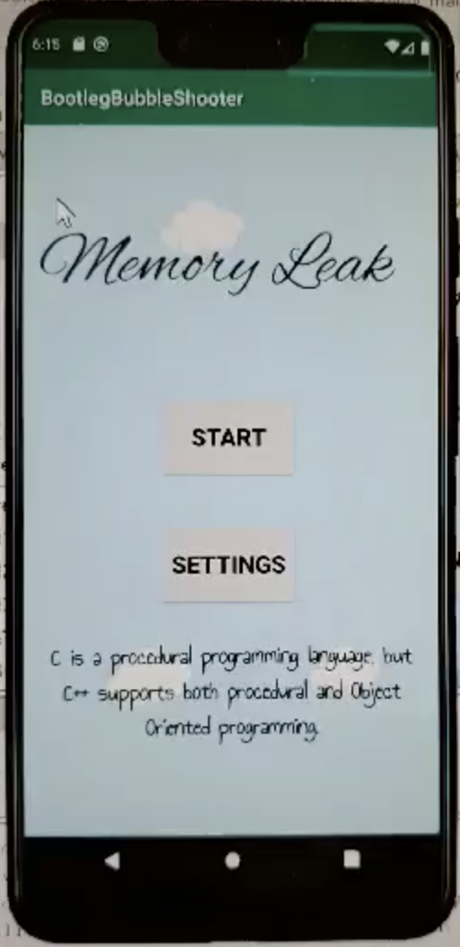 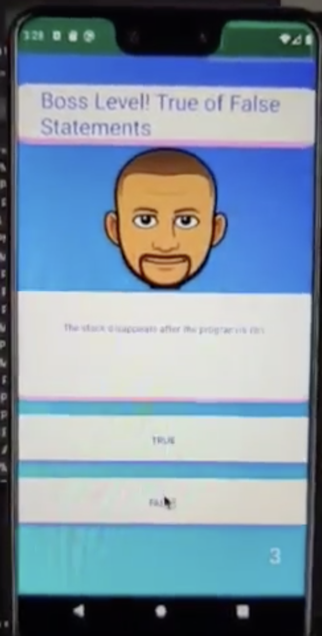

* as you can see, the theme of the homescreen and quizz interface was completely different, but this was solved further along in the app development process
* At this point, the homescreen had animations running in the background and the mechanics of the Quizzes in the Boss levels work well.

**First attempt at the “Normal Level”, main mechanics of the game 8/12/2019**

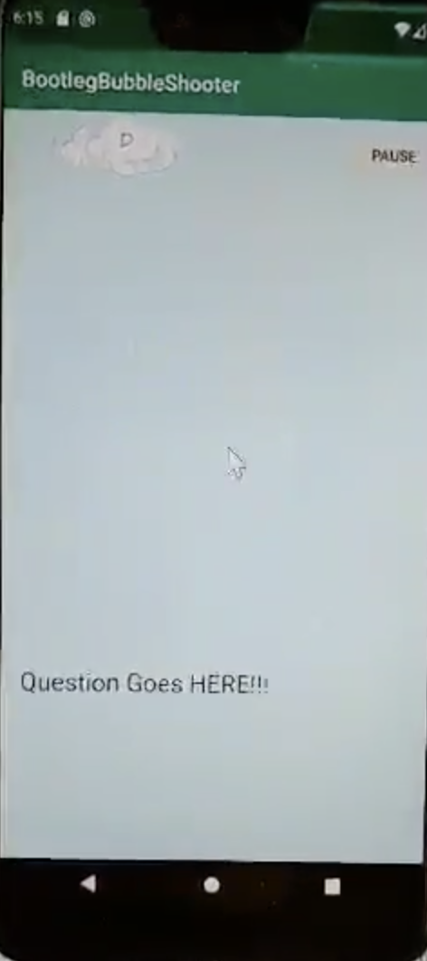

* As it can be seen, the mechanics have not yet been added, the rocket/cannon/ shooter has not yet been implemented, the bullet action is also missing, but as the first sketch, a lot of progress was made today.

**Meeting No.3 (9/12/2019)**

* We touched base on who has done what, separated the tasks regarding the documents, and made further progress on the design of the app in order to improve overall user experience.

**Refreshed look of the project home screen and Quiz screen**

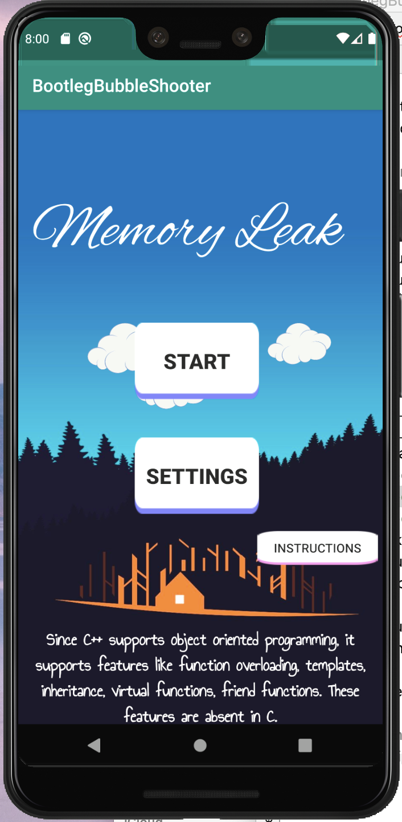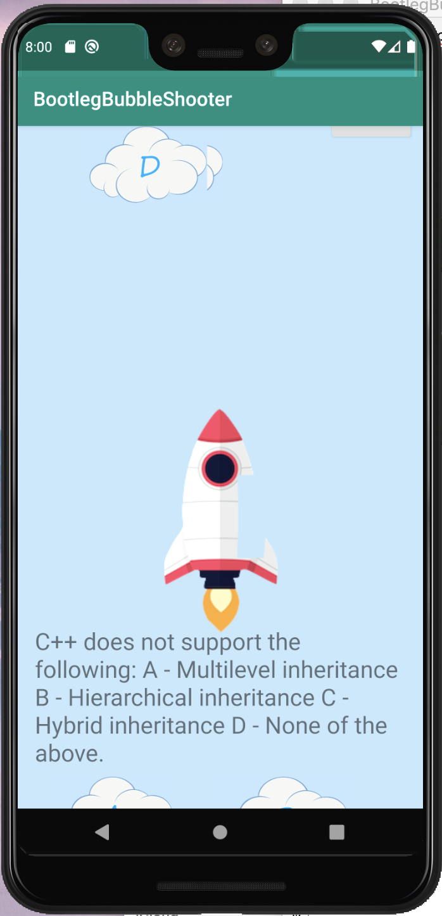

* The design of the app is improved immensely, there is now a theme of adventure and progress attached.
* As for the shooter, we have decided to go with a rocket to increase the sense of progress as it soars into the open sky.
* Double tapping the rocket would now generate a bullet heading up

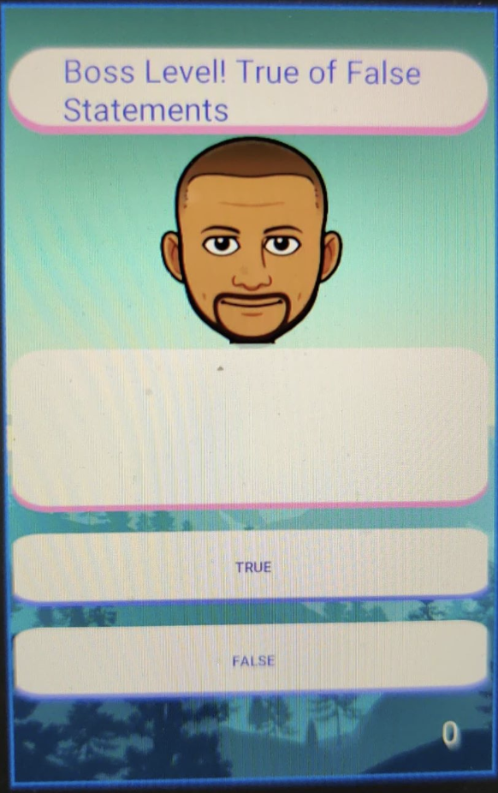

* The only change here is the changing of the background to fit it to the theme of adventure.

**Meeting No.4 (10/12/19)**

* Met to sort out documentation responsibilities
* Further improved UI design,
* Worked on the General Game Mechanics

**The design for the quiz app is further improved**

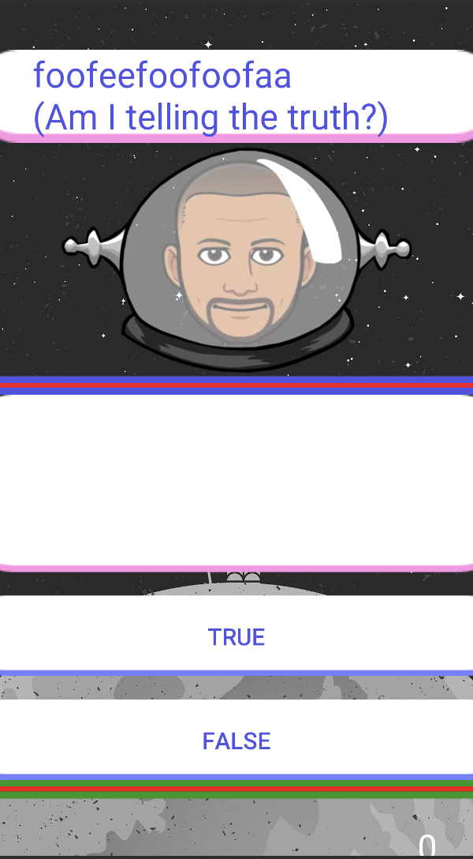

* Health bar introduced, when the player answers the Boss correctly, the bosses’ health bar decreases, when the player answers the Boss wrongly, the player’s health decreases.
* We also gave Professor densmore a helmet.