

Masters of Information Technology
CQ University SYDNEY CAMPUS
Introduction to Programming
Assignment 2 Report
Sydney Yummy Catering Event Management System
Student Name: Md. Aminul Islam (Jonnie)
Student ID: 12312185
Email: 12312185@cqumail.com
Contact: 0433 927 014
Tutor: Shouthiri Partheepan
Unit: Introduction to Programming
Unit Code: COIT20245
Campus: CQ University, Sydney, 400 Kent Street NSW 2000.

Difficulty Rating
3 / 5 ~ Moderate
(1 = Easiest, 5 = Most Difficult)
I rated this assignment a 3 out of 5. The individual concepts - Python classes, instance attributes, list management, and basic file I/O - were already introduced in lectures, so no entirely new language features were required. The difficulty came from integrating all these concepts together into a single, cohesive application that behaves correctly across many different user inputs.
Specifically, three areas lifted the difficulty above a 2: first, designing the boundary between the Event and EventManager classes so that responsibilities were cleanly separated; second, writing input-validation loops that handled every plausible bad input (empty strings, non-numeric text, out-of-range numbers, malformed dates) without crashing; and third, ensuring the file-persistence layer was robust enough to survive a missing file on first run or a corrupted line in an existing save file. These real-world edge cases demanded careful thinking that goes beyond simply translating lecture examples.

2. Difficulties Faced and How They Were Resolved

2.1 Designing Class Responsibilities (Event vs EventManager)
Challenge: When I first started writing the code I placed display and file logic directly inside the Event class, because that felt natural. The class quickly became oversized and hard to reason about.
Resolution: I applied the Single Responsibility Principle - Event only holds data about one event and knows how to convert itself to and from a pipe-delimited string (to_file_line() and from_file_line()). All collection operations - adding, displaying, saving, loading, and searching - moved into EventManager. This made each class independently testable and much easier to extend.

2.2 Date Validation: Format and Calendar Correctness
Challenge: A naive approach using string splitting (e.g. checking for two hyphens) would accept strings like '2025-13-45' even though month 13 and day 45 do not exist. I needed a solution that validated both the format and the actual calendar date.
Resolution: I used datetime.strptime(date_str, "%YY-%mm-%dd") inside a try/except ValueError block. Python's datetime module rejects impossible dates automatically, so a single try/except covered both format and range checks simultaneously. The function returns a clean True or False, keeping validation logic out of main().

2.3 Guest-Count Validation: Handling All Invalid Input Types
Challenge: The guest-count field needed to reject empty input, decimal numbers (e.g. '25.5'), negative numbers, plain text (e.g. 'abc'), and integers outside the 5–500 range - each in a different way and with a clear, specific error message.
Resolution: I applied a layered check inside get_positive_int(): first, strip() and an emptiness check catches blank input; then str.isdigit() rejects any string containing a decimal point, minus sign, or letters; finally, a range check 5 <= guests <= 500 catches out-of-bounds integers. Each layer prints a targeted error message so the user knows exactly what went wrong.

2.4 File I/O: Missing File on First Run and Corrupt Lines
Challenge: On the very first run there is no save file, so open() raises a FileNotFoundError. Additionally, if a user manually edits the save file and introduces a malformed line, the from_file_line() method raises a ValueError that would crash the program on startup.
Resolution: In EventManager.load_events() I wrapped the file-open call in an outer try/except FileNotFoundError that silently initialises an empty list when no file exists. Inside the line-reading loop, each call to Event.from_file_line() is wrapped in a try/except ValueError that skips corrupted lines and prints a warning, so one bad record cannot prevent the rest from loading.

2.5 Case-Insensitive Partial-Match Search
Challenge: A user searching for 'gala' should find an event named 'Annual Gala', but a simple equality check (keyword == event.name) would fail because of the different case and the partial match.
Resolution: I used the Python in operator after calling lower() on both the keyword and the event name: keyword.lower() in event.name.lower(). This single expression handles both case insensitivity and substring matching. I also added an explicit message when no matches are found, so the user is never left with silent, blank output

3. Test Cases and Screenshots
Each test case below covers both a valid (happy-path) scenario and one or more invalid (edge-case) scenarios to demonstrate that the program handles incorrect input gracefully at every step.

Test Case 1: Add a Valid Event
- Input: Name = ‘Shouthiri Mem Class Party’, Date = ‘2026-06-05’, Location = ‘Class 5.06’, Guests = ‘14’.
- Expected: Event added successfully; a confirmation message is displayed.
- Actual Result: PASS - event appears in the display list.

Screenshot: Test Case 1: Successful Add
Console shows menu, prompts for all five fields, and prints a success message after entry. The event should then appear when option 2 (Display) is selected.
Screenshot
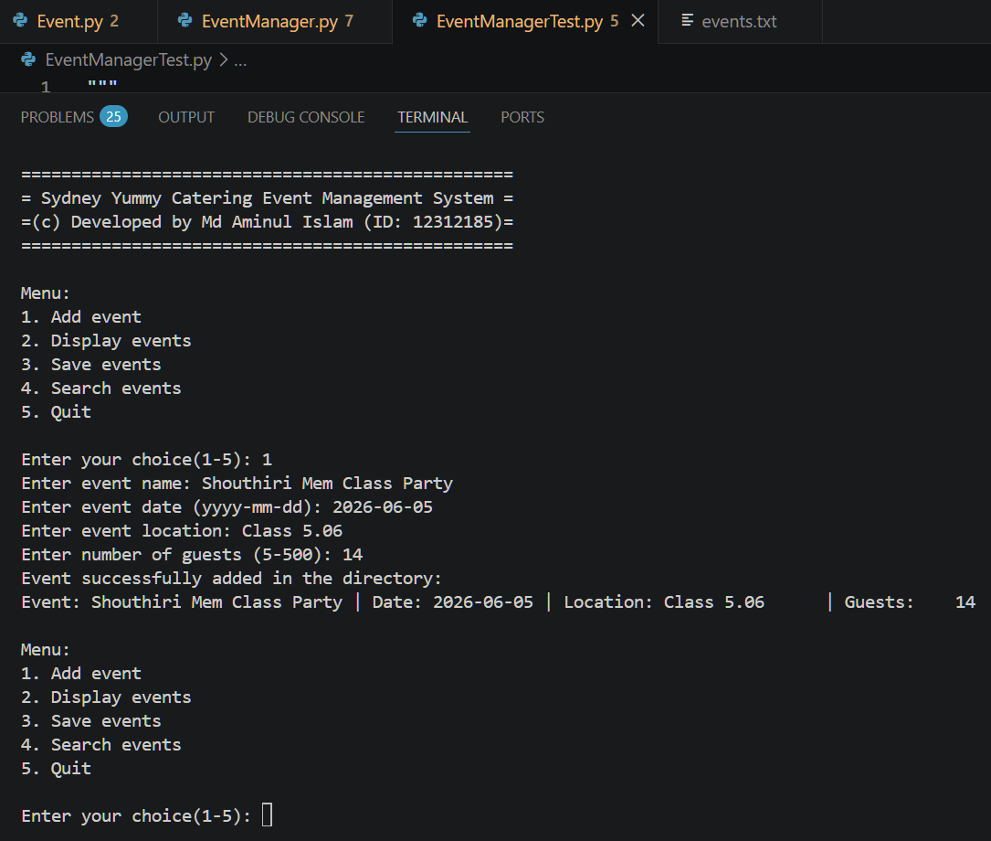

Test Case 2: Invalid Date (Impossible Calendar Date)
- Input: Date = '2026-13-32' (month 13, day 32- neither exists).
- Expected: Error message displayed; program re-prompts until a valid date is entered.
- Actual Result: PASS~error shown, loop continues.

Screenshot: Test Case 2: Invalid Date Entry
Console shows 'Invalid date. Please enter a valid date in yyyy-mm-dd format.' and re-displays the date prompt. Continues until a valid date (e.g. 2026-12-30) is accepted.
Screenshot
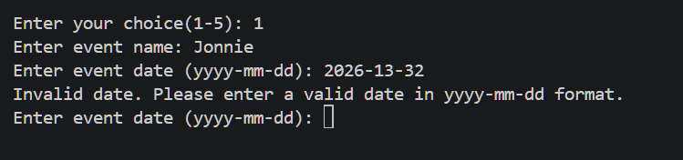

Test Case 3: Invalid Date (Wrong Format)
- Input: Date = '20-11-2025' (dd-mm-yyyy instead of yyyy-mm-dd).
- Expected: Error message displayed; program re-prompts.
- Actual Result: PASS ~ format mismatch detected and rejected.

Screenshot: Test Case 3: Wrong Date Format
Console shows the invalid-date error and re-prompts. Demonstrates that the format check (yyyy-mm-dd) is enforced separately from the calendar check.
Screenshot
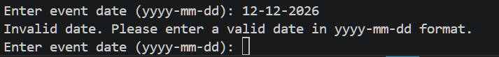

Test Case 4: Invalid Guest Count: Below Minimum
- Input: Guests = 3 (below the minimum of 5).
- Expected: ‘Please enter a number between 5 and 500.’ program re-prompts until a valid guest’s number is entered.
- Actual Result: PASS ~ out-of-range value rejected.

Screenshot: Test Case 4: Guest Count Below Minimum
Console shows the range-error message and repeats the guest prompt. A valid value (e.g. 50) is then entered and accepted.
Screenshot
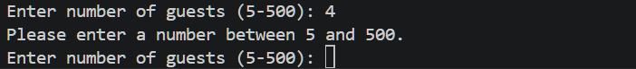

Test Case 5: Invalid Guest Count: Non-Numeric and Decimal Input
- Input: Guests = 'abc', then '5.5', then 505 (above maximum), then 50 (valid).
- Expected: Each invalid entry shows a specific error; only 50 is accepted.
- Actual Result: PASS ~ all three invalid types caught individually.

Screenshot: Test Case 5: Multiple Invalid Guest-Count Inputs
Console shows error messages for (non-numeric, non-whole-number, out-of-range) before the valid input 50 is accepted. Demonstrates the layered validation.
Screenshot
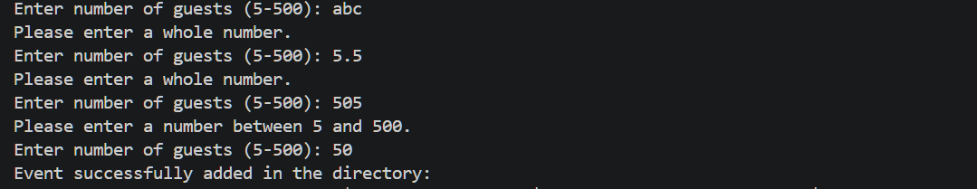

Test Case 6: Save Events to File
- Steps: Add two events, then select option 3 (Save).
- Expected: Confirmation message; Events saved to ‘events.txt’.
- Actual Result: PASS ~ Events saved in files.

Screenshot: Test Case 6: Save Events
Console shows Events saved to ‘events.txt’. after option 3. The raw contents of the save file (events.txt) can also be shown by option 2 ‘Display events
Screenshot
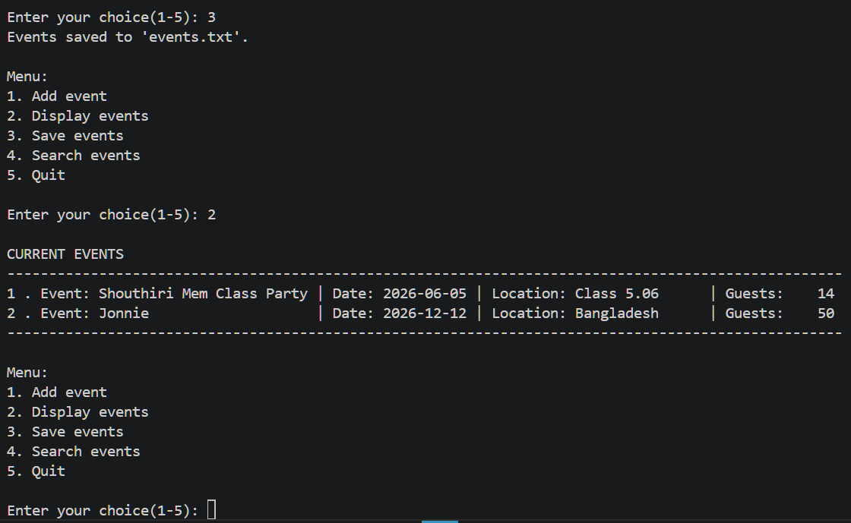

Test Case 7: Reload Events on Startup
- Steps: Restart the program after saving; select option 2 (Display).
- Expected: Both previously saved events appear in the list without re-entry.
- Actual Result: PASS ~ events loaded automatically from file.

Screenshot: Test Case 7: Reload on Startup
Startup message is shown, immediately followed by option 2 (Display). Both events saved in Test Case 6 are listed, confirming successful file load.
Screenshot
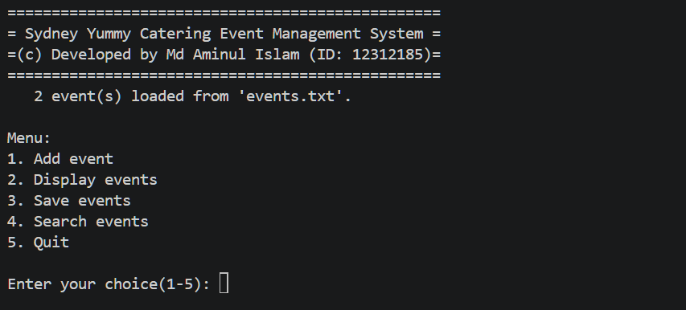

Test Case 8: Search: Partial, Case-Insensitive Match
- Input: Keyword = ‘party’ (stored event name is ‘Shouthiri Mem Class Party’).
- Expected: Matching event is displayed regardless of case.
- Actual Result: PASS ~ event found and displayed.

Screenshot: Test Case 8: Partial Case-Insensitive Search
Console displays Shouthiri Mem Class Party’ when the keyword ‘party’ (lowercase) is entered. Confirms that both partial matching and case insensitivity work correctly.
Screenshot
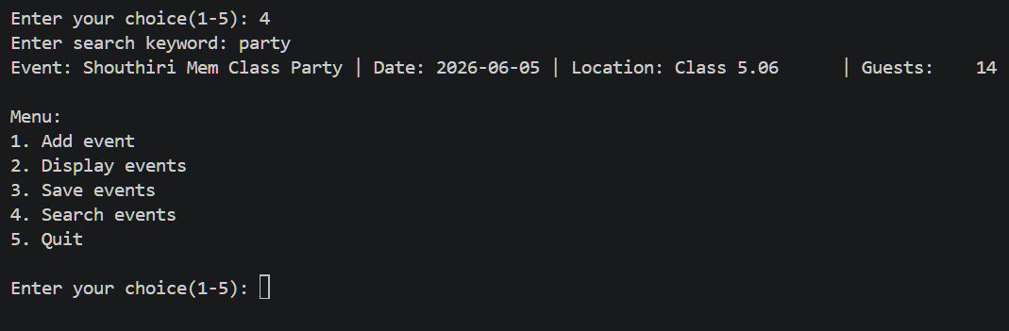

Test Case 9: Search: No Matching Results
- Input: Keyword = ‘jonnie.xyz’ (no event contains this string).
- Expected: A friendly 'No events found' message is displayed; no crash.
- Actual Result: PASS ~ empty-result message shown.

Screenshot: Test Case 9: Search with No Results
Console shows a ‘No events found matching ‘jonnie.xyz’ message. The menu re-appears normally, demonstrating that the no-result path is handled gracefully.
Screenshot
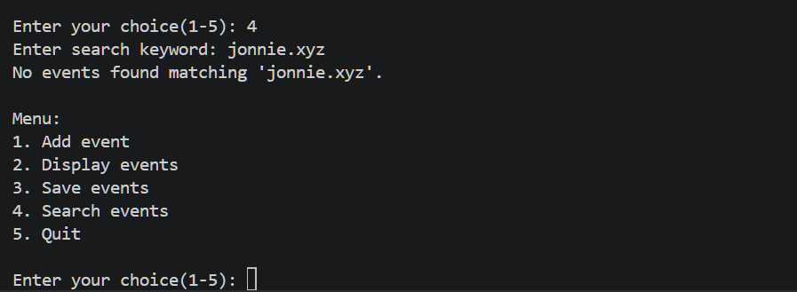

Test Case 10: Invalid Menu Choice and Empty Input
- Input: Enter empty space, then ‘9’, then ‘x’ at the main menu.
- Expected: ‘Invalid choice’ message; menu re-displays each time.
- Actual Result: PASS~ program never crashes on unexpected menu input.

Screenshot: Test Case 10: Invalid Menu Choice
Console shows ‘Invalid choice. Please select a number from 1 to 5.’ and re-displays the menu for each invalid entry. The program remains stable throughout.
Screenshot
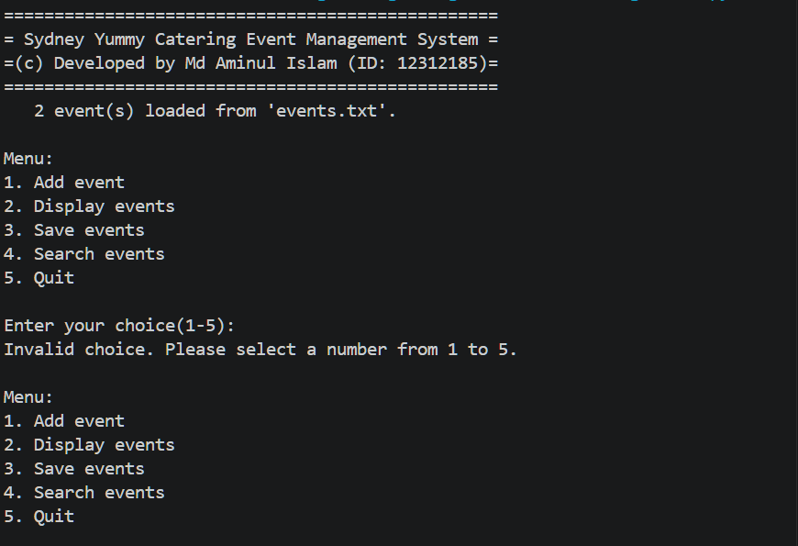
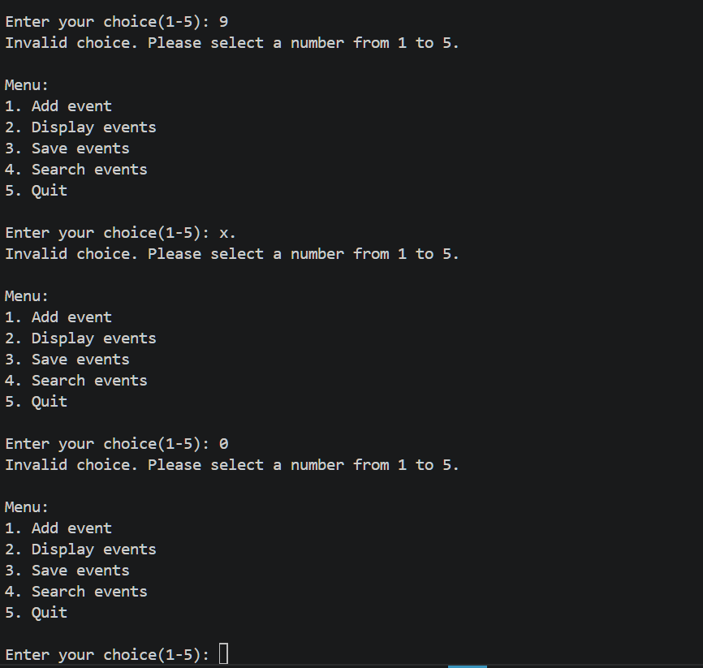

Test Case 11: Quit and Exit Msg
- Input: Enter ‘5’ at the main menu.
- Expected: Goodbye message
- Actual Result: PASS~ Program shows a goodbye msg

Screenshot: Test Case 11: Exit the Program
Console shows ‘Goodbye! Thank you for using the Sydney Yummy Catering Event Management System.’
Screenshot
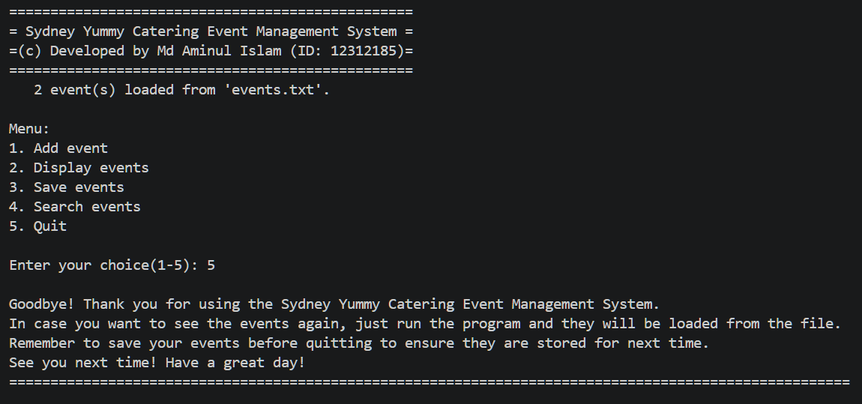

4. Conclusion
This assignment provided a thorough exercise in applying object-oriented design to a realistic console application. Splitting logic across two classes (Event and EventManager) made the codebase modular and easier to maintain. Writing exhaustive input-validation loops, covering empty input, wrong data types, out-of-range values, and malformed date strings, taught me the importance of defensive programming: assuming that users will enter unexpected data at every step.
The file-persistence layer reinforced how exception handling works in practice: a missing file on first run and corrupted lines in an existing file are both normal real-world conditions that a robust program must handle silently and gracefully. Overall, the assignment strengthened my ability to translate business requirements into clean, well-structured Python code and to think critically about edge cases before they become bugs.

Md. Aminul (Jonnie) Islam
Student ID: 12312185

