cbiuilddialog_1.h 宣告程式物件類別的內容

*#ifndef* CBIUILDDIALOG_1_H

*#define* CBIUILDDIALOG_1_H

*#include* <QDialog>

*#include* <QtWidgets>

class CBiuildDialog_1 : public QDialog

{

    Q_OBJECT

public:

    CBiuildDialog_1(QWidget *parent = nullptr);

    ~CBiuildDialog_1();

private:

       QTextEdit *displayTextEdit;

       QPushButton *colorbtn;

       QPushButton *errorbtn;

       QPushButton *filebtn;

       QPushButton *fontbtn;

       QPushButton *inputbtn;

       QPushButton *pagebtn;

       QPushButton *porgressbtn;

       QPushButton *printbtn;

private slots:

       void doPushBtn();

};

*#endif* *// CBIUILDDIALOG_1_H*

cbiuilddialog_1.cpp 功能撰寫檔案

#include "cbiuilddialog_1.h"

#include <QtPrintSupport/qprinter.h>

#include <QtPrintSupport/qpagesetupdialog.h>

#include <QtPrintSupport/QPrintDialog>

#include <QtPrintSupport/QPrintPreviewDialog>

CBiuildDialog_1::CBiuildDialog_1(QWidget *parent)

    : QDialog(parent)

{

// 建立變數

    QGridLayout* gridlayout = *new* QGridLayout;

    displayTextEdit = *new* QTextEdit(QString("Qt的標準對話盒"));

    colorbtn        = *new* QPushButton(QString("顏色對話盒"));

    errorbtn        = *new* QPushButton(QString("錯誤對話盒"));

    filebtn         = *new* QPushButton(QString("檔案對話盒"));

    fontbtn         = *new* QPushButton(QString("字型對話盒"));

    inputbtn        = *new* QPushButton(QString("輸入對話盒"));

    pagebtn         = *new* QPushButton(QString("頁面設定對話盒"));

    porgressbtn     = *new* QPushButton(QString("進度對話盒"));

    printbtn        = *new* QPushButton(QString("列印對話盒"));

// 版面中 新增工具 並且 排版

    gridlayout->addWidget(colorbtn, 0, 0, 1, 1);

    gridlayout->addWidget(errorbtn, 0, 1, 1, 1);

    gridlayout->addWidget(filebtn, 0, 2, 1, 1);

    gridlayout->addWidget(fontbtn, 1, 0, 1, 1);

    gridlayout->addWidget(inputbtn, 1, 1, 1, 1);

    gridlayout->addWidget(pagebtn, 1, 2, 1, 1);

    gridlayout->addWidget(porgressbtn, 2, 0, 1, 1);

    gridlayout->addWidget(printbtn, 2, 1, 1, 1);

    gridlayout->addWidget(displayTextEdit, 3, 0, 3, 3);

    setLayout(gridlayout);

    setWindowTitle(QString("內建對話盒"));

    resize(400,300);

// 連接所有按鈕至doPushBtn()

    connect(colorbtn, SIGNAL(clicked()), *this*, SLOT(doPushBtn()));

    connect(errorbtn, SIGNAL(clicked()), *this*, SLOT(doPushBtn()));

    connect(filebtn, SIGNAL(clicked()), *this*, SLOT(doPushBtn()));

    connect(fontbtn, SIGNAL(clicked()), *this*, SLOT(doPushBtn()));

    connect(inputbtn, SIGNAL(clicked()), *this*, SLOT(doPushBtn()));

    connect(pagebtn, SIGNAL(clicked()), *this*, SLOT(doPushBtn()));

    connect(porgressbtn, SIGNAL(clicked()), *this*, SLOT(doPushBtn()));

    connect(printbtn, SIGNAL(clicked()), *this*, SLOT(doPushBtn()));

}

// 按鈕動作處理

void CBiuildDialog_1::doPushBtn()

{

    QPushButton* btn = qobject_cast<QPushButton*>(sender());

*if*(btn == colorbtn)

    {

        QPalette palette = displayTextEdit->palette();

        const QColor& bgcolor = QColorDialog::getColor(

            palette.color(QPalette::Base),

*this*,

            QString("設定背景顏色")

        );

*if*(bgcolor.isValid()){

            palette.setColor(QPalette::Base, bgcolor);

            displayTextEdit->setPalette(palette);

        }

    }

*if* (btn == errorbtn)

    {

        QErrorMessage box(*this*);

        box.setWindowTitle(QString("錯誤訊息盒"));

        box.showMessage(QString("錯誤訊息盒實例XX"));

        box.showMessage(QString("錯誤訊息盒實例YY"));

        box.showMessage(QString("錯誤訊息盒實例ZZ"));

        box.exec();

    }

*if*(btn == filebtn)

    {

        QString FileName = QFileDialog::getOpenFileName(*this*, QString("打開檔案"), ".", QStringLiteral("任何檔案(*.*)"

                                                                                                      ";;文字檔(*.txt)"

                                                                                                      ";;XML檔(*.xml)"));

        displayTextEdit->setText(FileName);

    }

*if*(btn == fontbtn)

    {

        bool ok;

        const QFont& font = QFontDialog::getFont(&ok, displayTextEdit->font(), *this*, QString("字體對話盒"));

*if*(ok) displayTextEdit->setFont(font);

    }

*if*(btn == inputbtn)

    {

        bool ok;

        QString text = QInputDialog::getText(*this*, QString("輸入對話盒"), QString("輸入文字"), QLineEdit::Normal, QDir::home().dirName(), &ok);

*if*(ok && !text.isEmpty()) displayTextEdit->setText(text);

    }

*if*(btn == porgressbtn)

    {

        QProgressDialog progress(QString("正在載入中"), QString("取消"), 0, 10000, *this*);

        progress.setWindowTitle(QString("進度對話方塊"));

        progress.show();

*for* (int i=0;i<10000 ;i++ ) {

            progress.setValue(i);

            qApp->processEvents();

*if*(progress.wasCanceled()){

*break*;

            }

            qDebug() << i;

        }

        progress.setValue(10000);

    }

*if*(btn == pagebtn)

    {

        QPrinter printer(QPrinter::HighResolution);

        QPageSetupDialog* dlg = *new* QPageSetupDialog(&printer, *this*);

        dlg->setWindowTitle(QString("頁面設定方塊"));

*if*(dlg->exec() == QDialog::Accepted) {

        }

    }

*if*(btn == printbtn)

    {

        QPrinter printer(QPrinter::HighResolution);

        QPrintDialog dialog(&printer, *this*);

*if*(dialog.exec() != QDialog::Accepted)

*return*;

    }

}

// 關閉時結束動作

CBiuildDialog_1::~CBiuildDialog_1(){}

**顏色對話盒**

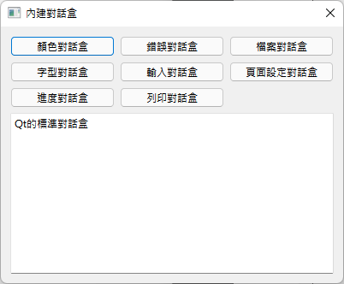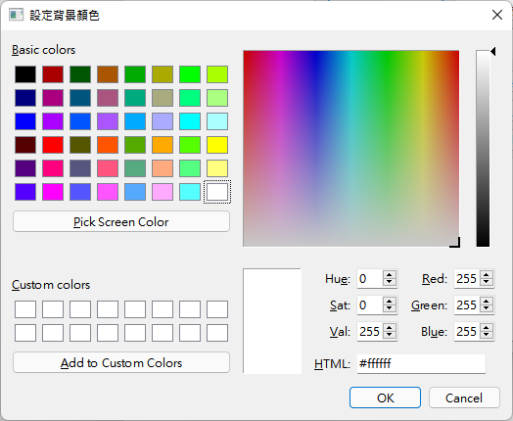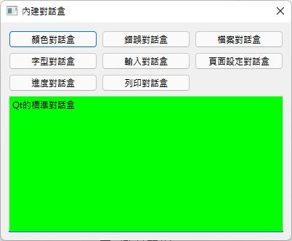

**錯誤訊息盒**

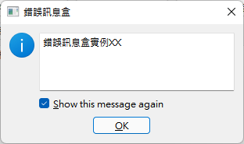 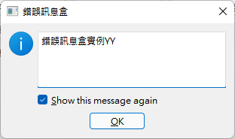 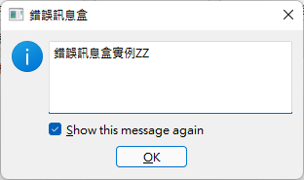

**檔案對話盒**

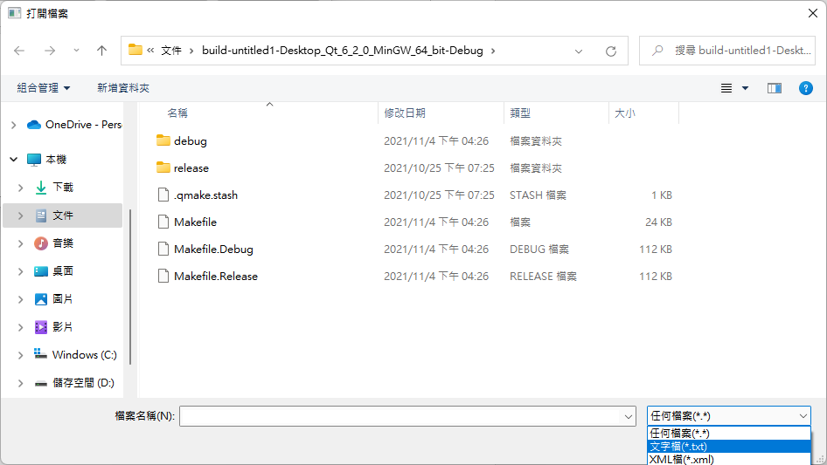

**字體對話盒**

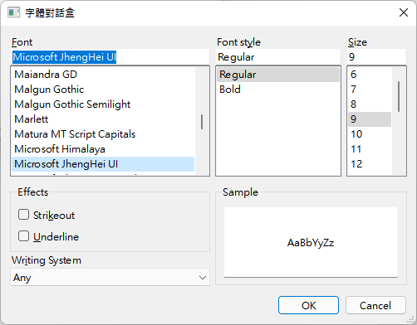

**輸入對話盒**

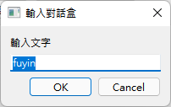 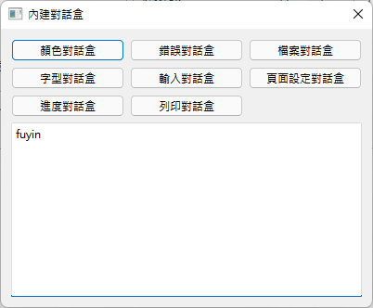

**版面設定**

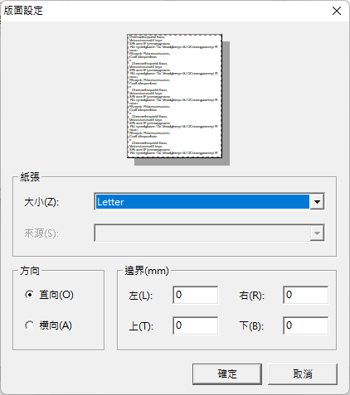

**進度對話方塊**

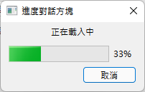

**列印對話方塊**

