A2 – Dolphin Adventure 2

Jonathan Cross

CSC 165

Section 02

# Game in action

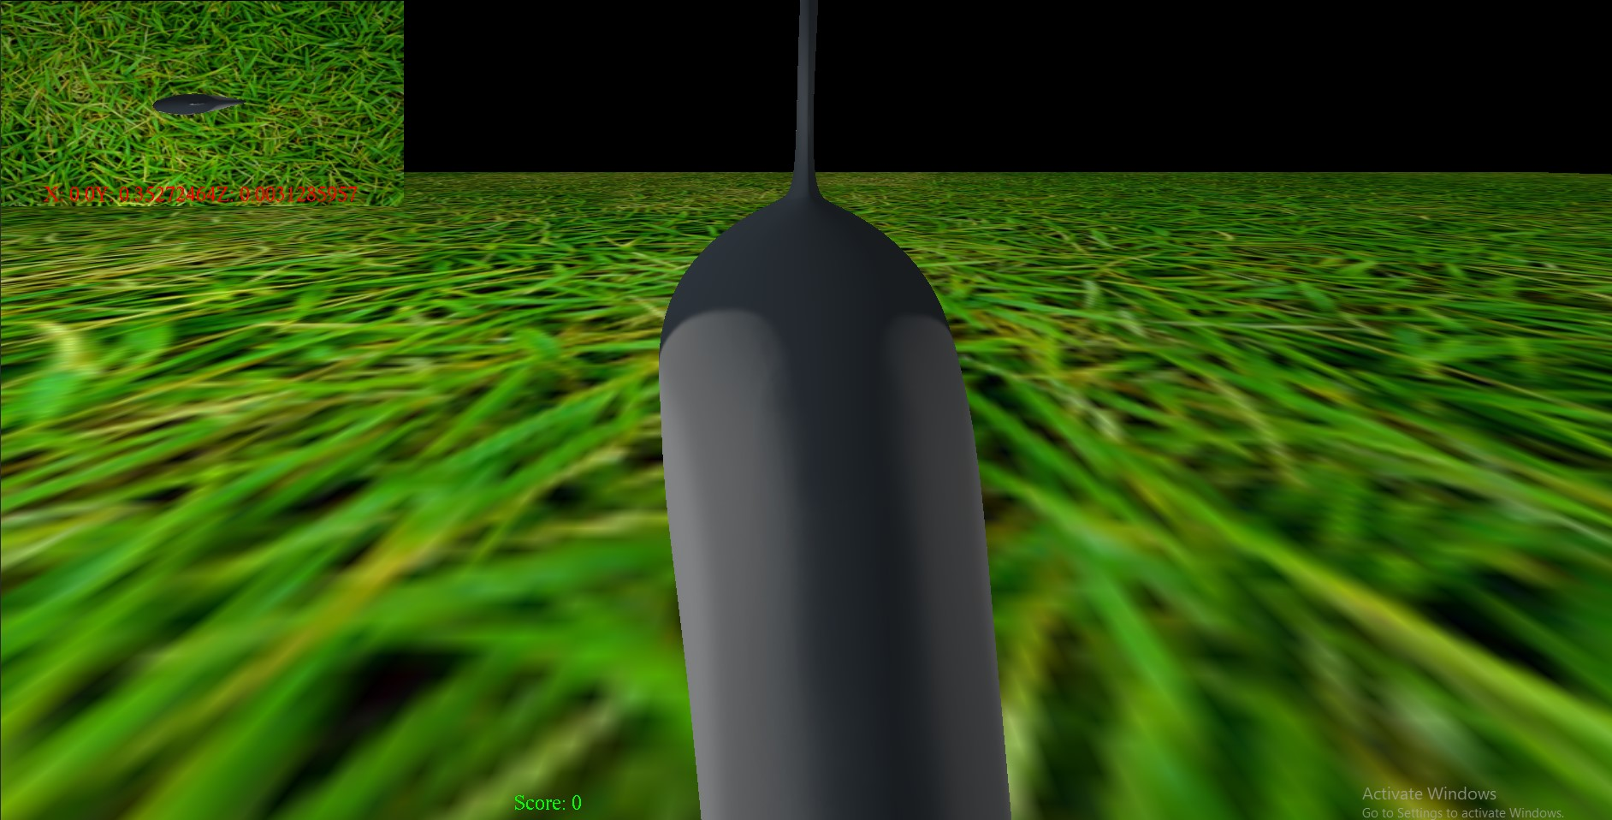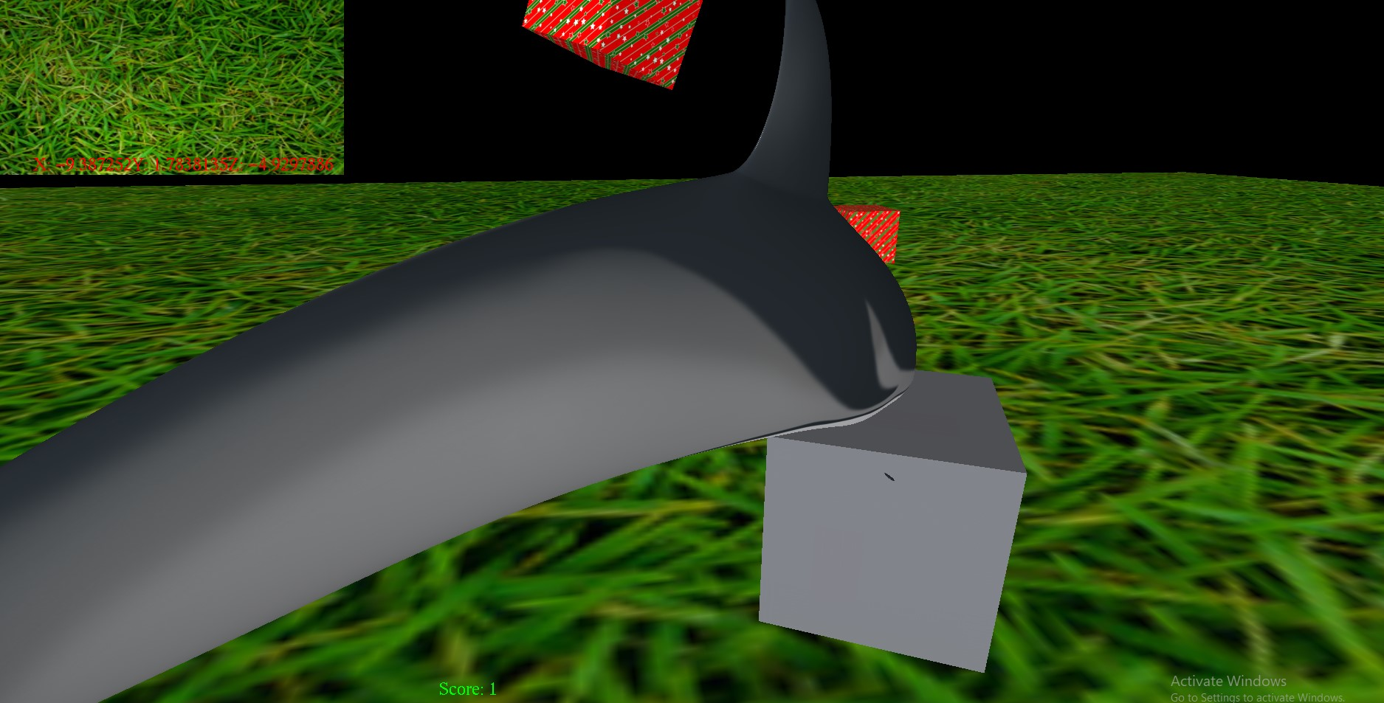

# How the game is played

You will ride around on your dolphin to collect each prize with the controls provided below. If you finish fast enough, your score will double!

W/S and left joystick up and down will move you forward and backwards.

A/D and left joystick side to side will move pan your avatar to the left and right.

Up/Down keys and right joystick up and down wil pan your view up and down.

Right joystick Left/Right will move the orbit camera to the left and right

I/K keys pan the small camera up and down

J/L keys pan the small cam Left and Right

Y/H keys will zoom the small camera in and out

# Node Controllers

The two node controllers I used were Rotate Controller and Bounce Controller.

Rotate controller is used to rotate the prizes in place once they've been obtained.

Bounce controller is used to bounce the prizes in place once they've been obtained.

# Scene Graph

The Scene Graph change I made from the previous assignment added child prizes to the dolphin. The rotation and translation matrices are both propagated to the child prizes after an initial translation to move them up towards the front of the dolphin.

Additional game activities

if u finish the game in less than a minute and a half, you can double your points.

# Additional Game Objects

no additional game object

[Changes made to Tage](https://www.publicdomainpictures.net/en/view-image.php?image=307010&picture=christmas-paper-star-texture)

* Added the Bounce Node Controller
* OrbitController3D was added
* Added the LinkedHashMap patch to RenderSystem
* JavaDocs for classes were added

# Lapses

Orbit Camera Elevation and Zoom

Adding more bindings for controller and keyboard

# Extra

Deleting texture from original prize after obtaining it.

# Assets

dolphin assets that were provided. prize texture was taken from a public domain picture website:

https://www.publicdomainpictures.net/en/view-image.php?image=307010&picture=christmaspaper-star-texture

Grass png <https://www.publicdomainpictures.net/en/view-image.php?image=22222&picture=grass-pattern>

gray prize texture

[https://www.publicdomainpictures.net/en/view-image.php?](https://www.publicdomainpictures.net/en/view-image.php?image=214548&picture=silver-background)

[image=214548&picture=silver-background](https://www.publicdomainpictures.net/en/view-image.php?image=214548&picture=silver-background)

skybox:

<https://opengameart.org/content/interstellar-skybox-png>