**A Divided Landscape**

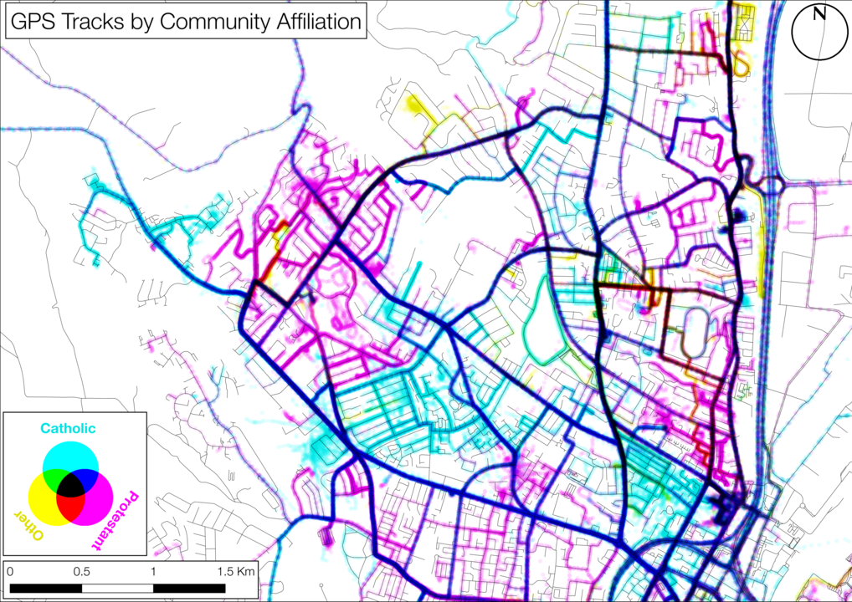 **GIS Mapping of Shared and Divided Landscapes**

Most research on urban segregation has focused on global patterns of residential division captured at a single moment in time, often using government census data about where people live in cities. The Belfast Mobility Project examined how segregation may arise through the patterning of everyday movements and use of activity spaces beyond the home and over time. Based on analysis of over 20 million GPS tracking data points, the GIS image presented opposite visualises how members of Catholic and Protestant communities in North Belfast tend to use different pathways and frequent different kinds of activity spaces. Indeed, as Figure 1 below illustrates, residents spend most of their time in spaces located in their own communities and little time in ‘outgroup’ areas.

Figure 1: Percentage of time spent within or moving through different types of spaces

Two further aspects of the patterning of activity-space segregation in North Belfast are worth noting.

**Examples of T-Communities in North Belfast**

* 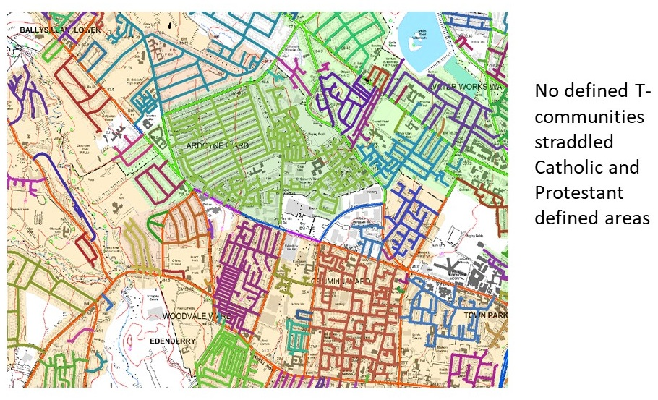First, to a large extent, it is maintained by residents’ movements through, and use of, tertiary street networks or ‘T-Communities’ *(Grannis, 1998).* Such networks form systems of social and spatial (dis)connection between neighbours, enabling segregation to emerge even in contexts where different communities live in close proximity to one another. Grannis (1998) has labelled such networks ‘T-communities’.
* Second, activity-space segregation marked social relations even in ‘public’ spaces that would ordinarily be sites of urban mixing. For example, parks are typically conceived as quintessentially open and inclusive facilities designed for members of all communities to enjoy freely. However, our walking interview data suggests that the use of parks in North Belfast is often organise d along sectarian lines, with residents using different access points and sometimes avoiding completely areas associated with the ‘other’ community. At this point in North Belfast’s history, we would describe areas such as parks as ‘liminal spaces’ – they are *simultaneously* public, open spaces and sectarian and divided spaces. In their everyday lives, local residents must negotiate this ‘in betweenness’ as they engage in such ordinary activities as walking their dogs or taking their kids to the play areas.

**Alexandra Park**

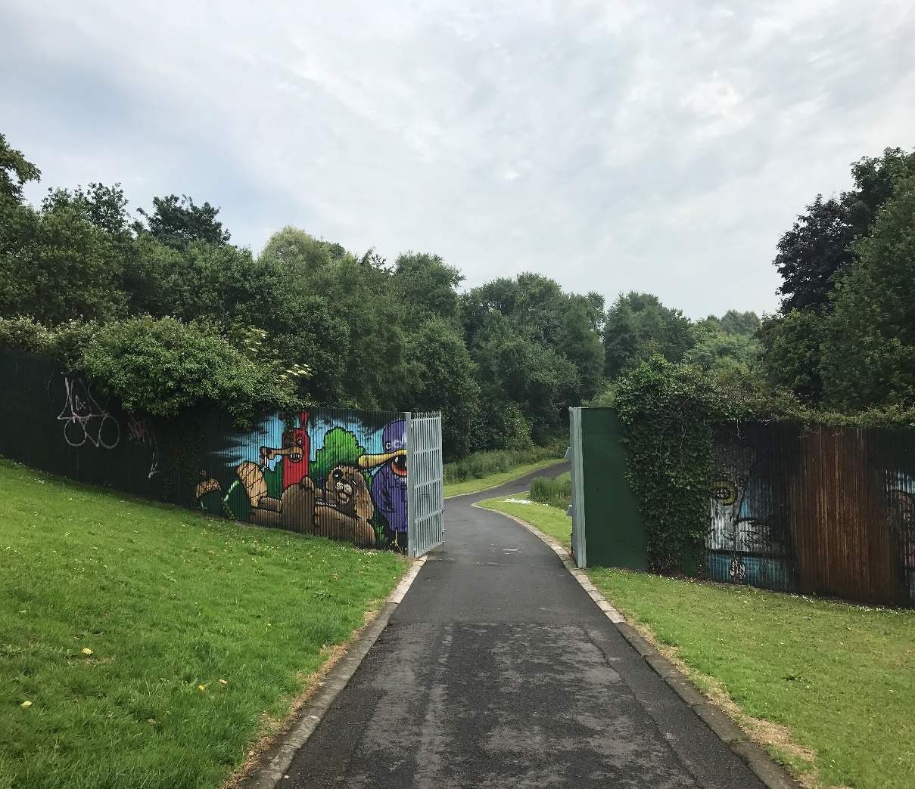

A 3.5-metre high peace wall was erected in 1994 to divide Alexandra Park – a Victorian park located in North Belfast – into Protestant and Catholic areas; however, in 2011, the photographed gate linking the two communities was installed, signifying an opening up of the space.