Numerical Analysis Homework 2025-2026 — Report
NTUA, School of Mechanical Engineering
Course: Numerical Analysis (K. Giannakoglou / V. Asouti)

Student key digits: K1 = 6 (last digit of registration number), K2 = 6 (second-to-last), K3 = 0 (third-to-last).
All algorithms are implemented from scratch in solution.py. NumPy is used only for arrays / dense linear-algebra; matplotlib only for the plots. No black-box numerical solver is used.
To reproduce: python3 solution.py — produces the plots in plots/ and the numerical log in results.txt.

1. Bezier curve (6 control points)

Control points
With K1=6, K2=6, K3=0:
i | Xᵢ | Yᵢ
0 | 0.0 | 0.0
1 | 3.0 | 4 + K2/12 = 4.500000
2 | 4 + K1/10 = 4.600000 | 10.0
3 | 5.5 | 3.0
4 | 6.0 | 5 + K3/8 = 5.000000
5 | 7.0 | 0.0

Mathematical equations
The degree-5 Bezier curve is the standard Bernstein form
B(t) = Σᵢ₌₀⁵ C(5,i) · tⁱ · (1−t)⁵⁻ⁱ · Pᵢ, t ∈ [0,1].
Substituting the control points and expanding into monomials in t we obtain (coefficients of t^k):
k | x(t) | y(t)
0 | 0.000000 | 0.000000
1 | 15.000000 | 22.500000
2 | −14.000000 | 10.000000
3 | 7.000000 | −135.000000
4 | −2.000000 | 175.000000
5 | 1.000000 | −72.500000

Hence
x(t) = 15t − 14t² + 7t³ − 2t⁴ + t⁵
y(t) = (45/2) t + 10t² − 135t³ + 175t⁴ − (145/2) t⁵
(Sanity check: x(0)=y(0)=0, x(1)=15−14+7−2+1=7, y(1)=22.5+10−135+175−72.5=0 — both endpoints reproduce the first/last control points, as expected.)

Plot
The curve was sampled at 100 equally-spaced t (Δt = 1/99) and is plotted with the control polygon — see plots/p1_bezier.png.
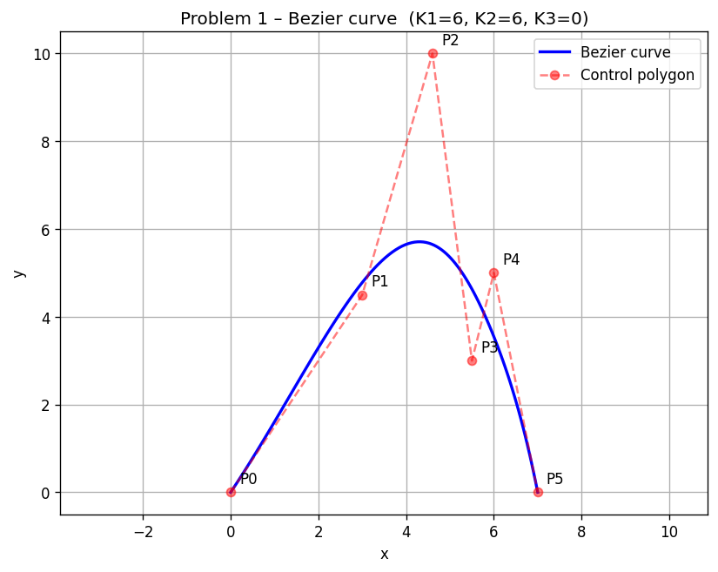

2. Tangent angle along the curve
For a parametric curve the slope is dy/dx = (dy/dt)/(dx/dt). Using the standard derivative formula for a degree-n Bezier curve,
B′(t) = n · Σᵢ₌₀^(n−1) C(n−1,i) · tⁱ · (1−t)^(n−1−i) · (Pᵢ₊₁ − Pᵢ),
so B′(t) is itself a degree-4 Bezier curve with control points Qᵢ = 5(Pᵢ₊₁ − Pᵢ):
i | Qxᵢ | Qyᵢ
0 | 15.0 | 22.5
1 | 8.0 | 27.5
2 | 4.5 | −35.0
3 | 2.5 | 10.0
4 | 5.0 | −25.0

The tangent angle (in degrees) is
θ(t) = (180/π) · atan2(y′(t), x′(t)).
Plotted in plots/p2_tangent.png. A few representative values: θ(0) = 56.310°, θ(0.25) = 51.821°, θ(0.5) = −35.078°, θ(0.75) = −67.486°, θ(1) = −78.690°. The angle is monotonically decreasing on t ∈ [≈0.1, 1], consistent with the visual shape of the curve (rising, turning over the maximum, then dropping).
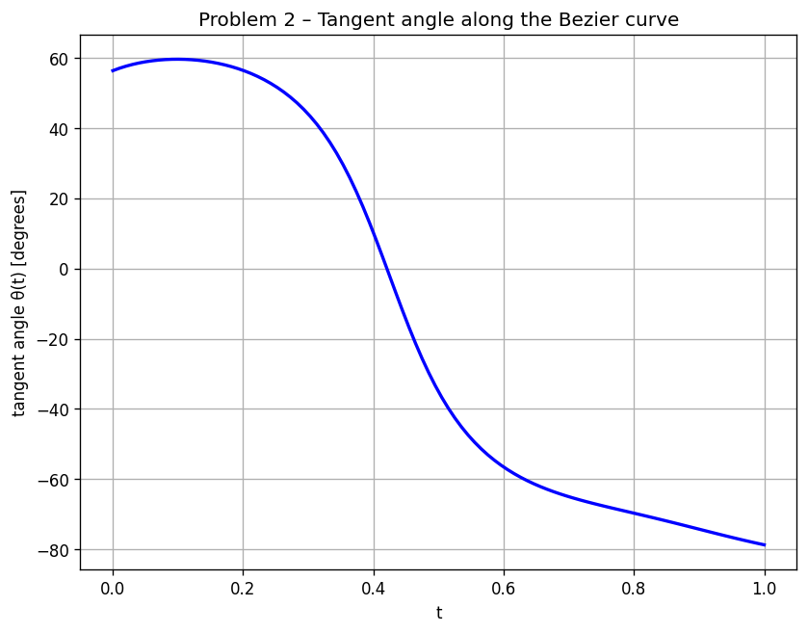

3. Volume of revolution (Gauss-Legendre quadrature)
The body of revolution about the x-axis has
V = π · ∫_{x(0)}^{x(1)} y(x)² dx = π · ∫₀¹ y(t)² · x′(t) dt.
The integrand g(t) = y(t)² · x′(t) is the product of (deg 5)² = deg 10 and deg 4, hence a polynomial of degree 14. A Gauss-Legendre rule with m nodes is exact on polynomials of degree 2m−1, so an exact result needs m ≥ 8. Therefore the values at m = 2, 3, 4, 5 are approximate.
The exact analytic value, obtained by polynomial expansion + term-by-term integration of g(t) (every monomial t^k contributes 1/(k+1)) is
V* = 344.572 848 084 958.

Results
m | V(m) | |V(m) − V*|
2 | 351.117330512449 | 6.544482 × 10⁰
3 | 321.380133749620 | 2.319271 × 10¹
4 | 347.119878378522 | 2.547030 × 10⁰
5 | 344.545194110158 | 2.765397 × 10⁻²

Comments
The Gauss rule converges very fast despite the integrand being 14-th degree: the error drops from 6.5 (m = 2) to ~2.8 × 10⁻² (m = 5), i.e. two and a half orders of magnitude in three additional nodes. This is the classical geometric / super-algebraic convergence of Gauss-Legendre on smooth integrands. The non-monotone jump at m = 3 (worse than m = 2) is normal: the error of a Gauss rule depends on the (2m)-th derivative of the integrand and need not decrease monotonically.

4. Eight equally-x-spaced points (Newton-Raphson)
The Bezier curve has x(0)=0, x(1)=7 and x′(t) ≥ min(15, 8, 4.5, 2.5, 5) = 2.5 > 0, so x(t) is strictly increasing and the inverse problem x(t) = x* has a unique solution for every x* ∈ [0,7]. We pick
xᵢ* = 7·i / 7 = i, i = 0, 1, …, 7,
and solve f(t) = x(t) − xᵢ* = 0 by Newton-Raphson:
tₖ₊₁ = tₖ − (x(tₖ) − xᵢ*) / x′(tₖ)
with initial guess t₀ = xᵢ*/7. Tolerance: |f| < 10⁻¹².

Results (8 points)
i | xᵢ* | tᵢ | yᵢ | iters
0 | 0.000000 | 0.00000000 | 0.000000 | 1
1 | 1.000000 | 0.07123777 | 1.609167 | 5
2 | 2.000000 | 0.15377571 | 3.297141 | 5
3 | 3.000000 | 0.25244560 | 4.781832 | 6
4 | 4.000000 | 0.37594681 | 5.650274 | 6
5 | 5.000000 | 0.54083183 | 5.355261 | 5
6 | 6.000000 | 0.76681091 | 3.547728 | 4
7 | 7.000000 | 1.00000000 | 0.000000 | 1

Detailed convergence — x* = 2
k | tₖ | x(tₖ) | f = x(tₖ) − x*
0 | 0.2857142857 | 3.29469864 | 1.29470 × 10⁰
1 | 0.1344823991 | 1.78045387 | −2.19546 × 10⁻¹
2 | 0.1534145566 | 1.99596646 | −4.03354 × 10⁻³
3 | 0.1537755795 | 1.99999856 | −1.43664 × 10⁻⁶
4 | 0.1537757082 | 2.00000000 | −1.82743 × 10⁻¹³

Detailed convergence — x* = 5
k | tₖ | x(tₖ) | f = x(tₖ) − x*
0 | 0.7142857143 | 5.78776700 | 7.87767 × 10⁻¹
1 | 0.5221649859 | 4.90202350 | −9.79765 × 10⁻²
2 | 0.5405198746 | 4.99838940 | −1.61060 × 10⁻³
3 | 0.5408317483 | 4.99999956 | −4.44899 × 10⁻⁷
4 | 0.5408318345 | 5.00000000 | −3.28626 × 10⁻¹⁴

In both cases we observe the classic quadratic convergence of Newton's method: the error roughly squares each step (after the first iteration).
The 8 points are plotted on the Bezier curve in plots/p4_eqspaced.png.
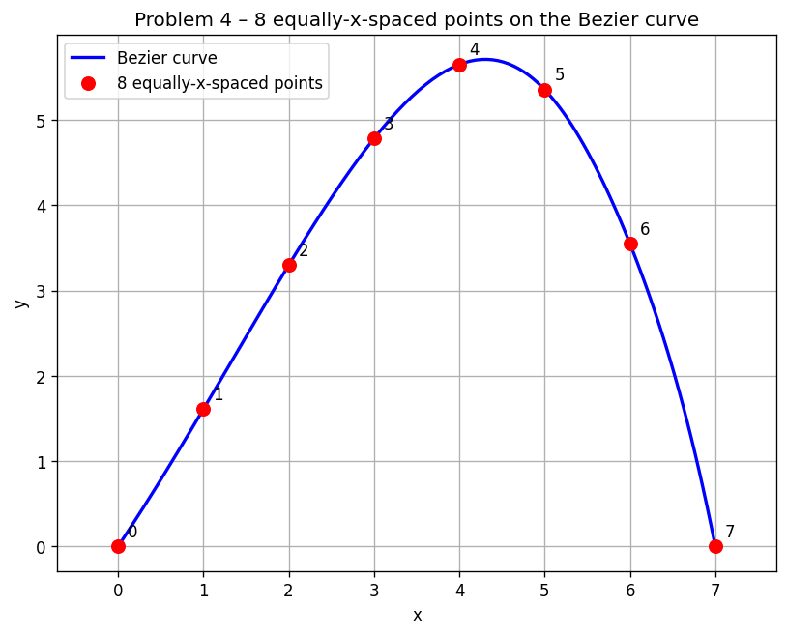

5. Natural cubic spline through these 8 points
The 8 abscissae xᵢ = 0, 1, …, 7 are uniform, hᵢ = 1. With yᵢ = (0, 1.6092, 3.2971, 4.7818, 5.6503, 5.3553, 3.5477, 0) we build a piecewise-cubic S(x) of class C². Letting Mᵢ = S″(xᵢ), the natural-spline conditions M₀ = M₇ = 0 together with the continuity-of-second-derivative system
hᵢ₋₁ Mᵢ₋₁ + 2(hᵢ₋₁ + hᵢ) Mᵢ + hᵢ Mᵢ₊₁ = 6 · ((yᵢ₊₁ − yᵢ)/hᵢ − (yᵢ − yᵢ₋₁)/hᵢ₋₁), i = 1, …, n−1
yield a tridiagonal linear system. Solving it gives
i | Mᵢ
0 | 0.00000000
1 | 0.17022523
2 | −0.20805769
3 | −0.55768944
4 | −1.25868369
5 | −1.38830539
6 | −2.26321500
7 | 0.00000000

On each interval [xᵢ, xᵢ₊₁] the spline is
Sᵢ(x) = [Mᵢ (xᵢ₊₁ − x)³ + Mᵢ₊₁ (x − xᵢ)³] / (6 hᵢ) + (yᵢ/hᵢ − Mᵢ hᵢ/6) (xᵢ₊₁ − x) + (yᵢ₊₁/hᵢ − Mᵢ₊₁ hᵢ/6) (x − xᵢ).
Plotted at 400 sample points in plots/p5_spline.png; superimposed against the Bezier curve in plots/p5_compare.png. The two curves are visually indistinguishable at the scale of the plot. A direct numerical comparison gives a maximum point-wise deviation of approximately max_x |y_s(x) − y_B(x)| ≈ 0.18 (occurring near the maximum where the curvature is largest). The Bezier curve is a single global degree-5 polynomial whereas the spline is a piecewise cubic forced through 8 sampled points; the small discrepancy is the natural error of the C²-cubic interpolant on a smooth curve sampled with Δx = 1.
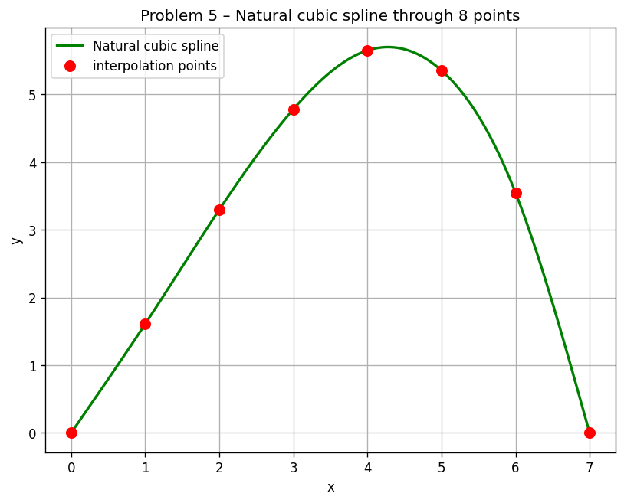
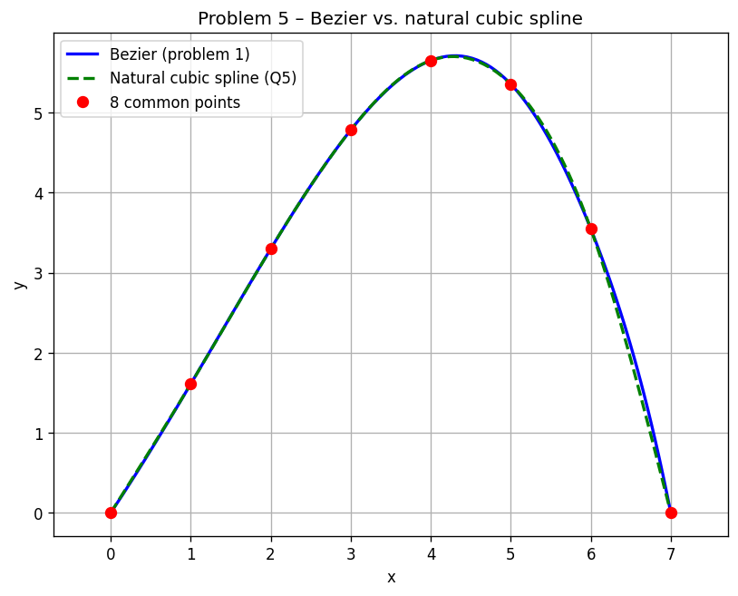

6. Cubic B-spline interpolation of 5 data points

Data
i | xᵢ | yᵢ
0 | 0.5 | 6.0
1 | 2.0 | 2 + K2/12 = 2.500000
2 | 4 + K1/10 = 4.600000 | 1.0
3 | 5.0 | 4.0
4 | 6.0 | 8 + K3/8 = 8.000000

Setup
Using uniform knot spacing and parameter uⱼ = j at data point j, each segment Sₖ(t), t ∈ [0,1], k = 0..3, is
Sₖ(t) = (1/6) · [(1−t)³ Pₖ + (3t³ − 6t² + 4) Pₖ₊₁ + (−3t³ + 3t² + 3t + 1) Pₖ₊₂ + t³ Pₖ₊₃].
Imposing Sₖ(0) = (xₖ, yₖ) for k = 0..3 and S₃(1) = (x₄, y₄) gives 5 equations in the 7 unknown control points P₀, …, P₆. Two more come from the natural boundary conditions S″(0) = S″(end) = 0, which in uniform-B-spline form read
P₀ − 2 P₁ + P₂ = 0, P₃ − 2 P₄ + P₅ = 0,
and a 7×7 system is solved twice (once for x, once for y). The resulting control points are
i | Pᵢ,ₓ | Pᵢ,ᵧ
0 | −0.537500 | 9.732143
1 | 0.500000 | 6.000000
2 | 1.537500 | 2.267857
3 | 5.350000 | −0.071429
4 | 4.662500 | 4.017857
5 | 6.000000 | 8.000000
6 | 7.337500 | 11.982143

Explicit polynomial of every segment
Substituting and collecting in monomials, every segment has the form x(t) = αx₀ + αx₁ t + αx₂ t² + αx₃ t³, y(t) = αy₀ + αy₁ t + αy₂ t² + αy₃ t³:
Segment 1/4 — between Q₀ and Q₁:
x(t) = 0.500000 + 1.037500 t + 0 · t² + 0.462500 t³
y(t) = 6.000000 − 3.732143 t + 0 · t² + 0.232143 t³
Segment 2/4 — between Q₁ and Q₂:
x(t) = 2.000000 + 2.425000 t + 1.387500 t² − 1.212500 t³
y(t) = 2.500000 − 3.035714 t + 0.696429 t² + 0.839286 t³
Segment 3/4 — between Q₂ and Q₃:
x(t) = 4.600000 + 1.562500 t − 2.250000 t² + 1.087500 t³
y(t) = 1.000000 + 0.875000 t + 3.214286 t² − 1.089286 t³
Segment 4/4 — between Q₃ and Q₄:
x(t) = 5.000000 + 0.325000 t + 1.012500 t² − 0.337500 t³
y(t) = 4.000000 + 4.035714 t − 0.053571 t² + 0.017857 t³
(One easily checks Sₖ(0) = Qₖ and S₃(1) = Q₄.)
The curve sampled at 400 points and the control polygon are in plots/p6_bspline.png.
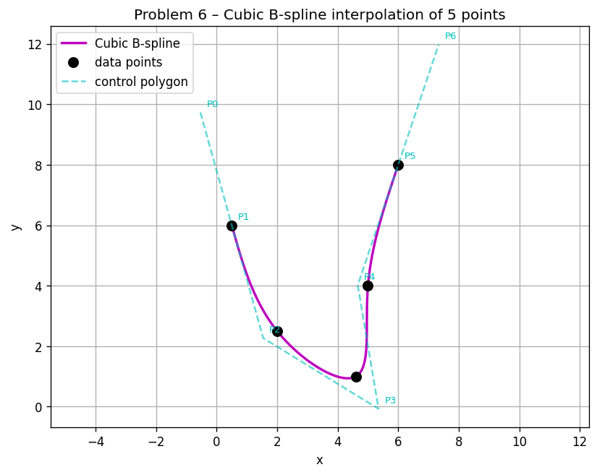

7. Intersections of the two curves (fixed-point iteration)
The cubic spline of §5 is y = y_s(x) for x ∈ [0,7]; the cubic B-spline of §6 is the parametric curve (x_b(u), y_b(u)) for u ∈ [0,4]. An intersection satisfies
F(u) := y_b(u) − y_s(x_b(u)) = 0.
This is rewritten as the fixed-point problem u = G(u) := u − α F(u) with constant relaxation α. Convergence of the basic fixed-point iteration
uₖ₊₁ = uₖ − α · F(uₖ)
requires |G′(u*)| = |1 − α F′(u*)| < 1, i.e. 0 < α F′(u*) < 2. We estimate F′(u₀) numerically (central differences with ε = 10⁻⁴) at the mid-point of each bracket of a sign change of F, and pick α = 1/F′(u₀), which gives |G′(u*)| ≈ 0 near the root and very fast (effectively linear-becoming-superlinear in practice) contraction.
A 4000-point sweep of F(u) over [0,4] reveals two sign changes, hence two intersections.

Convergence — Intersection 1
α = −0.147653, starting u₀ = 0.884721:
k | uₖ | F(uₖ)
0 | 0.884721180074 | −1.07131 × 10⁻³
1 | 0.884562998104 | −3.02963 × 10⁻⁸
2 | 0.884562993630 | −1.71418 × 10⁻¹²
3 | 0.884562993630 | 8.88 × 10⁻¹⁶ (≈ 0)

Convergence — Intersection 2
α = +0.199305, starting u₀ = 3.290323:
k | uₖ | F(uₖ)
0 | 3.290322579823 | −6.68142 × 10⁻⁴
1 | 3.290455743493 | 2.41921 × 10⁻⁸
2 | 3.290455738672 | −1.75149 × 10⁻¹²
3 | 3.290455738672 | −8.88 × 10⁻¹⁶ (≈ 0)

Intersections found
# | u* | x* | y*
1 | 0.8845629936 | 1.7378432 | 2.8593571
2 | 3.2904557387 | 5.1715470 | 5.1681144

Plotted with red stars on the two curves in plots/p7_intersections.png.
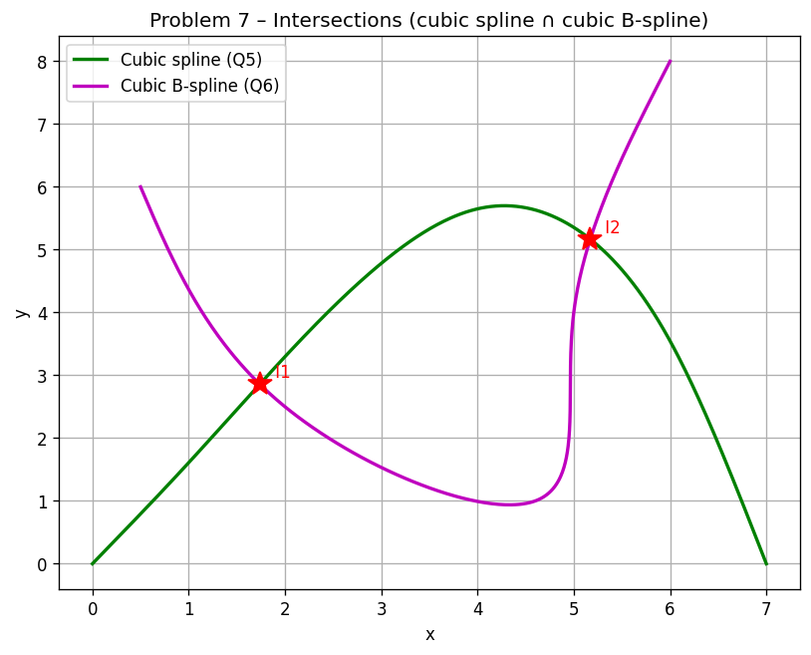

Files in this submission
File | Contents
solution.py | All 7 problems implemented from scratch
results.txt | Full numerical log produced by the script
REPORT.md | Markdown source of this report
REPORT.docx | Word version of this report
plots/p1_bezier.png | Problem 1 — Bezier curve
plots/p2_tangent.png | Problem 2 — tangent angle θ(t)
plots/p4_eqspaced.png | Problem 4 — 8 equally-x-spaced points
plots/p5_spline.png | Problem 5 — natural cubic spline
plots/p5_compare.png | Problem 5 — Bezier vs cubic spline
plots/p6_bspline.png | Problem 6 — interpolating cubic B-spline
plots/p7_intersections.png | Problem 7 — intersections

