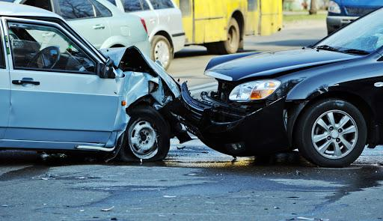

LOS ANGELES TRAFFIC COLLISION ANALYSIS

IDENTIFYING PATTERNS AND CORRELATIONS IN ORDER TO HELP REDUCE CRASHES AND POTENTIALLY SAVE LIVES

Debasis Chatterjee, Christopher Webster, Dalis Riley, Jonathan Ortiz

IST 652 SCRIPTING FOR DATA ANALYSIS

Professor Jason Anastasopoulos

Syracuse University | 2020

|  |  |
| --- | --- |
|  | P a g e | **1** |
|  |  |
| **Table of Contents** |  |
| **Introduction** | 3 |
| **About The Data** | 4 |
| **Source Data** | 4 |
| Original Dataset | 4 |
| Median Income Dataset | 5 |
| Weather Dataset | 6 |
| **Pre-Processing** | 8 |
| Cleaning The Data | 8 |
| Data Dictionary | 9 |
| **Methods of Analysis** | 12 |
| **Analysis: Location** | 13 |
| Area Name | 17 |
| Council Districts | 18 |
| Streets | 19 |
| Results and Findings: Location | 23 |
| **Analysis: Demographics** | 24 |
| Victim Gender | 24 |
| Victim Age | 26 |
| Victim Descent | 27 |
| Victim Income | 31 |
| Results and Findings: Demographics | 32 |
| **Analysis: Time/Day** | 33 |
| Yearly Pattern | 33 |
| Day of Week | 36 |
| Month | 37 |
| Hour of Day | 39 |
| Results and Findings: Time/Day | 41 |
| **Analysis: Weather** | 42 |
| Temperature | 42 |
| Precipitation | 45 |
| Results and Findings: Weather | 47 |
| **Conclusions and Recommendations** | 48 |

|  |  |
| --- | --- |
|  | P a g e | **2** |
|  |  |
| **Limitations of Study** | 50 |
| **References** | 51 |

P a g e | **3**



**INTRODUCTION**

As the second largest in the United States, Los Angeles has traffic challenges due to a large and growing population and an increase in the number of cars. A better understanding of the factors that contribute to accidents can help government officials, companies, citizens and other interested parties to understand how to make the city safer and more drivable.

The goal is to explore the trends and correlations between the data to provide useful information that can help answer our proposed analysis questions:

What are the most dangerous intersections?

What are the most common collision areas in Los Angeles?

What are the best/worst times of the day for accidents? Best/worst month?

What is the demographic makeup of victims in collisions?

What is the relationship between income and collision victims?

Do certain temperatures or weather play a factor?

The goal of making Los Angeles traffic safer will not only help save lives and money, but it can potentially be a translatable example to other cities around the world and inspire others. In 2018, at least 240 people were killed in Los Angeles traffic collisions. The issue is of such importance to Los Angeles that by 2025, the goal is to have zero traffic deaths.1 Despite programs designed to help reduce these collisions, fatal car crashes have increased 32% in Los Angeles since 2015 and more people have died in car crashes than shootings in that same timeframe.2 Many layers and factors exist for these traffic collisions. The objective of this report is to highlight noticeable trends and patterns that can possibly lead to solutions in the future for this important crisis in Los Angeles and abroad.



1

2

<https://la.curbed.com/2019/3/26/18277621/los-angeles-traffic-deaths-2019-data-stats> [https://www.latimes.com/local/lanow/la-me-ln-traffic-deaths-bike-pedestrian-los-angeles-vision-zero-20190425-](https://www.latimes.com/local/lanow/la-me-ln-traffic-deaths-bike-pedestrian-los-angeles-vision-zero-20190425-story.html)

[story.html](https://www.latimes.com/local/lanow/la-me-ln-traffic-deaths-bike-pedestrian-los-angeles-vision-zero-20190425-story.html)

P a g e | **4**



**ABOUT THE DATA**

**SOURCE DATA**

ORIGINAL DATASET

The Los Angeles Traffic Collision Data is publicly available from Kaggle.com is owned by the City of Los Angeles. This contains 481,568 incidents from 2010 to 2019. Since the dataset continually updates on Kaggle, our latest download of the dataset happened on July 19, 2019.

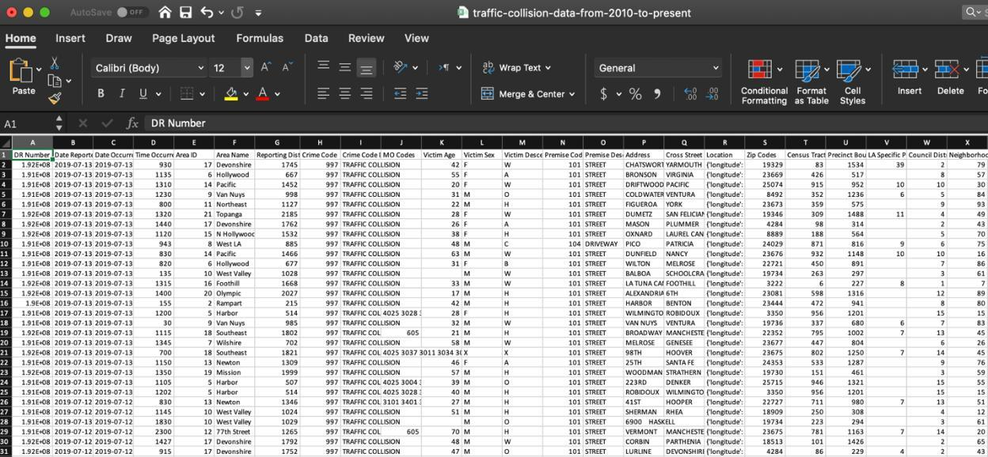

**FIGURE 1 - LOS ANGELES TRAFFIC DATA 2010-2019 FROM KAGGLE.COM**

Multiple data sets were incorporated into analysis beyond the original Kaggle dataset in order to get more data that was not included in this original dataset such as weather and income data.

P a g e | **5**



MEDIAN INCOME DATASET

To answer the analysis question about income, outside data was needed since the original dataset did not have income information. For Median Income, incomes were pulled from the LA Chamber of Commerce website. They were then inputted into a CSV and merged into the original data frame. The incomes are for Council Districts in Los Angeles and are from 2016. Other ways were examined to link income to our dataset such as by Area Names and Zip Code, but in both attempts at doing that, there were not enough matches to the original dataset. Council District was found to be the most effective way to merge income with the rest of the data.

Source: <https://lachamber.com/clientuploads/pdf/2018/18_BeaconReport_LR.pdf>

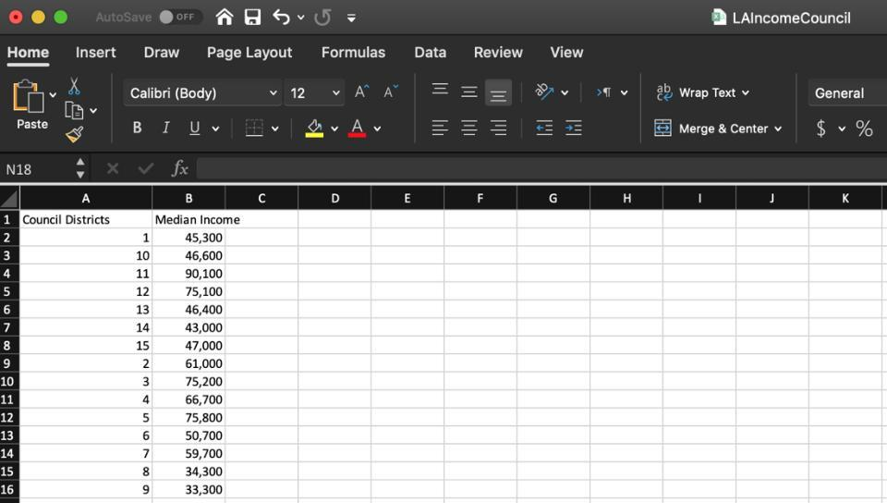

**FIGURE 2 - MEDIAN INCOME DATA FROM LA CHAMBER OF COMMERCE**

P a g e | **6**



WEATHER DATASET

The weather data was scraped from the website Wunderground.com. Once in CSV form, each weather CSV contained 359 rows and 7 columns (*Date*, *HighTemp*, *LowTemp*, *AverageTemp*, *Precipitation*, *NauticalTwilight, NauticalTwilightSet*). It was then pulled into main dataset witha merge. We were able to scrape 2017, 2018, and 2019, but since 2019 was not complete, we decided to only import 2017 and 2018. This led us to the scope of our project focusing on only the years of 2017 and 2018. The weather dataset provided other ways to enrich our comparison analysis by adding characteristics such as temperature ranges, precipitation, and the times of sunset and sunrise.

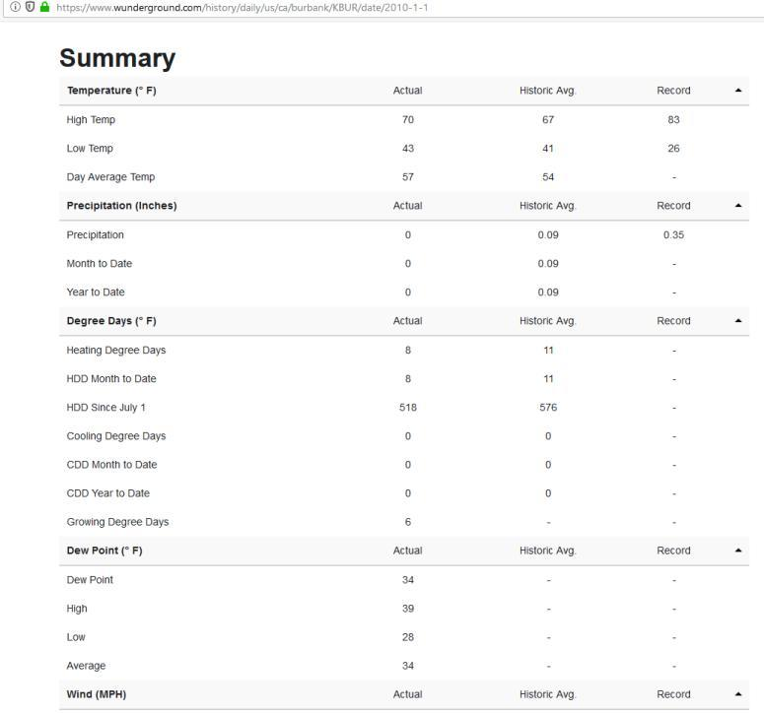

**FIGURE 3, UNSTRUCTURED DATA IN JAVASCRIPT FORM SCRAPED**

P a g e | **7**

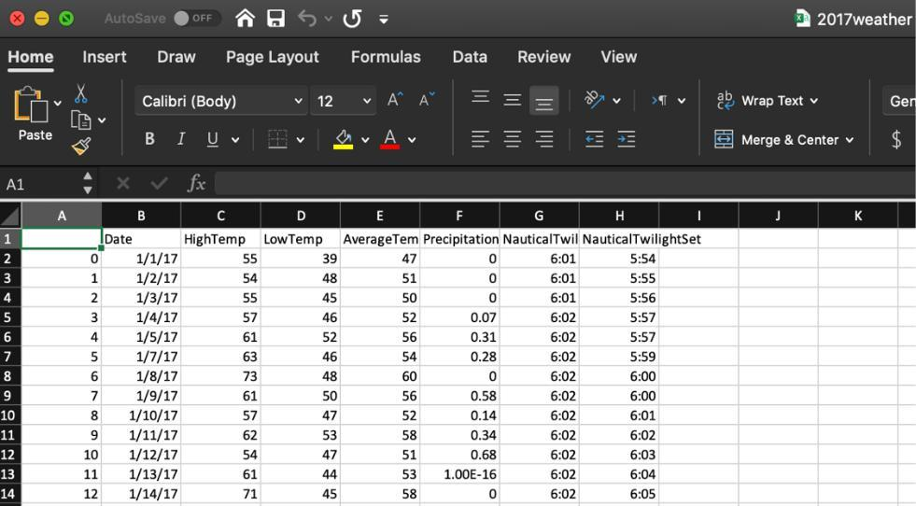

**FIGURE 4 - LA WEATHER DATA FROM WUNDERGROUND.COM**

P a g e | **8**



**PRE-PROCESSING**

CLEANING THE DATA

* The Median Income dataset was cleaned by doing string replace to remove the commas in the numbers and to take away the $ characters. It was also converted to float data type. After it was cleaned, it was

‘inner’ merged on the column *Council Districts* with the LA dataset.

* The Weather datasets for 2017 and 2018 were concatenated first to make a combined dataset. The weather data was converted to DateTime format, and then ‘inner’ merged with the LA dataset on the column *Date*.
* The different data types of each column were evaluated and converted to its desired type
* Columns that were not needed were then removed:
  1. *DR Number Area ID Crime Code*

*Crime Code Description Premise Code Precinct Boundaries Date Reported Neighborhood Councils (Certified) Census Tracts*

*MO Codes*

*LA Specific Plans Reporting District*

* Blank values and NAs were removed with the dropna() function.
* *Time Occurred* column was broken up into hours into a *hours* column
* *Date* was converted to DateTime and broken up into *months*, *weekdays*, and *year* columns.
* Year subsets were created in order to give flexibility to analyze any given year (la_2017 and la_2018 were concatenated and used to filter main dataset to show only data from 2017 and 2018)
* *Location* was broken up into *longitude* and *latitude* columns to make it easier to analyze with mapvisualizations
* *Date Occurred* was dropped as well
* LA weather data from 2017-2019 was then merged with the traffic data set in a new laWeather dataset
* For the laWeather data set, the columns *Unnamed: 0* and *Location* were dropped since they were not needed anymore

P a g e | **9**



DATA DICTIONARY

A data dictionary with column names, description, data types, and processing steps is below. After everything was merged and cleaned, the final LA collision dataset for analysis had **90,855** **rows** and **19 columns.**

|  |  |  |  |  |  |  |  |  |  |  |
| --- | --- | --- | --- | --- | --- | --- | --- | --- | --- | --- |
|  | **Column** |  |  | **Description** |  |  | **Data Type** |  | **Range of Values** |  |
|  |  |  |  |  |  |  |
|  | **Area Name** |  |  | The 21 geographic areas |  |  | Object |  | ‘Devonshire’, |  |
|  |  |  |  | or Patrol Divisions |  |  |  |  |  |  |
|  |  |  |  |  |  |  |  | ‘West Valley’, |  |
|  |  |  |  | given a name based on |  |  |  |  |  |
|  |  |  |  |  |  |  |  |  |  |
|  |  |  |  | landmark or surrounding |  |  |  |  | ‘Topanga’, |  |
|  |  |  |  | community it is |  |  |  |  | ‘Mission’, |  |
|  |  |  |  | responsible for |  |  |  |  |  |
|  |  |  |  |  |  |  |  |  | ‘Hollywood’, |  |
|  |  |  |  |  |  |  |  |  | ‘Olympic’, |  |
|  |  |  |  |  |  |  |  |  | ‘Northeast’, |  |
|  |  |  |  |  |  |  |  |  | ‘Rampart’, |  |
|  |  |  |  |  |  |  |  |  | ‘Wilshire’, |  |
|  |  |  |  |  |  |  |  |  | ‘West LA’, |  |
|  |  |  |  |  |  |  |  |  | ‘Pacific’, |  |
|  |  |  |  |  |  |  |  |  | ‘N Hollywood’, |  |
|  |  |  |  |  |  |  |  |  |  |  |
|  |  |  |  |  |  |  |  |  | ‘Van Nuys’, |  |
|  |  |  |  |  |  |  |  |  | ‘Foothill’, |  |
|  |  |  |  |  |  |  |  |  | ‘Central’, |  |
|  |  |  |  |  |  |  |  |  | ‘Hollenbeck’, |  |
|  |  |  |  |  |  |  |  |  | ‘Newton’, |  |
|  |  |  |  |  |  |  |  |  | ‘Southwest’, |  |
|  |  |  |  |  |  |  |  |  | ‘Southeast’, |  |
|  |  |  |  |  |  |  |  |  |  |  |
|  |  |  |  |  |  |  |  |  | ‘Harbor’, |  |
|  |  |  |  |  |  |  |  |  | ‘77th Street’ |  |
|  |  |  |  |  |  |  |  |  |  |  |
|  | **Time Occurred** | |  | Time of collision |  |  | Integer |  | Time values | |
|  |  | |  |  |  |  |  |  |  | |
|  | **Victim Age** |  |  | Age of victim of car |  |  | Integer |  | Age values from 0-99 |  |
|  |  |  |  | collision |  |  |  |  |  |  |
|  | **Victim Sex** | |  | Sex of the victims |  |  | Object |  | F - female | |
|  |  |  |  |  |  |  |  |  | M - male | |
|  |  |  |  |  |  |  |  |  |  |  |

P a g e | **10**



|  |  |  |  |
| --- | --- | --- | --- |
|  | Genders called “H” and |  | X - unknown |
|  | “N” were ignored in |  |  |
|  | analysis since no |  |  |
|  | indication what they |  |  |
|  | represented from Kaggle |  |  |
|  | website and also |  |  |
|  | represented a very small |  |  |
|  | amount |  |  |
|  |  |  |  |
| **Victim Descent** | Ethnicity of victim of | Object | A - Other Asian |
|  | collision |  | B - Black |
|  |  |  | C - Chinese |
|  |  |  | D - Cambodian |
|  |  |  | F - Filipino |
|  |  |  | G - Guamanian |
|  |  |  | H - |
|  |  |  | Hispanic/Latin/Mexican |
|  |  |  | I - American |
|  |  |  | Indian/Alaskan Native |
|  |  |  | J - Japanese |
|  |  |  | K - Korean |
|  |  |  | L - Laotian |
|  |  |  | O - Other |
|  |  |  | P - Pacific Islander |
|  |  |  | S - Samoan |
|  |  |  | U - Hawaiian |
|  |  |  | V - Vietnamese |
|  |  |  | W - White |
|  |  |  | X - Unknown |
|  |  |  | Z - Asian Indian |
| **Premise Description** | Indicates type of | Object | 42 unique values such as |
|  | location where collision |  | ‘STREET’, ‘PARKING |
|  | occurred |  | LOT’, ‘FREEWAY’. |
| **Address** | Street address of | Object | Streets |
|  | collision |  |  |
| **Cross Street** | Nearest intersection | Object | Cross street |
|  | street to Address |  |  |
| **Location** | GPS coordinates of | Object | Latitude and Longitude |
|  | collision with longitude |  | coordinates |
|  | and latitude |  |  |
| **Zip Codes** | Zip code of collision | Object | 5 digit number |
|  |  | (Converted |  |
|  |  | from float to |  |
|  |  | integer and |  |
|  |  | then to string |  |
|  |  | ) |  |

|  |  |  |  |  |  |  |  |
| --- | --- | --- | --- | --- | --- | --- | --- |
|  |  |  |  |  |  | P a g e | **11** |  |
|  |  |  |  |  |  |  |  |
|  |  |  |  |  |  |  |  |
|  |  | **Council Districts** |  | Council District number | Integer | Values from 1-15 |  |
|  |  |  |  | of collision |  |  |  |
|  |  | **Median Income** |  | Median Household | Float | Dollar value |  |
|  |  |  |  | Income associated with |  |  |  |
|  |  |  |  | Council District, |  |  |  |
|  |  | **Date** |  | Date of collision | DateTime |  |  |
|  |  |  |  |  |  |  |  |
|  |  | **year** |  | Year of collision | Integer | Values from 2010 – 2019 |  |
|  |  | **month** |  | Month of collision | Integer | Values from 1-12 |  |
|  |  | **weekday** |  | Day of the week of | String | Monday to Sunday |  |
|  |  |  |  | collision |  |  |  |
|  |  | **hours** |  | Hour in day of collision | Integer | Values from 1-23 |  |
|  |  |  |  |  |  | (military time) |  |
|  |  | **longitude** |  | Longitude of location | Float |  |  |
|  |  |  |  |  |  |  |  |
|  |  | **latitude** |  | Latitude of location | Float |  |  |
|  |  |  |  |  |  |  |  |
|  |  | **HighTemp** |  | Highest observed | Integer | Temperature in F |  |
|  |  |  |  | temperature in the day |  |  |  |
|  |  | **LowTemp** |  | Lowest observed | Integer | Temperature in F |  |
|  |  |  |  | temperature in the day |  |  |  |
|  |  |  |  |  |  |  |  |
|  |  | **AverageTemp** |  | Average observed | Integer | Temperature in F |  |
|  |  |  |  | temperature in the day |  |  |  |
|  |  | **Precipitation** |  | Amount of precipitation | Float | Rainfall in inches |  |
|  |  |  |  | observed in inches |  |  |  |
|  |  | **NauticalTwilightRise** |  | Occurs when the center | Time |  |  |
|  |  |  |  | of the suns is between 6 |  |  |  |
|  |  |  |  | -12 degrees above the |  |  |  |
|  |  |  |  | horizon. At this point |  |  |  |
|  |  |  |  | artificial light is starting |  |  |  |
|  |  |  |  | to not be needed for |  |  |  |
|  |  |  |  | outdoor activities. |  |  |  |
|  |  | **NauticalTwilightSet** |  | Occurs when the center | Time |  |  |
|  |  |  |  | of the Suns between 6 - |  |  |  |
|  |  |  |  | 12 degrees above the |  |  |  |
|  |  |  |  | horizon. At this time |  |  |  |
|  |  |  |  | artificial light is usually |  |  |  |
|  |  |  |  | needed for outdoor |  |  |  |
|  |  |  |  | activities |  |  |  |
|  |  | **rain** |  | Column to indicate if | Boolean | Yes or No |  |
|  |  |  |  | day had rain or not |  |  |  |



**TABLE 1 - DATA VARIABLES INCLUDED IN ANALYSIS**

P a g e | **12**



**METHODS OF ANALYSIS**

Python software will be utilized to import the data, cleanse, develop models and create interesting visualizations to help understand the data. Analysis was broken up into four categories along with some questions to help guide the process. Each group member worked on at least one section:

1. Location
2. Demographics
3. Time/Day
4. Weather

By breaking up the analysis into four distinct categories it allowed for a more structured way to analyze the data. In order to guide analysis, a hypothesis was created for each category. This hypothesis was used as a way to find evidence to prove or disprove the statement.

Exploratory analysis was first done on all the data in order to understand the different kinds of distributions across attributes. Then multi-variable plots and visuals were created to see the types of relationships different variables. Analysis methods such as word clouds, maps, line charts, boxplots, bar graphs, heatmaps, and other types of visuals were used.

P a g e | **13**



**ANALYSIS: LOCATION**

Hypothesis:

**Certain areas of Los Angeles increase the likelihood of car collisions.**

Fields:

*Area Name*, *Zip Codes*, *Council Districts*, *Cross Streets*, *latitude* and *longitude.*

The location was analyzed in many ways. Heat maps of the collisions were made to show patterns of where the concentration of collisions in Los Angeles occur.

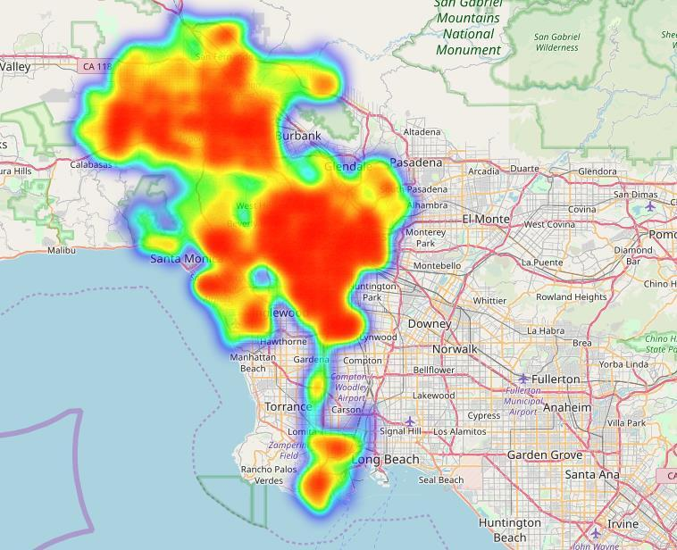

**FIGURE 5, HEAT MAP OF ALL THE COLLISIONS FROM 2017 TO 2018**

The map shows a concentration of collisions, the redder the color the higher concentration, in the middle of LA, towards the bottom, and farther north. These areas were also found to be concentrated during different times of the day.

P a g e | **14**

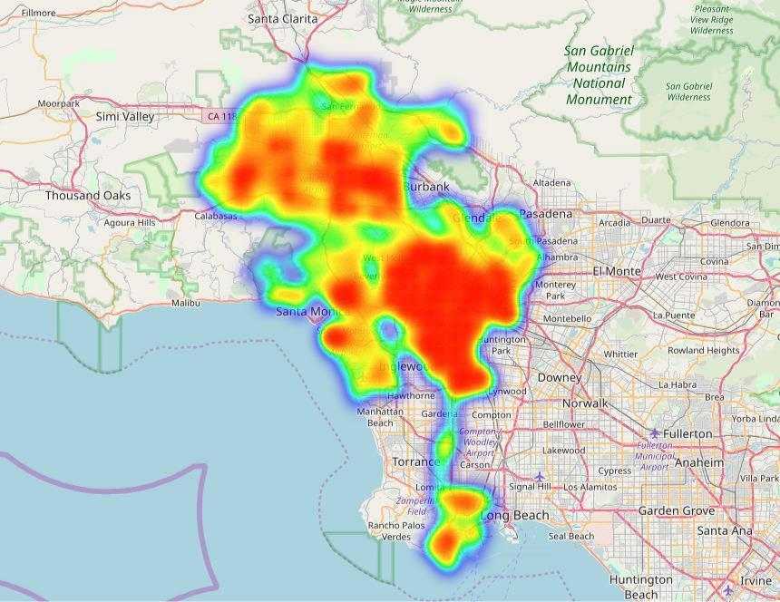

**FIGURE 6, HEAT MAP OF CRASHES BETWEEN SUNRISE AND SUNSET**

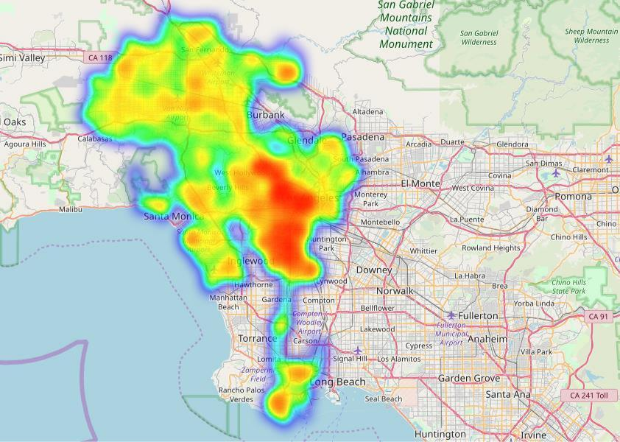

**FIGURE 7, HEAT MAP OF CRASHES BEFORE SUNRISE AND AFTER SUNSET**

These three heatmaps highlight how the center of LA has the most crashes at all times of the day. The map of crashes when it is visibly dark shows the northern part of LA has less accidents at night.

P a g e | **15**

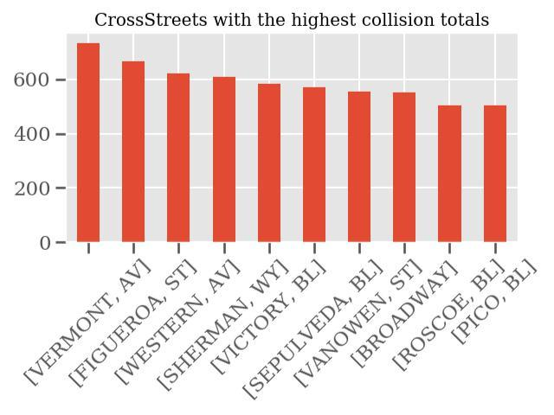

**FIGURE 8, BARCHART SHOWING CROSS STREETS WITH MOST COLLISIONS**

**Intersections of Collisions**

|  |  |  |  |  |
| --- | --- | --- | --- | --- |
| Cross Street |  | Address |  | Total Collisions |
|  |  |  |  |  |
| SEPULVEDA BL |  | SHERMAN WY |  | 60 |
|  |  |  |  |  |
| NORDHOFF ST |  | TAMPA AV |  | 59 |
|  |  |  |  |  |
| WHITSETT AV |  | SHERMAN WY |  | 52 |
|  |  |  |  |  |
| WOODMAN AV |  | SHERMAN WY |  | 52 |
|  |  |  |  |  |
| RODEO RD |  | BREA AV |  | 50 |
|  |  |  |  |  |
| SEPULVEDA BL |  | BURBANK BL |  | 47 |
|  |  |  |  |  |
| VICTORY BL |  | TOPANGA CANYON BL |  | 47 |
|  |  |  |  |  |
| PLUMMER ST |  | ST TAMPA AV |  | 46 |
|  |  |  |  |  |
|  | **TABLE 2,** | **MOST COLLISIONS BY SAME CROSS STREET AND** | **ADDRESS** |  |

P a g e | **16**

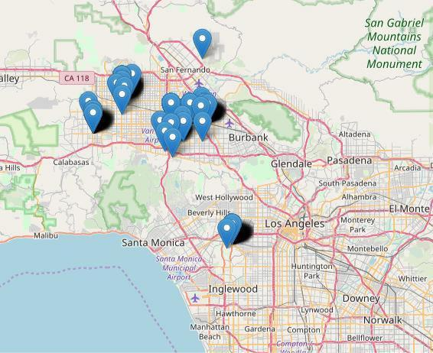

**FIGURE 9, UNIQUE CROSS STREET AND ADDRESSES WITH MOST COLLISIONS (EACH POINT REPRESENTING MANY COLLISIONS)**

Although the middle of Los Angeles had the most concentration of collisions, the northern parts near Burbank had unique combinations with more frequent accidents. These may want to be analyzed to see if there is an issue. The airport may be a heavy traffic area.

P a g e | **17**



AREA NAME

*Area Name* was examined to find out which areas were the most impacted by collisions:

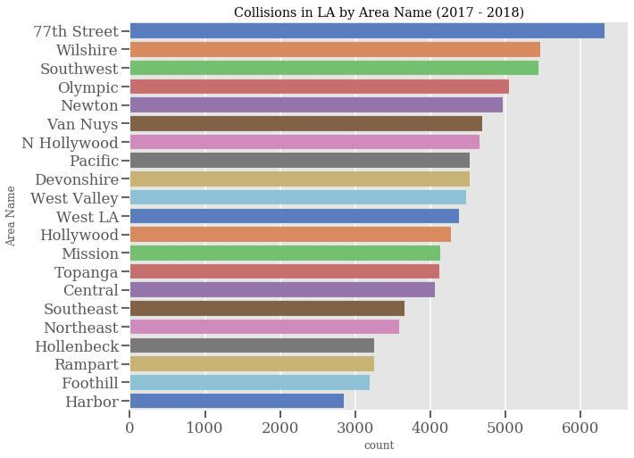

**FIGURE 10 - LA COLLISIONS BY AREA NAME**

P a g e | **18**



COUNCIL DISTRICTS

Council Districts were also looked at:

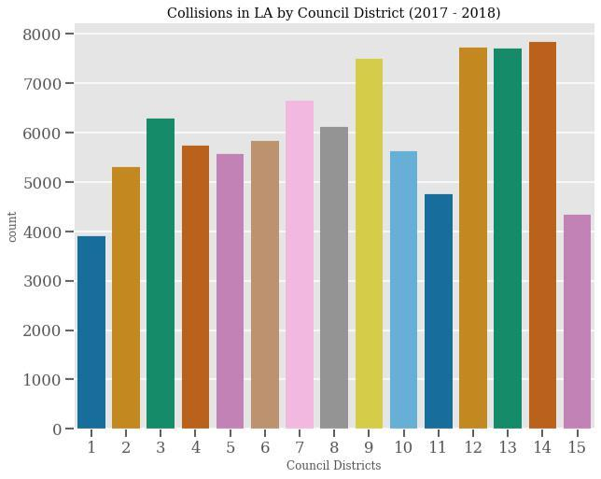

**FIGURE 11 - LA COLLISIONS BY COUNCIL DISTRICT**

P a g e | **19**



STREETS

Streets from the *Address* field were examined to see which streets were involved in the most collisions:

|  |  |  |  |  |
| --- | --- | --- | --- | --- |
| WESTERN |  | AV | 1322SHERMAN |  |
| WY | 1242VENTURA |  | BL | 1239VICTORY |
| BL | 1129SEPULVEDA |  | BL | 1120VERMONT |
| AV | 1083FIGUEROA |  | ST | 1053ROSCOE |
| BL | 938VANOWEN |  | ST | 900OLYMPIC |
| BL | 888VAN NUYS |  | BL | 876SUNSET |
| BL | 834PICO |  | BL | 788BROADWAY |
| 729 |  |  |  |  |
| Addresses with the most collisions | | |  |  |
| WESTERN |  | AV | 1322 |  |
| SHERMAN |  | WY | 1242 |  |
| VENTURA |  | BL | 1239 |  |
| VICTORY |  | BL | 1129 |  |
| SEPULVEDA |  | BL | 1120 |  |
| VERMONT |  | AV | 1083 |  |
| FIGUEROA |  | ST | 1053 |  |
| ROSCOE |  | BL | 938 |  |
| VANOWEN |  | ST | 900 |  |
| OLYMPIC |  | BL | 888 |  |
| VAN NUYS |  | BL | 876 |  |
| SUNSET |  | BL | 834 |  |
| PICO |  | BL | 788 |  |
| BROADWAY |  |  | 729 |  |
| NORMANDIE |  | AV | 701 |  |
| WILSHIRE |  | BL | 696 |  |
| VENICE |  | BL | 661 |  |
| LAUREL CANYON | | BL | 634 |  |
| CENTRAL |  | AV | 622 |  |
| WASHINGTON | | BL | 613 |  |
| FLORENCE |  | AV | 594 |  |
| 3RD |  | ST | 576 |  |
| LA BREA |  | AV | 572 |  |
| CRENSHAW |  | BL | 557 |  |
| TOPANGA CANYON | | BL | 557 |  |
| RESEDA |  | BL | 551 |  |
| SATICOY |  | ST | 542 |  |
| BURBANK |  | BL | 530 |  |
| MAIN |  | ST | 527 |  |
| MANCHESTER | | AV | 517 |  |

P a g e | **20**

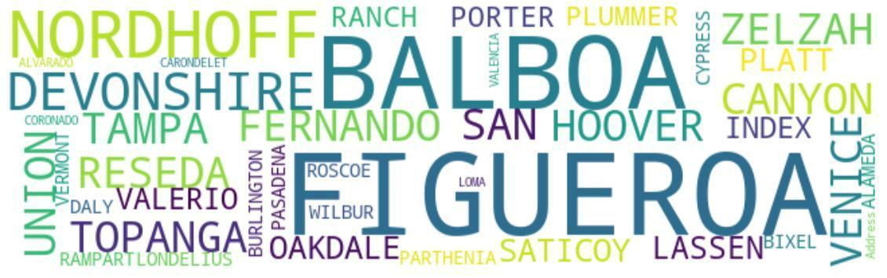

**FIGURE 12 - WORD CLOUD OF ADDRESS STREETS INVOLVED IN COLLISIONS**

P a g e | **21**



Streets from the *Cross Streets* field were examined to see which streets were involved in the most collisions.

Cross Streets with the most collisions

|  |  |  |
| --- | --- | --- |
| VERMONT | AV | 740 |
| FIGUEROA | ST | 674 |
| WESTERN | AV | 634 |
| SHERMAN | WY | 612 |
| VICTORY | BL | 587 |
| SEPULVEDA | BL | 577 |
| BROADWAY |  | 561 |
| VANOWEN | ST | 558 |
| ROSCOE | BL | 515 |

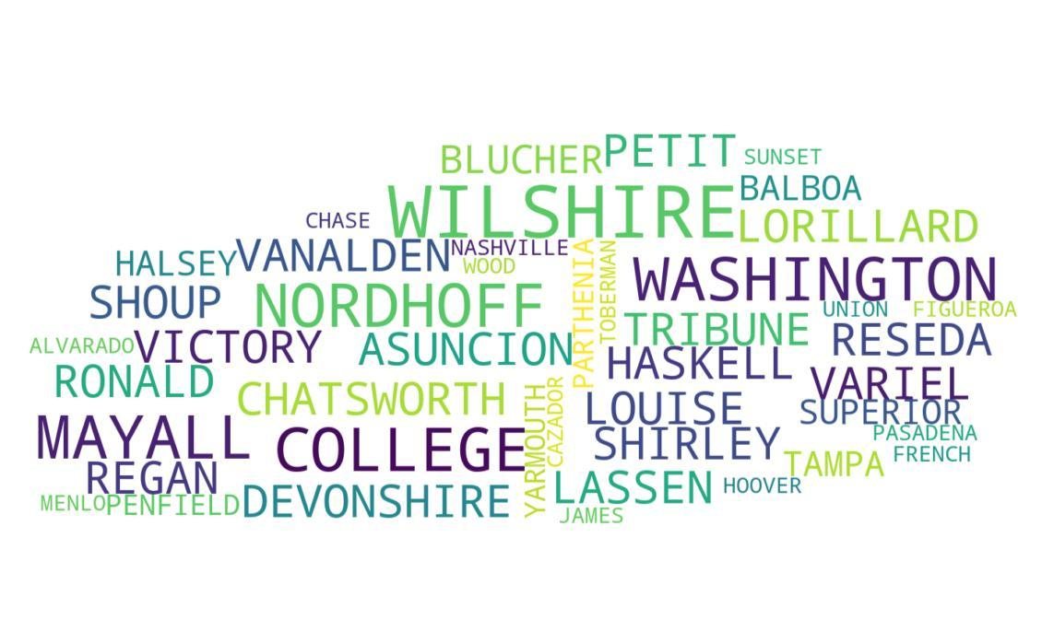

**FIGURE 13 - WORD CLOUD OF CROSS STREETS INVOLVED IN COLLISIONS**

P a g e | **22**



When combining the cross streets with addresses, the **top 8 streets with the most collisions** was determined:

|  |  |  |  |  |
| --- | --- | --- | --- | --- |
| Cross Street |  | Address |  |  |
| SEPULVEDA | BL | SHERMAN | WY | 60 |
| NORDHOFF | ST | TAMPA | AV | 59 |
| WOODMAN | AV | SHERMAN | WY | 53 |
| WHITSETT | AV | SHERMAN | WY | 52 |
| RODEO | RD | LA BREA | AV | 50 |
| SEPULVEDA | BL | BURBANK | BL | 47 |
| VICTORY | BL | TOPANGA CANYON | BL | 47 |
| PLUMMER | ST | TAMPA | AV | 45 |

P a g e | **23**



RESULTS AND FINDINGS: LOCATION

* The middle of the city has a similar density of collisions during at all times, at night, and during the day.
* When it is dark there are fewer collisions in the northern area compared to the daytime.
* The center of Los Angeles had the heaviest concentration of crashes but, the northern area had a handful of locations with more collisions than anywhere where else.
* Council Districts with the most collisions: 12/13/14.
* Cross Streets with the most collisions:
  + SEPULVEDA BL & SHERMAN WY
  + NORDHOFF ST & TAMPA AV
  + WHITSETT AV & SHERMAN WY
  + RODEO RD & LA BREA AV

P a g e | **24**



**ANALYSIS: DEMOGRAPHICS**

Hypothesis:

**Certain ages, genders, and ethnicities make an individual more susceptible to becoming a victim of a car collision.**

Fields:

*Victim Age*, *Victim Descent*, *Victim Sex*, *Median Income*, *Council Districts*

VICTIM GENDER



|  |  |
| --- | --- |
| Breakdown of gender | **There are substantially more men involved in collisions compared to** |
| counts in collisions: | **women:** |

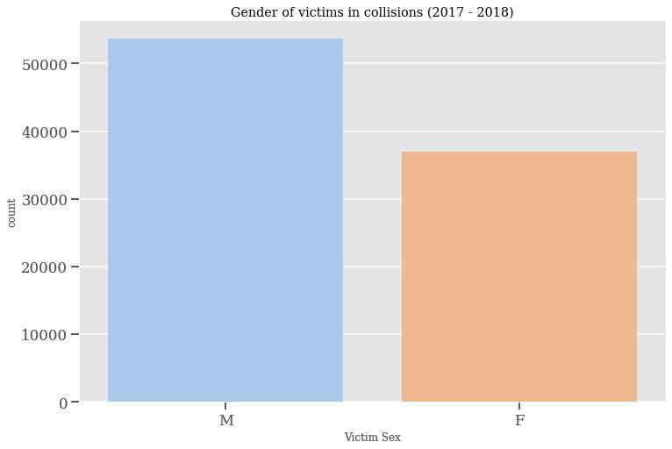

1. 53676
2. 36914
3. 231
4. 18

**N**6

**FIGURE 14**

* **Men comprise 59.09% of victims In a car crash in Los Angeles.** This is largerthan the 50% male population in Los Angeles. [(https://censusreporter.org/profiles/16000US0644000-los-angeles-ca/)](https://censusreporter.org/profiles/16000US0644000-los-angeles-ca/)
* Many possibilities could account for this, such as how men are often more aggressive in general and this could possibly translate onto the road. Further exploration is necessary.



**FIGURE 15 - COMPARISON OF GENDERS IN COLLISIONS**

P a g e | **25**



We then looked at the gender breakdown by the ethnicity of the victims in order to see if there were any interesting relationships:

**Hispanic**

|  |  |
| --- | --- |
| M | 22328 |
| F | 14662 |
| X | 4 |

1. 3

N1

**Asians**

|  |  |
| --- | --- |
| M | 1987 |
| F | 1675 |
| N | 1 |

1. 1

H1

**Whites**

|  |  |
| --- | --- |
| M | 12004 |
| F | 8122 |

1. 2

N1

**Blacks**

|  |  |
| --- | --- |
| M | 6971 |
| F | 6283 |
| H | 6 |
| X | 1 |

1. 1
   * For Asians and Blacks, the gender breakdown of victims is fairly even, near 50%, which is in line with the 50% gender divide in Los Angeles among all races.
   * **For Whites and Hispanics, though, males make up 60% of the gender of victims within the same race.**

o This is an interesting deviation from the standard 50/50 gender divide in the Los

Angeles population. This could be due to a culture differences or some other factor. It would be interesting for further examination.

P a g e | **26**



VICTIM AGE

An exploration of the distribution of victim ages was done:

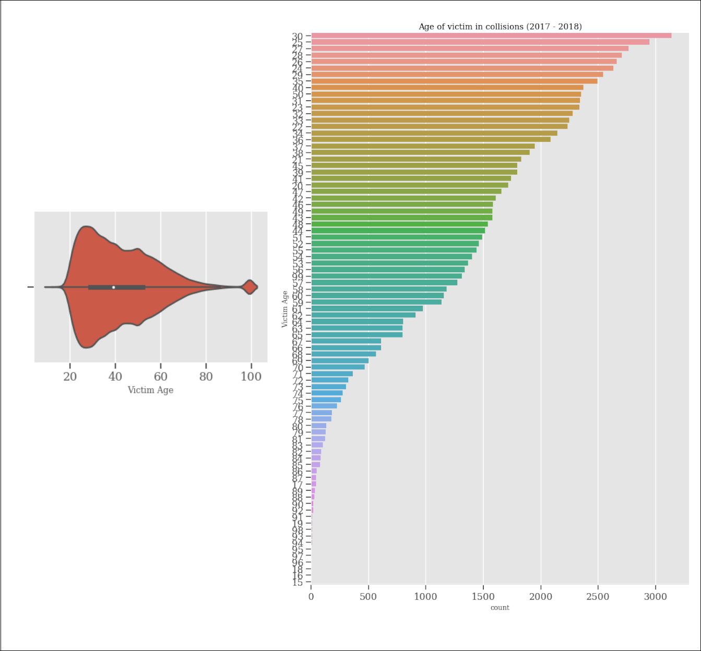

**FIGURE 16 - COMPARISON OF VICTIM AGE IN COLLISIONS**

* From this we can see that the **top 5 victim ages are all under 30 years old** and a younger demographic.
* **The average age of a victim was 41.81 years old** compared to the average age in Los Angeles of 35.8 yearsold .3



1. <https://censusreporter.org/profiles/16000US0644000-los-angeles-ca/>

P a g e | **27**



**Victim Age distribution by race:**

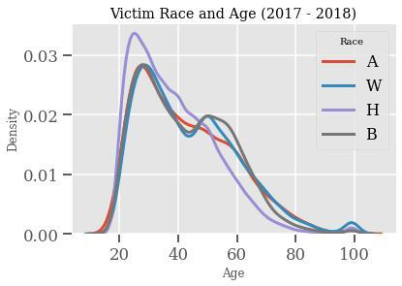

**FIGURE 17 - COMPARISON OF VICTIM RACE AND AGE IN COLLISIONS**

Most of the victim ages spike from the range of 20 to 40 years old for all the major ethnicities.

**Victim age distribution by gender:**

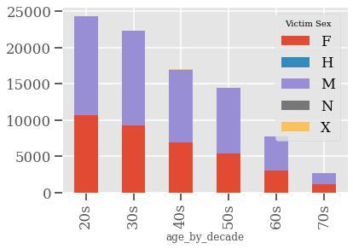

**FIGURE 18, BINNED AGES AND GENDERS**

Binned age groups help show the gender breakdown for each age decade. Men unsurprisingly hold a higher proportion of victims for every decade until around the 70s where it is almost 50/50. We can also see that as each decade passes, the amount of victims goes down.

VICTIM DESCENT

P a g e | **28**

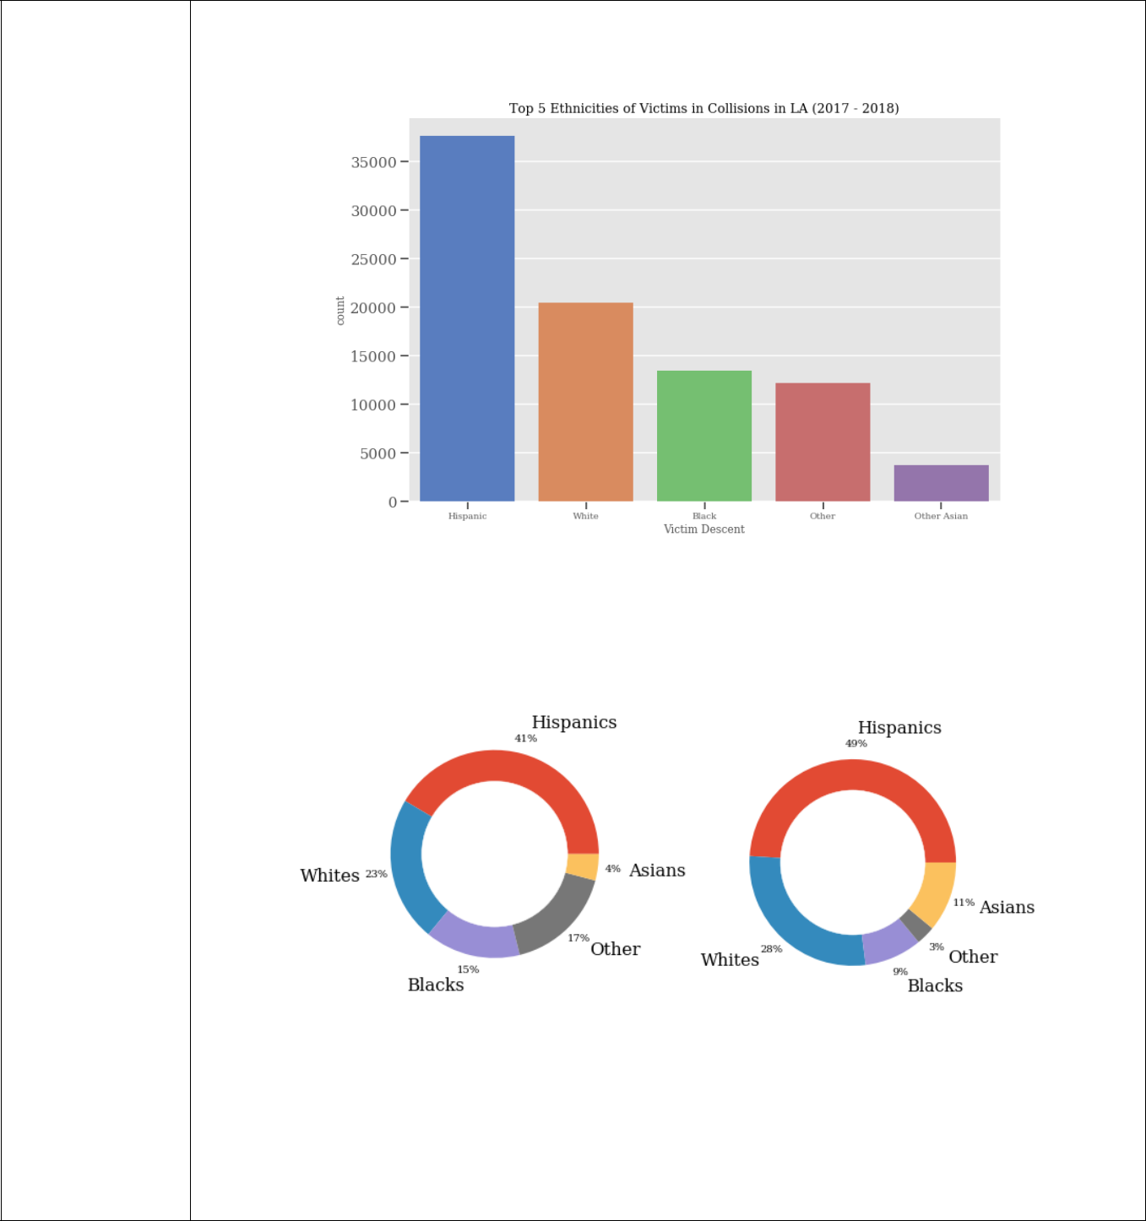

|  |  |
| --- | --- |
| Breakdown of | **The ethnicities of victims in the most crashes were analyzed:** |
| victim descents in |  |
| collisions: |  |

1. 37657
2. 20484
3. 13529
4. 12256
5. 3730
6. 1820
7. 717
8. 285
9. 126
10. 48

|  |  |  |
| --- | --- | --- |
| **J** | 42 | **FIGURE 19, TOP 5 ETHNICITIES IN COLLISIONS** |
|  |  |

1. 35
2. 35
3. 30
4. 29
5. 12
6. 5
7. 4
8. 1

**FIGURE 20, COLLISION ETHNICITIES (LEFT) AND LA POPULATION ETHNICITIES (RIGHT)**

**SOURCE:** [**HTTPS://CENSUSREPORTER.ORG/PROFILES/16000US0644000-LOS-ANGELES-CA/**](https://censusreporter.org/profiles/16000US0644000-los-angeles-ca/)

**FIGURE 21 - COMPARISON OF ETHNICITIES IN COLLISIONS**

P a g e | **29**



* Hispanics comprise the highest total for ethnicities involved in a collision (41.45%) followed by Whites (22.55%) and Blacks (14.89%). It Is not surprising that Hispanics are the highest since there is a 49% Hispanic population in Los Angeles. The high percentage is actually below the population average.
* Whites 22.55% total Is below the 28% total of Whites in Los Angeles population.
* **Blacks only compose 9% of the population yet are victims in 14.89% of car accidents**. This is an interesting finding and would merit more investigation into why thisis the only major ethnicity group to have a pattern of being involved in more car accidents compared to their population average.
* **Asians make up only 4% of car victims with a 11% population in general in Los Angeles**. This is an interesting finding that defies some of the preconceived notions thatAsians are poorer drivers. For whatever reason, Asians tend to not be in many car accidents in Los Angeles compared to their population average.

P a g e | **30**



**We also looked at how Council Districts related to victim race:**

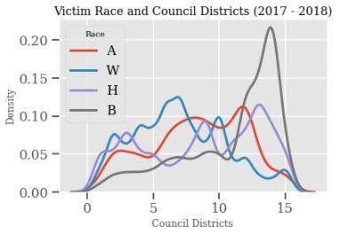

a

**FIGURE 22 - COMPARISON OF COUNCIL DISTRICTS IN COLLISIONS**

It seems that the latter number districts are composed with more Hispanics and Blacks. For whatever reason, the districts from 10-15 seem to have a lot more collisions which are areas comprised of mostly Blacks

P a g e | **31**



VICTIM INCOME

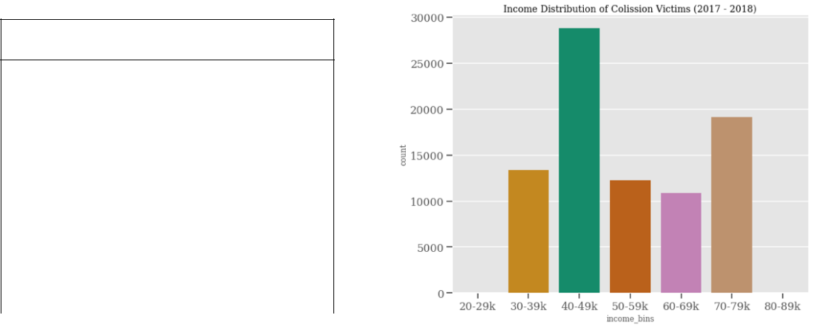

**Victim Income Breakdown**



|  |  |  |
| --- | --- | --- |
| Income Range | Count | Percentage |
|  |  |  |
| **30-39k** | 13410 | 15.86% |
|  |  |  |
| **40-49k** | 28816 | 34.08% |
|  |  |  |
| **50-59k** | 12266 | 14.51% |
|  |  |  |
| **60-69k** | 10900 | 12.89% |
|  |  |  |
| **70-79k** | 19166 | 22.66% |



**TABLE 3 - VICTIM INCOME BREAKDOWN**

**FIGURE 16 - INCOME DISTRIBUTION OF COLLISIONS**

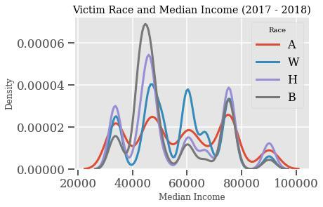

**FIGURE 23 - VICTIM RACE AND MEDIAN INCOME IN COLLISIONS**

* Here we see a spike in the 40k income range for the Hispanic and Black demographic. It is the highest point for both races. For Whites, the peak is at around 55k while Asians peak around 63k.
* Average income for Blacks in LA is $34,500 while its peak income for victims is around 37k
* Average income for Whites in LA is $61,100 while its peak income for victims is around 55k
* Average income for Hispanics in LA is $40,300 while its peak income for victims is near 40k
* Average income for Asians in LA is $57,800 while its peak income for victims is around 65k

1. This is an interesting finding since Asians were also much likely to be victims in a car collision compared to others, and they are also the only group that when someone does become a victim, they tend to be from the higher range of income.

Source: <https://statisticalatlas.com/place/California/Los-Angeles/Household-Income>

P a g e | **32**



RESULTS AND FINDINGS: DEMOGRAPHICS

* Men are more likely to be in an accident compared to women.
* Frequency of collisions is proportional to race/ethnicity.
* Age 30 has the highest number of collisions and the top 5 ages are all below 30.
* People who self-identify as Black, compose 9% of the population but are victims in 14.89% of car accidents.
* People who self-identify as Asian make up only 4% of car victims but comprise 11% of the population.
* 34.08% of accident victims have a median income between $40-49K.

P a g e | **33**



**ANALYSIS: TIME/DAY**

Hypothesis:

**Certain times of the day and days of the week are more dangerous and result in more car collisions.**

Fields:

*Month*, *year*, *hours*, *weekday, NaughticalTwilightSet, NaughticalTwilightRise*

YEARLY PATTERN

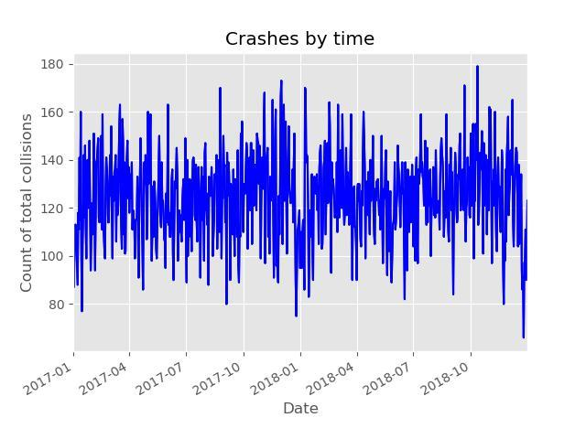

**FIGURE 24, COLLISIONS IN A TWO YEAR PERIOD**

This is a classic example of a time series plot. Clearly there is some variation in the bigger picture as the thickest blue area varies in height, but on a smaller level there is much more variability.

P a g e | **34**

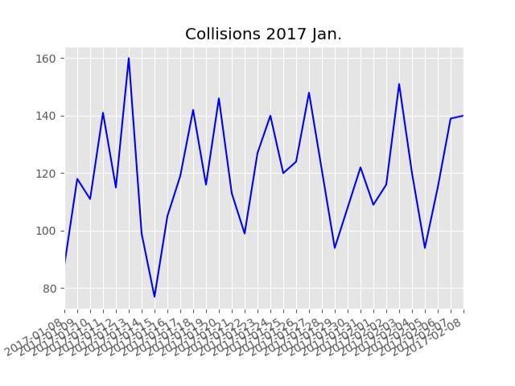

**FIGURE 25, COLLISIONS BY DAY IN A ONE MONTH PERIOD**

Here the variability from the graphs is more noticeable when viewed from a one-month period. The line has a pattern of building up, slightly dipping, peaking, then falling again. The lowest points are Sunday. As the week goes on Monday has more crashes, Tuesday even more, Wednesday has increased collisions. Then collisions drop off some on Thursday. **Friday is the** **peak collision day.** Each of the highest points are Fridays. Collisions drop off on Saturdays andSundays.

Summary of top weekday occurrences

Friday 14313

Wednesday 13456

Thursday 13270

Tuesday 13054

Monday 12627

Saturday 12157

Sunday 11092

The time of day shows a pattern of when collisions occurred:

P a g e | **35**

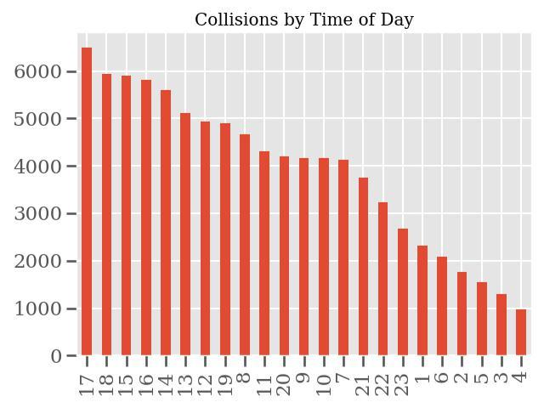

**FIGURE 26, COLLISIONS BY THE HOUR IN MILITARY TIME**

This graph shows that most collisions in LA occur around 12PM to 5PM. It appears that Friday and Wednesday at from 12PM to 5PM are peak times, however, this is by no means a majority of the collisions.

P a g e | **36**



DAY OF WEEK

Day of week was explored to see if any particular days were troublesome:

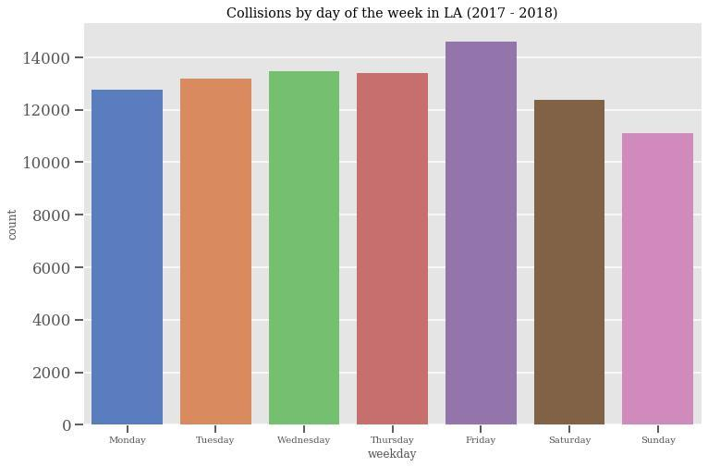

**FIGURE 27 - COLLISIONS BY DAY OF THE WEEK 2017-2018**

This shows the counts by day.

P a g e | **37**



MONTH

Collisions by month was looked at to see which months had an increased chance of car accidents:

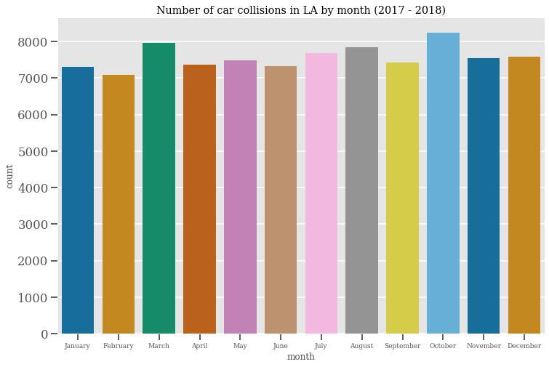

**FIGURE 28 - CAR COLLISIONS BY MONTH 2017-2018**

We can see that October is the most common month as well as March and August.

P a g e | **38**



2017 January to April month patterns:

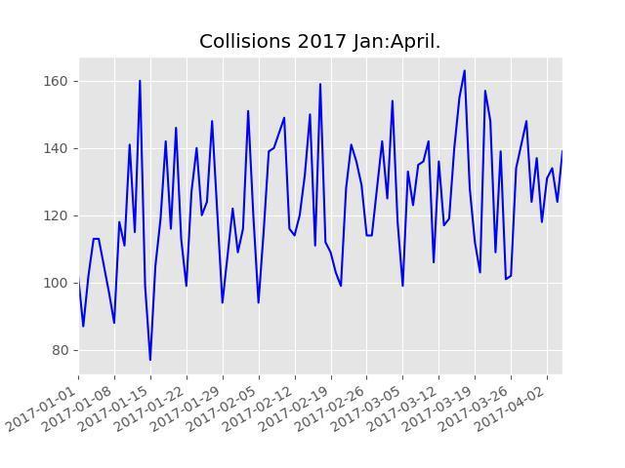

**FIGURE 29**

P a g e | **39**



HOUR OF DAY

The hour of day was examined by day of the week:

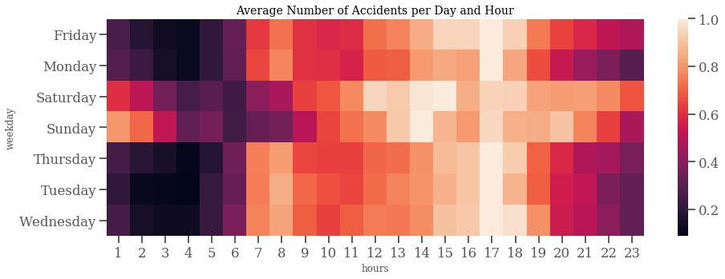

**FIGURE 30 - HEATMAP OF COLLISIONS BY DAY OF WEEK AND HOURS**

It is interesting to see that there are a lot of darker boxes from 1am to 6am during the weekdays, but that changes on the weekend during 1am to 3am. These brighter boxes indicate more collisions. A possible reason for this could be due to people going out during these late hours since they do not have work the next day.

P a g e | **40**



Victim descent was analyzed during daylight hours and sundown hours. Crashes were higher during the day overall, and no significant patterns emerged. Victim descent in day and night collisions.

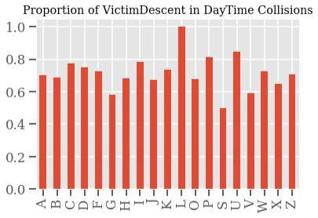

**FIGURE 31**

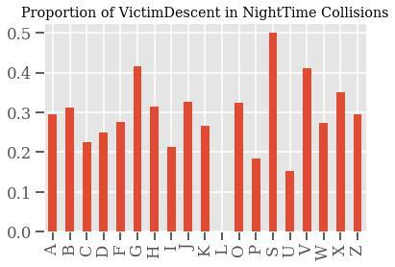

**FIGURE 32**

Summary of most collisions by specific dates in 2017-2018

2018-10-12 179

2017-12-01 173

2018-09-21 171

2017-08-25 170

2018-01-08 170

2018-01-09 169

2017-11-04 168

2017-11-30 166

2017-11-17 165

2018-12-07 165

These dates do not seem to be special, however there may have been large events or conventions during these dates. It was hypothesized that certain dates like New Year’s eve would have the most crashes.

P a g e | **41**



RESULTS AND FINDINGS: TIME/DAY

* The months have some variability, but some patterns are more obvious collisions have a cycle on the line charts.
* Trends occur by day of the week. On Sunday they are the lowest. Then increase on Monday, Tuesday, and Wednesday. Thursday's are slightly lower on average, then Crashes Peak.
* Holidays were assumed to have the most crashes; however, the data does not support this.
* The highest frequency of accidents is on Monday-Friday between 4-5pm

P a g e | **42**



**ANALYSIS: WEATHER**

Hypothesis:

**Colder and adverse weather (ex. Rain, severe heat) result in more car collisions.**

Fields:

*Temperature*, *precipitation*

TEMPERATURE

Temperature was analyzed to see what kind of factor it played in collisions:

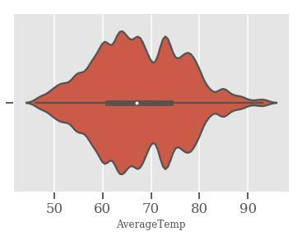

**FIGURE 33, AVERAGE TEMP**

The average temperature for the days of collisions is 67.46 degrees F which is higher than the average temperature in Los Angeles of 60.95 degrees F.4

Low temperatures below 40 degrees F and high temperatures above 100 degrees F were compared in the graph below in order to see the effect of extreme weather. There does not appear to be a correlation between low/high temperatures and more accidents. The average annual high temperature in LA is 72 degrees F and the average low temperature is 64 degrees F.5

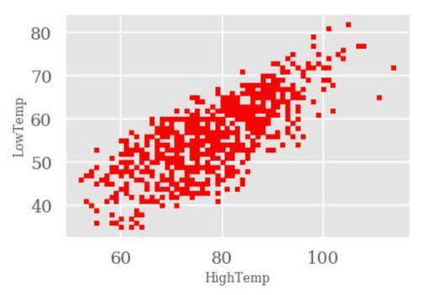

**FIGURE 34 - SCATTER PLOT OF LOW/HIGH TEMPERATURES AND COLLISIONS**



1. <https://www.usclimatedata.com/climate/california/united-states/3174>
2. : <https://www.usclimatedata.com/climate/los-angeles/california/united-states/usca1339>

P a g e | **43**

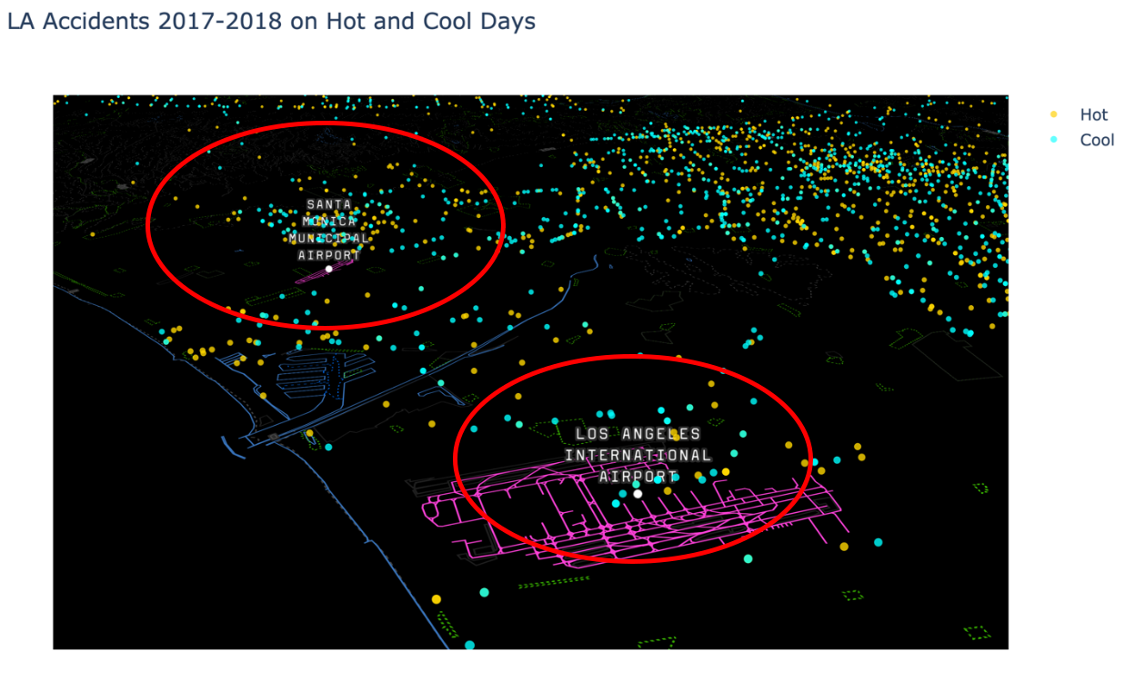

**FIGURE 35 - MAP OF SANTA MONICA AND LA AIRPORTS WITH COLLISIONS ON HOT/COLD DAYS**

This map of LA near the airports shows a higher concentration of accidents near the Santa Monica airport compared to the LA Airport on Hot (>100 deg. F) and Cool (<40 deg. F) days. It is also interesting to note that the Santa Monica airport is closing in 2028 and will be converted to a park. These maps of the area would be useful for city planners as they plan the area to understand how traffic collisions could be reduced in this area and if weather is a factor

Temperatures during the day of each collision were analyzed. The following tables show summaries of the Average Temperatures, daily high temperatures, and daily low temperatures.

Summary of top Average Temperature occurrences

1. 4603
2. 4347
3. 4345
4. 4058
5. 3932
6. 3881
7. 3858
8. 3641
9. 3546

P a g e | **44**



Summary of top High Temperature occurrences

1. 3739
2. 3710
3. 3471
4. 3369
5. 3134
6. 3099
7. 2961
8. 2836
9. 2744
10. 2690

Summary of top Low Temperature occurrences

1. 4892
2. 4873
3. 4795
4. 4650
5. 3789
6. 3641
7. 3621
8. 3568
9. 3374
10. 3290

There may be a correlation with cooler temperatures and accidents. No temperatures in the 90s or above was found in the top 10 frequently occurring temperatures. It appears that more moderate weather in the 60s to 80s has most of the accidents.

P a g e | **45**



PRECIPITATION

Since LA only averages about 15 inches of rain per year, precipitation is not as much of a factor as other large cities that are wetter. Our analysis showed different results for 2017-2018 with higher precipitation and accidents occurring around 5pm.

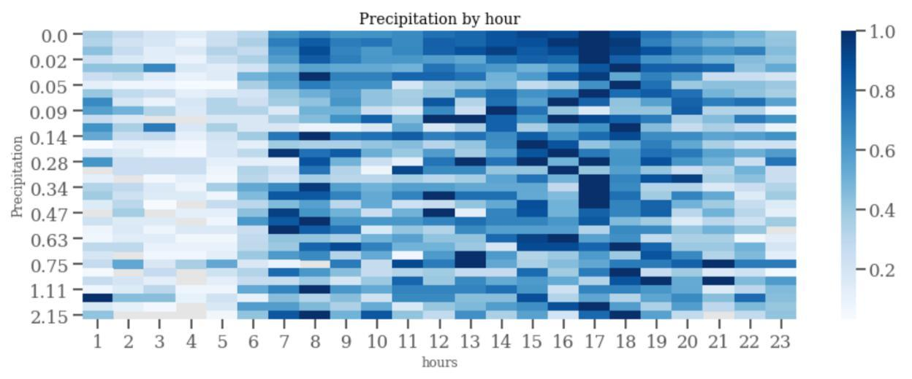

**FIGURE 36 - 2017-2018 PRECIPITATION BY HOUR**

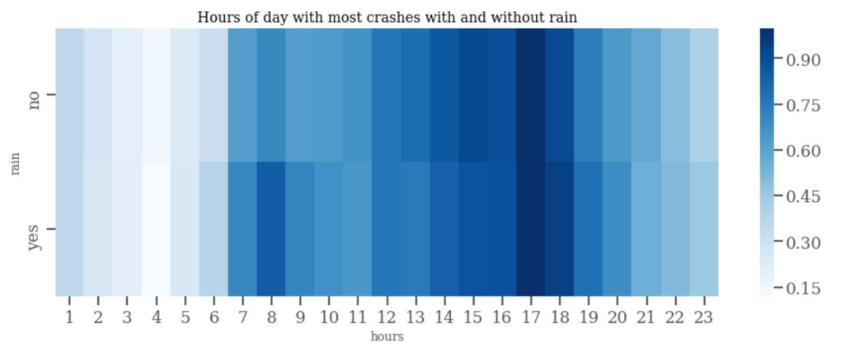

**FIGURE 37 - 2017-2018 COLLISIONS BY HOUR WITH/WITHOUT PRECIPITATION**

For this project, we also choose to explore the use of new 3-D maps to explore the traffic collision data. This allows for zooming/panning the data in a way where a subject matter expert (government official, city planner, citizen, etc) could observe variations in the data.

Although we did not have team members from LA, we did observe an area northeast of the Hawthorne Municipal airport where collisions appear to be more frequent (yellow dots show where a collision occurred with rain). A more detailed analysis of this area could reveal causes

P a g e | **46**



for these accidents at the boundary with the airport. Note: This report contains a static map of the precipitation. When running the code in Python, this map can be zoomed/panned to view the data interactively.

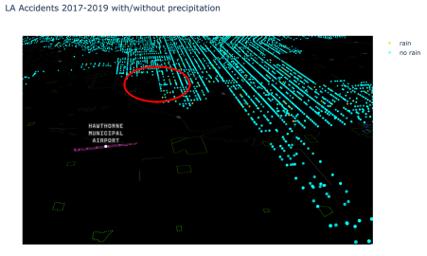

**FIGURE 38 - MAP OF AREA NEAR HAWTHORNE MUNICIPAL AIRPORT WITH RAIN/NO RAIN COLLISIONS**

Summaries of the top precipitation occurrences were analyzed for patterns.

Summary of top Precipitation occurrences

0.000000e+00 77563

1.000000e-16 4358

1.000000e-02 948

2.000000e-02 916

1.400000e-01 584

7.000000e-02 568

2.300000e-01 459

3.000000e-02 365

1.700000e-01 275

3.400000e-01 256

P a g e | **47**



RESULTS AND FINDINGS: WEATHER

Los Angeles benefits from having great weather most of the time and weather is not a major factor as in other "wetter" cities. However, when it rains during evening rush hour traffic, there is an increase in the number of collisions.

P a g e | **48**



**CONCLUSIONS AND RECOMMENDATIONS**

Los Angeles is a large and growing city which continues to attract more residents and vehicles. With the increase in the number of cars on the road comes additional traffic collisions and congestion. The analysis of the 2017-2018 data provides some interesting insights that can be used by a variety of people who are interested in LA traffic.

Below is a summary of our observations from this analysis:

1. What address/cross street combinations had the most collisions?
2. What are the most dangerous intersections?
   * SEPULVEDA BL & SHERMAN WY
   * NORDHOFF ST & TAMPA AV
   * WHITSETT AV & SHERMAN WY
   * RODEO RD & LA BREA AV
3. What are the most common collision areas in Los Angeles?
   * + 1. 77th Street Area
       2. Council Districts 12/13/14
       3. Generally in the heart of LA
4. What are the best/worst times of the day for accidents? Best/worst month?
   * + 1. Friday has the highest frequency of collisions.
       2. Sunday has the fewest amount of collisions.
       3. March and October have the highest number of collisions.
       4. The hours between 12PM to 5PM have the highest frequencies of collisions.
5. What patterns occur due to the amount of natural sunlight?

a. There appears to be a significantly less concentration of accidents in Northern LA during the night time. This may be due to less traffic by the airports.

* + - 1. The highest frequency of accidents is on Monday-Friday between 4-5pm.

1. What is the demographic makeup of victims in collisions?
   * + 1. Men are more likely to be in an accident compared to women.
       2. Frequency of collisions is proportional to race/ethnicity.
       3. Age 30 has the highest number of collisions.
       4. 34.08% of accident victims have a median income between $40-49K.
2. Do certain temperatures or weather play a factor?
   * + 1. When it rains during evening rush hour traffic, there is an increase in the number of collisions around 5pm.
       2. The area near the Hawthorne airport appears to have a higher proportion of weather-related accidents.



P a g e | **49**



The results of this study provide additional insights that can be used by city planners, government officials and citizens to better understand the Los Angeles traffic conditions sin 2017 and 2018. We recommend the use of this information in the following areas:

1. Additional studies of dangerous intersections and locations.
2. Warnings on interactive road signs during rush hour when it is raining.
3. Utilize this data and interactive maps for planning sessions with subject matter experts and citizens when starting new projects which impact roadways.
4. Public service campaign to educate the public with targeted messages to men.

P a g e | **50**



**LIMITATIONS OF STUDY**

For this study, we were limited by the years used. Ideally, we would have liked to use all the years since 2010 but we were only able to scrape two complete years for weather, and therefore this was the reason we limited the scope to two years.

For income, we were limited to finding the income by Council Districts since we were not able to find incomes for every Zip Code in the dataset easily. This was easier since there were only 15 Council District incomes to get instead of the hundreds of Zip Codes. On the other hand, it is not as accurate an indicator of income since each Council District is spread out over a big area and not as precise as maybe a specific Zip Code.

The dataset also only included the *victims* of a car collision and not the perpetrator. It also did not indicate the severity of injuries of the victim. It would have been interesting to have more information about the types and severity of injuries since that would add another layer of depth to the analysis. It would have also been interesting to get information about speed of the vehicles in the collision and whether or not the cars were speeding.

The code to import Twitter data related to #latraffic was created but the data was not included in the analysis because the API only provides real-time information. Since historical tweets were not available, the limited number of tweets using hashtags related to #latraffic was low and not enough data was collected for analysis.

P a g e | **51**



**REFERENCES**

Data and supporting material was obtained from <https://www.kaggle.com/cityofLA/los-angeles-traffic-collision-data>

Other sources included:

Unstructured Data

[www.wunderground.com/](http://www.wunderground.com/)

Color Themes

<https://seaborn.pydata.org/tutorial/color_palettes.html>

<https://medium.com/@andykashyap/top-5-tricks-to-make-plots-look-better-9f6e687c1e08>

Income Data

<https://lachamber.com/clientuploads/pdf/2018/18_BeaconReport_LR.pdf>

Twitter API & Mongo DB

<http://social-metrics.org/downloading-tweets-by-a-list-of-users-take3/>

<https://stats.seandolinar.com/collecting-twitter-data-storing-tweets-in-mongodb/>

<http://mrbool.com/tweepy-retrieving-and-storing-twitter-data-using-python-and-mongodb/36853>

<http://www.networkx.nl/data-science/twitter-data-python-store-mongodb/>

<https://pythondata.com/collecting-storing-tweets-with-python-and-mongodb/>

Cover images:

<https://www.rockylawfirm.com/wp-content/uploads/2015/04/side-impact.jpg>

[https://ca-https://www.latimes.com/local/lanow/la-me-la-worst-traffic-20180206-story.html](https://ca-times.brightspotcdn.com/dims4/default/37393ee/2147483647/strip/true/crop/1506x836+0+0/resize/840x466!/quality/90/?url=https%3A%2F%2Fca-times.brightspotcdn.com%2F00%2Fca%2F23e461805927b754cd1065831f14%2Fla-1517931058-91w5ihsp6t-snap-image)

Word cloud:

<https://www.datacamp.com/community/tutorials/wordcloud-python>