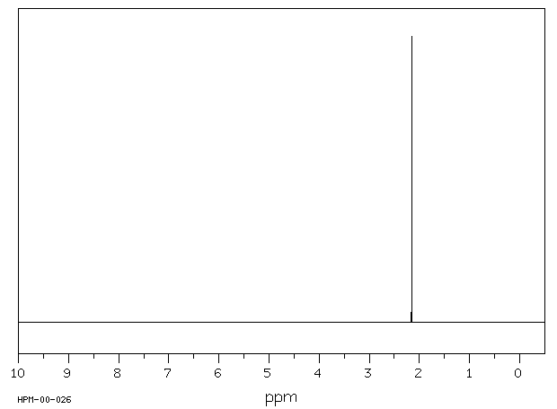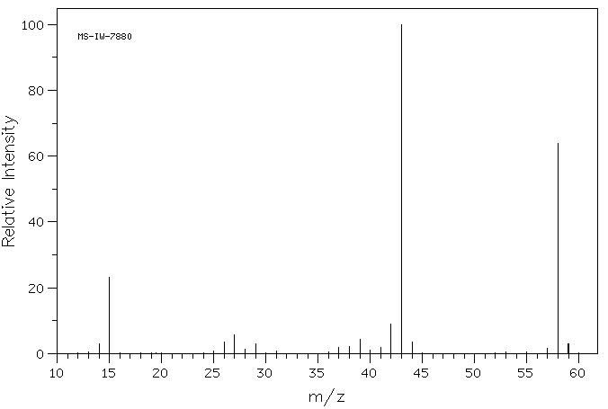
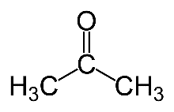 | 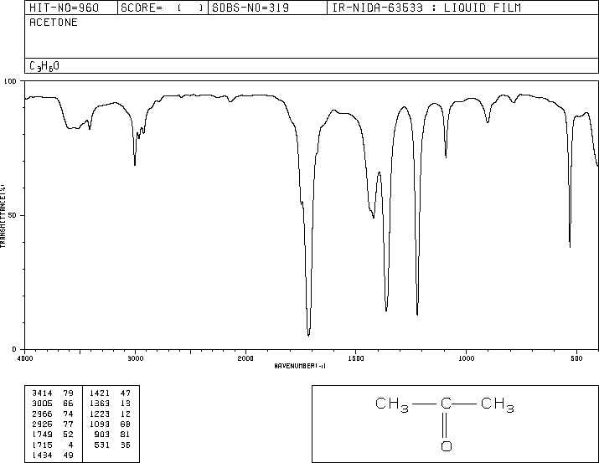

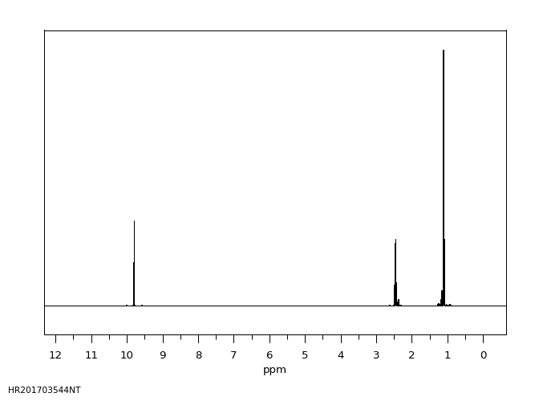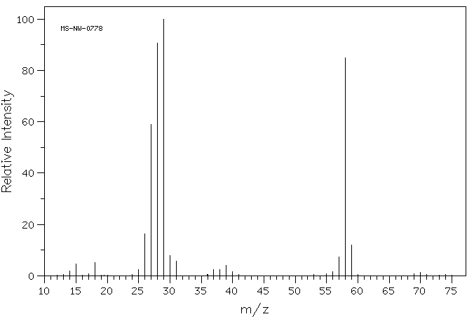
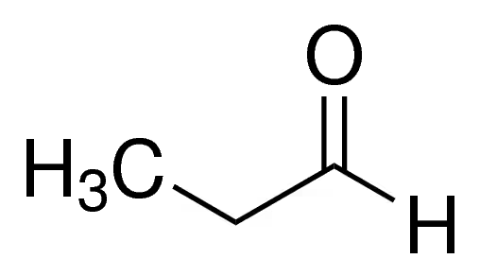 | 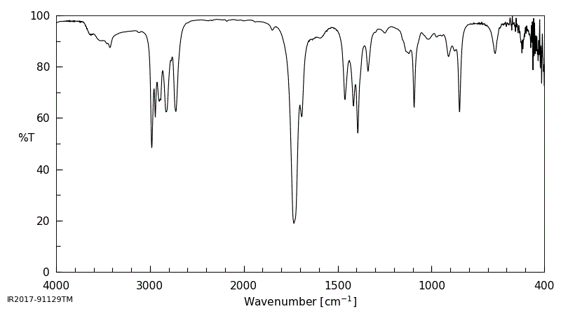

Consider the isomers of $C_{4}H_{9}Cl$. Draw the skeleton structures. Name the isomers. Assign the spectra given to the respective isomers.

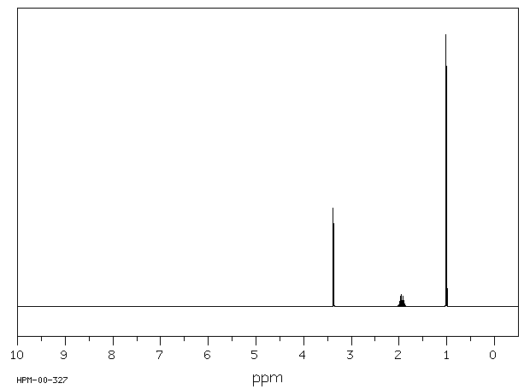 | 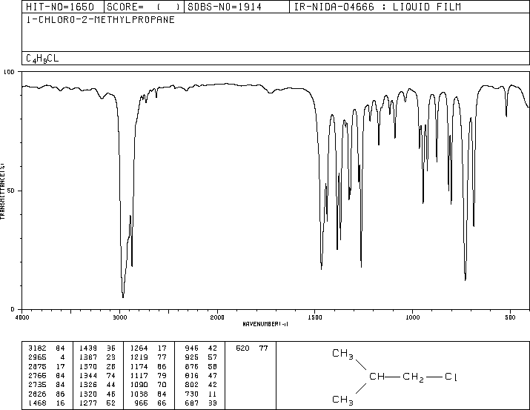 | 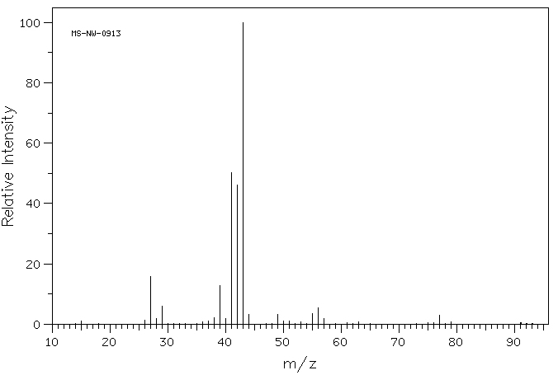
ppm |  | m/z

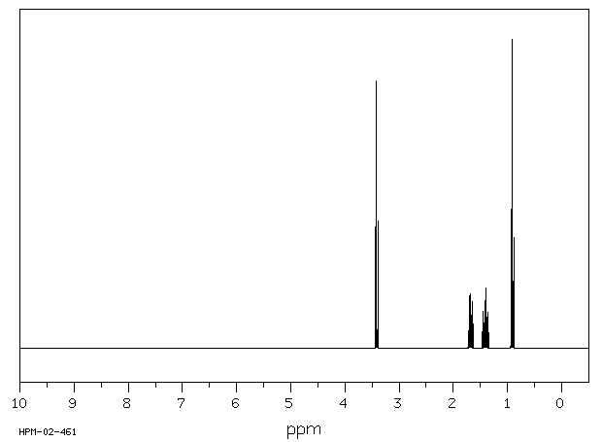 | 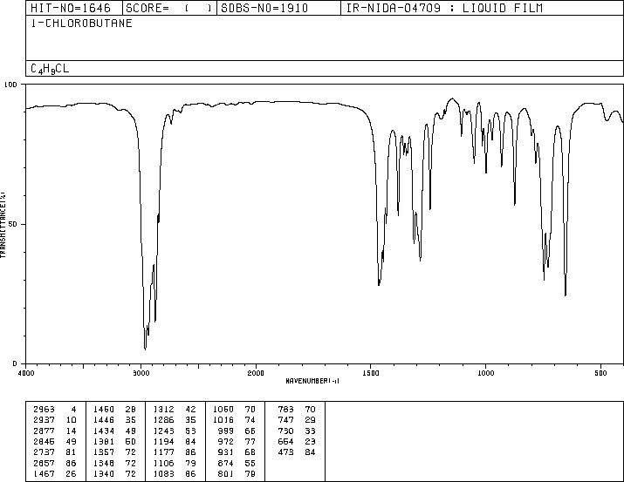 | 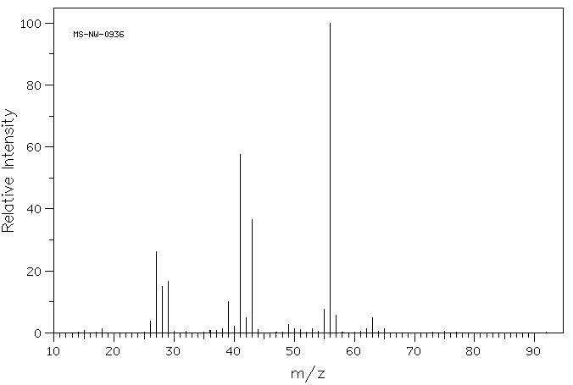
ppm

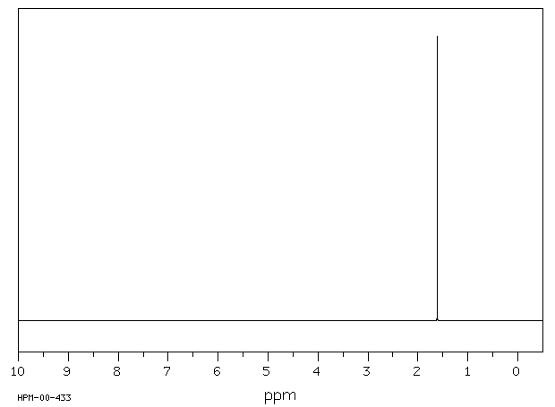 | 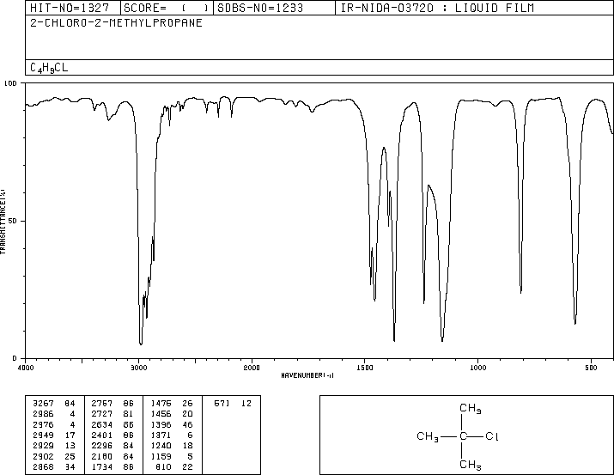 | 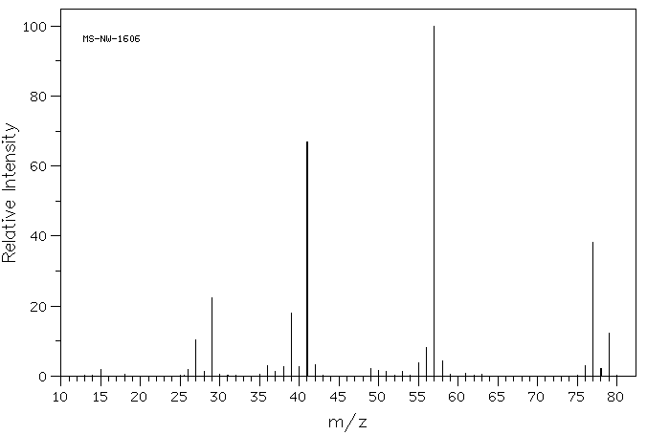
ppm

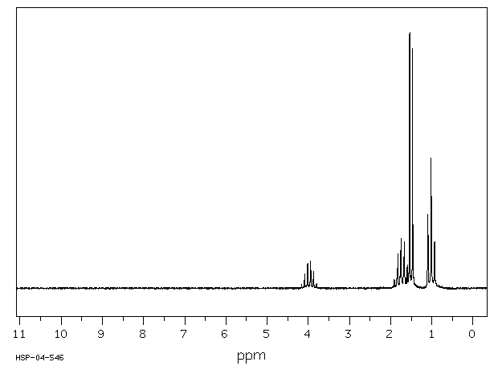 | 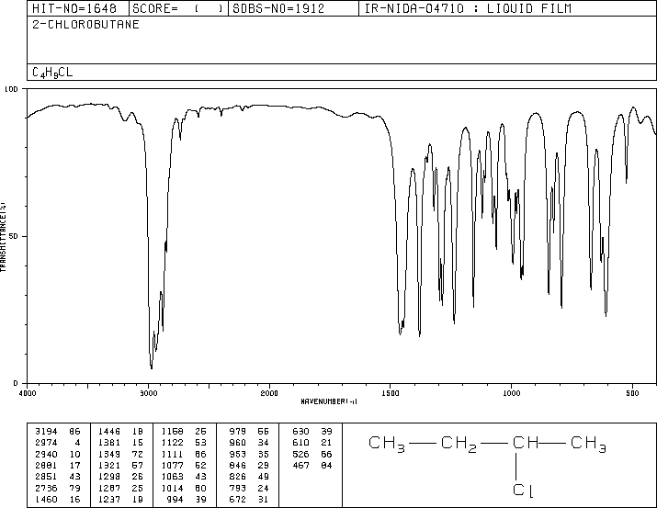 | 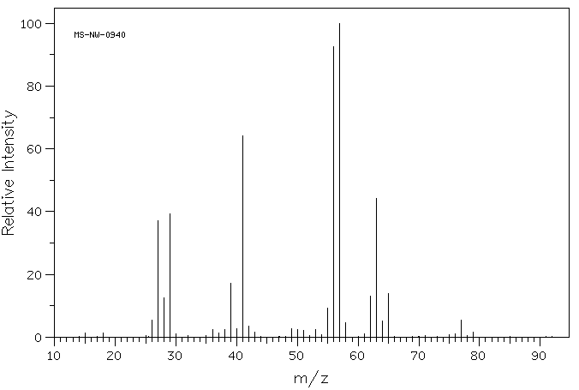
ppm

Molecular formula: $C_{7}H_{8}$
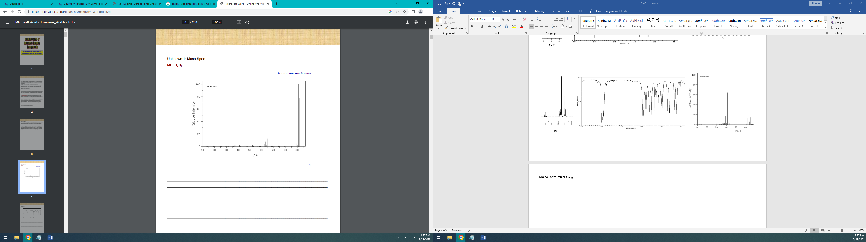 | 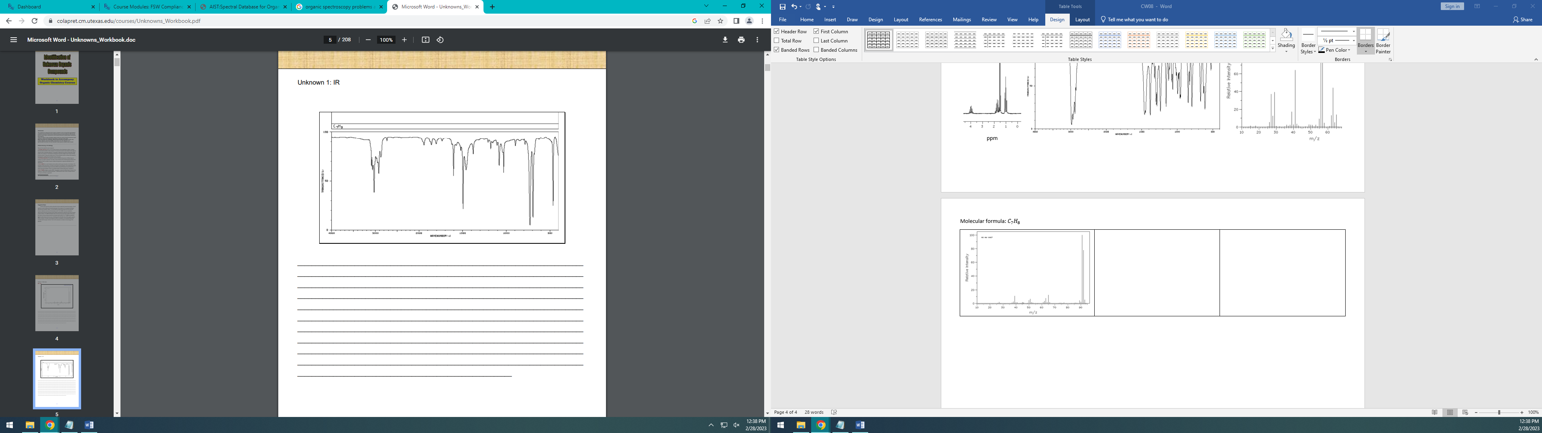
Mass Spectrum | IR Spectrum
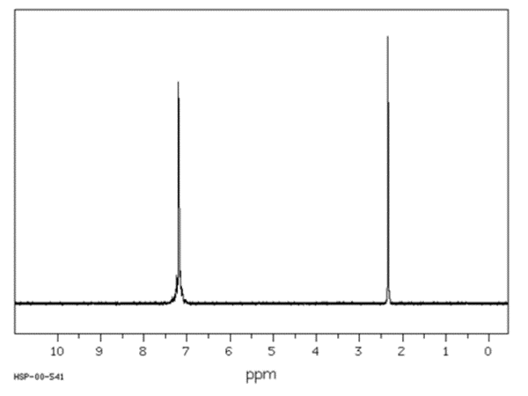 | 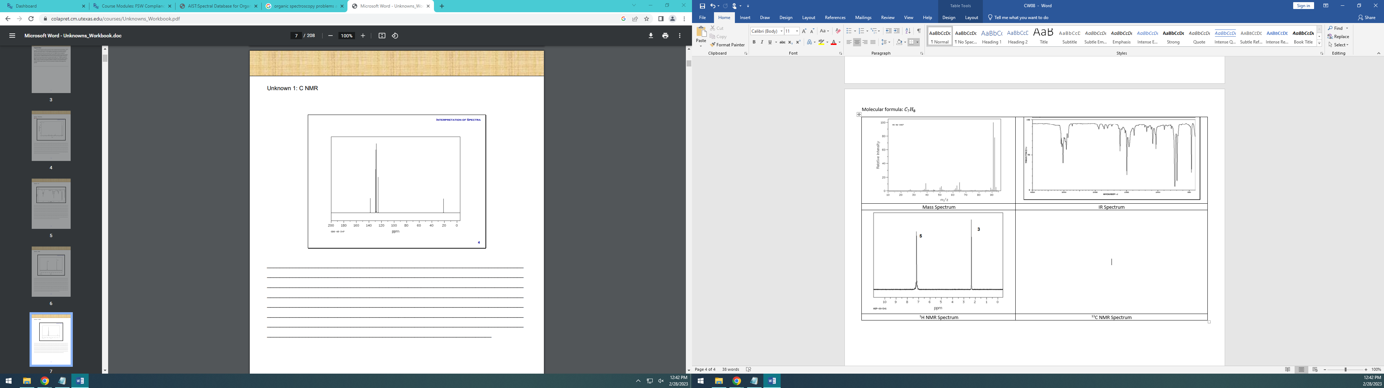
¹H NMR Spectrum | ¹³C NMR Spectrum

Structure:

Molecular formula: $C_{3}H_{7}Br$
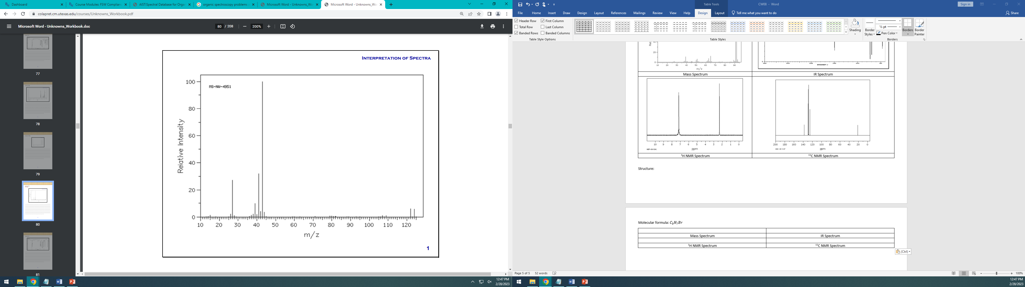 | 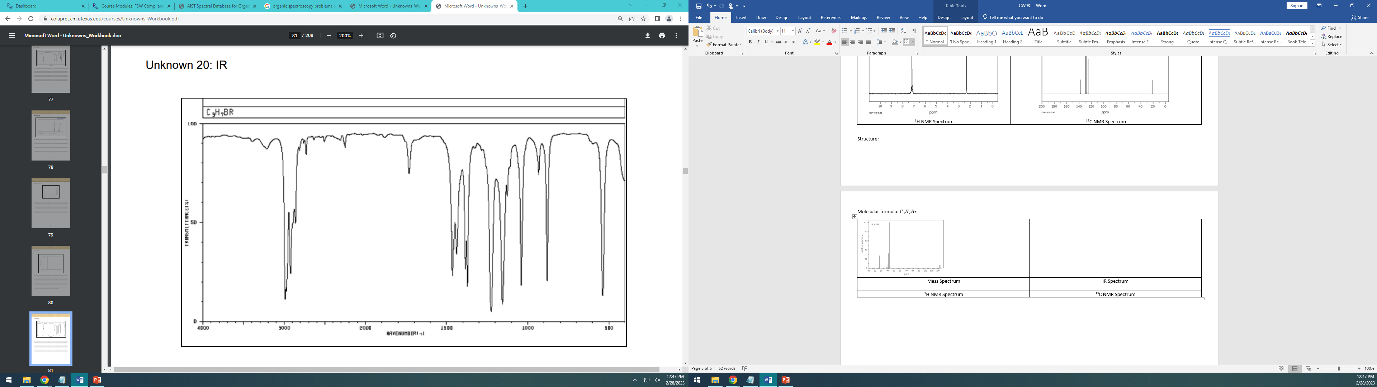
Mass Spectrum | IR Spectrum
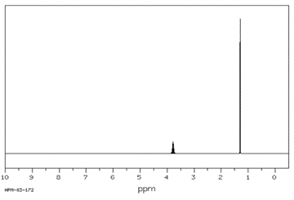 | 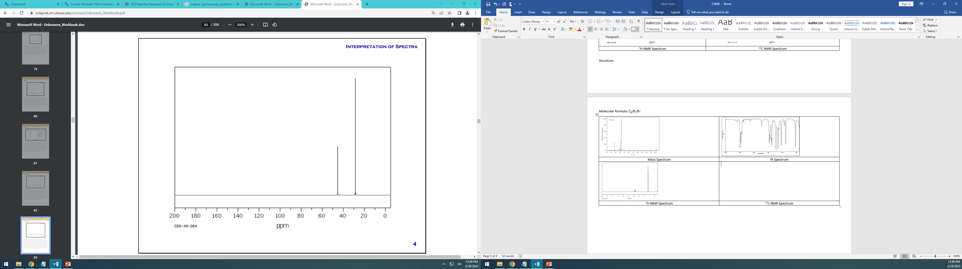
¹H NMR Spectrum | ¹³C NMR Spectrum

Structure:

Molecular formula: $C_{3}H_{7}Br$
 | 
Mass Spectrum | IR Spectrum
 | 
¹H NMR Spectrum | ¹³C NMR Spectrum

Structure:

