
CS5219
Automated Software Validation

Case Study:
Model Checking of an ATM System

25 April 2008

Submitted by:
Choo Zhi Min HT052430X
Edmund Leng Kian Jin HT052446J

Table of Contents

Abstract 3
1 Introduction 3
1.1 Objective 3
1.2 Method 3
2 Simulation Modes in SPIN Tool 4
2.1 Random Simulation 4
2.2 Guided Simulation 5
2.3 Exhaustive Depth-First Search Simulation 5
2.4 Simulation Mode for this Project 6
3 Assumptions 6
4 Modeling of the ATM System 8
4.1 Modeling 8
4.2 Results of Model Checking 13
5 Properties Checking 14
5.1 Stage 1: Preliminary Checking 14
5.2 Stage 2: Liveness and Safety Checking 18
6 Summary and Further Works 23
7 References 23
Appendix 24

Abstract
We applied model checking verification method on an ATM system. The ATM system was modeled in Promela language for withdrawal and balance enquiry transaction. It was then checked for deadlock and unreachable code with SPIN Model Checker. We also used SPIN Model Checker to apply LTL formulae on the ATM system and check for liveness and safety properties. We constructed the liveness and safety to check that the ATM would eventually enter certain designated states and never enter certain error states, such as dispense cash when user entered an incorrect password. Our result showed that the ATM model did not have deadlock and unreachable code, and has satisfied the liveness and safety properties.

Introduction

Objective
The objective of this project is to employ model checking technique to validate important properties of Automated Teller Machine (ATM). The book Object-Oriented Modeling and Design by James R Rumbaugh, et al [ref 1] provides a good description of ATM system. Based on the requirements from the book, we will construct Promela model to validate the properties of an ATM.

Method
We will use the ATM state diagrams from Object-Oriented Modeling and Design [ref 1] as the basis (shown in Appendix) to model the ATM. The state diagrams are the primary source for modeling the ATM with Promela language. The closed system of the ATM model consists of four active entities: User, ATM, Bank and Consortium. From the state diagram, we are able to extract various possible actions of the four active entities. The state diagram also helps us to identify properties that we want to validate. To set the scope of the project, we have introduced certain assumptions to simplify the model, and eventually produce the state diagrams to describe out ATM model (see section 3).
Once the ATM has been modeled, we will use SPIN Model Checker [ref 2] to validate the ATM model against deadlock, unexecuted code and properties that we will define below. For efficiency, we use JSPIN [ref3], a graphical user interface for SPIN model checker. We use JSPIN 4.3.1 that uses SPIN 4.3.
To validate against deadlock and unexecuted code, we set the verification mode to “Safety” (Menu Settings > Safety) according to the manual [ref3]. If the validation is successful, the output should report no errors and zero unreachable state.
To validate a LTL property, we create a .prp file to store the LTL formula in SPIN syntax, and then follow the steps below:
- Open the ATM Promela model: Menu File > Open
- Set the verification mode to “Acceptance”: Menu Settings > Acceptance
- Increase the number of entries in hashtable: Menu Options > Pan, append “-w25”.
- Load the LTL formula to JSPIN: Menu Convert > Load
- Translate the formula to Büchi automata: Menu Convert > Translate
- Verify the model against the formula: Menu Spin > Verify
If the validation is successful, the output should report no errors.

Simulation Modes in SPIN Tool
SPIN supports 3 simulation modes:
- random simulation,
- guided simulation,
- exhaustive depth-first search simulation.
To determine on the simulation mode to use in our project, we wrote a small Promela test program and run it through SPIN.
chan reader = [1] of {int};

proctype setReader(){
reader!1;
}
proctype unsetReader(){
reader!0;
}
init {
run setReader();
run unsetReader();
int x;
reader?x;
printf("%d\n", x);
assert(x==1);
}

Random Simulation
In a random simulation, SPIN randomly chooses a branch at a choice point of the computation tree, as illustrated below. When we run the SPIN on our Promela test program, we found that the two assertions are executed randomly. Sometimes an assertion violation for the first assertion is reported; sometimes it is reported for the second assertion. Because of this behaviour, random simulation is not suitable for our project because it explores only one execution trace.
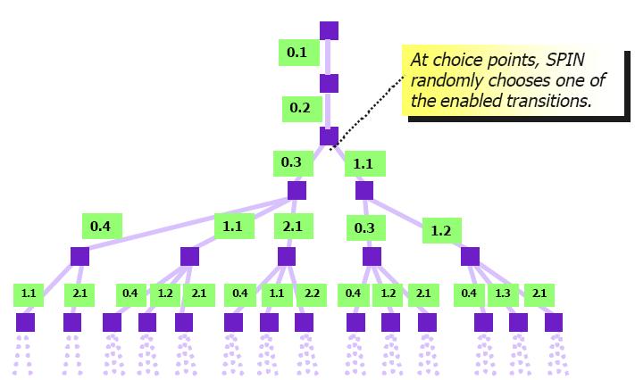

Guided Simulation
In a guided simulation, SPIN runs in an interactive mode. At each choice point, SPIN asks the user to select a branch to transit. It is easy run SPIN in this mode on our Promela test program because choice points are limited. However, one can imagine that the number of choice points to traverse in a complex system, such as the ATM system that we are going to validate, will be prohibitive in practice. And to know which branch to choose requires that the user already knows how the error can occur, which is not the case for our ATM system. Hence guided simulation is only useful for exploring a few known execution traces.

Exhaustive Depth-First Search Simulation
In an exhaustive depth-first search simulation, SPIN chooses an unexplored transition and remembers that it needs to come back and explore the others. When SPIN has finished with one subtree of the computation tree, it continues on with the siblings, until the entire computation tree is covered. The advantage of this mode is that it is automated and it covers all possible execution trace for validating the properties. The figure below illustrates this.

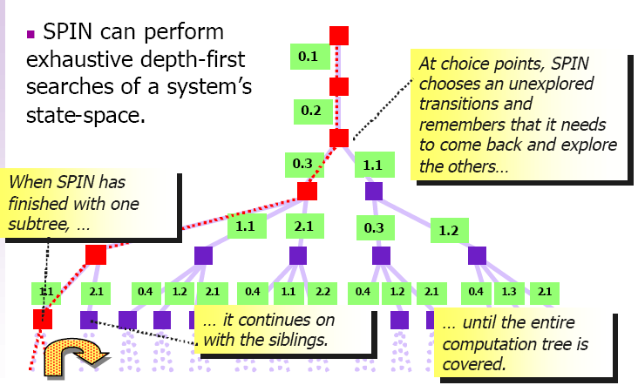

Simulation Mode for this Project
For the objective of the project, we want to explore all possible execution traces to validate the important properties that we are interested. We could not possibly explore a few traces or to know which traces to explore. Therefore, we have decided to perform exhaustive search on the Promela code that we have written for the ATM.

Assumptions
Given the time constraint and the complexity of the ATM machine, we have made the following assumptions to simplify our ATM model. This gives us time to concentrate on producing a working ATM model in Promela.
- In the event of a wrong password entered by the user, the ATM will prompt the User to reenter the password. Based on the state diagrams, this will cause an infinite loop between the User and ATM if a wrong password is entered repeatedly. In reality, most ATM will confiscate the card after 3 unsuccessful attempts. To simplify our program, after a wrong password is entered, the ATM will display an incorrect password message and eject the card.
- In the event of a failed transaction, the model from Object-Oriented Modeling and Design [ref 1] will wait 5 seconds, then display unsuccessful message and try again by requesting the user to specify transaction to be performed. To simplify our program, our model will skip the 5-second wait but will display unsuccessful message and request the user to specify transaction to be performed.
- The model from Object-Oriented Modeling and Design [ref 1] will verify account after user has entered correct password. If the account is a bad account (e.g. dormant account), the ATM will display bad account message, print a receipt and eject the card. To simplify our program, our model will skip account verification after user has entered correct password.
- The interaction diagram from Object-Oriented Modeling and Design [ref 1] only depicts a specific ATM transaction scenario: successful withdrawal of cash. There are many possible transactions that an ATM system can execute, e.g. unsuccessful withdrawal, unsuccessful and successful enquiry of account or user canceling the transaction at different points of the transaction, so on and so forth. For the purpose of this case study, we will limit our modeling of the system to the following transaction scenarios:
  - Successful withdrawal
  - Successful balance enquiry
  - User inserts unreadable card
  - User enters wrong password
  - User cancels transaction after being prompted for password
  - User cancels transaction after being requested to specify transaction to be performed
  - User cancels transaction after being requested to specify amount to be withdrawn
  - Unsuccessful transaction with consortium
  - Unsuccessful transaction with bank

Modeling of the ATM System

Modeling
Below are the state diagrams of our ATM system. It is based on the ATM model from Object-Oriented Modeling and Design [ref 1] but modified for the assumptions described in section 3.
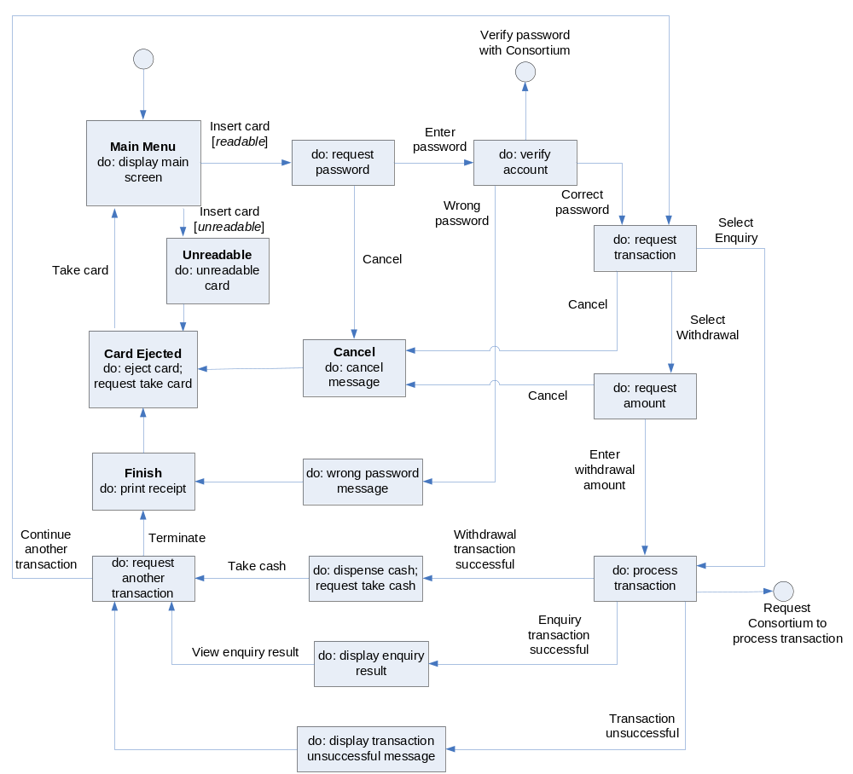
State Diagram for ATM

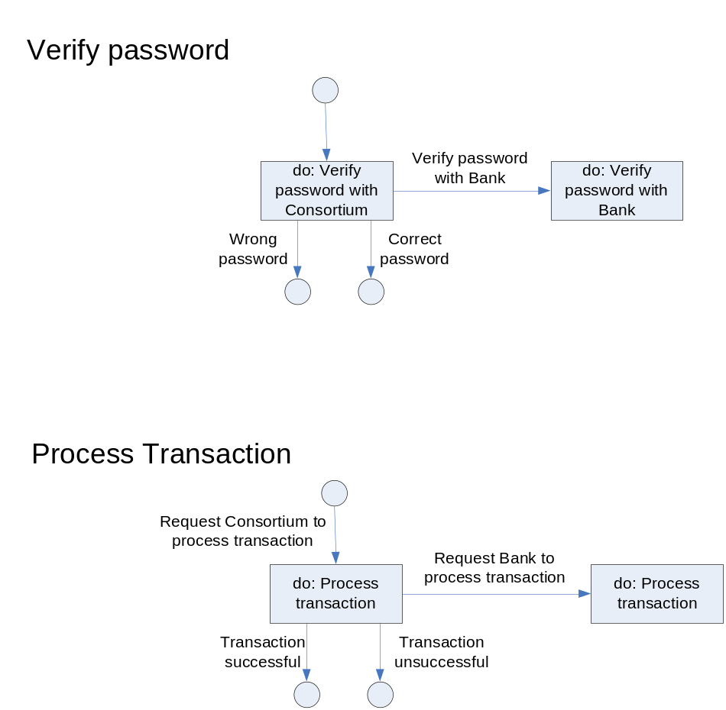
State Diagram for Consortium and Bank

We create four processes to model a transaction. The 4 processes will represent the 4 active entities exist in the ATM System:
- User
- ATM
- Consortium
- Bank
Each process consists of mainly if statements with guards. A snippet of ATM process is shown below:
proctype ATM(){
printf("initiating ATM Process...\n");
DisplayMenuState:
atm2user!DISPLAY_MAIN_MENU ->
printf("ATM Process: Main Menu...\n");
user2atm?INSERT_CARD ->
goto ReadCardState;

ReadCardState:
if
:: printf("ATM Process: Card is valid...\n");
atm2user!VALID_CARD;
printf("ATM Process: Prompt user for password...\n");
atm2user!REQUEST_PASSWORD;
goto ReceiveAccState;
:: printf("ATM Process: Card is unreadable...\n");
atm2user!INVALID_CARD;
atm2user!REQ_REMOVE_CARD;
goto EjectCardState;
fi;

...

}

The different actions that the different entities are able to take are represented by 4 mtypes in the Promela model:
Actions of ATM:
- DISPLAY_MAIN_MENU
- VALID_CARD
- INVALID_CARD
- REQUEST_PASSWORD
- VERIFY_PW_CON
- REQ_TRANSACTION
- REQ_AMT
- ATM_PROCESS_TRANS
- REQ_CONTINUE
- REQ_REMOVE_CARD

Action of User:
- INSERT_CARD
- ENTERED_PASSWORD
- CANCEL
- WITHDRAW
- ENQUIRY
- ENTERED_AMT
- TOOK_CASH
- TERMINATE
- CONTINUE
- REMOVED_CARD

Action of Consortium:
- VERIFY_PW_BANK
- CORRECT_PW
- INCORRECT_PW
- CONSORTIUM_PROCESS_TRANS
- TRANSACTION_SUCCESS
- TRANSACTION_UNSUCCESS
- ANOTHER_TRANSACTION
- END_TRANSACTION

Action of Bank:
- VERIFIED_PW
- WRONG_PW
- BANK_TRANS_SUCCESS
- BANK_TRANS_FAIL
- ANOTHER_TRANSACTION
- END_TRANSACTION

The Promela code for the 4 mtypes to represent the actions is shown below:
mtype = {DISPLAY_MAIN_MENU, VALID_CARD, INVALID_CARD, REQUEST_PASSWORD, VERIFY_PW_CON, REQ_TRANSACTION, REQ_AMT, ATM_PROCESS_TRANS, REQ_CONTINUE, REQ_REMOVE_CARD}; /* ATM action */

mtype = {INSERT_CARD, ENTERED_PASSWORD, CANCEL, WITHDRAW, ENQUIRY, ENTERED_AMT, TOOK_CASH, TERMINATE, CONTINUE, REMOVED_CARD};

mtype = {VERIFY_PW_BANK, CORRECT_PW, INCORRECT_PW, CONSORTIUM_PROCESS_TRANS, TRANSACTION_SUCCESS, TRANSACTION_UNSUCCESS};

mtype = {VERIFIED_PW, WRONG_PW, BANK_TRANS_SUCCESS, BANK_TRANS_FAIL, ANOTHER_TRANSACTION, END_TRANSACTION};

Six channels will be created to manage the communications between the different entities:
- user2atm: channel communication from User to ATM
- atm2user: channel communication from ATM to User
- atm2consortium: channel communication from ATM to Consortium
- consortium2atm: channel communication from Consortium to ATM
- consortium2bank: channel communication from Consortium to Bank
- bank2consortium: channel communication from Bank to Consortium
The 6 channels will be defined as mtype elements of length 1 (as shown below). The mtype element found in the channel at the specific instance will represent the state that the 4 different entities are in.
chan user2atm = [1] of {mtype};
chan atm2user = [1] of {mtype};
chan atm2consortium = [1] of {mtype};
chan consortium2atm = [1] of {mtype};
chan consortium2bank = [1] of {mtype};
chan bank2consortium = [1] of {mtype};

The Promela program is initialized by running all four processes:
init {
atomic {
run ATM();
run User();
run Consortium();
run Bank();
}
}

Results of Model Checking
We ran SPIN verification to check for deadlock and unexecuted code in the ATM model. As shown below, SPIN did not report “invalid end state”; hence there is no deadlock in the model. Furthermore, there is no error and unexecuted codes, as all processes have 0 unreached states.
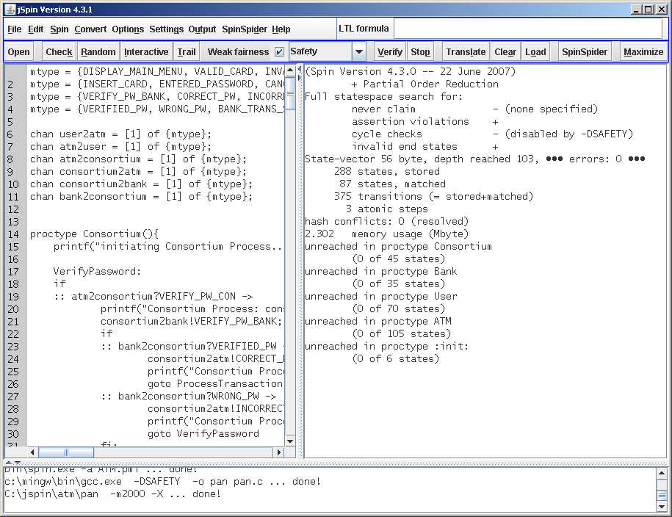

Properties Checking
For the scope of this project, we seek to check the properties of a successful withdrawal transaction. A successful withdrawal transaction is a transaction where user selects withdrawal option and withdrawal transaction is successful and ATM dispenses cash eventually.
We will perform the checking in two stages: a preliminary checking to assert withdrawal transaction and a final checking for liveness and safety properties of a withdrawal transaction.

Stage 1: Preliminary Checking
To begin checking the properties, we first place Booleans in the ATM Promela code as “checkpoints”, inside the ATM process where properties are to be checked. Booleans are not placed in Bank and Consortium process because any transaction failure at these points will be feedback to ATM process. User process does not have Booleans because human is external party and human behaviours are beyond the control of ATM machine.
Below are the Booleans we have declared and placed in the ATM Promela code.
Boolean | Meaning
user_cancel | User pressed cancel button?
password_correct | Is password correct?
withdraw_selected | Is withdraw selected when use is prompted to select transaction type?
enquiry_selected | Is balance enquiry selected when use is prompted to select transaction type?
receipt_printed | Is receipt printed?
card_ejected | Is card ejected?
cash_dispensed | Is cash dispensed?
transaction_success | Is transaction successful as feedback from consortium?
amount_entered | Is withdrawal amount entered by user?

When the “checkpoints” are added, we will perform a quick check by placing assertions in the CashDispenseState of the ATM process. The assertions will assert the following properties when cash is dispensed.
- password_correct: Correct password entered by User
- !user_cancel: User must not cancel at any point of the transaction
- withdraw_selected: User must select withdrawal during transaction selection
- !enquiry_selected: User must not select balance enquiry during transaction selection
- transaction_success: Withdraw transaction succeed
- amount_entered: User entered withdrawal amount
We ran the model checker with the assertion statements and there was no error, as shown below.
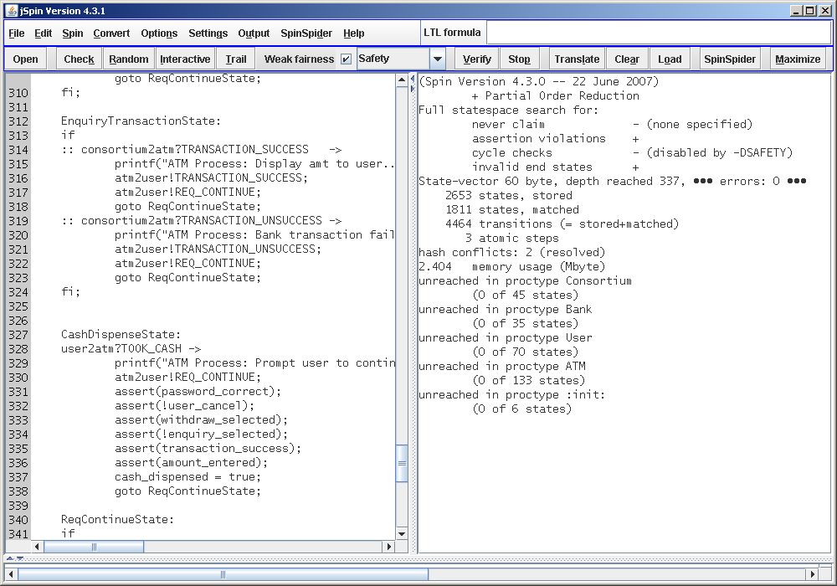
The two PrintReceiptState and EjectCardState after CashDispenseState have multiple entry points. So we check the properties of these two states with LTL properties, as shown below.
Property | If cash is dispensed and user chooses not to continue transaction, then ATM will eventually print receipt and eject card.  (Filename: preliminary-ltl-1.prp)
LTL Property | G (cash_dispensed Λ ¬continue_transaction  → F (receipt_printed Λ card_ejected) )
SPIN Syntax | [](cash_dispensed && !continue_transaction -> <>(receipt_printed && card_ejected))
Büchi automata | never { /* !( [](receipt_printed -> <>card_ejected) ) */  T0_init:  if  :: (! ((card_ejected)) && (receipt_printed)) -> goto accept_S4  :: (1) -> goto T0_init  fi;  accept_S4:  if  :: (! ((card_ejected))) -> goto accept_S4  fi;  }
Property | If ATM prints receipt, it will eventually eject card.  (Filename: preliminary-ltl-2.prp)
LTL Property | G (receipt_printed → F card_ejected)
SPIN Syntax | [](receipt_printed -> <>card_ejected)
Büchi automata | never { /* !([](cash_dispensed && !continue_transaction -> <>(receipt_printed && card_ejected))) */  T0_init:  if  :: (((! ((card_ejected)) && ! ((continue_transaction)) && (cash_dispensed)) || (! ((continue_transaction)) && ! ((receipt_printed)) && (cash_dispensed)))) -> goto accept_S3  :: (1) -> goto T0_init  fi;  accept_S3:  if  :: (((! ((card_ejected))) || (! ((receipt_printed))))) -> goto accept_S3  fi;  }

To verify these two LTL properties, we entered LTL property (SPIN syntax) to JSPIN, Translate it to Büchi automata and ran Verify in Acceptance mode. SPIN reported no errors for both LTL properties, as shown below.
[](cash_dispensed && !continue_transaction -> <>(receipt_printed && card_ejected))
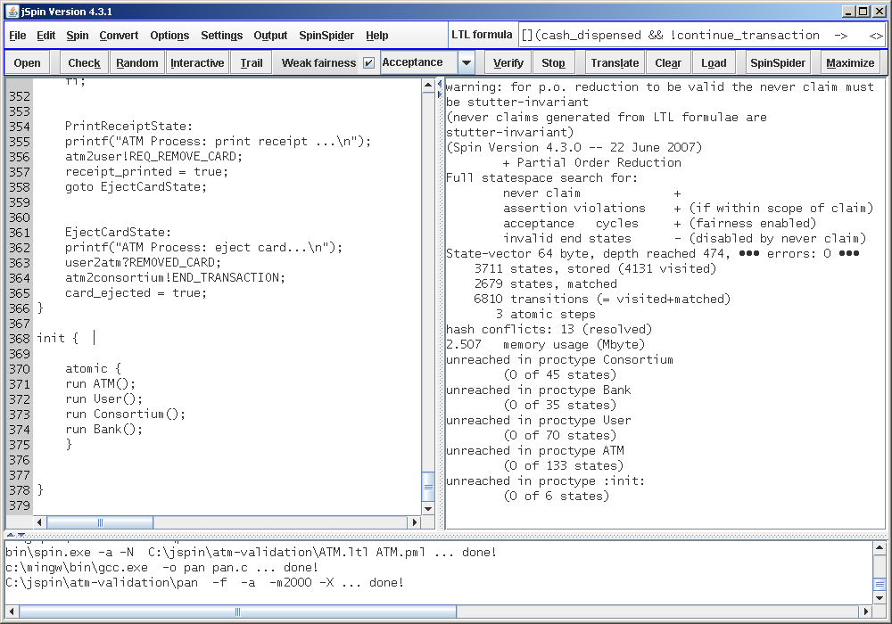

[](receipt_printed -> <>card_ejected)
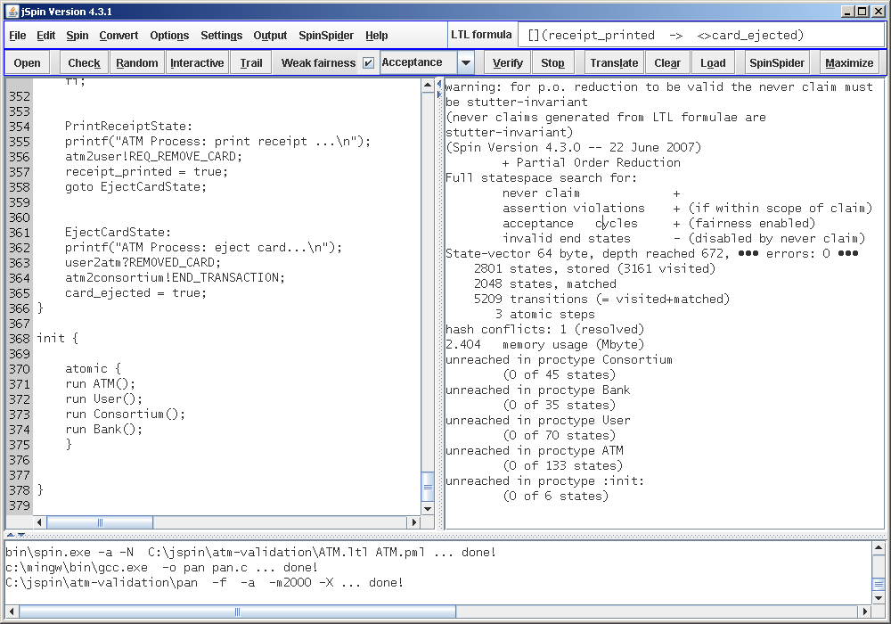

Stage 2: Liveness and Safety Checking
We will check the ATM model for the following liveness and safety properties:
Liveness 1 | If user chooses withdrawal and transaction is successful, then ATM will eventually dispense cash.  (Filename: liveness-1.prp)
LTL Property | G (withdraw_selected Λ transaction_success → F cash_dispensed )
SPIN Syntax | [](withdraw_selected && transaction_success -> <> cash_dispensed)
Büchi automata | never { /* !([](withdraw_selected && transaction_success -> <> cash_dispensed)) */  T0_init:  if  :: (! ((cash_dispensed)) && (transaction_success) && (withdraw_selected)) -> goto accept_S4  :: (1) -> goto T0_init  fi;  accept_S4:  if  :: (! ((cash_dispensed))) -> goto accept_S4  fi;  }
Liveness 2 | If the ATM dispenses cash, it will eventually print receipt.  (Filename: liveness-2.prp)
LTL Property | G (cash_dispensed → F receipt_printed)
SPIN Syntax | [](cash_dispensed -> <> receipt_printed)
Büchi automata | never { /* !([](cash_dispensed -> <> receipt_printed)) */  T0_init:  if  :: (! ((receipt_printed)) && (cash_dispensed)) -> goto accept_S4  :: (1) -> goto T0_init  fi;  accept_S4:  if  :: (! ((receipt_printed))) -> goto accept_S4  fi;  }
Liveness 3 | If the ATM dispenses cash, it will eventually eject card.  (Filename: liveness-3.prp)
LTL Property | G (cash_dispensed → F card_ejected)
SPIN Syntax | [](cash_dispensed -> <> card_ejected)
Büchi automata | never { /* !([](cash_dispensed -> <> card_ejected)) */  T0_init:  if  :: (! ((card_ejected)) && (cash_dispensed)) -> goto accept_S4  :: (1) -> goto T0_init  fi;  accept_S4:  if  :: (! ((card_ejected))) -> goto accept_S4  fi;  }
Safety 1 | If user enters incorrect password, the ATM will never dispense cash. (Filename: safety-1.prp)
LTL Property | G ¬ (¬password_correct Λ cash_dispensed)
SPIN Syntax | []!(!password_correct && cash_dispensed)
Büchi automata | never { /* !([]!(!password_correct && cash_dispensed)) */  T0_init:  if  :: (! ((password_correct)) && (cash_dispensed)) -> goto accept_all  :: (1) -> goto T0_init  fi;  accept_all:  skip  }
Safety 2 | If transaction in ATM fails, the ATM will never dispense cash.  (Filename: safety-2.prp)
LTL Property | G ¬ (¬transaction_success Λ cash_dispensed)
SPIN Syntax | []!(!transaction_success && cash_dispensed)
Büchi automata | never { /* !([]!(!transaction_success && cash_dispensed)) */  T0_init:  if  :: (! ((transaction_success)) && (cash_dispensed)) -> goto accept_all  :: (1) -> goto T0_init  fi;  accept_all:  skip  }
Safety 3 | If user does not choose to perform withdrawal transaction, the ATM will never dispense cash.  (Filename: safety-3.prp)
LTL Property | G ¬ (¬withdraw_selected Λ cash_dispensed)
SPIN Syntax | []!(!withdraw_selected && cash_dispensed)
Büchi automata | never { /* !([]!(!withdraw_selected && cash_dispensed)) */  T0_init:  if  :: (! ((withdraw_selected)) && (cash_dispensed)) -> goto accept_all  :: (1) -> goto T0_init  fi;  accept_all:  skip  }
Safety 4 | If user chooses to perform balance enquiry transaction, the ATM will never dispense cash.  (Filename: safety-4.prp)
LTL Property | G ¬(enquiry_selected Λ cash_dispensed)
SPIN Syntax | []!(enquiry_selected && cash_dispensed)
Büchi automata | never { /* !([]!(enquiry_selected && cash_dispensed)) */  T0_init:  if  :: ((cash_dispensed) && (enquiry_selected)) -> goto accept_all  :: (1) -> goto T0_init  fi;  accept_all:  skip  }

We will check for a successful single withdrawal transaction, where user performs a withdrawal transaction and ends the transaction after cash is dispensed; the user does not continue to other transaction after withdrawal. To model this single transaction mode, we commented continuous transaction mode and uncommented single transaction mode in ReqContinueState of ATM process, as shown below:
ReqContinueState:

/* to model single transaction mode */
continue_transaction = false;
goto PrintReceiptState;

/*
/* to model continuous transaction mode *
if
:: user2atm?TERMINATE ->
continue_transaction = false;
goto PrintReceiptState;
:: user2atm?CONTINUE ->
printf("ATM Process: Redirect user to select transaction type...\n");
atm2user!REQ_TRANSACTION;
atm2consortium!ANOTHER_TRANSACTION;
continue_transaction = true;
goto ReqTransactionState;
fi;
*/
To verify the above LTL properties, we loaded the LTL property file to JSPIN, then Translate it to Büchi automata and ran Verify in Acceptance mode. SPIN reported no errors for all LTL properties. Hence the ATM model has been validated to satisfy the above liveness and safety properties. The results of liveness 1 and safety 1 validation are shown below.

Liveness 1: [](withdraw_selected && transaction_success -> <> cash_dispensed)
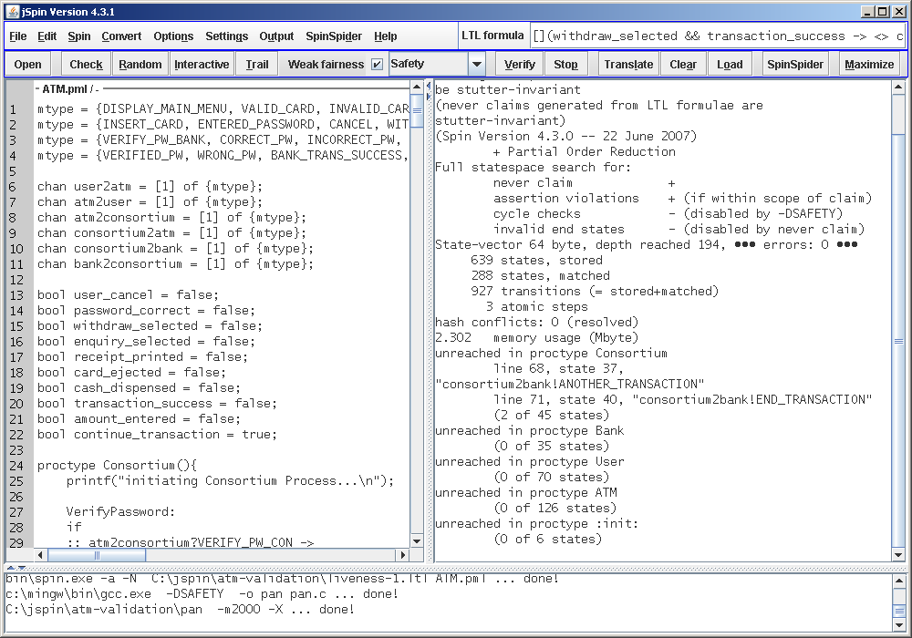
Safety 1: []!(!password_correct && cash_dispensed)
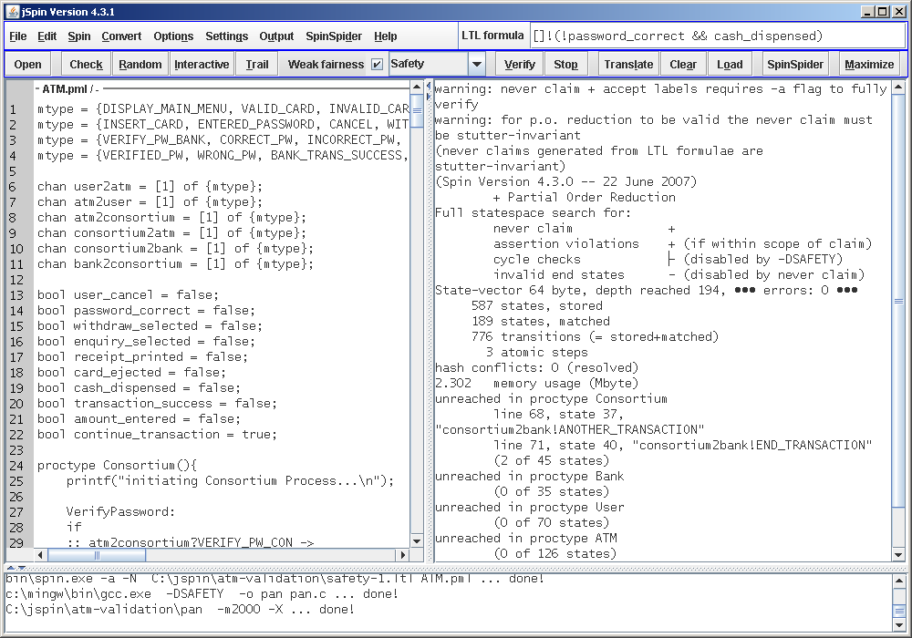

Summary and Further Works
We have successfully modeled an ATM system in Promela language and validated the model and its withdrawal transaction with SPIN Model Checker. We performed the validation in two stages. In the preliminary checking in stage 1, deadlock and unreachable code has been validated to be non-existent in the model. To cover the withdrawal transaction completely, the model has also have been validated against two LTL properties and no error was found. In the liveness and safety checking in stage 2, we constructed seven LTL formulae to validate the withdrawal transaction in the ATM model. We have covered important properties such as:
- If user chooses withdrawal and transaction is successful, then ATM will eventually dispense cash.
- If user enters incorrect password, the ATM will never dispense cash.
The stage 2 checking result showed that the ATM model has passed the liveness and safety properties validation. In summary, SPIN model checker has helped us to validate that our ATM model has no deadlock and unreachable code, and possesses desirable liveness and safety properties.
We recommend the followings for further works on the ATM model, which mainly address the assumptions made in this project:
- To model the ATM to confiscate the card after 3 unsuccessful attempts from the user to enter password.
- To model the 5-second waits on the ATM in the event of a failed transaction.
- To model the verification of account after the user enters the correct password.
- To model fund transfer transaction functionality.

References
- Rumbaugh, James R., et al, Object-Oriented Modeling and Design, Prentice Hall, 1991.
- SPIN Model Checker: http://spinroot.com/
- JSPIN, graphical user interface for the SPIN model checker: http://stwww.weizmann.ac.il/g-cs/benari/jspin/

Appendix

State Diagrams from Object-Oriented Modeling and Design [ref 1]
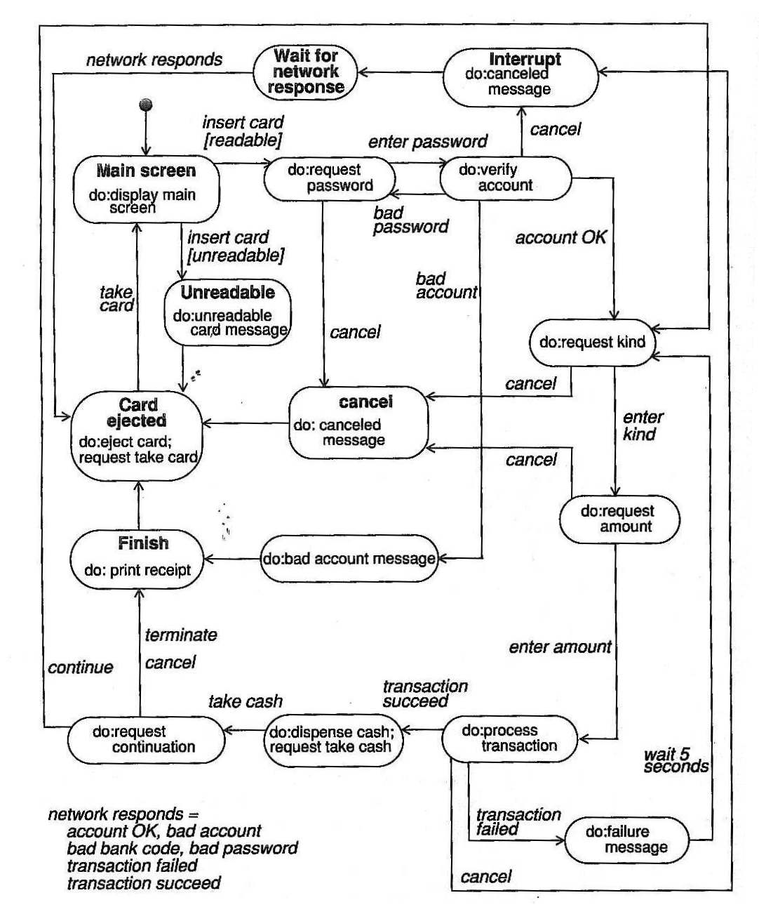
State diagrams for ATM
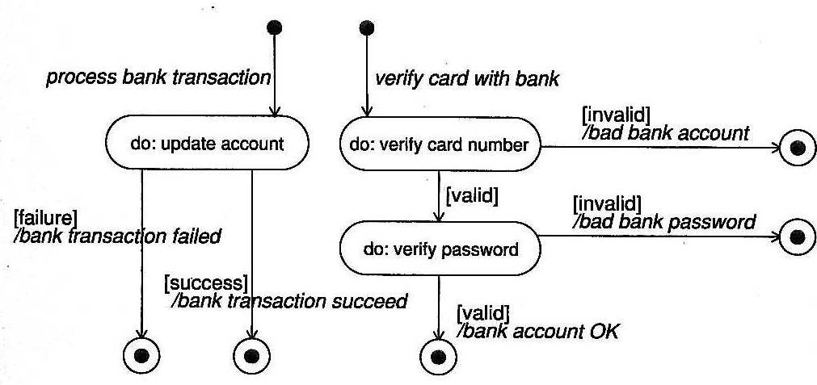
State diagrams for Bank

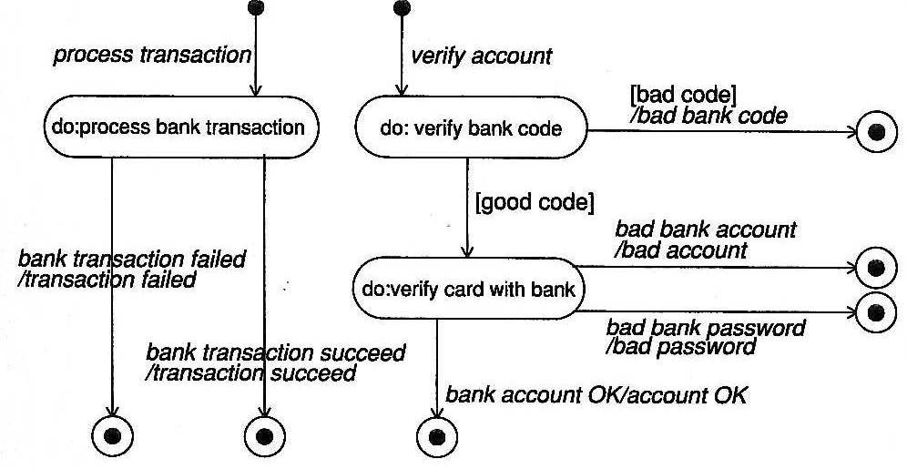
State diagrams for Consortium

