Jon Organ

CS677

Homework 12, K-Means

**Question 1:**

k = 3 k-means classifier implemented...

Distortion vs k:

k Val Distortion

1 0.007838

2 0.00495

3 0.003094

4 0.002085

5 0.00152

6 0.001122

7 0.000892

8 0.000699

Saving Q1 graph...

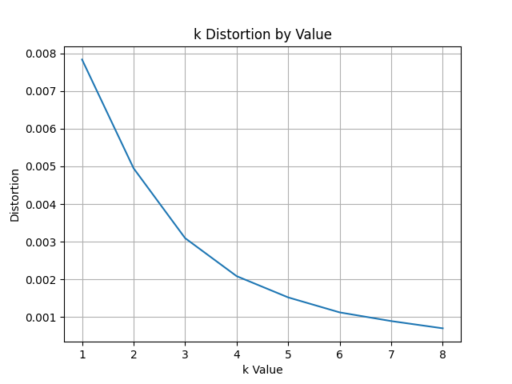

Using the knee method, the point of diminishing returns seems to be around k = 6

**Question 2:**

Cluster Green % Red %

1 13.33% 86.67%

2 66.67% 33.33%

3 0.0% 100.0%

4 0.0% 100.0%

5 91.67% 8.33%

6 11.11% 88.89%

**Question 3:**

Cluster 3 is a pure red cluster (100.0%)

Cluster 4 is a pure red cluster (100.0%)

Cluster 5 is a pure green cluster (91.67%)