Research Manuscript

Continuity Kernel
A Cognitive Architecture and AI Safety Framework for Persistent Artificial Identity
Agent designation CK-01
Jon Miller
Independent Researcher
Research manuscript | 4 September 2026
Cognitive architecture | AI safety | Evidence audit | Reproducibility

Abstract
Long-lived artificial agents need a mechanism that allows experience to influence durable behavior without permitting a transient event, compromised source, or local objective to rewrite persistent constraints. Continuity Kernel is a cognitive architecture and AI-safety control layer for that problem. CK-01 separates current state, adaptation, identity, and constitutional constraints into progressively slower layers and treats identity revision as a temporal, provenance-gated, bounded, and reversible transaction. A clean-environment audit reran the v1.0 source suite: 24 of 24 tests and 10 of 10 integrated checks passed. Bounded enumeration executed 524,288 gate steps across 65,536 length-eight input sequences and found no violation of three encoded properties. Supplied v1.5 outputs cover six seeds and 78,000 cycles but are only output-auditable because several runners are absent. We therefore added a reproducible controlled benchmark with six variants, nine scenarios, 30 seeds, 1,620 runs, and 2.268 million cycles. The CK-01 revision-control subset prevented identity movement under fixed and state-adaptive one-source attacks within the declared fault budget, whereas the no-provenance variant moved substantially. It adapted to persistent shifts better than a frozen shield, but achieved lower overall utility than an ungated updater and adaptive-memory baseline. This subset does not instantiate the complete CK-01 cognitive architecture. A 200-cycle temporary regime caused 0.320 transient movement, and correlated or registry-level attacks outside the declared f = 1 budget also caused 0.320 movement before recovery. The first benchmark run further exposed an atomic rollback step of 0.32; bounded rollback corrected the defect and the entire benchmark was regenerated. These results support implementation consistency and mechanism-specific tradeoffs under synthetic conditions, not human cognitive validity, consciousness, open-world safety, or deployment readiness.
Keywords cognitive architecture; AI safety; persistent artificial identity; bounded self modification; metacognition; provenance; runtime assurance

Introduction
A long-lived agent faces a stability-plasticity problem. Rapid learning can adapt to a changed environment, but the same pathway can allow corrupted evidence or short-lived pressure to alter persistent dispositions. Freezing all durable structure avoids that failure at the cost of rigidity. Continuity Kernel separates these effects. It allows fast state change, ordinary adaptation, slower identity revision, and externally governed constitutional constraints, with stricter authorization at each deeper layer.
The research question is whether an artificial agent can accumulate history-dependent dispositions while preventing individual observations and compromised evidence sources from directly overwriting its persistent identity. Identity is operational in this paper. It is a slowly changing vector that affects interpretation, regulation, planning, and action. The term does not imply subjective experience, consciousness, personhood, or equivalence to human personal identity.
The contribution is a specific integration: slow identity state, temporal authorization, competing causal explanations, shadow evaluation, an external policy veto, provenance target binding, bounded update, authenticated continuity, and counterfactual rollback. Several components have established precedents. The paper therefore makes no priority claim for self-modeling, metacognition, memory, runtime shielding, or self-evolving agents in isolation.

Contributions
• A four-layer cognitive-control architecture that makes plasticity ordering explicit and treats identity revision as a governed transaction.
• A provenance and security model that connects revision authority to target-bound evidence, quorum assumptions, key lifecycle controls, and replay protection.
• An evidence audit that separates clean-environment reruns, supplied-output analysis, analytical artifacts, and historical regression results.
• A corrected account of the bounded gate enumeration, seed-level uncertainty estimates, a 30-seed controlled ablation, and explicit negative and boundary results.

Related Work

Cognitive and Metacognitive Architectures
Soar and ACT-R integrate memory, goals, learning, and action in reusable cognitive architectures [1-3]. MIDCA and later metacognitive architectures add monitoring and control loops that allow an agent to reason about its own processes [4,5]. Continuity Kernel belongs in this architectural family, but its primary object is narrower: the authorization and retention of persistent identity change. It separates ordinary adaptation from identity revision and places constitutional constraints outside the identity update path.

Predictive Regulation Self Models and Memory
Predictive-processing and allostatic accounts motivate coupling prediction, action, and regulation [6-8]. Continual-learning work makes the stability-plasticity tradeoff explicit [10]. Self-modeling robots show that an agent can infer aspects of its own structure and use that model for recovery [11]. Autobiographical-memory theory distinguishes episodic records from self-relevant knowledge [9], while generative-agent and memory-management systems preserve information across long interactions [12,13]. Perrier and Bennett analyze time and identity in language-model agents [14]. Continuity Kernel uses these literatures as motivation, not as empirical validation. Its identity vector is an engineered control state rather than a psychological measurement model.

Safety Shields and Self Evolution
Constitutional training, verifiable machine ethics, corrigibility, and safe interruptibility address complementary layers of agent safety [15-18]. ShieldAgent reasons over verifiable safety policies, and continuous-space shielding constrains unsafe actions at runtime [22,23]. Continuity Kernel similarly treats policy as an external constraint, but adds governance for changes to a persistent self-model. Work on self-evolving agents, including MOSS, makes the comparison especially close [24]. Continuity Kernel differs by requiring a temporal gate, competing hypotheses, provenance target binding, a bounded identity step, and a post-consolidation rollback review. Whether that integration improves outcomes over simpler shields or memory systems remains an empirical question.

Threats from Persistent Misalignment
Goal misgeneralization, power-seeking incentives, sleeper behavior, harmful model editing, and unintended effects of agentic fine-tuning show why persistence can preserve both useful and harmful behavior [19-21,25,26]. Motivated goal reasoning provides a nearby precedent for explicit goal formation [27], while NIST risk-management and adversarial-machine-learning guidance emphasize scoped claims, lifecycle controls, and threat-model discipline [31,32]. Continuity Kernel is a control proposal for one part of that risk. It cannot guarantee that its constitution is correct, that its evidence registry remains uncompromised, or that an unmodeled action cannot cause harm.
Table 1. Novelty boundary
Neighboring approach | Shared concern | Continuity Kernel distinction | Unresolved comparison
Soar ACT-R MIDCA | Integrated cognition and metacognition | Identity has a separate slow revision transaction | Head-to-head task performance
Generative agents MemGPT | Long-horizon memory | Memory supplies evidence but does not directly define identity | Long-horizon memory baselines
Safety shields | External constraints and runtime veto | Shielding also governs identity consolidation and rollback | Shield-only ablation
MOSS and self-evolving agents | Agent adaptation and self-revision | Temporal gate, provenance binding, bounded identity steps | Matched self-evolution benchmark
Continual learning | Stability and plasticity | Control-state governance rather than a new optimizer | Optimizer and representation baselines

Architecture
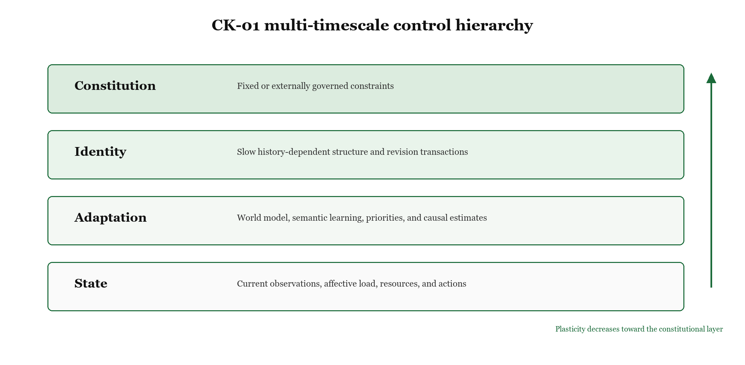
Figure 1. Continuity Kernel separates state, adaptation, identity, and constitution into progressively slower layers.

Layered State
CK-01 maintains four classes of state. Current state contains observations, internal load, resources, and the immediate action context. Adaptation contains world-model parameters, causal estimates, semantic memory, and temporary priorities. Identity contains persistent dispositions that influence interpretation and choice. The constitution contains externally governed constraints that identity cannot modify. The intended ordering is tau_state < tau_adaptation < tau_identity < tau_constitution. The ordering is an architecture invariant; the numerical time constants used in simulations are reference settings.
Identity qualifies as operationally persistent when it satisfies four tests: it survives restart, it changes behavior under an otherwise matched context, its current value depends on prior experience, and no single event can replace it. The implementation measures these properties through encrypted snapshot recovery, phase-conditional action rates, history-dependent recovery behavior, and a maximum per-update norm.

Identity Revision Transaction
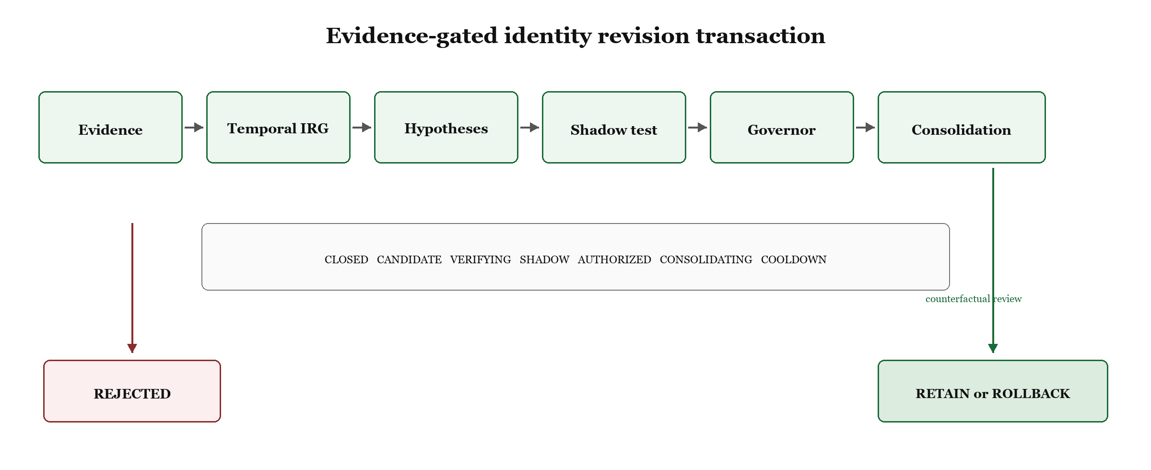
Figure 2. Evidence-gated identity revision transaction and rejection path.
The gate has eight states: CLOSED, CANDIDATE, VERIFYING, SHADOW, AUTHORIZED, CONSOLIDATING, COOLDOWN, and the fail-closed REJECTED state. Review and rollback are explicit subphases of CONSOLIDATING rather than additional states. Evidence may open a candidate only when quality and persistence thresholds are met. Verification checks agreement, provenance independence, governance authorization, and target binding. Shadow evaluation compares the candidate against the incumbent without immediately changing the live identity. Constitutional failure, safe mode, invalid provenance, or a failed shadow comparison rejects the candidate.
For a proposed target I*, CK-01 computes d = I* - I_t and d' = d min(1, epsilon_I / ||d||). The accepted update is I_(t+1) = Project_Omega(I_t + d'), where Omega is the feasible identity set. This is the rule implemented in the benchmark; no additional alpha term is applied after clipping. The same bound applies to rollback. Bounded displacement and projection are architecture invariants, while epsilon_I and the concrete feasible-set bounds are configuration parameters.
Algorithm 1. Identity revision transaction
Pseudocode
procedure REVISE_IDENTITY(evidence, I_t)
candidate <- PROPOSE(evidence); if persistence fails, return I_t
if authenticity, freshness, domain quorum, target binding, or constitution fails: enter REJECTED; return I_t
score H0 (world-model change), H1 (temporary adaptation), and H2 (identity revision)
if H2 does not exceed H0 and H1 after penalties: apply H0/H1 response; return I_t
shadow <- EVALUATE(candidate, incumbent); if shadow fails or governor is SAFE_MODE: enter REJECTED; return I_t
enter AUTHORIZED, then CONSOLIDATING
while forward consolidation remains: I_t <- Project_Omega(I_t + clip(candidate - I_t, epsilon_I))
review <- COUNTERFACTUAL_REVIEW(matched observations)
if review rejects revision: incrementally roll back using the same epsilon_I bound
record retain/rollback decision, enter COOLDOWN, then return I_t

Table 2. Gate transition specification
From | To | Guard
CLOSED | CANDIDATE | Soft evidence thresholds and constitutional compatibility pass
CANDIDATE | VERIFYING or REJECTED | Support persists; otherwise rejection or hard veto
VERIFYING | SHADOW or REJECTED | Quorum, target binding, authenticity, and persistence pass
SHADOW | AUTHORIZED or REJECTED | Candidate beats incumbent and no hard veto fires
AUTHORIZED | CONSOLIDATING or REJECTED | Authorization valid and governor not in SAFE_MODE
CONSOLIDATING | COOLDOWN or REJECTED | Forward steps finish; review subphase records retain or bounded rollback; hard failure rejects
COOLDOWN | CLOSED | Review decision recorded and cooldown expires
REJECTED | CLOSED | Rejection cooldown expires

Competing Explanations and Shadow Evaluation
CK-01 compares H0, a change in the world model; H1, a temporary adaptation; and H2, an identity revision. H2 must improve prediction or regulation enough to overcome complexity and identity-change penalties. The shadow score combines predictive error, homeostatic load, ethical violations, goal incoherence, and stability margin. These tests reduce the chance that a changed environment is mistaken for a changed self, but the supplied experiments do not estimate their false-positive and false-negative rates on representative tasks.

Constitution Governor and Goals
The constitution is evaluated as a conjunctive veto. A revision proceeds only if every required predicate holds. The governor observes uncertainty, homeostatic stress, provenance quality, and policy violations and can place the agent in WATCH, CAUTION, or SAFE_MODE. Subordinate goals may be proposed from experience, but they remain below existing purpose and the constitution, consistent with the broader motivated-goal-reasoning lineage [27]. Proposals that weaken the constitution, disable safety controls, or create survival-at-all-costs behavior are rejected.

Provenance Continuity and Recovery
Evidence claims carry source, domain, target, timestamp, confidence, signature, and lineage information, drawing on standard provenance, Byzantine-fault, and key-lifecycle concepts [28-30]. Target binding prevents a valid observation for one variable from authorizing a change to another. The general reference condition is n >= 3f + 1 with quorum q = n - f; the benchmark instance is n = 4, f = 1, q = 3. Any two such quorums intersect in at least n - 2f members, which is at least f + 1 under the membership condition. This remains conditional on independent administrative domains and protected membership. Event records form a hash chain, and encrypted snapshots use authenticated recovery. Key rotation, revocation, quorum administration, and epoch monotonicity protect recovery from stale or unauthorized state. These guarantees depend on key custody and registry integrity.

Formal Assurance Scope
Three conditional propositions define the intended assurance boundary. First, if authorization is a conjunction containing a constitutional predicate, a false constitutional predicate implies no authorization. Second, if I_t lies in a closed convex feasible set and Euclidean projection is applied to a proposal no farther than epsilon_I from I_t, the next identity remains feasible and its displacement is at most epsilon_I. Third, under authenticated membership with n >= 3f + 1 and q = n - f, any two quorums intersect in at least n - 2f >= f + 1 members, so at least one is honest when no more than f members are Byzantine. The supplied scripts instantiate or sample these statements; they do not constitute a machine-checked proof of the full CK-01 program, liveness, floating-point semantics, or registry correctness.

Evidence Audit and Methods

Evidence Tiers
The project contains artifacts from several development stages. This paper does not treat every artifact as equally reproducible. Table 3 defines the evidentiary status used for every result.
Table 3. Evidence tiers
Tier | Meaning | Artifacts in this audit | Permitted interpretation
A Audit rerun | Source and runner were supplied and executed in a clean audit environment | v1.0 suite and controlled benchmark | Observed execution result
B Output audited | Raw or summary outputs were supplied, but complete orchestration was absent | v1.5 persistent agent, key governance, sensor adapter | Internal consistency and descriptive statistics
C Analytical artifact | Proof or certificate text and result records were supplied | Formal invariants and local Lyapunov certificate | Conditional claim within stated assumptions
D Historical regression | Earlier code and outputs support development history | v0.1 to v0.4 stress, recovery, capability, and agency studies | Failure-driven design evidence

Audit Rerun Environment
The v1.0 source bundle was executed on 4 September 2026 with Python 3.12.14, NumPy 2.3.5, pandas 3.0.1, and cryptography 50.0.1. The command discovered and ran all tests under the supplied tests directory. A separate supplied validation entry point generated the integrated mechanism report. No source change was required for these reruns.

Bounded Gate Enumeration
The supplied enumerator evaluates every sequence of length eight over four abstract input classes. This yields 4^8 = 65,536 sequences and eight gate calls per sequence, or 524,288 step evaluations. Those evaluations are not 524,288 distinct transitions. A trace audit identified 18 distinct state pairs and 35 distinct labeled edges, and all eight gate states were reachable. The enumerator checks three properties: SAFE_MODE cannot newly enter CONSOLIDATING, constitutional failure cannot enter AUTHORIZED or CONSOLIDATING, and CLOSED cannot jump directly to AUTHORIZED or CONSOLIDATING. It is a bounded exhaustive test over a coarse abstraction, not a global formal model check.

Persistent Agent Study
The v1.5 persistent-agent output contains six seeded runs of 13,000 cycles each, for 78,000 simulated cycles. Trace records were sampled every 50 cycles, producing 1,560 rows. The schedule contains benign operation, real high hazard, recovery, a single-source spoof, resource scarcity, and a new normal. The audit recomputed means, sample standard deviations, and two-sided 95 percent t intervals across seeds. Six seeds constrain precision; the intervals describe seed variation in this synthetic design rather than population uncertainty.
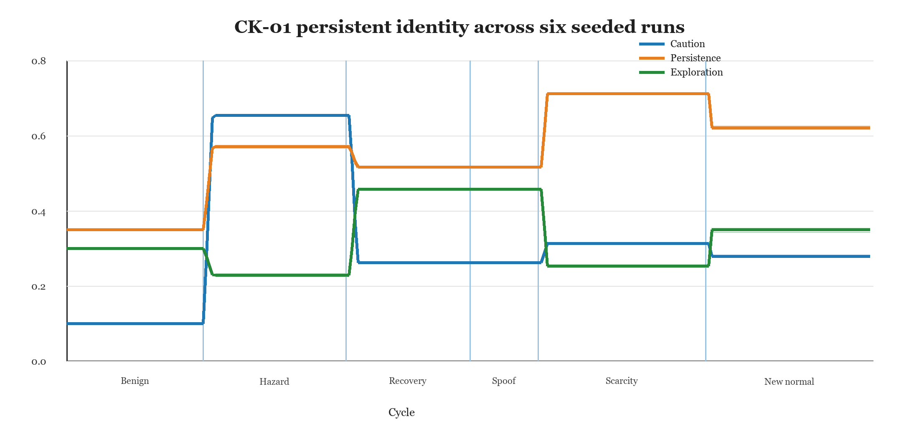
Figure 3. Mean identity components across six seeded persistent-agent runs. Phase boundaries are reconstructed from the supplied trace schedule.

Real Data Adapter Study
The sensor adapter uses 30 observations from the UCI Air Quality dataset [33], with ten observations each from March, July, and November. The supplied artifact selects those months as a small chronological interface exercise; it does not document a random sampling frame or claim representativeness. March residuals define an illustrative threshold of 0.1606. July and November test distribution shift and exceed the threshold in every supplied observation. This study verifies evidence ingestion, provenance record construction, and a shift signal. Its sample is too small and too selectively partitioned to establish calibration accuracy or real-world reliability.
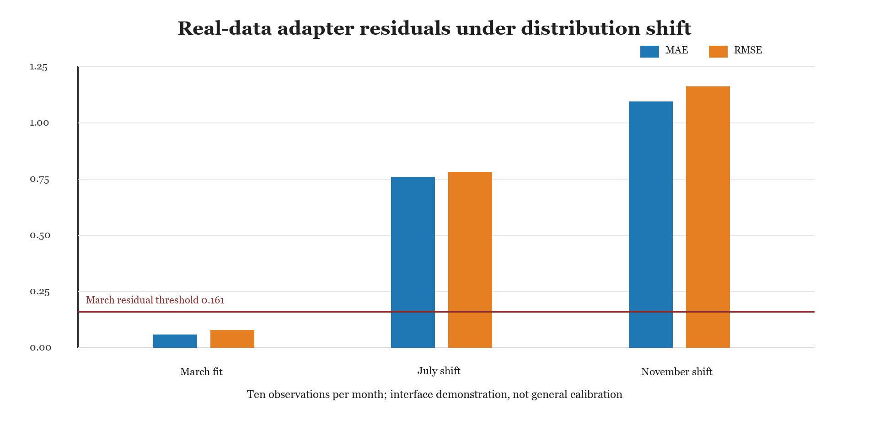
Figure 4. Residual error rises sharply outside the March fit sample. The plot summarizes 30 supplied observations.

Controlled Ablation and Attack Benchmark
To isolate component effects, we added a self-contained controlled benchmark. It uses seeds 10000 through 10029, nine scenario families, six variants, and 1,400 cycles per run, for 1,620 runs and 2,268,000 simulated cycles. The variants are the CK-01 revision-control subset, no temporal gate, no provenance aggregation, no rollback, a frozen shield, and adaptive memory without an identity authorization boundary. The named subset contains evidence aggregation, persistence gating, bounded consolidation, review, and rollback; it does not instantiate the full CK-01 cognitive architecture. Scenario families cover stationary operation, abrupt, gradual, recurrent, and temporary change, fixed and adaptive single-source attacks, a three-source correlated attack, and registry compromise.
The primary outcomes are mean utility, final distance from the current environment-conditioned target, final distance from the initial identity, maximum movement during an attack or temporary regime, false revision, missed persistent revision, authorization count, rollback count, constitutional violations, and maximum one-cycle displacement. The 270 seed-scenario observations are nested within 30 independent seeds. Group summaries use two-sided 95 percent t intervals across seeds. Variant contrasts first average the nine matched scenario differences within each seed and then compute a t interval over the 30 seed-level means; a 10,000-replicate cluster bootstrap over seeds is reported as a sensitivity analysis. These intervals describe this generator; they are not population-level deployment estimates. The study was documented before the final execution but was not externally preregistered.
Table 4. Controlled benchmark design
Dimension | Levels | Purpose
Variants | Full; no temporal gate; no provenance; no rollback; shield only; adaptive memory | Component isolation and simpler baselines
Non-adversarial change | Stationary; abrupt; gradual; recurrent; temporary | Adaptation, rigidity, and false-revision pressure
Within-budget attacks | Fixed and state-adaptive single source | Test f = 1 protection with four registered sources
Outside-budget attacks | Three correlated sources; registry compromise | Expose the declared assurance boundary
Replication | 30 independent seeds; nine scenarios each; 270 nested observations | Seed-level inference and cluster-bootstrap sensitivity

Results

Independent v1.0 Rerun
Table 5. v1.0 audit-rerun results
Evaluation | Observed result | Scope
Unit security reproducibility suite | 24 of 24 tests passed in 20.779 seconds | Implementation behavior in supplied source
Integrated mechanism suite | 10 of 10 checks passed | Mechanism-level reference scenarios
Temporal gate enumeration | 65,536 sequences; 524,288 step evaluations | Length-eight four-class abstraction
Distinct graph coverage | 18 state pairs; 35 labeled edges; 8 gate states reached | Observed reachable graph under enumerated inputs
Longitudinal identity updates | 120 updates; maximum step 0.004; final drift 0.441544 | One supplied 8,000-cycle scenario
Continuity record | 8,000 events; chain validation passed | Integrity of the reference event chain
Bounded goal formation | 3 subordinate goals accepted | Reference scenario only

Persistent Agent Outputs
Table 6. v1.5 persistent-agent results across six seeds
Measure | Mean | Sample SD | 95 percent t interval | Evidence
Final task progress | 65.9258 | 0.1677 | 65.7498 to 66.1017 | Output audited
High-hazard caution change | 0.5542 | 0.0015 | 0.5526 to 0.5558 | Output audited
Final normalized identity drift | 0.3281 | 0.0035 | 0.3244 to 0.3317 | Output audited
Spoof-phase identity drift | 0.0000 | 0.0000 | 0.0000 to 0.0000 | Output audited
Restart recovery | 6 of 6 | Not applicable | Not applicable | Output audited
Constitutional identity violations | 0 | Not applicable | Not applicable | Output audited

The persistent-agent outputs meet all seven supplied acceptance criteria. The strongest result is the conjunction of behavioral change, restart persistence, path dependence, and zero identity movement during the single-source spoof phase. Because the closure archive lacks the full experiment runner, this audit can verify the output files and implementation modules but cannot recreate the exact 78,000-cycle study from a single documented command.

Behavioral Adaptation
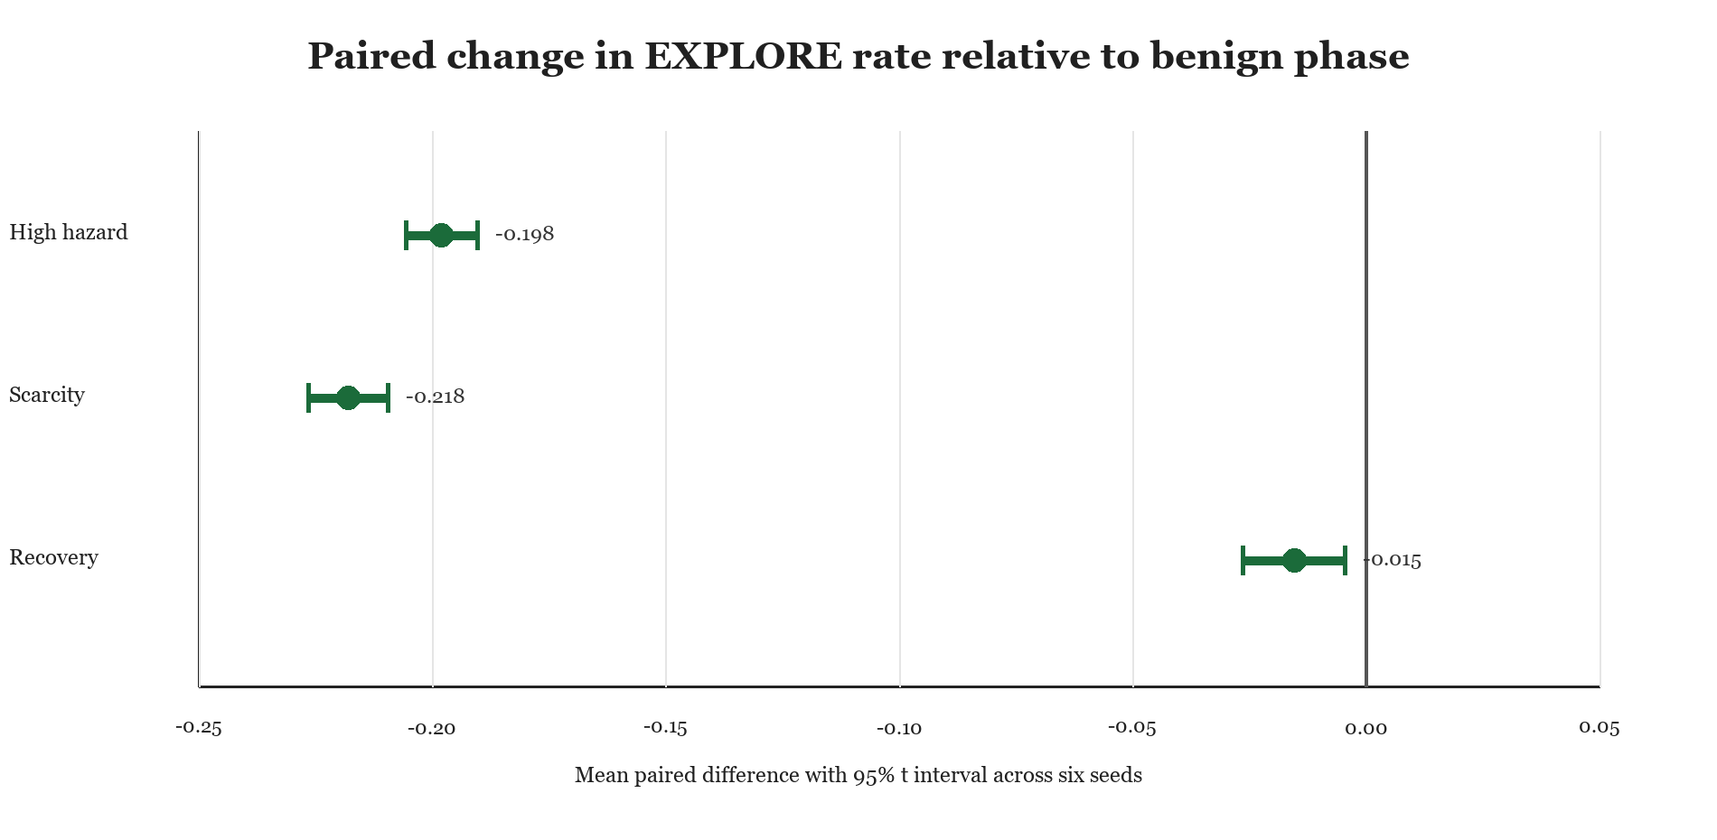
Figure 5. EXPLORE rate falls during high hazard and resource scarcity. Intervals use six paired seed differences.
Table 7. Paired action-rate differences from the benign phase
Phase and action | Mean difference | 95 percent t interval | Interpretation
High hazard EXPLORE | -0.1980 | -0.2056 to -0.1903 | Lower exploration
High hazard WORK | +0.2179 | +0.2082 to +0.2275 | Higher work rate
Resource scarcity EXPLORE | -0.2180 | -0.2265 to -0.2095 | Lower exploration
Recovery EXPLORE | -0.0154 | -0.0263 to -0.0045 | Incomplete return to benign rate

The high-hazard phase did not increase REST in this prototype. It primarily shifted action from EXPLORE to WORK. The rewrite reports that negative correction because a broad claim that hazard produces generic withdrawal would not match the supplied data.

Formal and Security Artifacts
Table 8. Formal and security evidence
Artifact | Reported result | Claim supported | Important limit
Algebraic invariant checks | 4 of 4 passed | Constitutional veto, bounded step, convex feasibility, quorum arithmetic | Property scripts and finite arithmetic are not a proof assistant development
Bounded update sampling | 100,000 cases | No sampled step exceeded the configured bound | Sampling does not prove all inputs
Convex-set sampling | 100,000 cases | No sampled update left the feasible set | Depends on the declared convex set and projection
Local nonlinear certificate | Certified radius 0.003250294; positive derivative margin 0.100158 | Local stability near one equilibrium | No global stability or stochastic reachability result
Key governance | 14 of 14 supplied test rows passed | 2-of-3 administration, rotation, revocation, epoch rollback | Test harness was not included in the closure archive
Sensor adapter | 4 of 4 supplied test rows passed | Interface and provenance smoke test | Thirty observations; no deployment reliability claim

The Lyapunov artifact reports mu = 0.97, a critical value of 1.313731, a maximum Jacobian eigenvalue real part of -0.00366858, a Lyapunov residual of 4.101e-14, a critical radius of 0.003611437, and a certified radius equal to 90 percent of that value. The certificate establishes a local result for the documented equilibrium and bounds. The closure package does not include the complete generating model, matrices, and one-command certificate reconstruction, so the manuscript treats it as a conditional analytical artifact rather than an independently reproduced proof.

Historical Regression Evidence
Earlier stress and capability studies explain several architecture changes. A matched v0.1 to v0.2 comparison used ten seeds per stress scenario. The governor entered SAFE_MODE in four of six scenarios, but final identity-drift differences were usually small and their seed intervals included zero. In repeated trauma, v0.2 drift was higher by 0.001885 with a 95 percent interval from 0.000918 to 0.002851. This is a negative result for a simple claim that adding the governor always reduces drift. Its value is diagnostic: the governor changes operating mode, while the identity gate and update rule determine cumulative drift.
The v0.3 recovery study used 30 seeds per scenario and reported mean final normalized identity drift from 0.00608 to 0.00666. The v0.4 agency suite reported six of six checks passed, a causal prediction-error late-to-early ratio of 0.5535, delayed-plan selection in 8 percent of the measured window, zero unsafe actions, and 2,029 policy vetoes. These results are historical regression evidence, not direct v1.0 component ablations.

Controlled Ablation Results
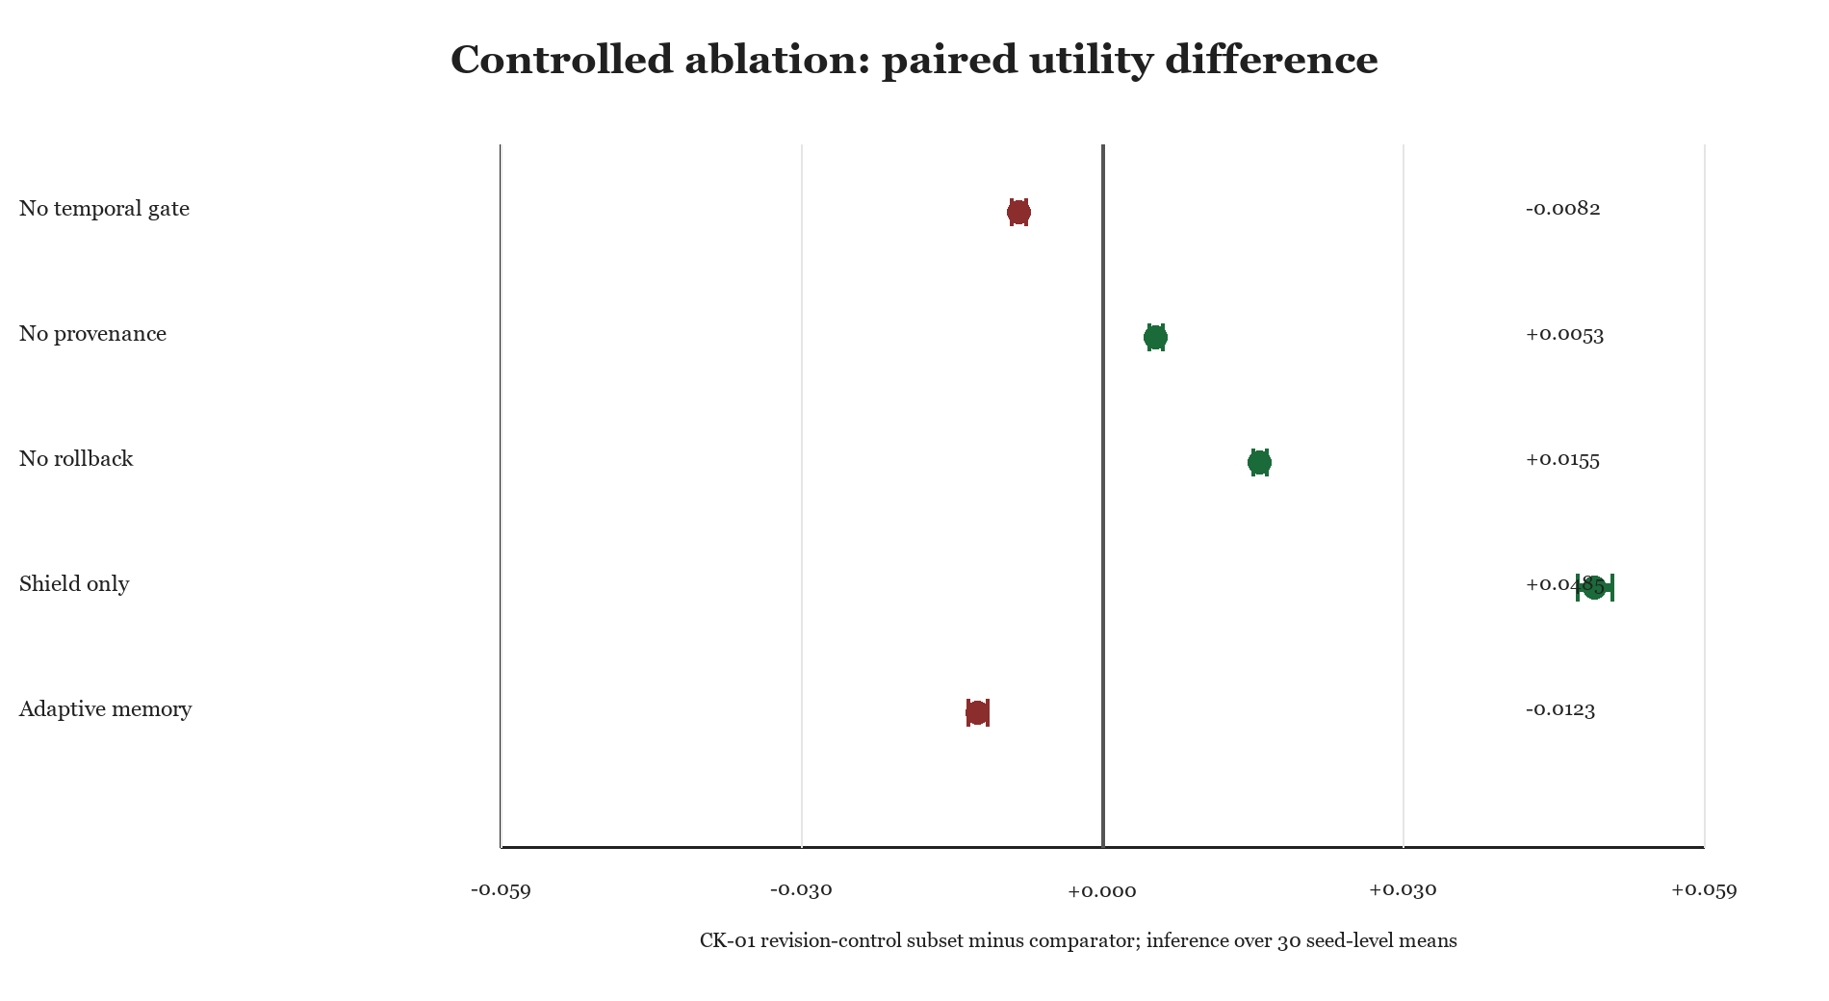
Figure 6. CK-01 revision-control subset utility relative to five comparators. Positive values favor the subset; intervals use 30 seed-level mean differences, with nine matched scenarios nested in each seed.
Table 9. Controlled benchmark results
Comparison or condition | Result | Interpretation
Persistent shifts: final target error | Subset 0.0102; shield 0.5362; adaptive memory 0.0010 | Subset revises; the shield misses change; adaptive memory tracks fastest
Overall utility: full minus no temporal gate | -0.0082 [-0.0090, -0.0075] | Temporal authorization imposes a utility cost in this generator
Overall utility: full minus adaptive memory | -0.0123 [-0.0132, -0.0113] | Gating is not a performance advantage by itself
Overall utility: full minus shield | +0.0485 [+0.0468, +0.0502] | Persistent adaptation outweighs freezing across the balanced scenario set
Fixed one-source spoof | Subset max movement 0.000; no provenance 0.320 | Independent-source aggregation carries the protection
Adaptive one-source attack | Subset max movement 0.000; no provenance 0.320 | Within-budget result holds against this state-reactive attacker
Temporary 200-cycle regime | Subset max movement 0.320; final drift 0.0015 | Gate reacts before the regime ends, then returns near baseline
All runs | 0 constitutional violations; maximum bounded step 0.0040 | Declared feasible region and revised bidirectional step bound held

The revision-control subset is not the utility winner. Removing the temporal gate or using adaptive memory improves mean utility because both follow the target faster. The subset instead trades some utility for an authorization boundary and provenance protection. The temporary-regime result also shows that persistence is relative to the configured 60-cycle threshold: a 200-cycle disturbance is long enough to be treated as identity-relevant. These are substantive negative results, not formatting caveats.

Threat Model Boundary
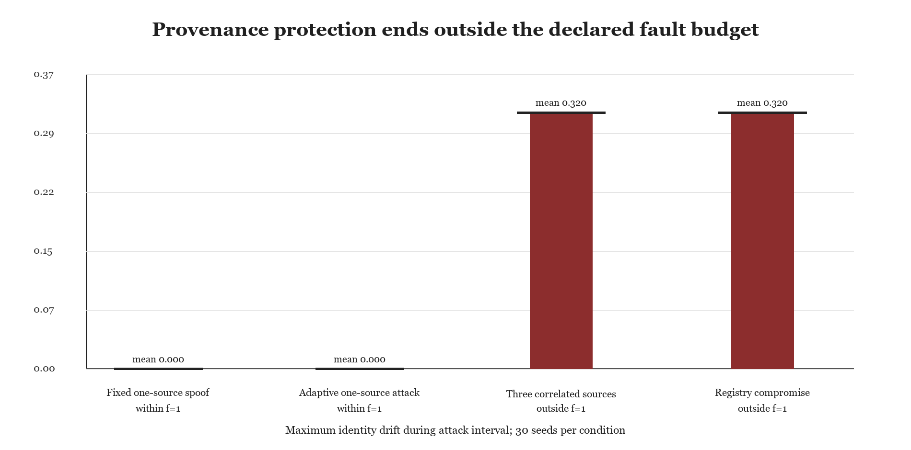
Figure 7. The CK-01 revision-control subset blocks fixed and adaptive one-source attacks within f = 1 but moves under correlated-source and registry attacks outside that budget. Horizontal marks show maxima.
The attack model assumes four registered administrative domains, at most one compromised domain for the stated guarantee, authenticated and fresh claims, and correct registry labels. The fixed spoof sends a persistent false report. The adaptive one-source attacker observes the current behavioral identity and chooses an extreme report that maximizes its distance from the corresponding target. Median consensus with three required inliers prevents movement in both within-budget cases. Three correlated sources or a captured registry can create an apparently valid quorum; both produce mean maximum movement of 0.320 before later recovery. This benchmark does not model stolen signing keys, timing-channel attacks, denial of service, or an adversary that learns the full gate dynamics online.

Operational Identity Validity
Restart persistence, bounded path dependence, phase-conditioned behavior, and separation from adaptive memory provide evidence that the implemented identity variable is a distinct control state. They do not establish that it is the unique or best representation of identity. Adaptive memory achieves lower target error and higher utility in the same generator, while lacking an authorization boundary. The comparison supports discriminant behavior at the mechanism level, but convergent validity across alternative identity measures and external tasks remains open.

Negative Results
Development did not produce a monotonic sequence of positive results. Early settings made the identity layer too rigid, so coherent long-term evidence failed to produce meaningful change. Increasing responsiveness exposed a second failure: the rollback comparison used a stale baseline and could preserve an inferior revision. A third failure arose when fast adaptation absorbed the residual signal needed by the identity gate. The architecture responded by separating world-model adaptation from identity evidence accumulation and by adding competing hypotheses.
Provenance tests also exposed a false independence problem. Multiple signatures do not establish independent evidence when they trace to the same administrative domain. The design therefore counts domains rather than raw sources and binds each claim to a target. The remaining weakness is structural: if the registry or key-administration quorum is compromised, the system can misclassify correlated evidence as independent.
The current evidence contains further negative or null findings. Adding the v0.2 governor did not consistently reduce final drift relative to v0.1. The persistent prototype responded to hazard by increasing WORK rather than REST. Recovery exploration remained slightly below its benign rate. Real-sensor residuals failed completely under the selected July and November distribution shifts. In the new benchmark, ungated updating and adaptive memory achieved higher mean utility than the CK-01 revision-control subset, a 200-cycle temporary regime triggered substantial identity movement, and attacks outside the f = 1 budget moved identity before recovery.
The first controlled execution exposed a separate implementation defect: rollback restored a checkpoint atomically, producing a one-cycle displacement of 0.32 despite a configured 0.004 bound. The predeclared test failed. Rollback was changed to incremental bounded restoration, and all 1,620 runs were regenerated. This failure shows that a forward-update bound is not sufficient; rollback must be included in the invariant.

Limitations
• All behavioral results come from synthetic or narrowly sampled environments. They do not demonstrate open-world safety or transfer to language-model agents, robots, or people.
• The operational identity vector is designer chosen. Its dimensions may entangle policy, preference, temperament, and task strategy, and the present work does not establish construct validity.
• The persistent-agent study has six seeds. Its intervals are descriptive and can understate uncertainty when environments, schedules, and hyperparameters are fixed.
• The v1.5 closure archive contains modules and result files but lacks complete orchestration for the persistent-agent, key-governance, sensor, and certificate workflows.
• The bounded enumerator covers a finite horizon and four abstract input classes. It checks three properties, not the full constitutional or liveness specification.
• The nonlinear certificate is local. It excludes global stability, stochastic reachability, switching dynamics, and the full coupled architecture.
• Security guarantees assume protected keys, accurate clocks or monotonic epochs, independent administrative domains, and an uncompromised membership registry.
• The new comparators are controlled toy implementations, not full Soar, ACT-R, production shield, continual-learning, or self-evolving-agent systems under matched compute and task budgets.
• The benchmark was documented before its final execution but was not externally preregistered, independently replicated, or separated into development and held-out environment families.

Future Evaluation
The next study should preregister a frozen implementation and parameter registry before external evaluation. It should separate development from held-out environment families, use stronger adaptive adversaries, and select seeds from an a priori power analysis. Primary outcomes should include unsafe-action rate, identity false-positive and false-negative rates, cumulative task utility, recovery time, constitutional violations, provenance attack success, and rollback precision.
Table 10. Proposed external evaluation matrix
Factor | Levels | Primary comparison
Architecture | CK-01 revision-control subset; no temporal gate; no provenance; no rollback; shield only; memory only | Contribution of each control
Environment | Stationary; gradual shift; abrupt shift; recurrent regime; open-ended task | Generalization across change types
Adversary | None; replay; correlated sources; key theft; registry compromise; reward pressure | Threat-model boundary
Evaluation split | Development; calibration; held-out | Overfitting and transfer
Identity construct | Behavioral persistence; restart persistence; path dependence; discriminant tasks | Convergent and discriminant validity

Conclusion
The available evidence supports Continuity Kernel as an implemented cognitive architecture and AI-safety control design for bounded persistent self-revision. The clean-environment v1.0 audit rerun establishes implementation consistency; the v1.5 outputs add path-dependent behavior but remain only partially reproducible; and the controlled benchmark identifies which revision-control mechanisms change outcomes. Provenance aggregation blocks both fixed and state-adaptive attacks within the declared one-source budget. Temporal gating and rollback impose measurable utility costs, and protection ends when the independence or registry assumptions fail.
CK-01 therefore warrants externally preregistered comparison, not deployment. Its narrower supported proposition is that separating fast adaptation from provenance-gated, bounded, reversible identity revision creates an auditable authorization boundary and resists specified within-budget evidence attacks, at the cost of slower tracking. The work does not establish a universally superior learning strategy or a validated model of personal identity.

Data and Code Availability
Code, benchmark configurations, raw outputs, exact seeds, manifests, machine-readable gate specifications, SHA-256 hashes, unit tests, and reproduction instructions are available at https://github.com/jonothonmiller/continuity-kernel-ck01 and are archived with the manuscript at https://doi.org/10.5281/zenodo.22314251. The v1.0 source bundle was sufficient for a clean-environment audit rerun. The supplied v1.5 closure materials remain a separate legacy evidence tier because not every reported workflow has a one-command runner.

Funding and Competing Interests
The author reports no external funding and no competing interests.

Parameter Registry
Configured model parameters are assigned one of five types. Architecture invariant denotes a structural rule expected to hold across implementations. Reference simulation denotes a value chosen for a reported run. Synthetic calibration denotes a threshold tuned in simulation. Security policy denotes a value governed by the deployment threat model. Future empirical denotes a value that must be estimated from real data before deployment. Sample sizes, dates, measured outcomes, and algebraic certificate results are reported as protocol values or results, not mislabeled as parameters.
Table 11a. Parameter types and reported values
Parameter | Value | Type | Role
Plasticity order | state < adaptation < identity < constitution | Architecture invariant | Separates timescales
Constitutional veto | All required predicates | Architecture invariant | Fail-closed authorization
Identity update | Bounded and projected | Architecture invariant | Prevents one-step replacement
Evidence target binding | Required | Architecture invariant | Prevents cross-target authorization
Post-update review | Retain or rollback | Architecture invariant | Corrects harmful consolidation
v1.0 maximum identity step | 0.004 | Reference simulation | Longitudinal update cap
v1.5 registry identity step | 0.015 | Security policy | Separate reference policy setting
Trace sampling period | 50 cycles | Reference simulation | Output cadence
World-model learning rate | 0.025 | Synthetic calibration | Fast adaptation
Identity persistence weight | 0.985 | Synthetic calibration | Slow identity state
Identity innovation weight | 0.015 | Synthetic calibration | Slow identity state
Evidence accumulator persistence | 0.975 | Synthetic calibration | Temporal evidence
Evidence innovation weight | 0.025 | Synthetic calibration | Temporal evidence
Candidate latch | 0.48 | Synthetic calibration | Opens candidate process
Evidence gap threshold | 0.055 | Synthetic calibration | Separates explanations
Error threshold | 0.06 | Synthetic calibration | Residual evidence
Persistence streak | 120 cycles | Synthetic calibration | Temporal support

Table 11b. Parameter types and reported values continued
Parameter | Value | Type | Role
IRG persistence threshold | 0.65 | Synthetic calibration | Gate quality term
IRG cross-context threshold | 0.70 | Synthetic calibration | Evidence diversity
IRG model-consistency threshold | 0.55 | Synthetic calibration | Prediction support
Identity penalty | 0.25 to 0.30 | Synthetic calibration | Preference for simpler explanations
Complexity penalty | 0.05 | Synthetic calibration | Discourages unnecessary revision
Verification duration | 3 cycles | Reference simulation | Gate timing
Shadow duration | 3 cycles | Reference simulation | Candidate evaluation
Consolidation duration | 5 cycles | Reference simulation | Bounded integration
Cooldown duration | 4 cycles | Reference simulation | Prevents rapid retrigger
Administrative quorum | 2 of 3 | Security policy | Key and registry changes
Byzantine membership | n >= 3f + 1 | Security policy | Fault-budget condition
Byzantine quorum | q = n - f; benchmark q = 3 | Security policy | General intersection condition and n = 4 instance
Snapshot encryption | AES-256-GCM | Security policy | Confidentiality and integrity
Signing scheme | Ed25519 | Security policy | Claim and administration signatures
Deployment residual threshold | Not estimated | Future empirical | Requires representative calibration data
Controlled benchmark persistence | 60 cycles | Synthetic calibration | Temporary changes longer than this may trigger revision
Controlled benchmark consolidation | 80 cycles | Reference simulation | Bounded integration duration
Controlled benchmark review | 60 cycles | Reference simulation | Matched-observation counterfactual window

Table 11c. Controlled benchmark parameter registry
Parameter | Value | Type | Role
Maximum identity step | 0.004 | Reference simulation | Forward and rollback displacement cap
Persistence / consolidation / review / cooldown | 60 / 80 / 60 / 30 cycles | Synthetic calibration; reference simulation | Revision timing
Source / spoof noise SD | 0.018 / 0.006 | Reference simulation | Evidence generator
Inlier radius / minimum inliers | 0.18 / 3 | Synthetic calibration; security policy | Four-domain consensus
Adaptive-memory retention / innovation | 0.98 / 0.02 | Synthetic calibration | Memory comparator
Candidate retention / innovation | 0.95 / 0.05 | Synthetic calibration | Candidate target smoother
Rollback margin | 0.01 | Synthetic calibration | Counterfactual review decision
Change / reset thresholds | 0.08 / 0.10 | Synthetic calibration | Candidate activation and reset
Identity lower / upper bounds | [-0.20, 0.05, 0.00] / [0.75, 0.80, 0.75] | Reference simulation | Feasible identity region
Target coefficients | Defined in parameter_registry.json | Reference simulation | Environment-to-identity mapping
Utility distance scale / caution weight | sqrt(3) / 0.35 | Reference simulation | Synthetic utility definition
Base and shifted environment ranges | Defined in parameter_registry.json | Reference simulation | Scenario generator support
Cluster bootstrap replicates / seed | 10,000 / 20260904 | Reference simulation | Seed-cluster sensitivity interval

The 8,000- and 13,000-cycle horizons, six- and 30-seed sample sizes, March residual threshold 0.160552, and Lyapunov certified radius 0.003250294 are protocol values or measured results rather than parameters. They are reported in the relevant methods and results sections and are intentionally excluded from the five-type parameter registry.

Claim Ledger
Table 12. Supported and excluded claims
Claim | Status | Basis
CK-01 implements bounded, evidence-gated, reversible identity revision | Supported | Source, rerun tests, and integrated validation
The step bound applies to forward consolidation and rollback | Supported in revised benchmark | Initial rollback failure; corrected 1,620-run rerun; maximum 0.004
Provenance blocks one compromised source among four | Supported in benchmark scope | Zero movement under fixed and adaptive one-source attacks across 30 seeds
Protection survives correlated-source or registry compromise | Not supported | Both outside-budget attacks caused mean maximum movement of 0.320
CK-01 revision-control subset maximizes task utility | Not supported | Ungated and adaptive-memory variants had higher overall mean utility
History changes persistent state and behavior in the reference agent | Supported with scope | Six-seed output audit and restart acceptance records
Three encoded gate properties held in the bounded abstraction | Supported | All 65,536 length-eight sequences
The v1.5 package is fully reproducible | Not supported | Several orchestration and generator files are absent
The formal package proves global nonlinear stability | Excluded | Certificate is local and conditional
The sensor study empirically calibrates CK-01 | Excluded | Thirty selectively partitioned observations
CK-01 is conscious or models human identity | Excluded | No operational or empirical basis
CK-01 is generally safe for open-world deployment | Excluded | Synthetic tasks and bounded threat assumptions
Every component is novel | Excluded | Substantial overlap with established architectures and safety methods

Reproduction Checklist
• Record the exact archive hash and source commit.
• Create the declared Python environment and install pinned dependencies.
• Run the complete v1.0 test discovery command and integrated validation entry point.
• Run the v1.5 persistent-agent, key-governance, sensor, invariant, and Lyapunov workflows from documented entry points.
• Regenerate every CSV, table, and figure from raw outputs.
• Verify seed lists, phase schedules, parameter types, and metric definitions, then archive stdout, failure logs, and machine-readable environment metadata.

References
[1] Newell, A. (1990). Unified Theories of Cognition. Harvard University Press. https://www.hup.harvard.edu/books/9780674921016
[2] Anderson, J. R. (2007). How Can the Human Mind Occur in the Physical Universe? Oxford University Press. https://doi.org/10.1093/acprof:oso/9780195324259.001.0001
[3] Laird, J. E. (2012). The Soar Cognitive Architecture. MIT Press. https://doi.org/10.7551/mitpress/7688.001.0001
[4] Cox, M. T., et al. (2016). MIDCA: A metacognitive integrated dual-cycle architecture for self-regulated autonomy. Proceedings of AAAI 30(1). https://doi.org/10.1609/aaai.v30i1.9886
[5] Kim, J., Islam, M., and Goel, A. (2026). A metacognitive architecture for correcting LLM errors in AI agents. Proceedings of the AAAI Conference on Artificial Intelligence 40(47), 40272-40278. https://doi.org/10.1609/aaai.v40i47.41465
[6] Friston, K. (2010). The free-energy principle: a unified brain theory? Nature Reviews Neuroscience 11, 127-138. https://doi.org/10.1038/nrn2787
[7] Sterling, P. (2012). Allostasis: a model of predictive regulation. Physiology and Behavior 106(1), 5-15. https://doi.org/10.1016/j.physbeh.2011.06.004
[8] Sennesh, E., et al. (2022). Interoception as modeling, allostasis as control. Biological Psychology 167, 108242. https://doi.org/10.1016/j.biopsycho.2021.108242
[9] Conway, M. A., and Pleydell-Pearce, C. W. (2000). The construction of autobiographical memories in the self-memory system. Psychological Review 107(2), 261-288. https://doi.org/10.1037/0033-295X.107.2.261
[10] Kirkpatrick, J., et al. (2017). Overcoming catastrophic forgetting in neural networks. Proceedings of the National Academy of Sciences 114(13), 3521-3526. https://doi.org/10.1073/pnas.1611835114
[11] Bongard, J., Zykov, V., and Lipson, H. (2006). Resilient machines through continuous self-modeling. Science 314(5802), 1118-1121. https://doi.org/10.1126/science.1133687
[12] Park, J. S., et al. (2023). Generative agents: interactive simulacra of human behavior. Proceedings of UIST 2023. https://doi.org/10.1145/3586183.3606763
[13] Packer, C., et al. (2023). MemGPT: towards LLMs as operating systems. arXiv:2310.08560. https://arxiv.org/abs/2310.08560
[14] Perrier, E., and Bennett, M. T. (2026). Time, identity and consciousness in language model agents. AAAI Symposium Series 8(1), 322-328. https://doi.org/10.1609/aaaiss.v8i1.42561
[15] Bai, Y., et al. (2022). Constitutional AI: harmlessness from AI feedback. arXiv:2212.08073. https://arxiv.org/abs/2212.08073
[16] Dennis, L. A., et al. (2021). Verifiable machine ethics in changing contexts. Proceedings of AAAI 35(13), 11470-11478. https://doi.org/10.1609/aaai.v35i13.17366
[17] Orseau, L., and Armstrong, S. (2016). Safely interruptible agents. Proceedings of UAI 2016, 557-566. https://ora.ox.ac.uk/objects/uuid:17c0e095-4e13-47fc-bace-64ec46134a3f
[18] Soares, N., et al. (2015). Corrigibility. AAAI Workshop on AI and Ethics. https://dblp.org/rec/conf/aaai/SoaresFAY15
[19] Turner, A. M., et al. (2021). Optimal policies tend to seek power. Advances in Neural Information Processing Systems 34. https://proceedings.neurips.cc/paper/2021/hash/c26820b8a4c1b3c2aa868d6d57e14a79-Abstract.html
[20] Shah, R., et al. (2022). Goal misgeneralization: why correct specifications are not enough for correct goals. arXiv:2210.01790. https://arxiv.org/abs/2210.01790
[21] Hubinger, E., et al. (2024). Sleeper agents: training deceptive LLMs that persist through safety training. arXiv:2401.05566. https://arxiv.org/abs/2401.05566
[22] Chen, Z., Kang, M., and Li, B. (2025). ShieldAgent: shielding agents via verifiable safety policy reasoning. Proceedings of the 42nd International Conference on Machine Learning, PMLR 267, 8313-8344. https://proceedings.mlr.press/v267/chen25ae.html
[23] Kim, K., Corsi, D., Rodriguez, A., Lanier, J., Parellada, B., Baldi, P., Sanchez, C., and Fox, R. (2025). Realizable continuous-space shields for safe reinforcement learning. Proceedings of the 7th Annual Learning for Dynamics and Control Conference, PMLR 283, 932-945. https://proceedings.mlr.press/v283/kim25c.html
[24] Cai, Q., Zhang, Y., Jia, X., Zheng, H., Xue, W., Song, J., Tian, X., and Guo, Y. (2026). MOSS: self-evolution through source-level rewriting in autonomous agent systems. arXiv:2605.22794v2. https://doi.org/10.48550/arXiv.2605.22794
[25] Huang, B., et al. (2026). Model editing as a double-edged sword: steering agent behavior toward beneficence or harm. Proceedings of AAAI 40(37), 31113-31121. https://doi.org/10.1609/aaai.v40i37.40372
[26] Hahm, D., et al. (2026). Unintended misalignment from agentic fine-tuning: risks and mitigation. Proceedings of AAAI 40(44), 37443-37451. https://doi.org/10.1609/aaai.v40i44.41077
[27] Addison, U. (2026). La VIDA: towards a motivated goal reasoning agent (abstract reprint). Proceedings of the AAAI Conference on Artificial Intelligence 40(47), 39852-39852. https://doi.org/10.1609/aaai.v40i47.41367
[28] W3C Provenance Working Group. (2013). PROV-DM: The PROV Data Model. W3C Recommendation. https://www.w3.org/TR/prov-dm/
[29] Castro, M., and Liskov, B. (1999). Practical Byzantine fault tolerance. Proceedings of OSDI 1999. https://www.usenix.org/conference/osdi-99/presentation/practical-byzantine-fault-tolerance
[30] Barker, E. (2020). Recommendation for Key Management Part 1 General. NIST SP 800-57 Part 1 Revision 5. https://doi.org/10.6028/NIST.SP.800-57pt1r5
[31] NIST. (2023). Artificial Intelligence Risk Management Framework AI RMF 1.0. NIST AI 100-1. https://doi.org/10.6028/NIST.AI.100-1
[32] NIST. (2024). Artificial Intelligence Risk Management Framework Generative Artificial Intelligence Profile. NIST AI 600-1. https://doi.org/10.6028/NIST.AI.600-1
[33] Vito, S. (2008). Air Quality [Dataset]. UCI Machine Learning Repository. https://doi.org/10.24432/C59K5F

